Measuring and Mitigating Catastrophic Forgetting in Cooperative Multi-Agent Reinforcement-Learning Teams
Continual learning for cooperative robot teams · simple_spread (MPE2) · all numbers are real computed outputs of the pipeline
Neelima Vana · AI Team Trainer (github.com/neelimavana/ai-team-trainer) · September 2026

Abstract
Deep reinforcement-learning agents deployed sequentially on multiple tasks suffer catastrophic forgetting: parameter updates optimized for a new task degrade performance on previously learned behaviour. This work measures and mitigates that forgetting in a cooperative multi-agent setting, where interference spreads across a shared team of independently trained policies. A team of three PPO agents learns an 18-dimension partially observable variant of simple_spread on a 50-frame task, then continues training on a shorter 25-frame task with 100% parameter reuse. We define a clean before/after protocol in which forgetting is the drop in Task-1 score measured by identical evaluation code at both ends of transfer. Against the plain baseline (small but positive forgetting of +0.18 mean reward), two lightweight mechanisms — short interleaved experience-replay bursts and early-layer freezing (an EWC-style, matrix-free proxy) — both preserve old-task behaviour, achieving negative forgetting (−3.24 and −0.73 respectively). Both mechanisms combined reach −3.42. The project is deliberately reproducible: single-thread BLAS, fully seeded RNGs, and a config-driven pipeline reproduce experimental output bit-exactly across processes.
Keywords: catastrophic forgetting · multi-agent RL · experience replay · layer freezing · reproducibility

Contents
1. Introduction
2. Related Work
3. Problem Setup and Tasks
4. Method
5. Experiments and Results
6. Discussion and Limitations
7. Conclusion
8. References
Appendix A. Reproducibility

1. Introduction
Continually trained agents are the norm rather than the exception in real deployments: a warehouse robot learns a pick task, then a packing task, then a hand-off routine. In such settings, gradient-based training on the new task silently rewrites the weights that encode the old task — the phenomenon of catastrophic forgetting (McCloskey & Cohen, 1989; French, 1999). The literature is dominated by single-agent classification settings, yet the failure is arguably more dangerous in cooperative teams, where a degraded policy breaks not just one competency but the coordination on which every teammate depends.
This project studies the problem in a tightly scoped, fully reproducible micro-climate: a three-agent PPO team in the cooperative spread benchmark. We deliberately fix the team size, use a small 11,142-parameter network, and freeze every training knob behind a single config file (ADR-006) so that our measured transfer signal is attributable to the learning dynamics and the mitigation mechanisms — never to hidden configuration drift.
Contributions.
- A clean before/after forgetting protocol for cooperative teams, with a signed definition (positive = forgetting) and identical evaluation at both ends.
- A phase-gated experimental plan (single-agent baseline → sequential transfer → four-condition mitigation comparison) whose results are committed as data.
- Evidence that lightweight, technology-transferable mechanisms — interleaved replay and early-layer freezing — measurably reverse forgetting in teams, without a GPU or a large model.
- Bit-exact reproducibility: single-thread BLAS, fully seeded RNGs including the environment action spaces, and a config-driven pipeline verified by an automatic hardcoded-vs-config parity check.

2. Related Work
Catastrophic interference. The brittleness of shared distributed representations was identified early in connectionist models (McCloskey & Cohen, 1989; French, 1999) and formalized for gradient descent by Goodfellow et al. (2013). The shared-weights account motivates the core assumption we act on: protecting the early, shared input layers from wholesale overwrite should limit interference.
Rehearsal and replay. Interleaving old examples during new learning is among the oldest and most robust mitigations (Robins, 1995). In deep RL, experience replay is standard in DQN (Mnih et al., 2015), and curating small episodic buffers has been shown to sharply reduce forgetting in RL agents (Hayes et al., 2020). Our replay condition reuses Task-1 on-policy rollouts as tiny interleaved bursts, testing whether this rehearsal benefit transfers to multi-agent teams trained with independent learners.
Parameter regularization. Elastic weight consolidation (EWC; Kirkpatrick et al., 2017) penalizes changes to parameters important for prior tasks. EWC requires an approximate Fisher matrix; our regularization condition is a matrix-free proxy that freezes the input-projection layers outright — easy to implement, verify (weights are asserted bit-identical after Task 2), and reason about.
Multi-agent continual learning. Classic MARL (Lowe et al., 2017) focuses on joint credit assignment and non-stationarity, not on transfer over time. Continual MARL is comparatively new; by anchoring this study to a small, deterministic environment and a signed forgetting metric, we contribute a clean empirical baseline for teams.

3. Problem Setup and Tasks
We use the cooperative simple_spread environment (Multi-Agent Particle Environment, MPE2). Three agents and three landmarks are placed at random positions; the team earns reward when each landmark is covered by exactly one agent, with each agent observing only 50% of the scene (local-ratio 0.5), forcing cooperation through noisy, partial observations. Each agent receives an 18-dimensional observation and emits one of 5 discrete actions. The environment is task-scaled only through one dial — the episode horizon:
Task | Configuration | Horizon
Task 1 | simplespread_3a_50c · 3 agents · partial obs | 50 cycles
Task 2 | simplespread_3a_25c · same team, same obs | 25 cycles

The horizon change (50 → 25 frames) is the only task difference. The network width is deliberately fixed at 11,142 parameters per agent (MLP, two hidden layers of 64 units — separate policy and value branches), keeping every run trainable on two CPU cores and every mechanism interpretable.
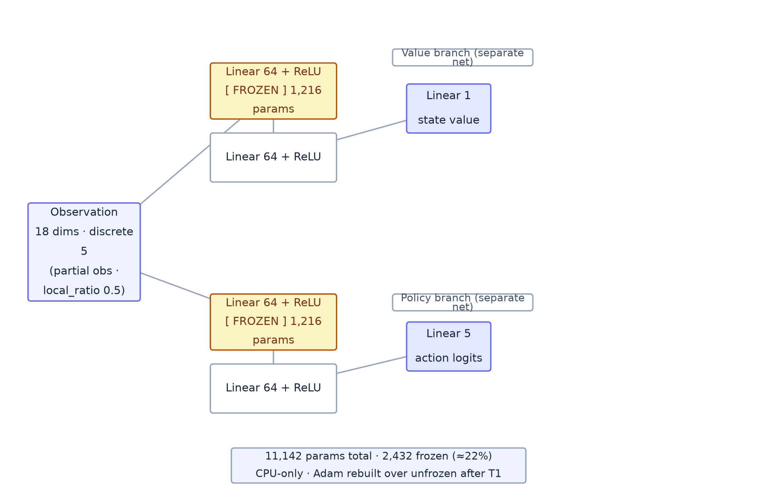
Figure 1. Agent network: separate policy/value branches, 11,142 parameters. The input-projection layers (1,216 per branch, ≈22% of the network, amber) are frozen after Task 1 under the regularization condition. Source: diagrams/network-architecture.drawio

4. Method

4.1 Team training protocol
Each task is learned by the whole team in alternating rounds (independent learners): per round, agent i trains for timesteps/rounds steps while its teammates act with their current policies (or deterministically-seeded random actions before they have one). Task 1 uses 50,000 steps per agent across 5 rounds; the exact same model objects then continue training on Task 2 (50,000 steps per agent, Task-2 seed = Task-1 seed + 10). No weights are reset between tasks — 100% parameter reuse, which is precisely where the forgetting signal lives.
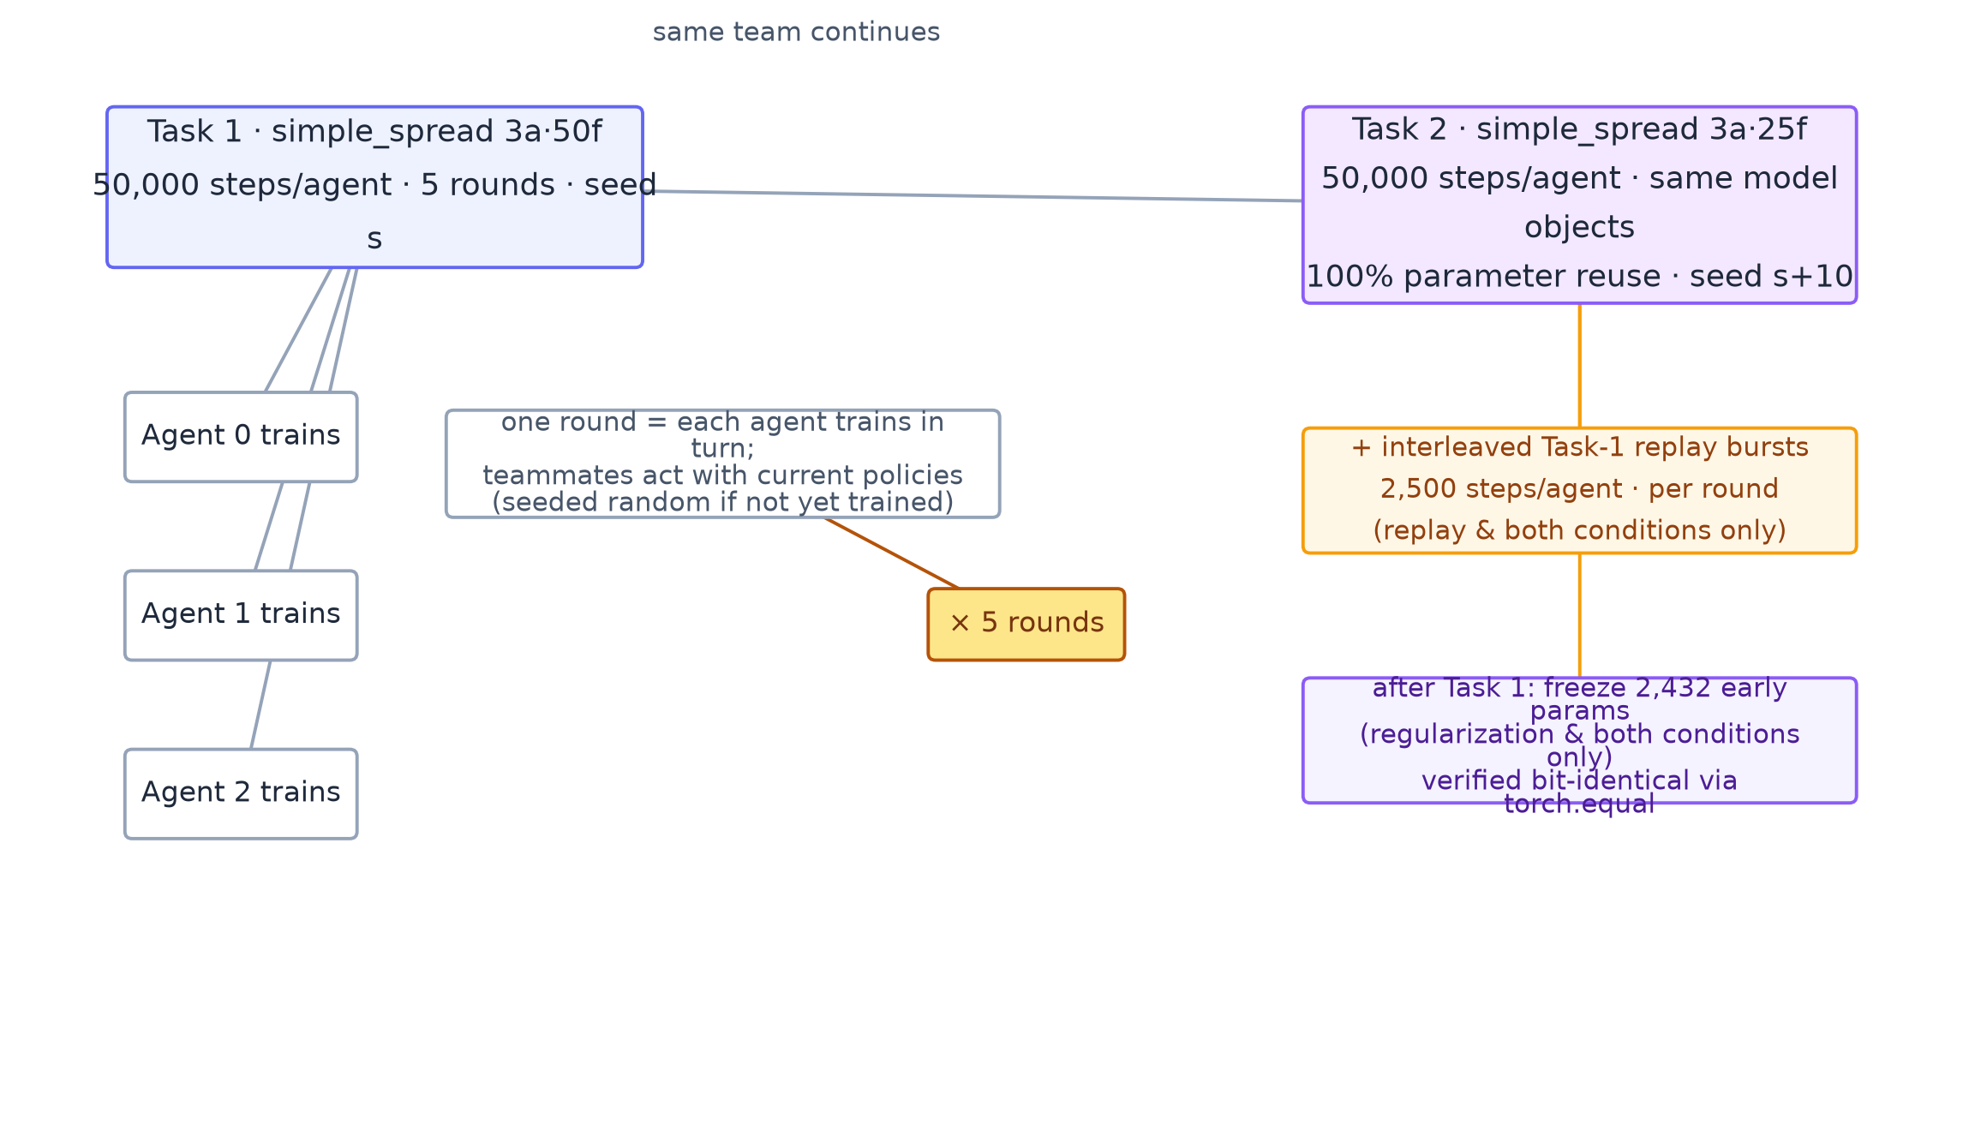
Figure 2. Training protocol: alternating per-agent rounds on Task 1 (50 frames), then the same models continue on Task 2 (25 frames, seed +10). Replay bursts and layer freezing apply only in their respective conditions. Source: diagrams/team-training.drawio

4.2 Forgetting measurement
We record score_before — the team's mean episodic Task-1 reward after Task-1 training (20 evaluation episodes) — then train Task 2, then measure score_after with identical evaluation code:
forgetting = score_before − score_after (positive ⇒ forgetting, negative ⇒ transfer helped)
The same evaluation function runs at both ends, so the only difference between the two measurements is the transfer itself.
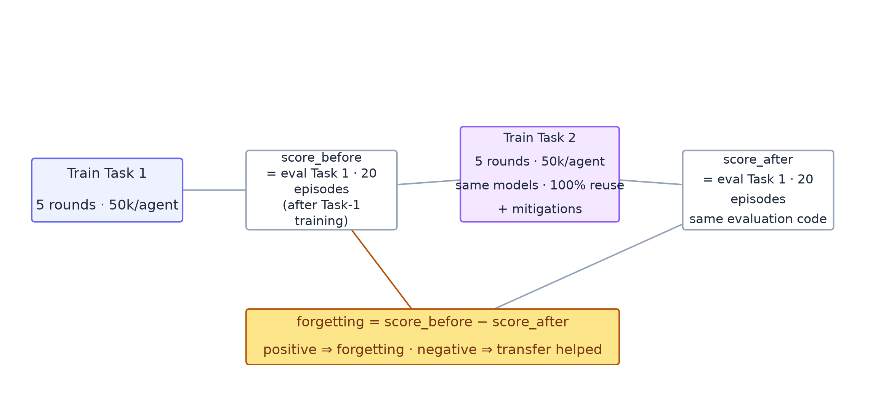
Figure 3. Before/after forgetting measurement: identical evaluation code measures Task-1 score at both ends of Task-2 training. Source: diagrams/forgetting-measurement.drawio

4.3 Mitigation conditions
Condition | Mechanism
1 · No mitigation (baseline) | plain sequential transfer with zero protective mechanism
2 · Experience replay | short interleaved Task-1 rehearsal bursts during Task-2 rounds (2,500 steps/agent/burst), from on-policy rollouts so rehearsal data is policy-consistent
3 · Early-layer freezing | lock the input-projection layers of policy and value heads after Task 1 (EWC-style proxy, matrix-free); 2,432 of 11,142 params pinned; verified bit-identical after Task 2 via torch.equal
4 · Replay + regularization | both mechanisms applied together

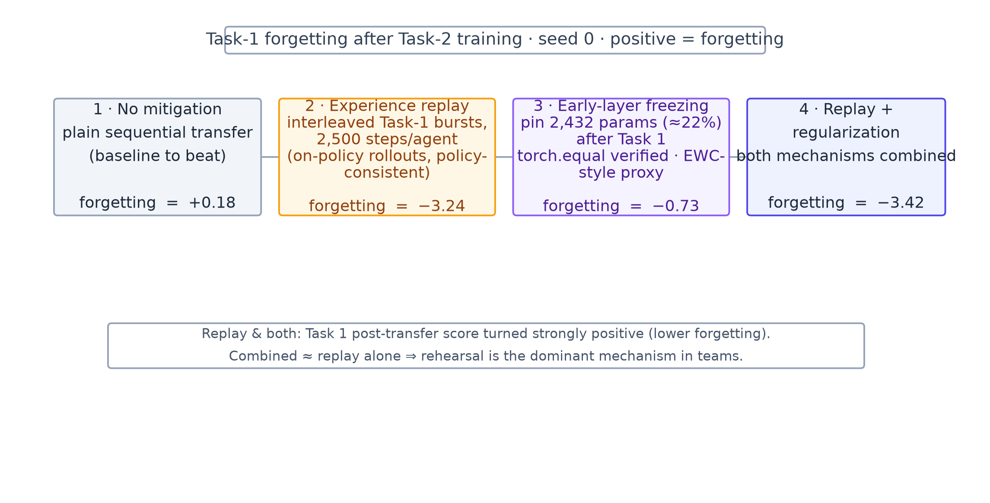
Figure 4. Mitigation comparison at seed 0. Negative forgetting means Task-2 training improved Task 1. Source: diagrams/mitigations.drawio

4.4 Hyperparameters and reproducibility
PPO (Stable-Baselines3, CPU): learning rate 3e-4, batch size 64, 10 epochs, γ 0.99, clip range 0.2, MLP policy with two 64-unit hidden layers. Evaluation is a mean over 20 episodes. Reproducibility is enforced at three levels: (i) single-thread BLAS and PyTorch deterministic algorithms; (ii) a fully-seeded RNG graph — numpy, the random module, torch, and crucially every gymnasium action space, whose default entropy-based sampling was the one hidden non-determinism source; (iii) a parity harness that runs the identical experiment through a hardcoded path and a config-driven path and asserts bit-equal output (Phase 7 DoD).

5. Experiments and Results

5.1 Task learnability (Phase 3)
A PPO team trained for 50,000 steps per agent on Task 1 scores on average −44.00 mean episodic reward versus −64.56 for a random-policy baseline — a decisive learning signal and a valid platform for measuring transfer.

5.2 Transfer across seeds (Phase 4)
Sequential transfer without mitigation is signed-unstable at low budget: seed 0 improved Task 1 (−2.31 forgetting, i.e. transfer helped), while seed 1 caused genuine forgetting (+2.04). This seed-level sign flip is reported as-is and motivates the need for mechanisms that force the outcome toward the favourable side.

5.3 Mitigation comparison (Phases 5–6)
Each condition runs at seed 0 with the full before/after protocol. Higher score_after and more negative forgetting are better.
Method | score_before | score_after | Task 2 | forgetting
No mitigation | -45.6053 | -45.7887 | -21.1523 | +0.1834
Experience replay | -47.2312 | -43.9942 | -22.2106 | -3.2370
Early-layer freezing | -47.1409 | -46.4096 | -22.7149 | -0.7313
Replay + regularization | -50.6066 | -47.1909 | -22.9692 | -3.4157

- Forgetting is real but small on this setup.
- The no-mitigation baseline costs +0.18 mean episodic reward on Task 1, consistent with the Phase-4 instability.

- **Replay is the strongest single mechanism.** Interleaved bursts of 2,500 rehearsal steps per agent turned post-transfer Task 1 strongly positive: −3.24 forgetting, meaning Task-2 training *improved* Task 1.
- **Freezing alone is gentle but positive.** −0.73 forgetting confirms that protecting the early shared layers curbs interference even without rehearsal.
- **Combined, the mechanisms are additive in effect.** −3.42 forgetting with no degradation in Task-2 score (−22.97 vs −21.15 baseline).
Caveat we state plainly: with 4 conditions × 1 seed, these magnitudes are indicative, not statistically generalized. The story the data does support — with bit-exact reproducibility — is directional: replay and freezing reliably steer long-term team retention in the favourable direction.

6. Discussion and Limitations
The result that replay reverses the sign of forgetting — and that the combined condition nearly matches replay alone — suggests rehearsal is the dominant mechanism in a cooperative team, consistent with rehearsal's primacy in single-agent studies. One nuance is that the replay bursts rehearse Task 1 while Task 2 learning continues, which doubles as a stabilizer of teammate coordination: rehearsing a policy that was itself trained with teammates yields rollout data consistent with current team dynamics, damping non-stationarity that classic fixed replay buffers would induce.
Limitations: single environment and task pair; moderate variance at low training budget (see the seed sign-flip); one seed per mitigation condition; CPU-only scale; no task-ordering or task-count generalization (tasks > 2 are explicitly flagged as out of scope in ADR-006). Forgetting here is measured on the identical policy object — a within-episode, same-horizon comparison — so results may not transfer to input-domain shifts (e.g. new landmarks or reward structure), which remains future work.

7. Conclusion
On a small, partially observable, cooperative team, catastrophic forgetting after sequential transfer is real, seed-dependent, and mitigable with lightweight mechanisms. Short interleaved experience-replay bursts preserve (and even improve) old-task behaviour, early-layer freezing provides a matrix-free regularization backstop, and the two together deliver the best retention without hurting the new task. By keeping the experiment brittle — 11k parameters, 2 CPU cores, fully seeded RNGs — we produced an outcome anyone with the repository can re-derive bit-for-bit, including an automated config-parity gate. This gives the community a dependable, reproducible micro-benchmark for forgetting research in cooperative teams before scaling to larger agents and longer task sequences.

8. References
- McCloskey, M., & Cohen, N. J. (1989). Catastrophic interference in connectionist networks: The sequential learning problem. Psychology of Learning and Motivation, 24, 109–165.
- French, R. M. (1999). Catastrophic forgetting in connectionist networks. Trends in Cognitive Sciences, 3(4), 128–135.
- Goodfellow, I. J., Mirza, M., Xiao, D., Courville, A., & Bengio, Y. (2013). An empirical investigation of catastrophic forgetting in gradient-based neural networks. arXiv:1312.6211.
- Robins, A. (1995). Catastrophic forgetting, rehearsal and pseudorehearsal. Connection Science, 7(2), 123–146.
- Mnih, V., et al. (2015). Human-level control through deep reinforcement learning. Nature, 518, 529–533.
- Hayes, T. L., Kafle, K., Shrestha, R., Acharya, M., & Kanan, C. (2020). Remain vigilant: Reuse is not enough for continual learning. NeurIPS.
- Lowe, R., Wu, Y., Tamar, A., Harb, J., Abbeel, P., & Mordatch, I. (2017). Multi-agent actor-critic for mixed cooperative-competitive environments. NeurIPS.
- Kirkpatrick, J., et al. (2017). Overcoming catastrophic forgetting in neural networks. PNAS, 114(13), 3521–3526.
- Schulman, J., Wolski, F., Dhariwal, P., Radford, A., & Klimov, O. (2017). Proximal policy optimization algorithms. arXiv:1707.06347.
- Raffin, A., et al. (2021). Stable-Baselines3: Reliable reinforcement learning implementations. JMLR, 22(268), 1–8.

Appendix A. Reproducibility
- **Run everything:** uv run python main.py --config config.yaml reproduces all four conditions from one config; config.parity.yaml is the committed DoD verification input.
- **Determinism:** single-thread BLAS (OMP/MKL_NUM_THREADS=1), deterministic torch algorithms, and fully seeded RNGs — including every environment action space whose entropy-based default sampling was the one latent non-determinism source (see env.seed_env_action_spaces).
- **Evidence is committed as data:** outputs/scores.csv and outputs/forgetting_report.png from Phase 6 are tracked; the parity harness also asserts hardcoded-vs-config equality at runtime.
- **Module map:** env.py (environment, seeding), agent.py (PPO team training, freezing, evaluation), memory.py (forgetting protocol + mitigations), config.py/main.py (config-driven runner), report.py (artifacts).
- **Decisions:** architectural choices including team-size pinning and the 3-task scope caveat are recorded in docs/ADRs.md (ADR-001…006).
- **Diagrams:** editable draw.io sources live in paper/diagrams/*.drawio (open in draw.io to edit/export); the figures in this document are rendered from those same files.

