LJ POLYTECHNIC

A MINI PROJECT REPORT ON
MUSIC RECOMMENDATION SYSTEM
(2025 - 2026)

MACHINE LEARNING

Submitted by:

Sr. | Enrolment | Student Name
1 | 23012250210200 | Nayak Dhruv Ashishbhai
2 | 23012250210201 | Neelkanth Patel
3 | 23012250210202 | Nirmal Dhruvkumar Sunilkumar
4 | 23012250210203 | Nirmal Dhyey Himanshubhai
5 | 23012250210204 | Nirmit Ishit Sheth
6 | 23012250210208 | Panchal Darshil Manubhai

MUSIC RECOMMENDATION SYSTEM

INTRODUCTION
With the rapid growth of digital music platforms, the amount of music available online has increased dramatically. Streaming platforms such as Spotify, Apple Music, and YouTube Music host millions of songs. Because of this huge volume of content, users often find it difficult to discover songs that match their preferences. This challenge has led to the development of Music Recommendation Systems.
A Music Recommendation System is an intelligent system that suggests songs to users based on various factors such as musical characteristics, listening history, or similarity between songs. These systems use Machine Learning techniques to analyse music data and identify patterns that can help predict which songs a user might enjoy.
The main goal of this project is to develop a content-based music recommendation system that suggests songs similar to a given input song. Instead of relying on user history, the system analyses the acoustic properties of songs and compares them mathematically to determine similarity.
The proposed system uses a dataset containing more than 411,088 songs with detailed acoustic features such as danceability, energy, loudness, tempo, and valence. These features represent the musical characteristics of each track. By analysing these features, the system can identify songs that share similar musical patterns.
The project uses the Content-Based Filtering approach, which is a popular method in recommendation systems. This approach compares the features of items and recommends items that are similar to the user's selected item.

Machine Learning libraries such as Pandas, NumPy, and Scikit-Learn are used to preprocess the dataset, normalize feature values, and calculate similarity scores between songs.
The final output of the system provides a list of recommended songs along with a similarity match percentage, allowing users to easily discover new music that matches their taste.
The main objectives of this project include:
- To design and implement a music recommendation system using machine learning.
- To analyse acoustic song features for similarity detection.
- To recommend songs with high similarity scores.
- To create an interactive interface for users to explore music suggestions.
This project demonstrates how machine learning techniques can be used in real-world applications such as music streaming platforms to improve user experience and content discovery.

ALGORITHM USED
The core algorithm used in this project is Content-Based Filtering combined with Cosine Similarity to identify similar songs based on their audio features.
Content-Based Filtering works by analysing the characteristics of items (songs) and recommending items that share similar attributes. In this system, each song is represented by a feature vector containing its acoustic properties.
Feature Parameters Used
The system analyses the following five important audio characteristics:
- Danceability
Danceability describes how suitable a track is for dancing. It considers rhythm stability, tempo, and beat strength. Songs with higher danceability values are more rhythmic and energetic.
- Energy
Energy measures the intensity and activity level of a song. High-energy songs are typically fast, loud, and powerful, while low-energy songs are calmer and softer.
- Loudness
Loudness represents the overall volume level of a track measured in decibels (dB). This helps identify whether a song is soft or very loud.
- Tempo
Tempo indicates the speed of a song measured in Beats Per Minute (BPM). Faster songs have higher tempo values.
- Valence
Valence measures the emotional tone of a song. Songs with high valence sound happier and more positive, while songs with low valence sound sad or emotional.
Data Normalization
Before performing similarity calculations, all feature values are normalized using StandardScaler. Normalization ensures that all features contribute equally to the similarity score and prevents one feature from dominating the results.
Cosine Similarity Algorithm
The main similarity calculation is performed using Cosine Similarity.
Cosine similarity measures the angle between two vectors in multi-dimensional space. If two songs have very similar feature vectors, the angle between them will be small and the cosine value will be close to 1.
The cosine similarity value ranges between:
- 1 → Very Similar Songs
- 0 → No Similarity
Recommendation Process
The recommendation process follows these steps:
- User enters a song name.
- The system retrieves the feature vector of that song.
- Cosine similarity is calculated between the selected song and all other songs.
- Songs are ranked based on similarity score.
- The Top 20 most similar songs are recommended.
This algorithm allows the system to efficiently analyse large music datasets and generate meaningful song recommendations.

MODEL TRAINING
Although recommendation systems using similarity do not require traditional classification training, the system still performs several preprocessing and preparation steps to prepare the dataset.
Dataset Used
The project uses the spotify_tracks.csv dataset, which contains more than 411,088 songs with detailed metadata and acoustic features.
The dataset includes the following attributes:
- Song Name
- Artist Name
- Genre
- Danceability
- Energy
- Loudness
- Tempo
- Valence
These features are extracted from audio analysis tools used by streaming platforms.
Data Preprocessing
Before using the dataset, several preprocessing steps are performed:
- Data Cleaning
  - Removing missing values.
  - Removing duplicate records.
- Feature Selection
  - Selecting only relevant audio features for similarity calculations.
- Feature Scaling
  - Applying StandardScaler to normalize numeric features.
- Vector Representation
  - Each song is converted into a numerical vector containing the five selected features.
Similarity Matrix Creation
After preprocessing, the system calculates a Cosine Similarity Matrix between all songs in the dataset.
This matrix stores similarity scores between each pair of songs. When a user selects a song, the system quickly retrieves the most similar songs using this matrix.
System Implementation
The system is implemented using the following Python libraries:
- Pandas – Data manipulation and dataset handling
- NumPy – Mathematical calculations
- Scikit-Learn – Feature scaling and similarity computation
- Streamlit – Web-based user interface
This architecture allows the recommendation engine to process large datasets efficiently and provide real-time recommendations.

PREDICTION OUTPUT
Unlike classification models, recommendation systems do not always use traditional accuracy metrics. Instead, performance is evaluated based on similarity scores and recommendation quality.
Recommendation Output
When a user enters a song name, the system generates a list of Top 20 recommended songs.
Each recommendation includes:
- Song Name
- Artist Name
- Similarity Match Percentage (example given below)
Input Song | Recommended Songs | Match Score
Shape Of You | Dance Monkey | 98%
Shape Of You | Blinding Lights | 94%
Shape Of You | Levitating | 92%
Graphical Analysis of the Dataset
To better understand the dataset and recommendation behaviour, several visualization graphs were generated. These graphs help analyse the distribution of music features, dataset characteristics, and similarity patterns.
Feature Correlation Heatmap
The feature correlation heatmap shows the relationship between different audio features used in the dataset. These features include danceability, energy, loudness, tempo, and valence.
The correlation values range between -1 and 1, where values closer to 1 indicate strong positive relationships. In this dataset, most features have low correlation with each other, which means each feature contributes independently to the recommendation process.
This independence between features is beneficial for the recommendation system because it allows the algorithm to consider multiple musical characteristics separately while calculating similarity. As a result, the system can provide more balanced and accurate song recommendations.
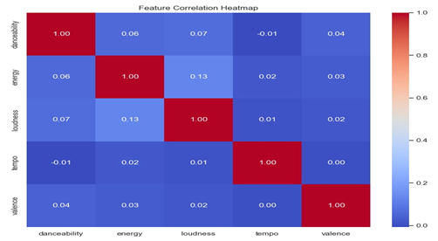

Distribution of Audio Features
The distribution graphs show how the main audio features are spread across the dataset. These histograms represent the distribution of danceability, energy, loudness, tempo, and valence.
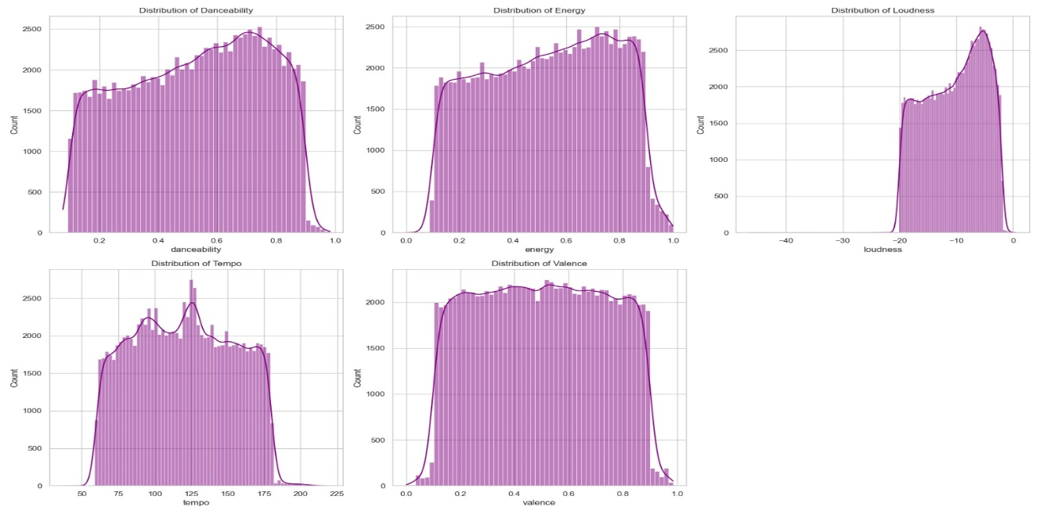

The graphs help understand the characteristics of songs in the dataset. For example, many songs fall within moderate to high danceability and energy ranges, while tempo values mostly lie between common music ranges used in modern songs.
Analysing feature distribution also helps verify that the dataset contains a balanced range of musical characteristics.
This ensures that the recommendation system can suggest songs from different musical styles and moods rather than focusing on only one type of music.
Genre Distribution (Bar Graph)
The genre distribution bar chart displays the most common music genres present in the dataset. It shows the number of songs available in each genre such as Pop, Hip-Hop/Rap, Rock, Electronic Dance Music (EDM), Classical, Country, Jazz, and R&B/Soul.
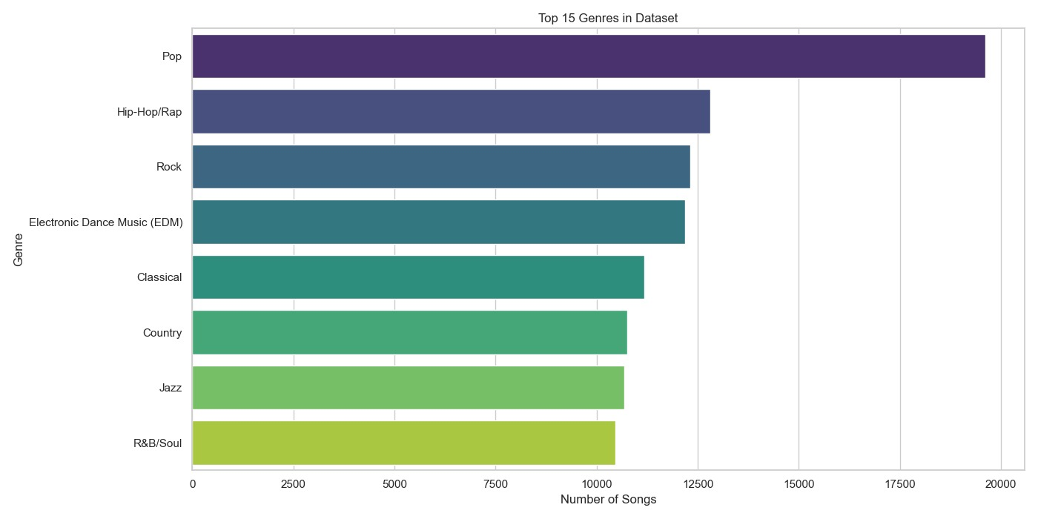

From the graph, Pop music contains the largest number of songs in the dataset, followed by Hip-Hop/Rap and Rock. This indicates that the dataset has strong representation of popular music genres.
Understanding genre distribution is important because it helps evaluate whether the dataset is diverse enough for training a recommendation system. A dataset with multiple genres improves the system’s ability to suggest songs across different musical preferences.
Match Percentage Distribution
The match percentage distribution graph shows how similar the recommended songs are to the input song. The similarity values are converted into percentages to make them easier for users to interpret.
Most recommended songs fall within a 97% to 99.5% similarity range, indicating that the system successfully identifies songs with highly similar musical characteristics.
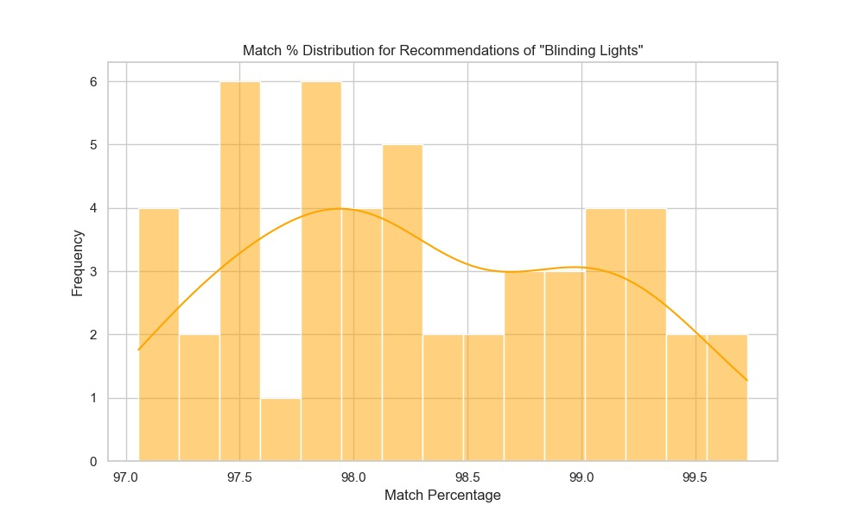

This graph also helps evaluate the effectiveness of the recommendation algorithm. A high concentration of recommendations within a narrow similarity range indicates that the system is consistently providing relevant song suggestions.

Screenshots:

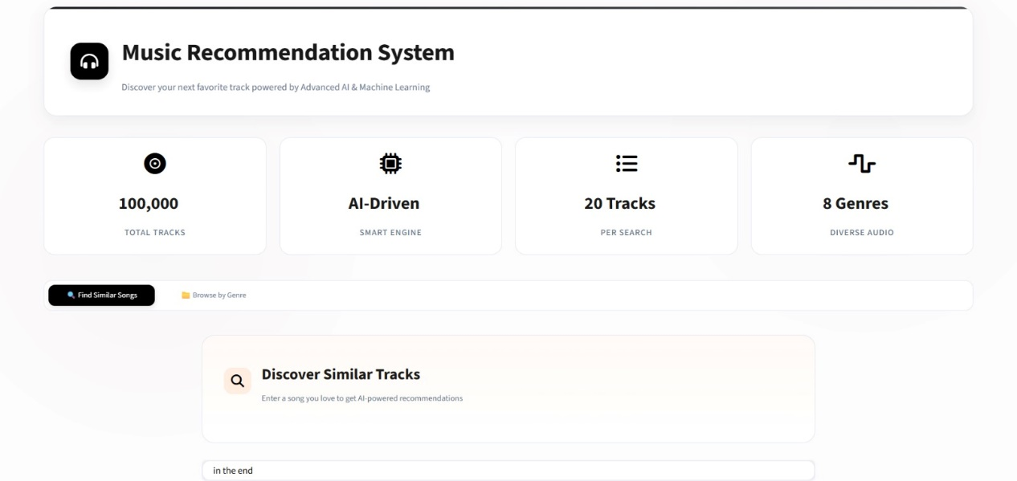
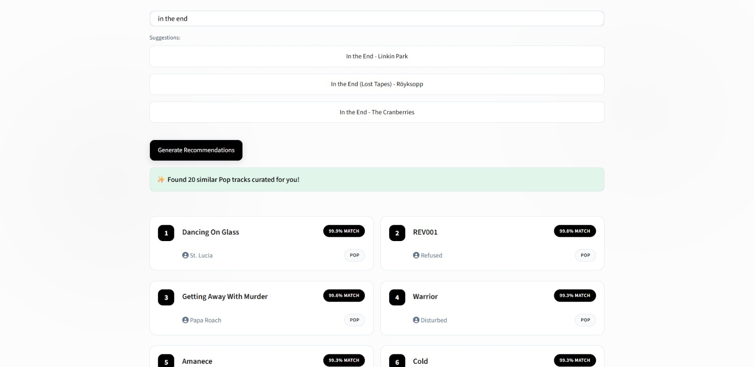

5. Conclusion
The Music Recommendation System successfully demonstrates how Machine Learning techniques can be applied to music discovery platforms. By analysing acoustic features of songs, the system can identify patterns and recommend songs that share similar musical characteristics.
The use of Content-Based Filtering and Cosine Similarity allows the system to generate highly relevant song recommendations without requiring user listening history. This makes the system simple, efficient, and scalable for large music datasets.
The system was able to analyse over 411,088 songs and provide real-time recommendations with high similarity scores. The use of data normalization and feature vectorization ensured that all song attributes contributed equally to the similarity calculation.
The integration of an interactive user interface using Streamlit makes the system user-friendly and accessible for music exploration.
Overall, this project highlights the importance of machine learning in modern digital platforms. Recommendation systems are widely used in industries such as music streaming, e-commerce, and online entertainment to enhance user engagement and improve personalized experiences.
In the future, the system can be further improved by integrating Collaborative Filtering, user listening history, and real-time APIs from music streaming platforms. These improvements would allow the system to provide even more accurate and personalized music recommendations.

