Project Report On

Online Grocery Shopping


Darji Harsh(22171371017) Ajmeri Danish (23171371001)
Kadiya Krish (23171371030)
Kadiya Neel (23113771031)

Guide Name: . Sanjay Chaudhary

Submitted to, Semester-VI Department : Information Technology
Institute of Technology
Ganpat University



CERTIFICATE

TO WHOMSOEVER IT MAY CONCERN

This is to certify that DarjiHarsh(22171371017),Ajmeri Danish (23171371001),Kadiya,Krish (23171371030),Kadiya Neel (23171371031) students of Diploma Semester VI (Information Technology) has completed his full semester on site project work titled “Online grocery shopping”satisfactorily in partial fulfillment of the requirement of Diploma Information Technology of Ganpat University, Kherva, Mehsana in the year 2026.

Prof. Sanjay Chaudhary(Project Guide) H.O.D Bhasker Patel

Sr.No | Topic Name  Index | Page No.
1 | PROBLEM IDENTIFICATION, DEFINATION&MODIFICATION | 5
 | 1.1 ABSTRACT
 | 1.2 EXISTING SYSTEM
 | 1.3 TECHNOLOGY OVERVIEW
2 | SYSTEM REQUIREMENT GATHERING SPECIFICATION | 7
 | 2.1 INTRODUCTION
 | 2.2 PROJECT OVERVIEW
 | 2.3 FUNCTION REQUIREMENT
 | 2.4 NON-FUNCTION REQUIREMENT
 | 2.5 PROBLEM STATEMENT TECHNICAL FEASIBILITY
3 | PROBLEM SOLUTION OUTLINE | 9
 | 3.1 MODULES DESCRIPTION
 | 3.2 FEASIBILITY STUDY
4 | DIAGRAMS | 16
 | 4.1 USE CASE DIAGRAM
 | 4.2 ACTIVITY DIAGRAM
 | 4.3 DATA FLOW DIAGRAM
 | 4.4 DFD LEVEL-0
 | 4.5 DFD LEVEL-1
 | 4.6 ENTITY RELATIONSHIP DIAGRAM
5 | DATA DICTIONARY | 21
 | 5.1 CUSTOMER
 | 5.2 PRODUCTS
 | 5.3 PAYMENT

 | 5.4 CART ITEM
6 | UI DESIGN | 19
 | 6.1 CUSTOMER SIDE
 | 6.2 CART
 | 6.3 CHECKOUT
7 | FUTURE SCOPE | 26
 | 7.1 FUTURE ENCHANTMENT
 | 7.2 FUTURE SCOPE
 | 7.3 CONCLUSION
8 | REFERENCES | 29
 | 8.1 links
 | 8.2code

1.
PROBLEM IDENTIFICATION, DEFINATION
& MODIFICATION

1.1 ABSTRACT

Online grocery shopping is a supermarket that allows online purchasing of fruits, vegetables etc.you can conveniently computer to place your order online .you can select your choice of fruits and vegetable from the grocery store .once you have finalized the order, then you can add an item to the shopping cart. When you checkout from shopping cart, then you order will be develop at the doorstep. When you are satisfied with this order, service and quantity then you pay cash on the spot upon delivery.

- Admin has monitor everything in online grocery shop
- Admin can add ,delete and update the grocery item(fruits and vegetable etc)
- Admin can verify the orders of the online shop
- The user can view the grocery shop item(fruits ,vegetables etc)
- The user filla form providing his/her name ,number, address,
city delivery timeslot andpayment method(cash on delivery) after he/she check out the
shopping cart

- Grocery item(fruite,vegetable etc) will be delivered to the user at the home with respect to the selected time slove

1.2 EXISTING SYSTEM

Process: Customers must physically travel to a supermarket or grocery store.

- Customer Effort: This involves spending time going to the store, dealing with
crowds of other shoppers, and standing in lines at the checkout counter.

- Time Constraints: Shopping is limited by the store's operating hours, reducing the customer's freedom to shop at their own convenience.

- Product Information: Customers must manually check product details, prices, and compare offerings across multiple physical stores to find the best selection.

1.3TECHNOLOGY OVERVIEW

The documents provide a high-level view of the technical components and management systems required to implement the Online Grocery Shopping System.

- System Architecture Components

- Customer Management: Handling user details and interactions.

- Shopping Management: Directly related to the user browsing experience and product selection.

- Order Management: Processing and tracking orders placed by customers.

- Payment Management: Handling transactions, which includes payment types like Cash on Delivery.

- System/User Management and Login Management: Covering registration, authentication, and access control for both users and the admin

2. SYSTEM REQUIREMENT GATHERING SPECIFICATION

2.1INTRODUCTION
Here's a draft online grocery shopping introduction for a software requirements specification (SRS) document:

    - Purpose
The purpose of this Software Requirements Specification (SRS) document is to define the requirements for an online grocery shopping application. The application will allow customers to browse and purchase groceries from the convenience of their homes or on-the- go via a web or mobile interface.

    - Project Scope
- The online grocery shopping application will provide the following main features: User registration and authentication
- Browse products by category, search, and filters Add products to a virtual shopping cart Checkout process with payment integration Order tracking and status updates
- User profile and order history
- Administrative functionality for product/inventory management
- The initial version will focus on the core e-commerce functionality for a single grocery store. Future iterations may include expanded features such as subscription services, recipes, dietary preferences, and support for multiple store locations.

    - Definitions, Acronyms, and Abbreviations

Term SRS UI UX

Definition
Software Requirements Specification User Interface
User Experience

    - References
Grocery.com Requirements Document v1.2
IEEE Recommended Practice for Software Requirements Specifications (IEEE Std 830- 1998)

    - Overview
The remaining sections of this SRS document provide a detailed description of the functional and non-functional requirements, use cases, constraints, assumptions, and other specifications for the online grocery shopping application. This document will serve as a guide for the development and validation efforts.

2.3 FUNCTION REQUIREMENT

- Registration :
Users’ information has to be compelled to be registered within the system thus on establish every one of them unambiguously and do the required group action as real potential. like on the name of the bill are issued. On the far side, this plenty of things require measure there wherever we will reference him.
Without registration, there are a few options and pages one user can see which are landing on the home page and taking the features to read but he won’t be allowed to use those.
For use, he will have to register. One person needs to put all the details correctly and precisely as it will be helpful in identifying them and believing that he is the real person
who has booked for the same.

Login:

After registration one will register within the system because of the operator of the system either on behalf of the user. When this he has the different helpful interfaces accessible for any actions. Here either bride or groom both have to log in with their unique identity and passwords. After this, they will be directed to the primary user interface from where they have further options.

Logout:

Loging out means to end access to a computer system or a website. Logging out informs the computer or website that the current user wishes to end the login session. Log out is also known as log off, sign off or sign out

Forgot password:

This is quite often that people tend to forget the password they keep for the login. So, this could be very tedious and hectic to recover the password manually in case if one needs to login in an emergency. So, to overcome this problem we have this module named ass forgot the password, and using this module users can recover their password in seconds.
So here we need only to put our registered email Id and hit the enter. Then one confirmation email will go to the email where he may reset the password. In seconds one can use this module and get rid of the forgetting password problem.

- view product:

The view Product function is typically responsible for displaying the details of a specific product to the user. Its primary purpose is to retrieve and present all relevant information about a particular product, such as its name, description, price, images, and any other associated data.

- search product:

Ability for users to add products to a shopping cart.Display of the current contents of the shopping cart, including product details, quantities, and total cost.Option to update quantities or remove items from the shopping cart.Persistence of the shopping cart across user sessions or devices.

Add to cart:

Add to cart means the action of adding an item to the virtual purchasing order. When a consumer locates an item they wish to purchase, they click the icon. The item is then placed in their purchasing cart until they decide to proceed to checkout or continue browsing.

Product details:
Each product listing should provide detailed information such as the product name, brand, weight or volume, price, unit price, nutritional information and high-quality images.

Pricing
Store owners should be able to set prices for their products

promotions:
create targeted promotions and discounts to attract customers.

Reviews and feedback:

Users should be able to read reviews and ratings left by other users to help them make informed purchasing decisions

2.4 NON-FUNCTION REQUIREMENT

Performance :

This includes requirements related to the speed, scalability, and responsiveness of the system. For example, a requirement that the system should be able to handle a certain number of concurrent users or process a certain amount of data within a specific time frame.

Security:

This includes requirements related to the protection of the system and its data from unauthorized access, as well as the ability to detect and recover from security breaches.

Usability:

This includes requirements related to the ease of use and understandability of the
system for the end-users.

Reliability:

This includes requirements related to the system’s ability to function correctly and consistently under normal and abnormal conditions.

Maintainability:
This includes requirements related to the ease of maintaining the system, including
testing, debugging, and modifying the system.

Portability:
This includes requirements related to the ability of the system to be easily transferred to different hardware or software environments.

Compliance:

This includes requirements related to adherence to laws, regulations, industry standards,
or company policies.

2.5 PROBLEM STATEMENT

- The traditional grocery shopping model requires customers to physically visit stores, which is often a time-consuming and inconvenient process. This approach forces shoppers to deal with crowds and spend time standing in lines at the checkout. Furthermore, comparing product prices and varieties can be tedious when relying solely on physical store visits

- Therefore, there is a clear need for an efficient, reliable, and easily accessible solution that allows customers to shop for essentials 24/7 and compare prices from the comfort of their home. The Online Grocery Shopping System project addresses this gap by creating a digital platform for seamless e-commerce

- Technical Feasibility
  - The project is technically feasible. It relies on well-established and mature web technologies, including standard e-commerce architecture, database management (as seen in the Data Dictionary ), and common payment gateway integration. The core functional requirements, such as user authentication, product search, and cart management, are standard components of modern web applications. The team possesses the necessary skills or can acquire the resources to implement the required features, like the login module and order management.

PROBLEM SOLUTION OUTLINE

3.1 MODULES DESCRIPTION

- The Issue: The traditional grocery shopping model is time-consuming and inconvenient for modern customers. It forces shoppers to endure

- physical travel, crowds, and long checkout lines, limiting purchasing to fixed store hours.

- The Gap: There is a need for a seamless, 24/7 accessible platform that provides the convenience of shopping from home, easy price comparison, and reliable delivery, eliminating the friction points of physical stores.

- The Solution: The Online Grocery Shopping System is proposed to create a dedicated web/mobile platform for the purchase and home delivery of grocery items.

- Proposed Solution (Conceptual - Section 10) The solution is an e-commerce platform with two main stakeholders: the User (Customer) and the Admin.

- User Workflow: A customer registers, securely logs in, browses the product catalog using search and category filters, adds items to their virtual shopping cart, and proceeds to checkout. At checkout, the user provides delivery details and selects Cash on Delivery as the initial payment method.

- Admin Workflow: The Admin manages the application's entire backend, including verifying orders and controlling the product inventory (adding new items, updating prices, and deleting discontinued products).

- Delivery: Once the order is confirmed, the groceries are prepared and delivered to the user at the selected delivery timeslot.

Modules Description (Based on DFD Level 1)
The system is logically divided into several interconnected modules to manage different aspects of the e-commerce transaction

*Module
Login Management
Customer Management
Shopping Management
Order Management
Payment Management
System/User Management

3.2 FEASIBILITY STUDY

- Technical Feasibility

The project is technically feasible as it relies on proven and readily available e-commerce technologies (web architecture, relational databases). The team has the necessary skills to implement the identified functional requirements (Login, Product Search, Cart Logic).

Operational Feasibility

The project is operationally feasible because it directly solves the current inconvenience of physical shopping, aligning with the end-users' need for 24/7 convenience. The defined roles for the User and Admin ensure the system integrates smoothly into grocery operations without major procedural changes.

Schedule Feasibility

The project is feasible within the schedule because the initial scope is limited to a single store and core features (e.g., Cash on Delivery only). The structured three-phase timeline (Planning, Development, Testing) provides a clear roadmap for on-time delivery.

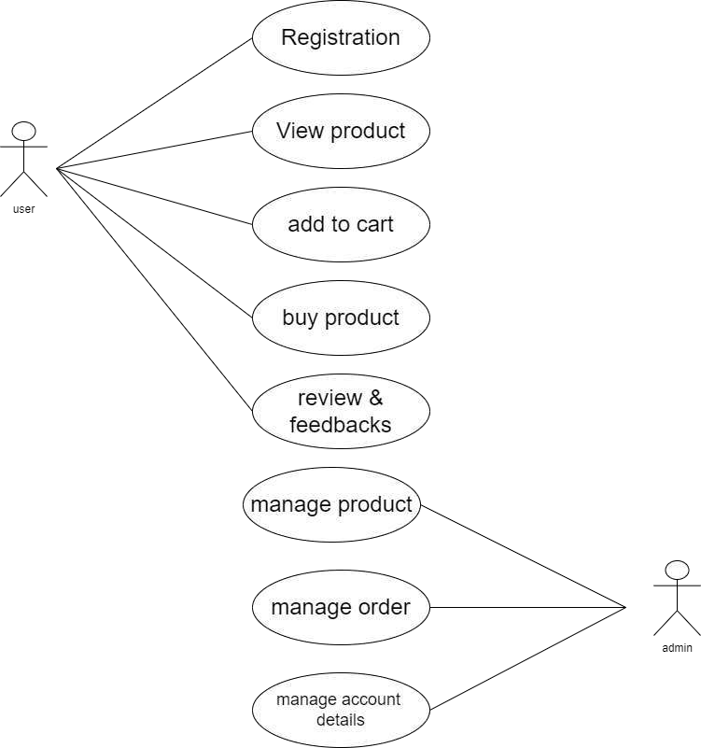
4.DIAGRAMS

.Use Case Diagram

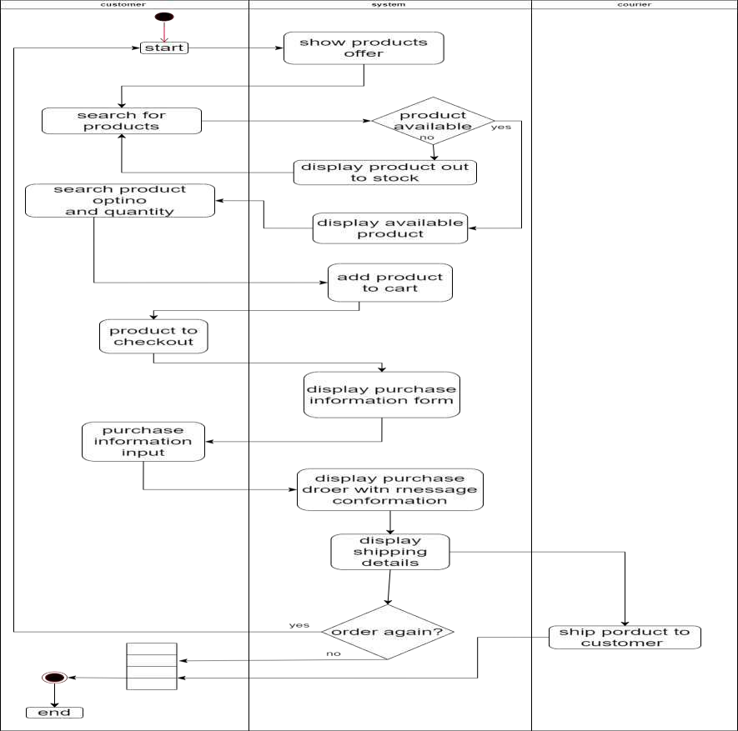
6.ACTIVITY DIAGRAM

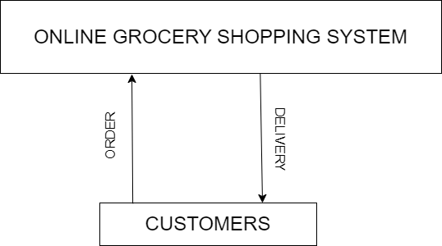

.DFD (Data-flow diagram)
Level 0 DFD

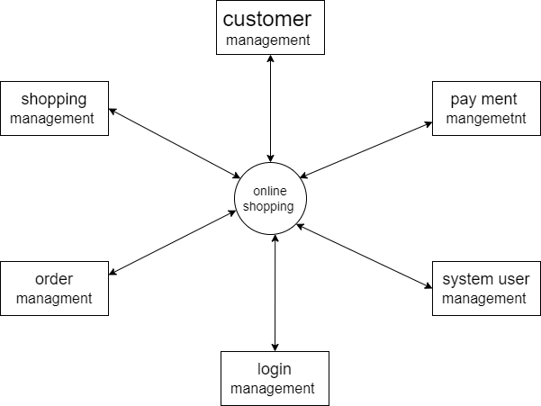

Level 1 DFD

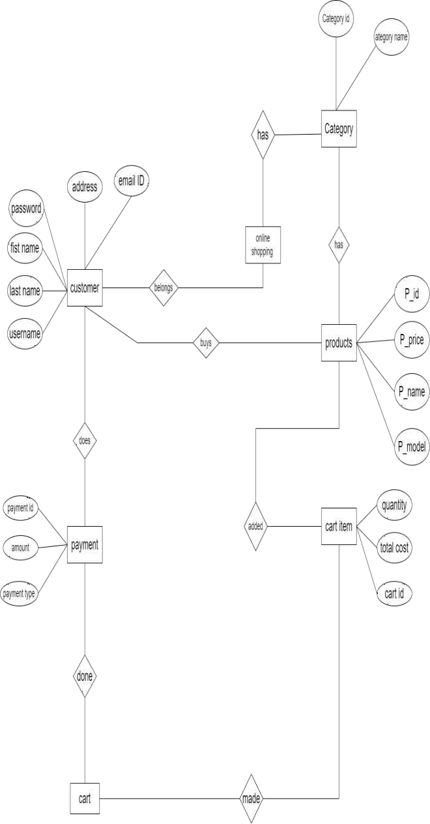
ENTITY RELANTIONSHIP DIAGRAM

5.DATA DICTIONARY

Table name : customer

Field name | datatype | size
password | number | 20
username | varchar | 20
address | varchar | 20
Email id | varchar | 20

Table name : products

Field name | datatype | size
P_password | number | 20
P_ID | number | 20
P_name | varchar | 20
P_model | varchar | 20

Table name : payment

Field name | Data type | Size
Payment id | Number | 20
Amount | Number | 20
Payment type | varchar | 20

Table name : cart item

Field name | Data type | Size
cart id | Number | 20
Total cost | Number | 20
Quantity | varchar | 20

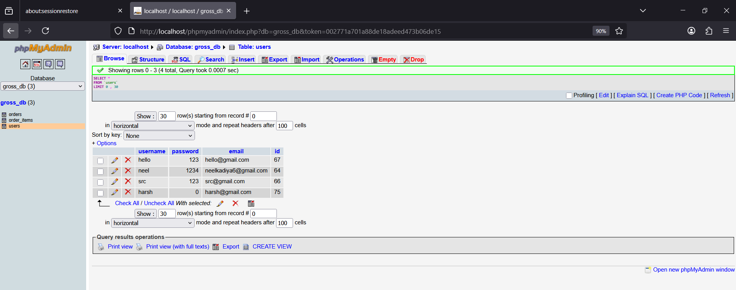

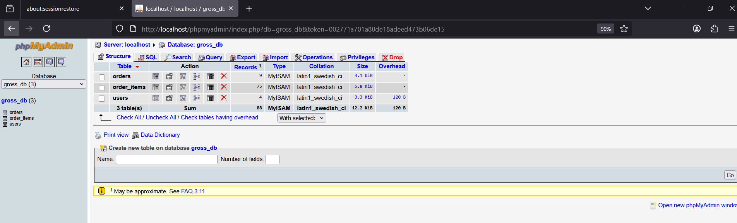

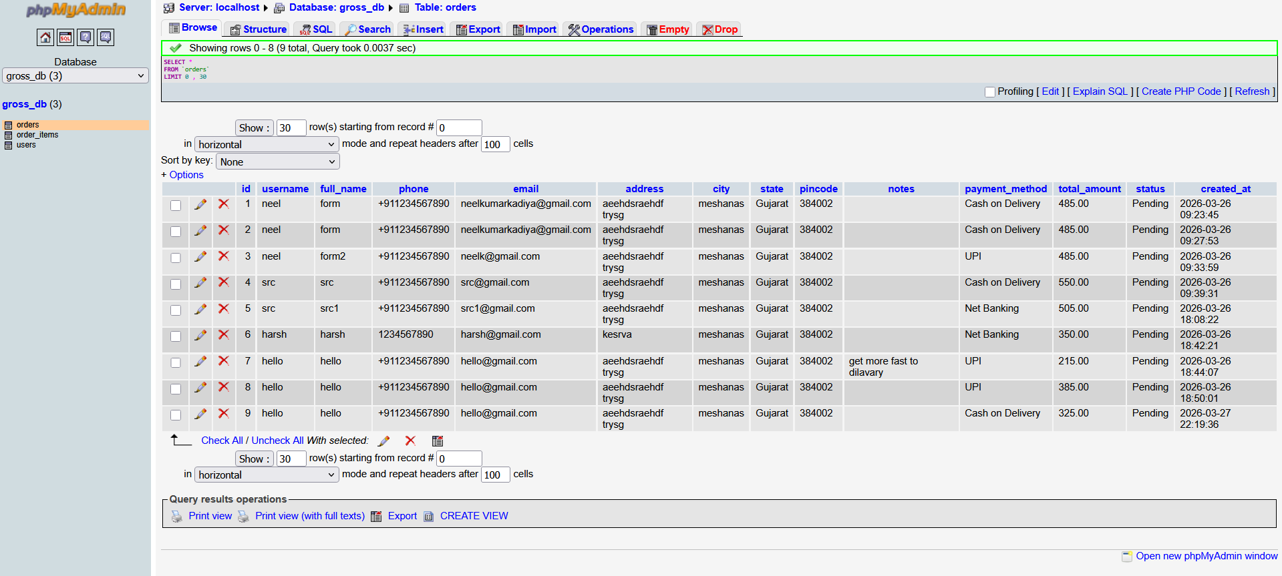

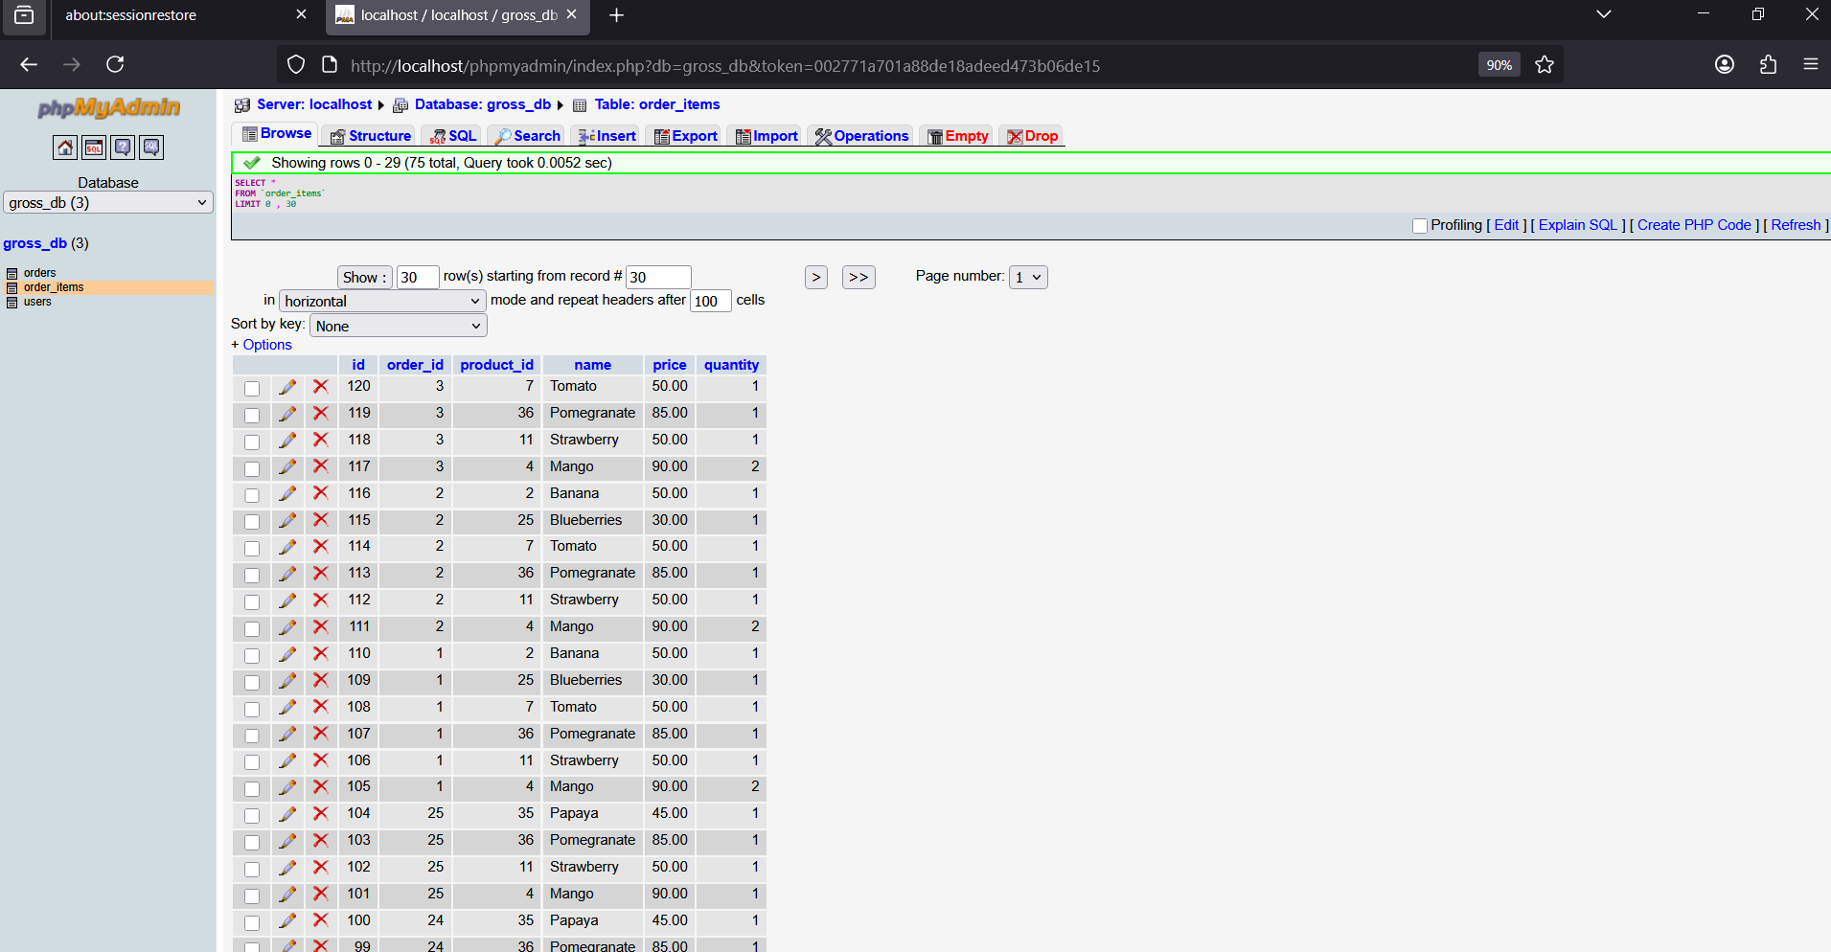

6 .UI DESIGN
User side

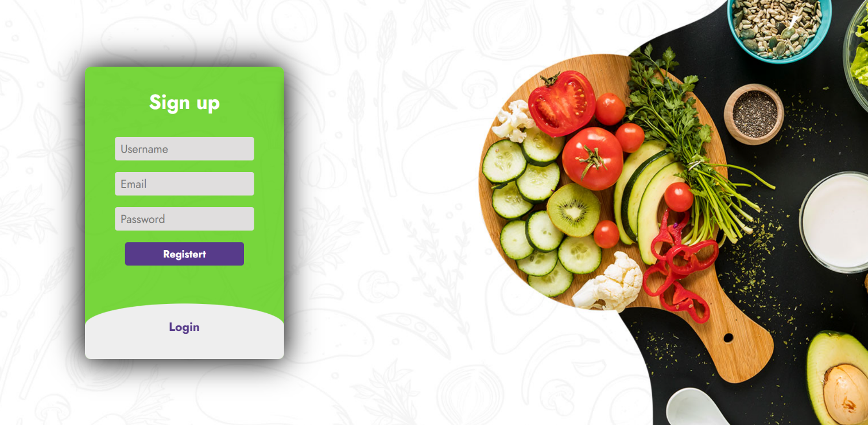



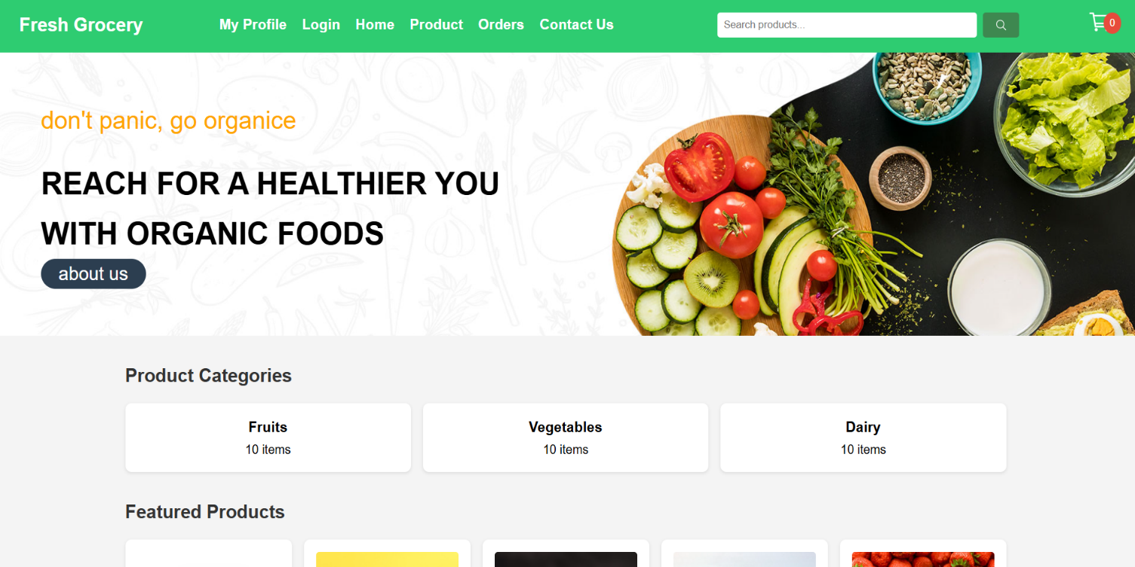

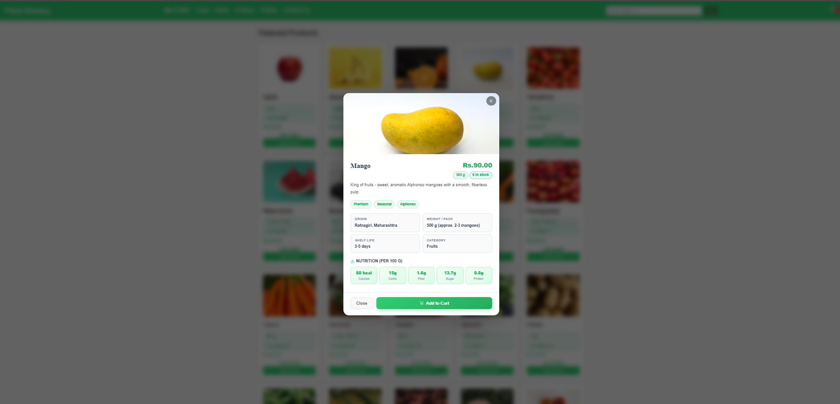

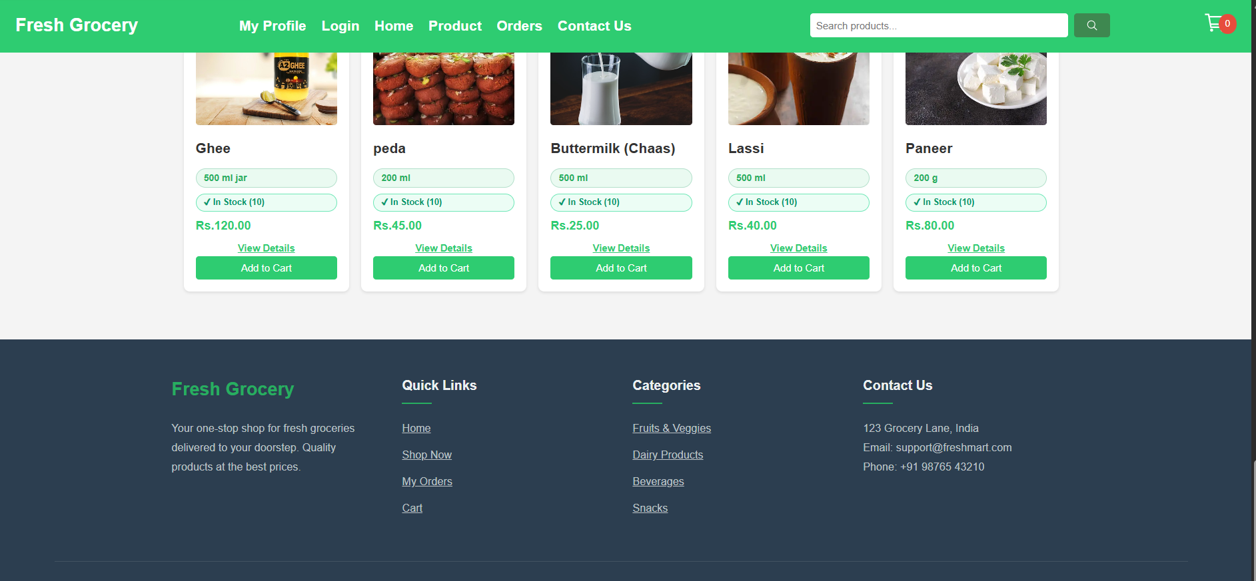

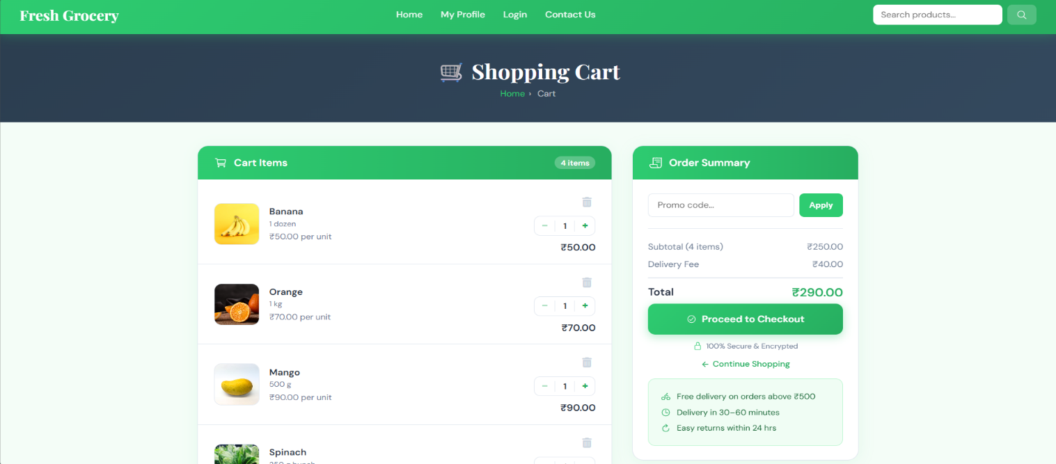

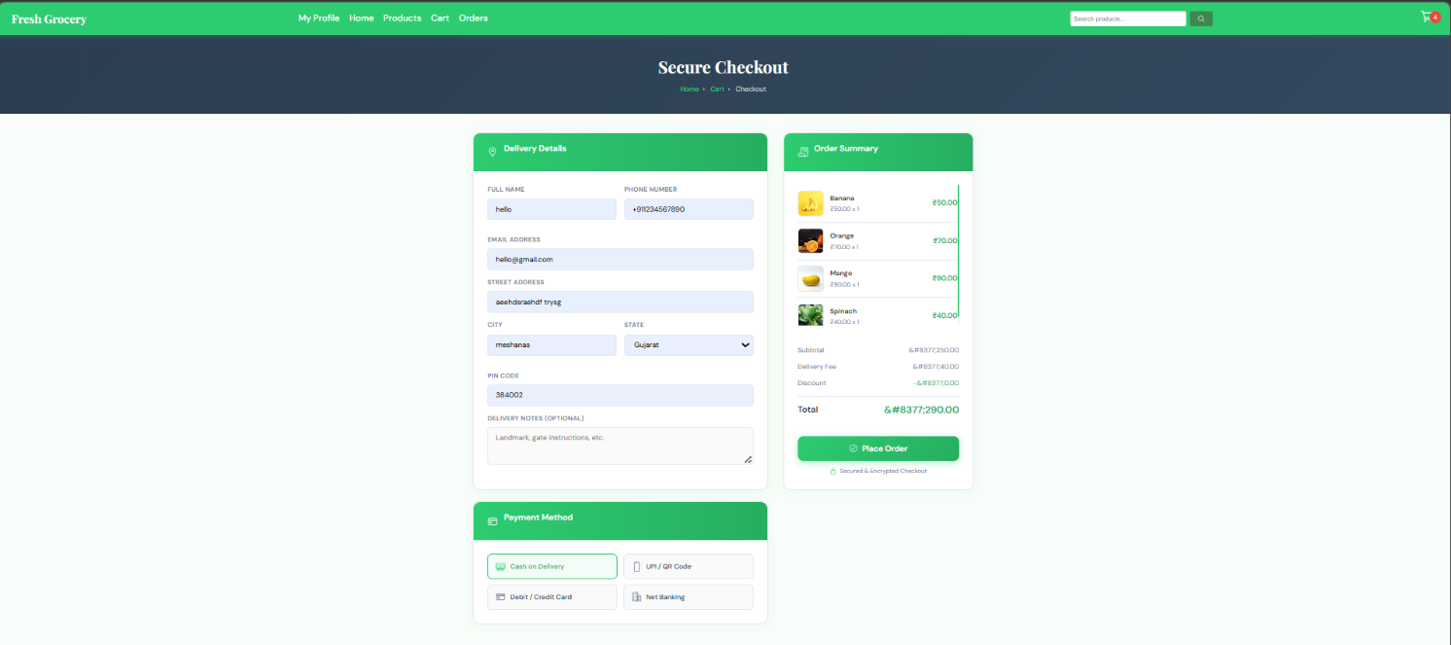

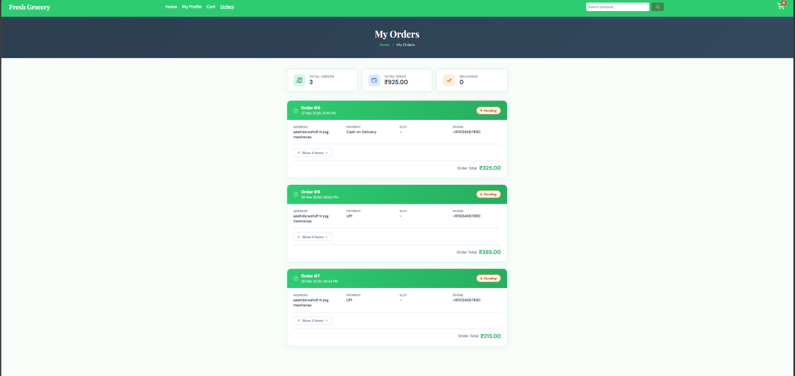

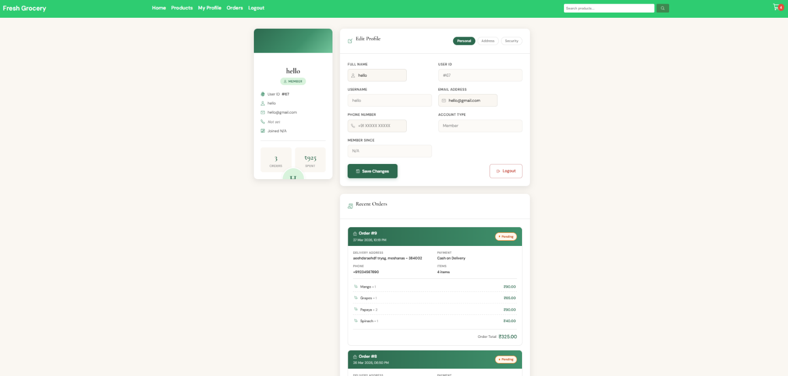

Admin side



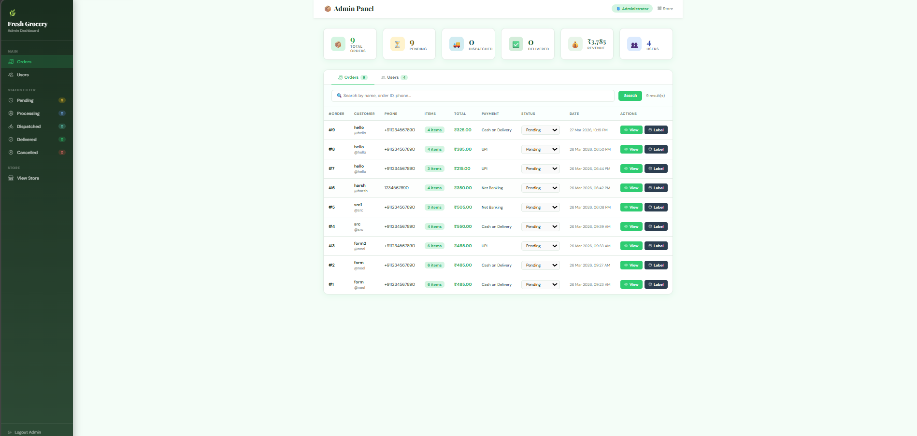

7. Future Scope

7.1FUTURE ENHANCEMENT

These enhancements focus on adding value and improving the user experience within the existing single-store e-commerce framework:

- Subscription Services: Implementing a model that allows customers to set up recurring orders for frequently purchased grocery items, simplifying the replenishment process
.
- Recipe Integration: Adding a dedicated section where users can browse recipes, with the ability to automatically add all required ingredients directly to their shopping cart.

- Dietary Preferences and Filters: Developing advanced user profile settings that allow customers to specify dietary restrictions (e.g., gluten-free, vegan) or allergies, and then filter product results accordingly.

- Personalized Recommendations: Utilizing user purchasing history to suggest relevant products and promotions, improving cross-selling and overall sales.

7.2 FUTURE SCOPE

These points define the project's long-term vision, primarily focusing on scaling the application's reach and operational capacity:
- Support for Multiple Store Locations: Expanding the application's operational range to manage inventory, pricing, and fulfillment for more than one physical grocery store.
- Advanced Payment Gateways: Integrating a wider array of online payment options (credit/debit cards, digital wallets, net banking) to move beyond the initial Cash on Delivery-only model.

- Enhanced Logistics Module: Implementing a dedicated courier/delivery application or module to optimize delivery routes, provide real-time tracking for customers, and improve efficiency of the delivery timeslot system.

- Mobile Application Development: Developing native mobile applications (iOS/Android) to specifically cater to "on-the-go" usage, ensuring optimal performance and user experience.

CONCLUSION

- It saves time and energy you don't have to waste your time going to stores, dealing with crowds and standing in lines

- 24/7 availability-online grocery stores are open round the clock of 24/7..the availability of online stores give you the freedom to shop at your own convenience

- Variety- another advantage of e-grocery is variety you can visit many stores to find the same selection...!!

- Comparison of prices it allows you to easily check prices and compare with just a few clicks it is very straightforwardto conduct price comparisons from one site to another..

- Customers are usually satisfied- now a days, shopping online is very reliable.. customers can give feedback and reviews...about products !!

8. References

- https://www.flipkart.com
- https://www.irjmets.com
- https://images.app.goo.gl/81HxieGzvVjUyvtW8
- https://claude.ai/login?returnTo=%2F

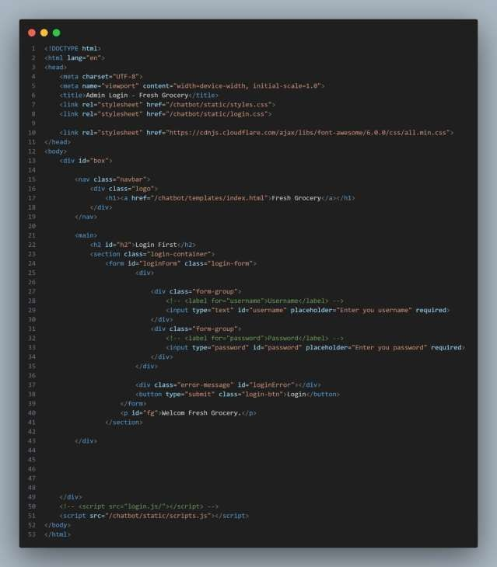
- code

Login page code

9. GANTT CHART

PROJECT GANTT CHART — Online Grocery Shopping
Semester: 29 Dec 2025 – 22 Apr 2026 | Lab Sessions: Monday & Wednesday Only | Dept: Information Technology, Ganpat University
PROJECT PHASE / ACTIVITY | W1  Dec 29 | W2  Jan 5 | W3  Jan 12 | W4  Jan 19 | W5  Jan 26 | W6  Feb 2 | W7  Feb 9 | W8  Feb 16 | W9  Feb 23 | W10  Mar 2 | W11  Mar 9 | W12  Mar 16 | W13  Mar 23 | W14  Mar 30 | W15  Apr 6 | W16  Apr 13 | W17  Apr 20
Lab Day → | Mon  Wed | Mon  Wed | Mon  Wed | Mon  Wed | Mon  Wed | Mon  Wed | Mon  Wed | Mon  Wed | Mon  Wed | Mon  Wed | Mon  Wed | Mon  Wed | Mon  Wed | Mon  Wed | Mon  Wed | Mon  Wed | Mon  Wed
1. Problem
Identification
& Definition
2. System
Requirement
Gathering
3. Problem
Solution
Outline
4. Diagrams
(Use Case,
DFD, ER)
5. Data
Dictionary
6. UI
Design
7. Future
Scope &
Conclusion
8. References
& Submission
LEGEND: ■ Monday Lab Active ■ Wednesday Lab Active □ No Activity

