Project Report On

Online Grocery Shopping


Darji Harsh(22171371017) Ajmeri Danish (23171371001)
Kadiya Krish (23171371030)
Kadiya Neel (23113771031)

Guide Name: . Sanjay Chaudhary

Submitted to, Semester-VI Department : Information Technology
Institute of Technology
Ganpat University


CERTIFICATE

TO WHOMSOEVER IT MAY CONCERN

This is to certify that DarjiHarsh(22171371017),Ajmeri Danish (23171371001),Kadiya,Krish (23171371030),Kadiya Neel (23171371031) students of Diploma Semester VI (Information Technology) has completed his full semester on site project work titled “Online grocery shopping”satisfactorily in partial fulfillment of the requirement of Diploma Information Technology of Ganpat University, Kherva, Mehsana in the year 2026.

Prof. Sanjay Chaudhary(Project Guide) H.O.D Bhasker Patel

4.DIAGRAMS

5.DATA DICTIONARY
Table name : customer
Field name | datatype | size
password | number | 20
username | varchar | 20
address | varchar | 20
Email id | varchar | 20
Table name : products
Field name | datatype | size
P_password | number | 20
P_ID | number | 20
P_name | varchar | 20
P_model | varchar | 20
Table name : payment
Field name | Data type | Size
Payment id | Number | 20
Amount | Number | 20
Payment type | varchar | 20
Table name : cart item
Field name | Data type | Size
cart id | Number | 20
Total cost | Number | 20
Quantity | varchar | 20

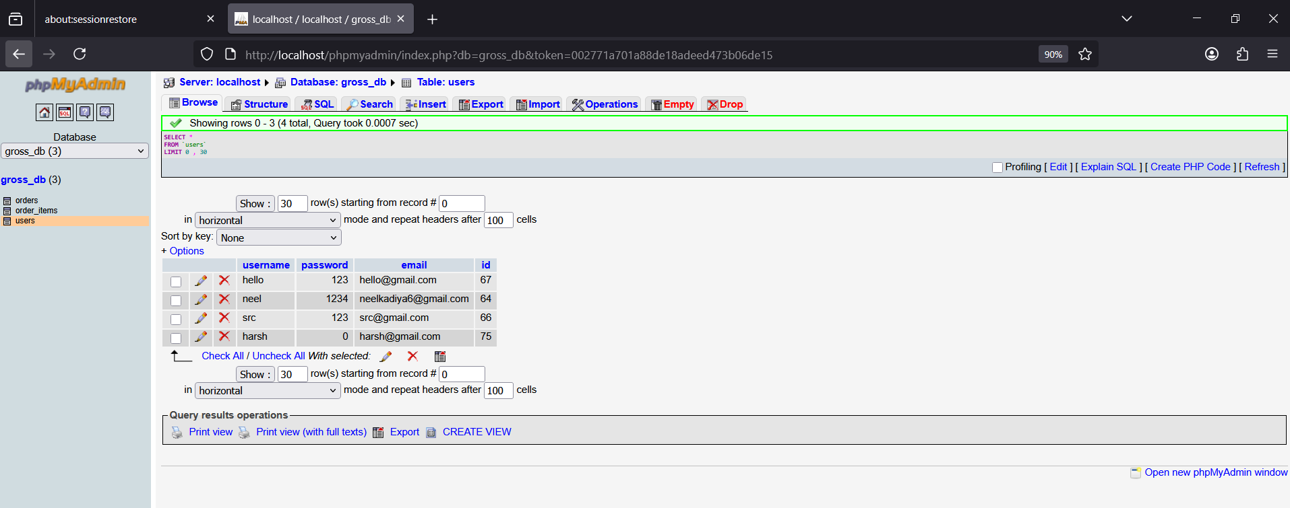

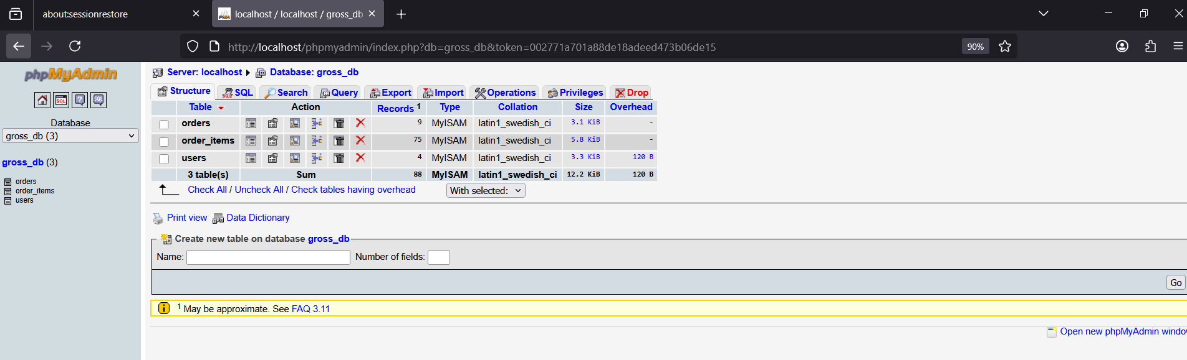
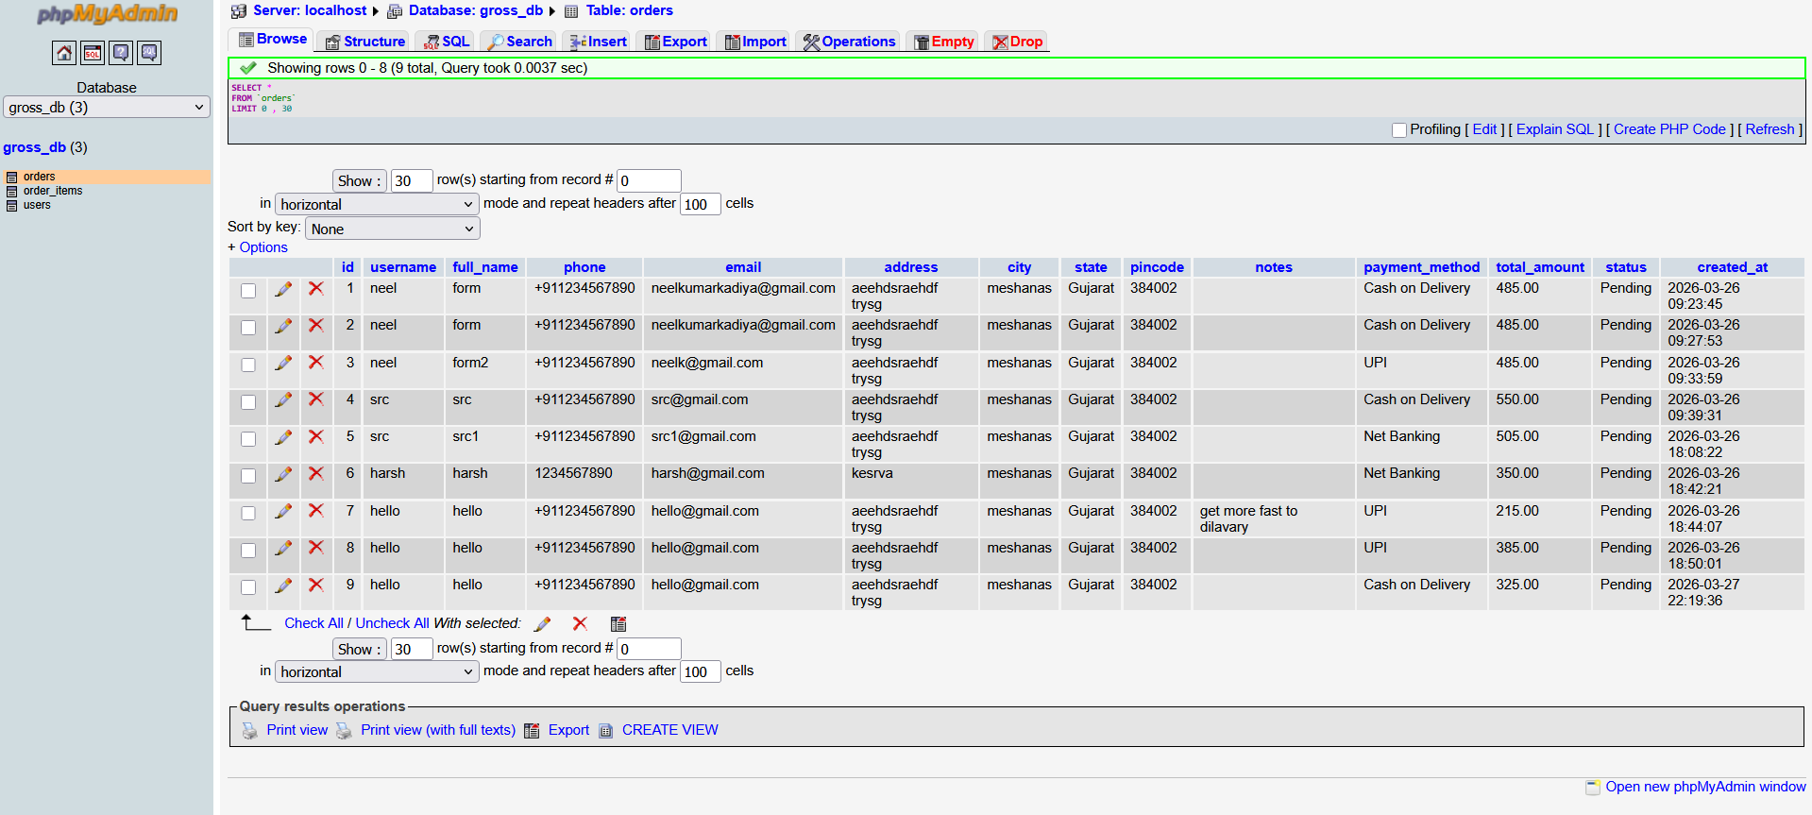
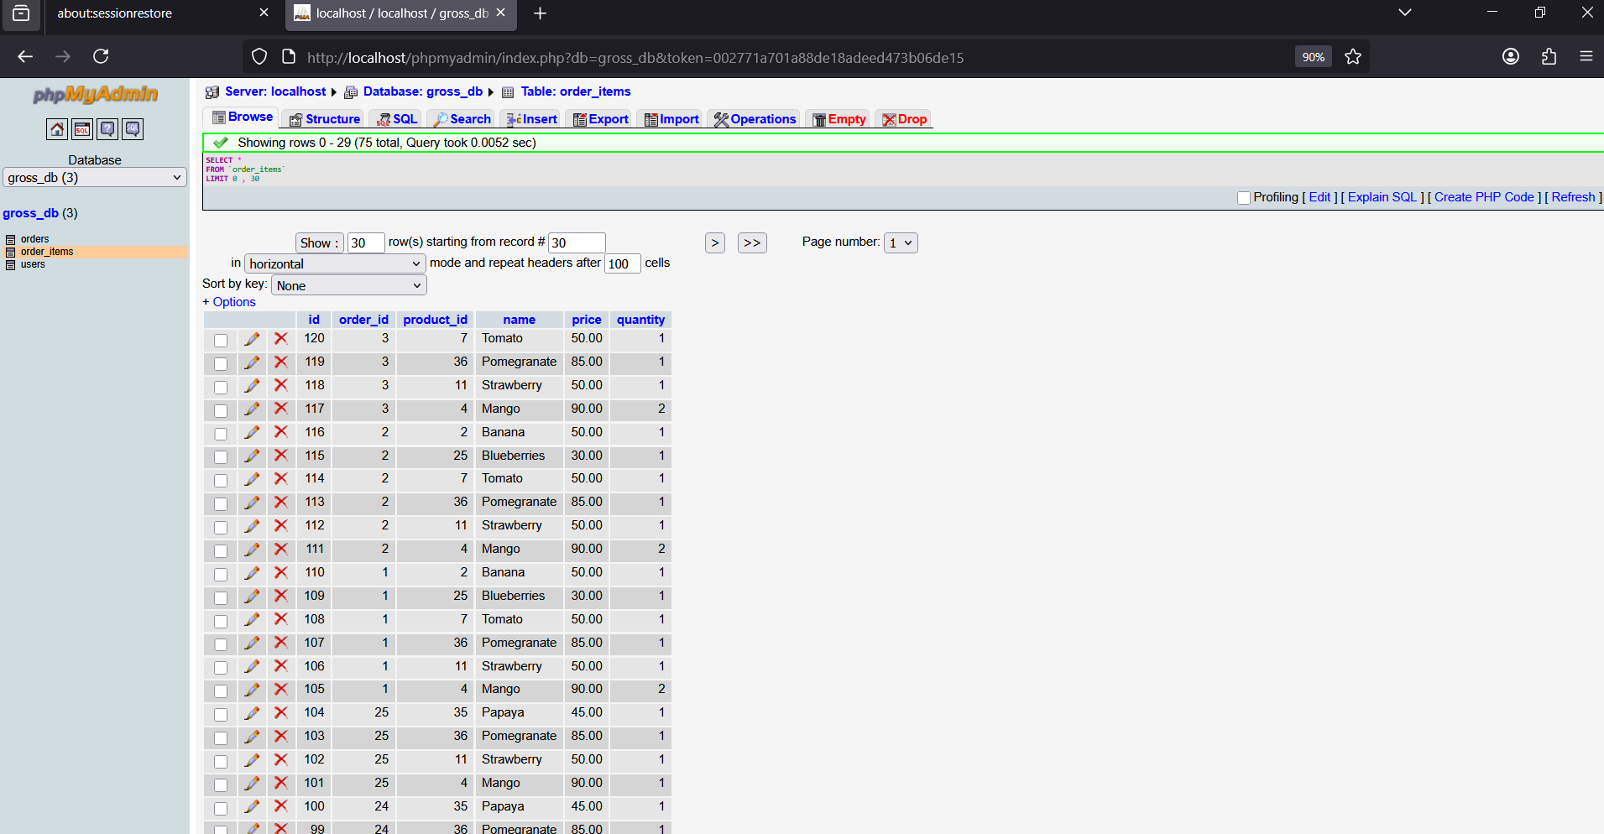

6 .UI DESIGN
User side



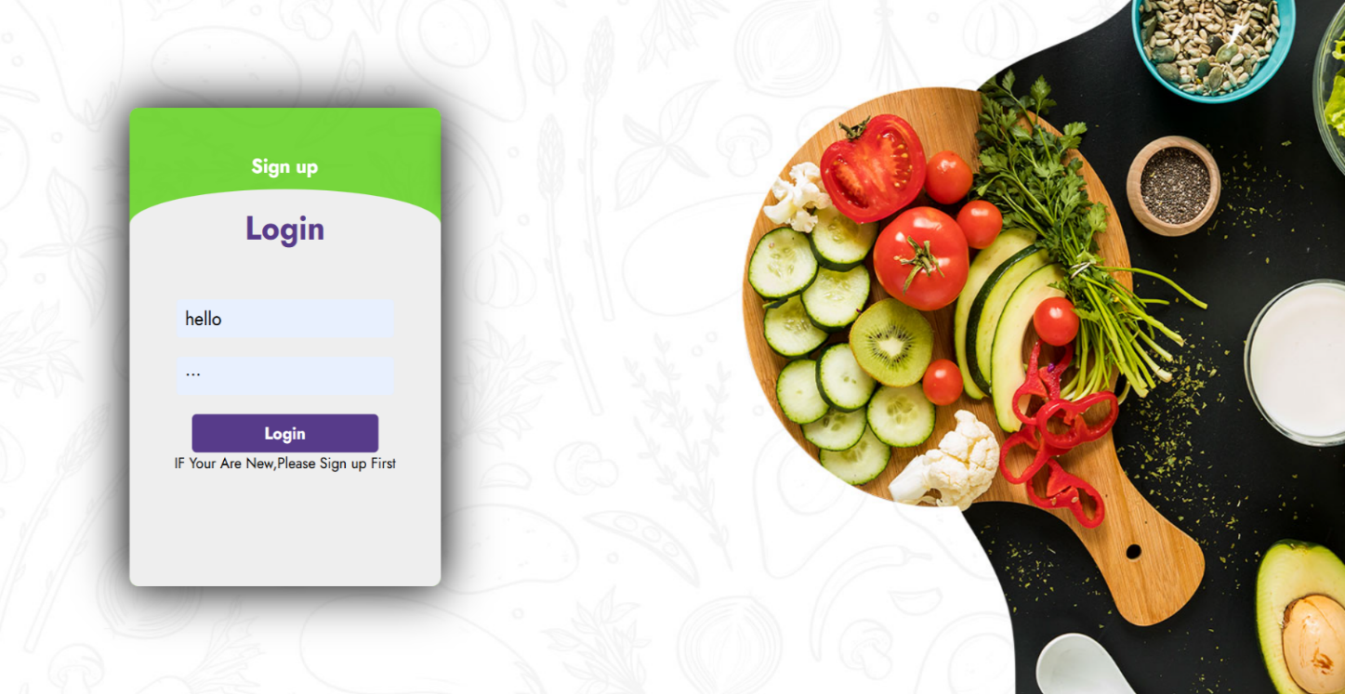

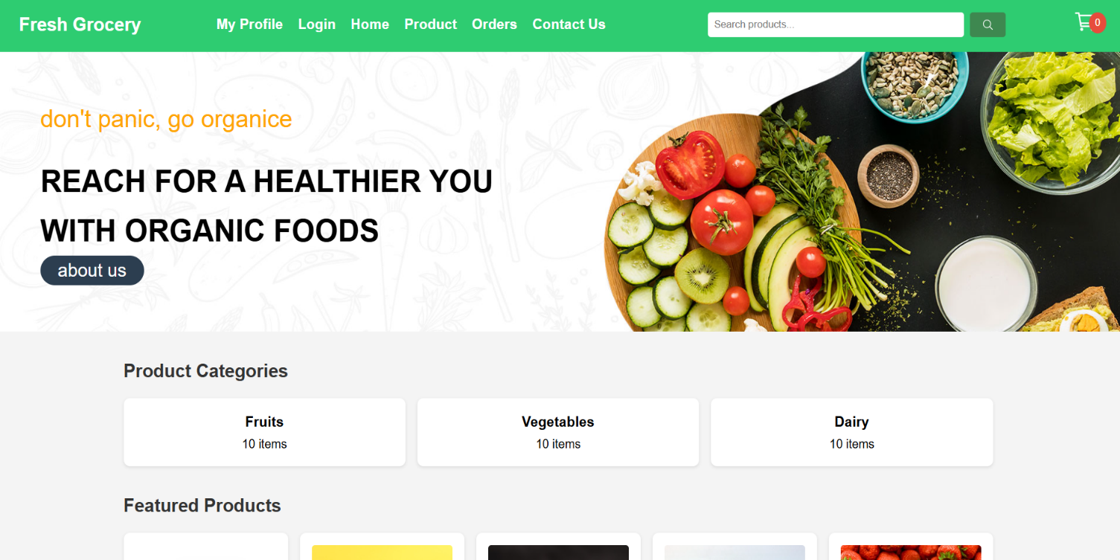

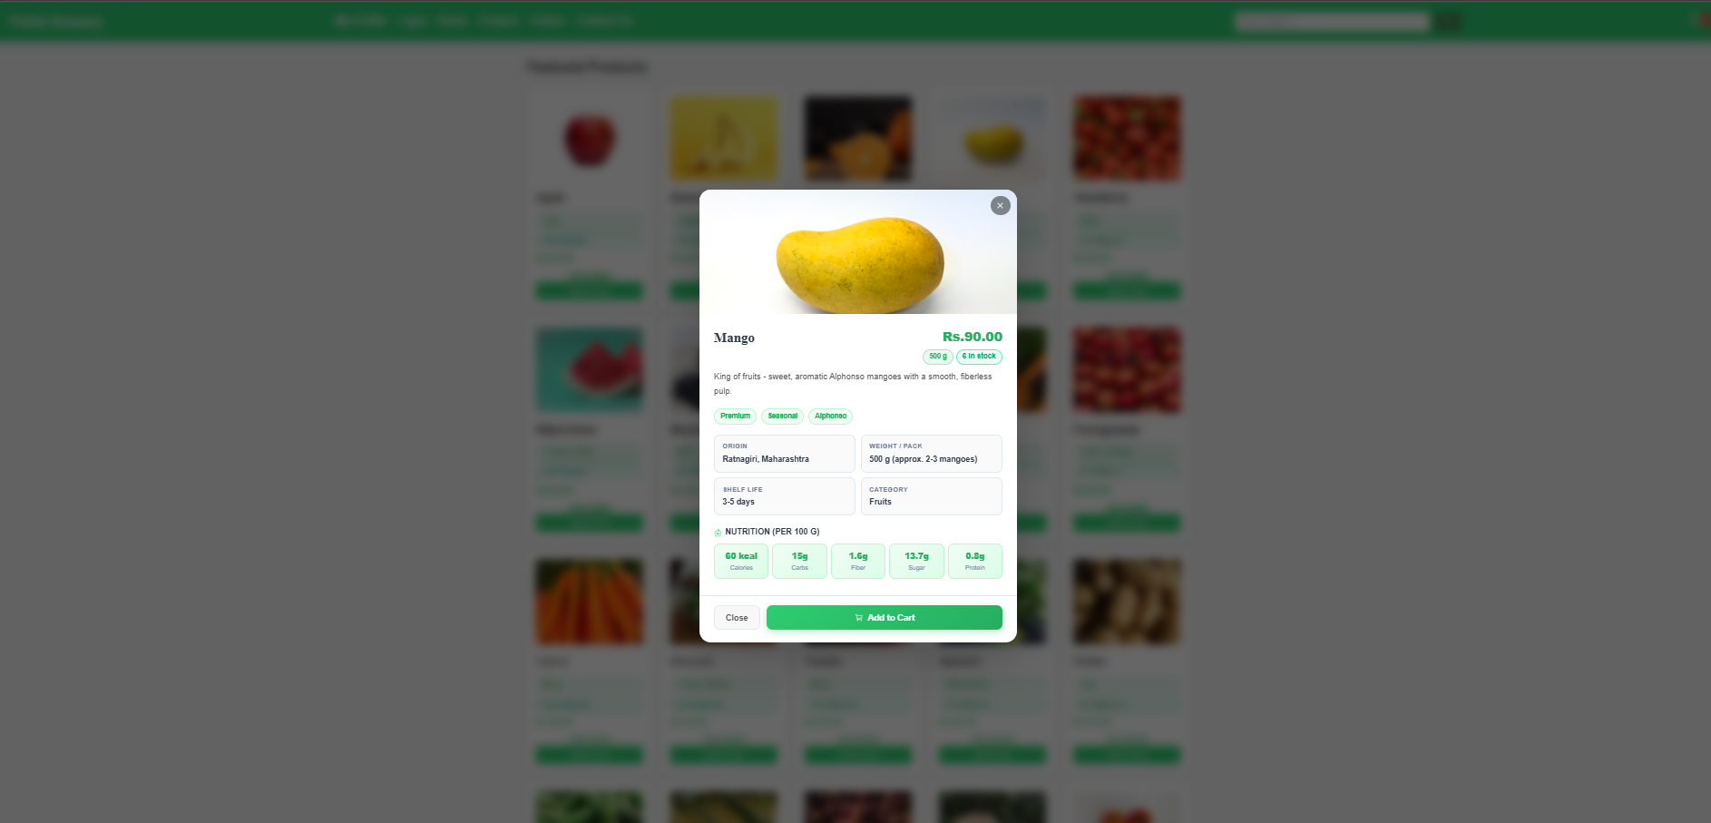

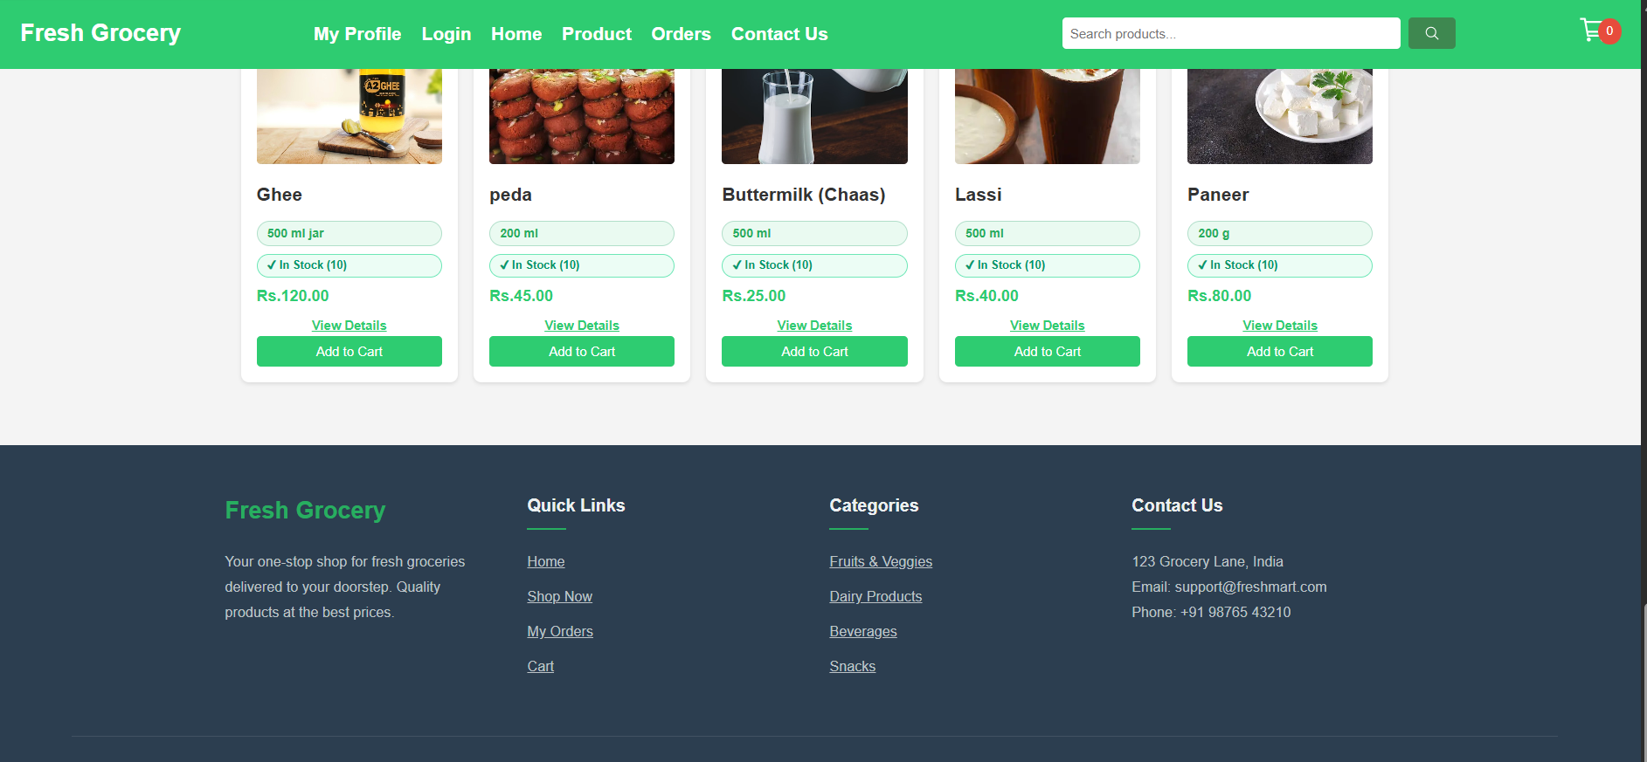
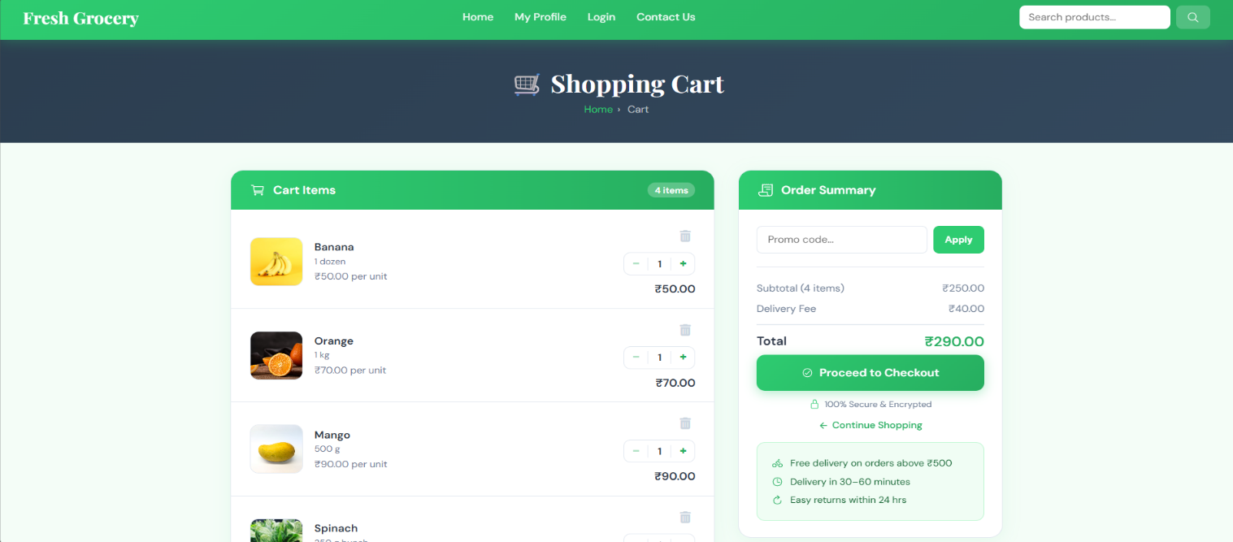
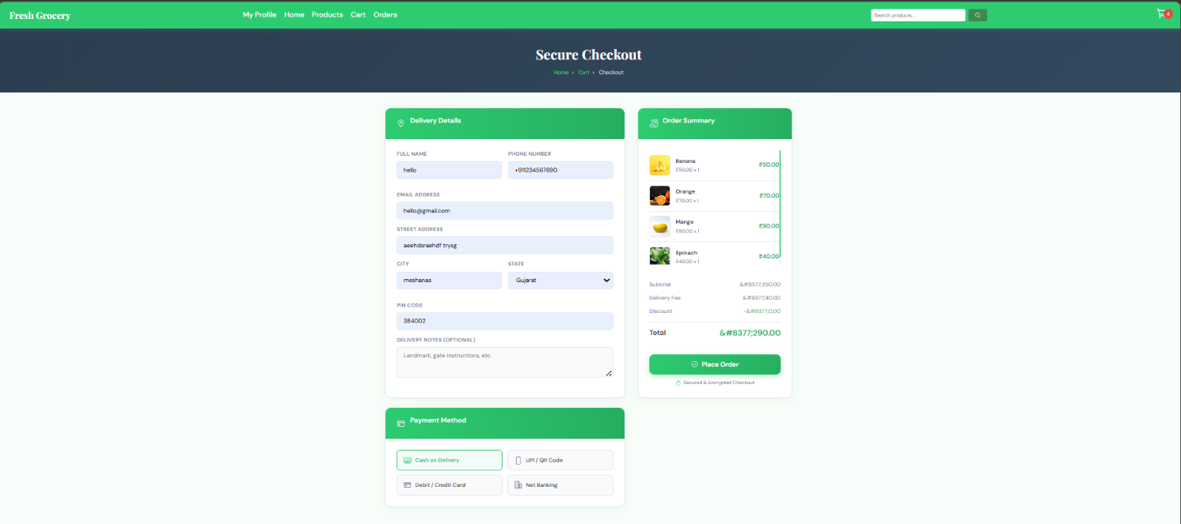

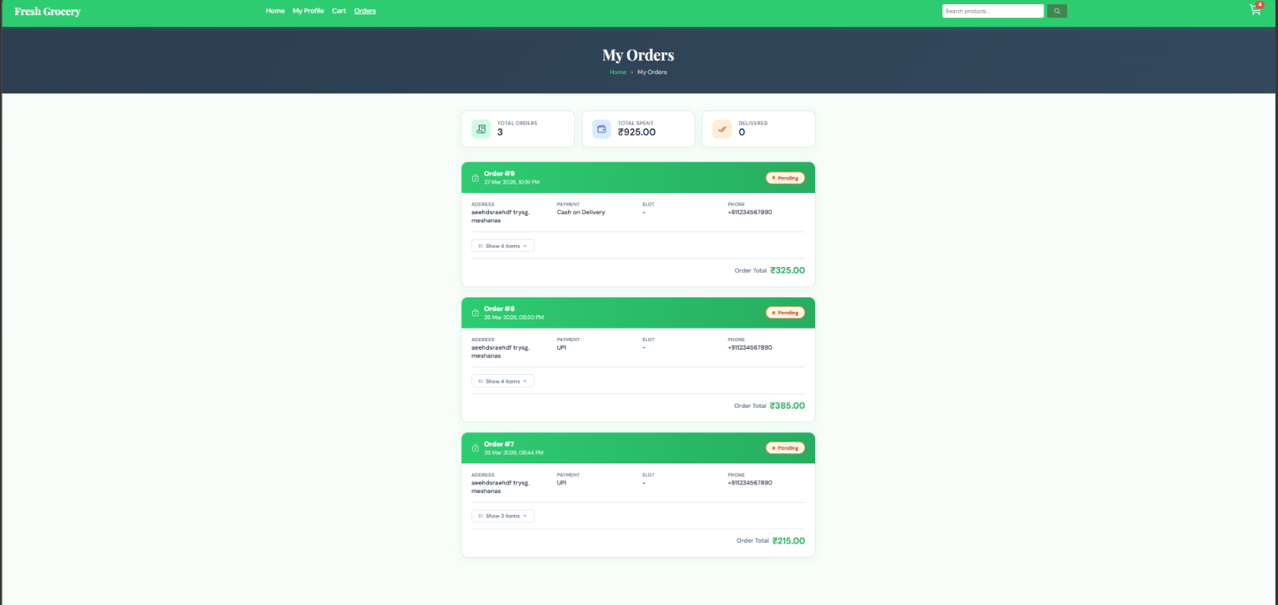

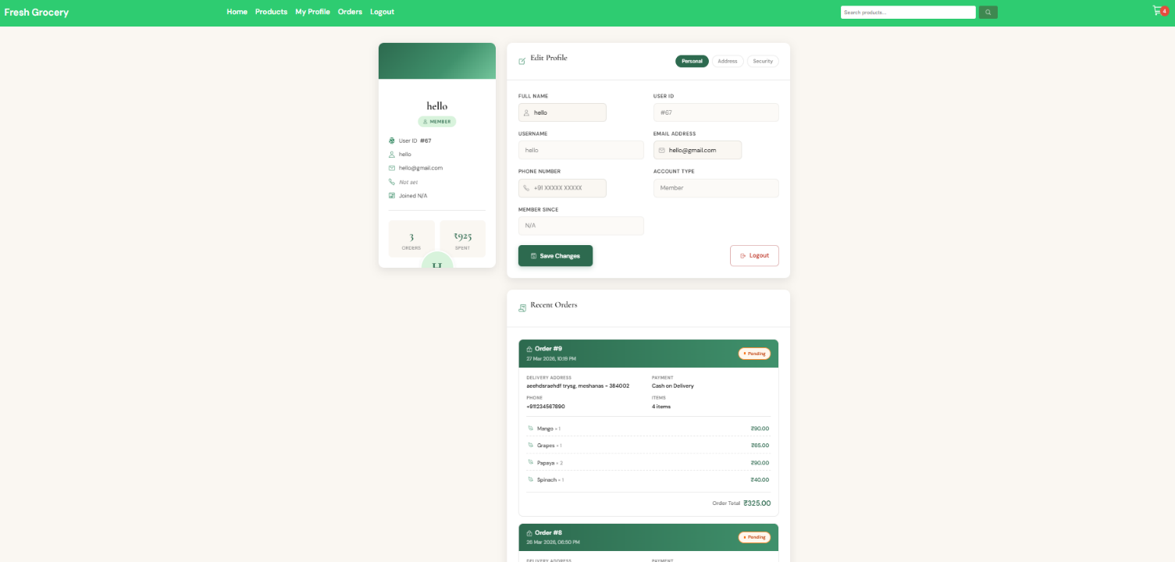

Admin side
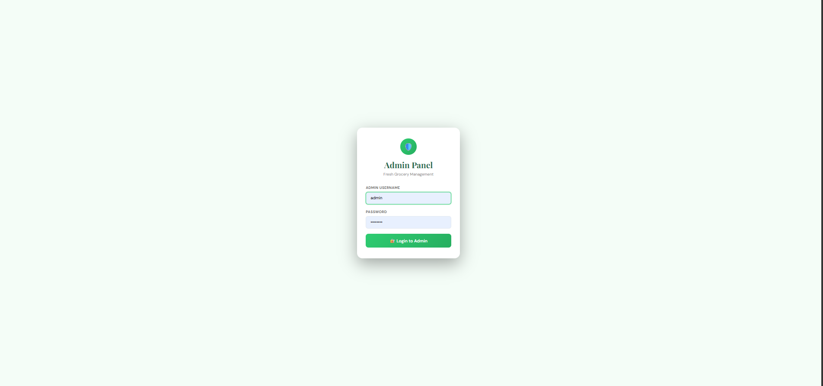

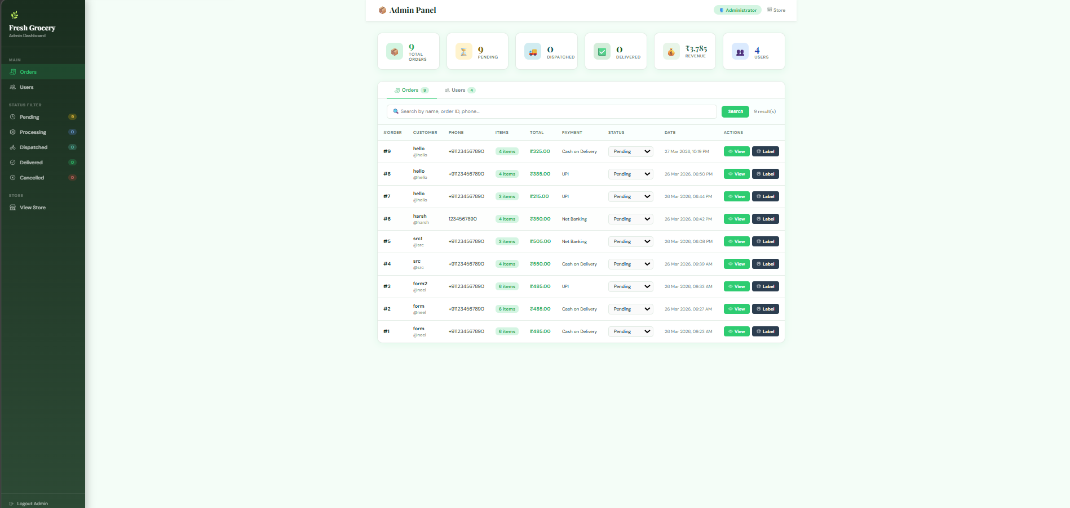

9. GANTT CHART

PROJECT GANTT CHART — Online Grocery Shopping
Semester: 29 Dec 2025 – 22 Apr 2026 | Lab Sessions: Monday & Wednesday Only | Dept: Information Technology, Ganpat University
PROJECT PHASE / ACTIVITY | W1  Dec 29 | W2  Jan 5 | W3  Jan 12 | W4  Jan 19 | W5  Jan 26 | W6  Feb 2 | W7  Feb 9 | W8  Feb 16 | W9  Feb 23 | W10  Mar 2 | W11  Mar 9 | W12  Mar 16 | W13  Mar 23 | W14  Mar 30 | W15  Apr 6 | W16  Apr 13 | W17  Apr 20
Lab Day → | Mon  Wed | Mon  Wed | Mon  Wed | Mon  Wed | Mon  Wed | Mon  Wed | Mon  Wed | Mon  Wed | Mon  Wed | Mon  Wed | Mon  Wed | Mon  Wed | Mon  Wed | Mon  Wed | Mon  Wed | Mon  Wed | Mon  Wed
1. Problem
Identification
& Definition
2. System
Requirement
Gathering
3. Problem
Solution
Outline
4. Diagrams
(Use Case,
DFD, ER)
5. Data
Dictionary
6. UI
Design
7. Future
Scope &
Conclusion
8. References
& Submission
LEGEND: ■ Monday Lab Active ■ Wednesday Lab Active □ No Activity

9. TESTING MODULE
Testing is a critical phase of the Software Development Life Cycle (SDLC). It verifies that the Online Grocery Shopping system works correctly and meets all functional requirements before deployment.
9.1 Black Box Testing
Black Box Testing is a software testing technique in which the tester evaluates the functionality of the application WITHOUT knowing the internal code, structure, or implementation. The tester only focuses on:
• INPUTS given to the system
• OUTPUTS / responses produced by the system
• Whether the actual output MATCHES the expected output

This approach is ideal for testing the Online Grocery Shopping system because it tests the application exactly as an end-user would interact with it — through the UI without any access to backend code.
Advantages of Black Box Testing
• No knowledge of internal code is required — any team member can perform it.
• Tests the system from the user’s perspective, finding real usability issues.
• Can be performed at any stage of development.
• Helps detect missing or incorrect functionalities quickly.
• Suitable for both Functional Testing and Regression Testing.

9.2 Black Box Test Cases — Online Grocery Shopping
The following test cases were designed and executed to validate all major modules of the system. Each test case includes the input given, the expected output, the actual output observed, and the final PASS/FAIL status.

TC ID | Module |  | Test Input | Expected Output | Actual Output | Status
TC-01 | User Registration |  | Valid name, email, password | Account created, redirect to login | Account created successfully | PASS
TC-02 | User Registration |  | Invalid email format (e.g. abc@) | Error: “Invalid email” | Validation error shown | PASS
TC-03 | User Login |  | Correct email & password | Redirect to home page | Login successful | PASS
TC-04 | User Login |  | Wrong password | Error: “Invalid credentials” | Error message displayed | PASS
TC-05 | Product Search |  | Search “Tomato” | List of tomato products shown | Products displayed | PASS
TC-06 | Product Search |  | Empty search box | Show all products | All products displayed | PASS
TC-07 | Add to Cart |  | Click Add to Cart on product | Item added; cart count +1 | Cart updated correctly | PASS
TC-08 | Add to Cart |  | Add same item twice | Quantity updated to 2 | Quantity incremented | PASS
TC-09 | Checkout |  | Fill all fields & submit | Order confirmed, email sent | Order placed successfully | PASS
TC-10 | Checkout |  | Leave address field empty | Error: “Address required” | Validation error shown | PASS
TC-11 | Admin Login |  | Admin credentials | Redirect to admin dashboard | Admin panel opened | PASS
TC-12 | Admin Product |  | Add new product with details | Product listed in catalog | Product added successfully | PASS
TC-13 | Admin Product |  | Delete existing product | Product removed from catalog | Product deleted | PASS
TC-14 | Forgot Password |  | Enter registered email | Reset link sent to email | Password reset email sent | PASS
TC-15 | View Order |  | Customer checks order history | Order list with status shown | Orders displayed | PASS
9.3 Types of Black Box Testing Used
Equivalence Partitioning: Inputs are divided into valid and invalid groups. For example, valid email formats vs. invalid email formats during registration.
Boundary Value Analysis: Tests at the edge of input ranges. For example, minimum/maximum characters allowed in the password field.
Decision Table Testing: Tests combinations of conditions. For example, login with correct email + wrong password, wrong email + correct password, etc.
Error Guessing: Tester uses experience to guess likely error areas such as empty cart checkout, duplicate registration with same email, etc.

9.4 How to Use Black Box Testing — Step-by-Step Guide
Follow these steps to perform Black Box Testing on the Online Grocery Shopping system:
Step | Action | Description | Tool / Technique
Step 1 | Identify Test Scenarios | List all features of the system (login, product search, cart, checkout, admin) without looking at the source code. | Requirements Document, SRS
Step 2 | Design Test Cases | For each feature, create test cases with: Test ID, Module, Input values, Expected output, Actual output, and Pass/Fail status. | Test Case Template (TC-01 to TC-15)
Step 3 | Prepare Test Data | Create real input data: valid emails, wrong passwords, empty fields, product names, address details, etc. | Manual test data / dummy accounts
Step 4 | Execute Tests | Open the application in a browser. Perform each test case one by one. Enter the inputs and observe the system response. | Browser (Chrome / Firefox), Local Server
Step 5 | Record Results | Write the Actual Output in the test table. Mark each test as PASS if actual matches expected, else mark FAIL. | Test Case Table (above)
Step 6 | Report Defects | For any FAIL result, note the bug: what input caused it, what went wrong, and the expected vs actual difference. | Bug Report / Issue Tracker
Step 7 | Re-Test after Fix | After developers fix the reported bug, re-run the failed test cases to confirm they now pass (Regression Testing). | Same test cases, updated build

9.5 Test Execution Summary
Total Test Cases | Tests Passed | Tests Failed | Pass Rate
15 | 15 | 0 | 100%

All 15 test cases passed successfully. The Online Grocery Shopping system performs as expected across all tested modules including User Registration, Login, Product Search, Add to Cart, Checkout, Admin Management, and Password Recovery.

