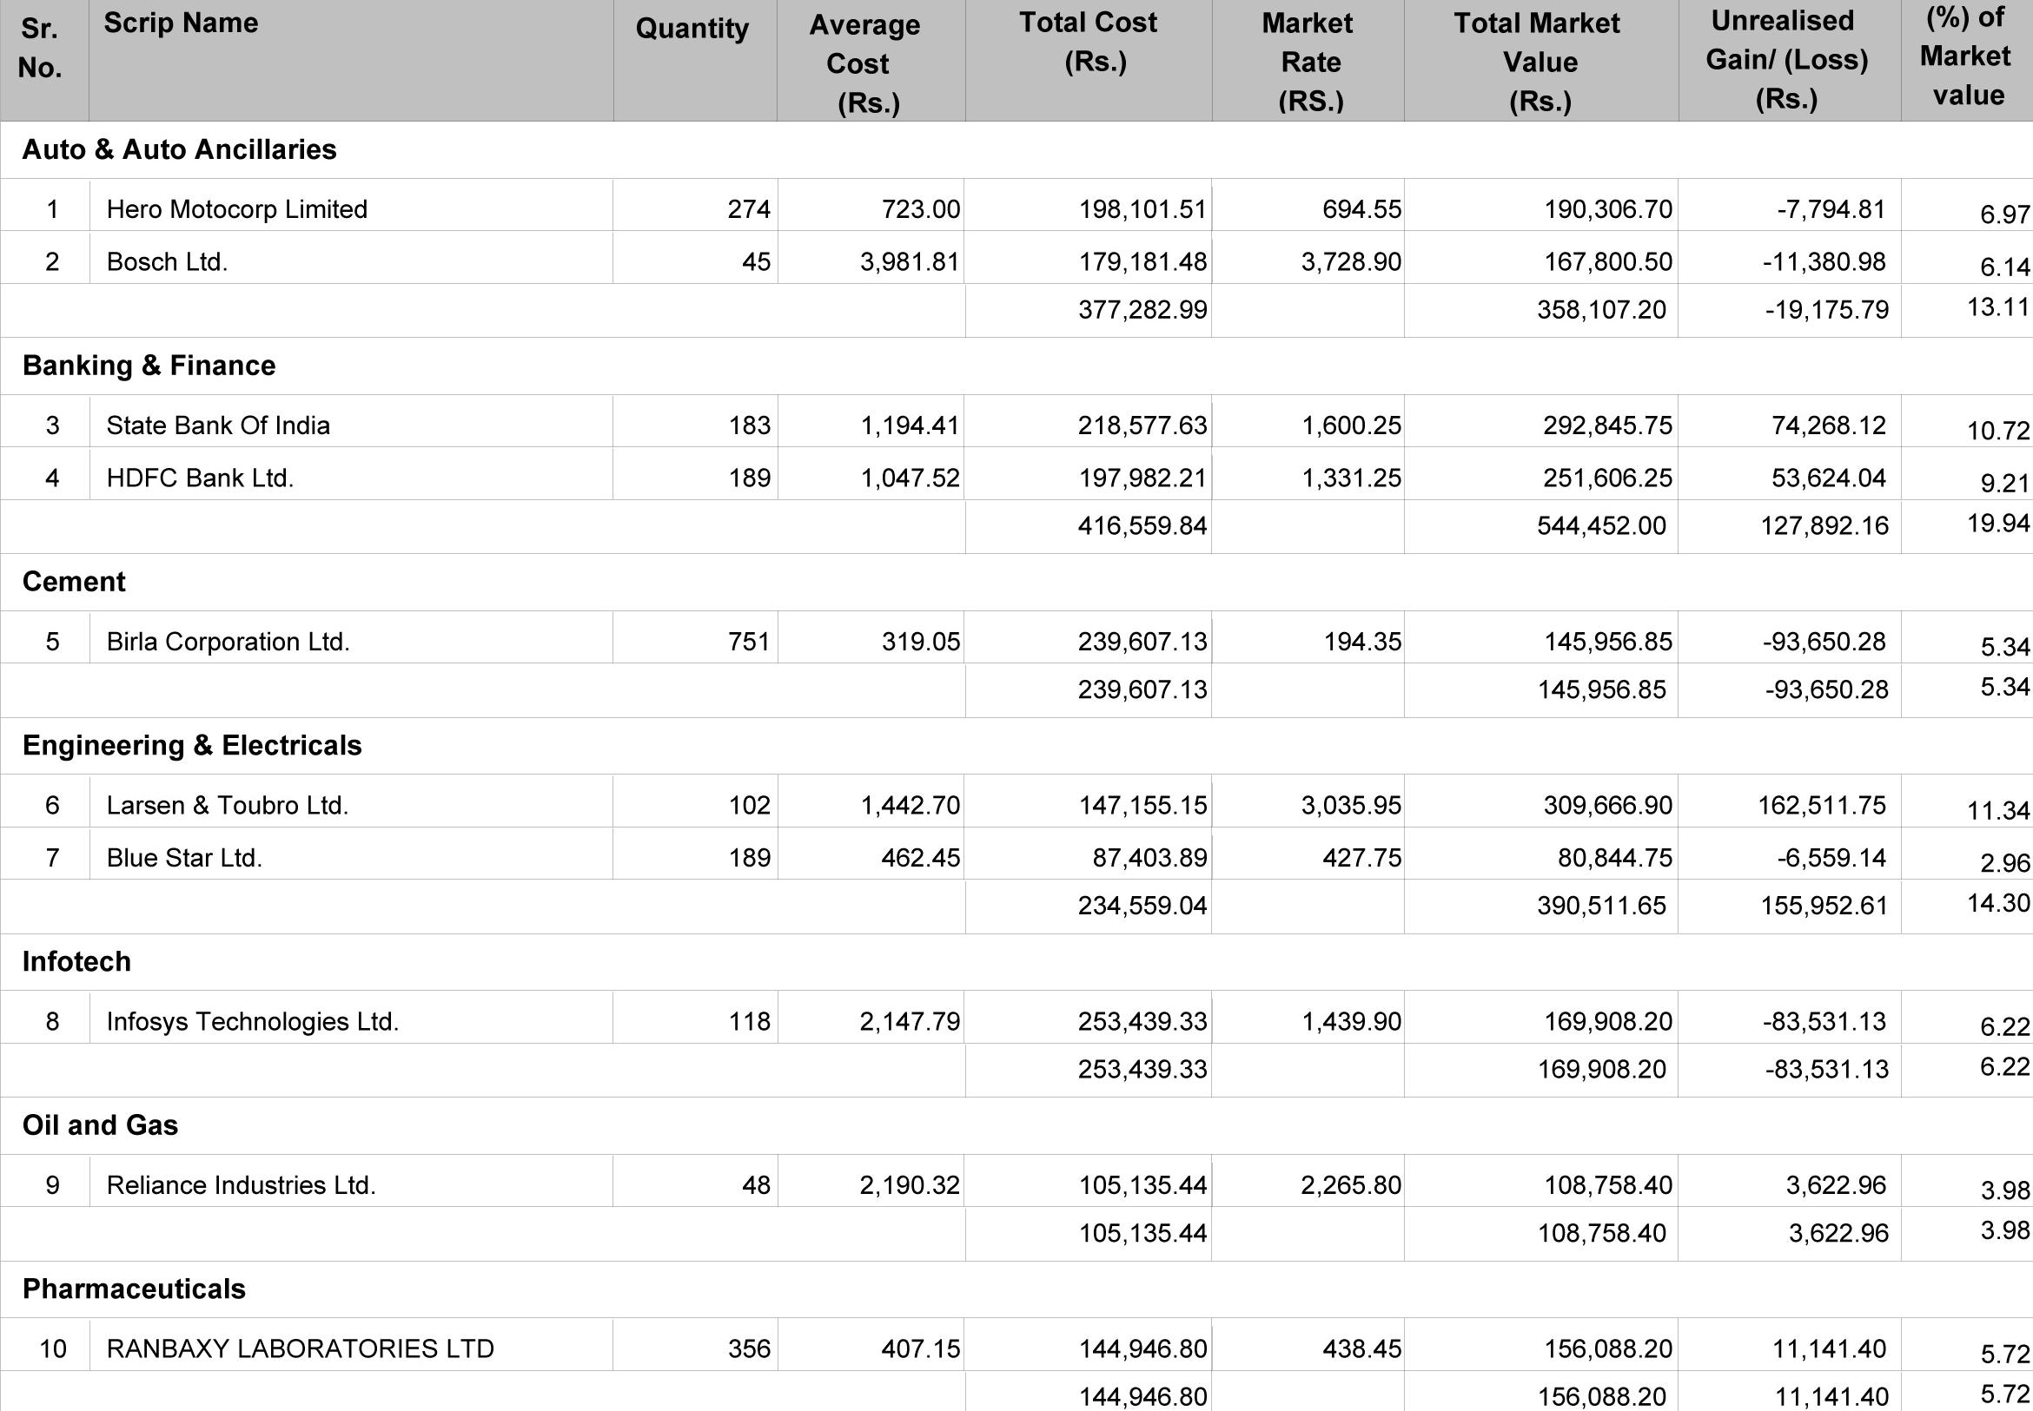

**751**

**319.05**

**Infotech**

**8**

**Infosys Technologies Ltd.**

**118**

**2,147.79**

**253,439.33**

**1,439.90**

**169,908.20**

**253,439.33**

**169,908.20**

**Oil and Gas**

**407.15**

**438.45**

10 **RANBAXY LABORATORIES LTD 356**

**144,946.80**

**156,088.20**

**Sr. Scrip Name**

**No.**

**Auto & Auto Ancillaries**

|  |  |
| --- | --- |
| **Unrealised (%) of**  **Gain/ (Loss) Market**  **(Rs.) value** | |
|  | |
| **-7,794.81** | **6.97** |
| -11,380.98 | **6.14** |
| **-19,175.79** | **13.11** |
|  | |
| **74,268.12** | **10.72** |
| **53,624.04** | **9.21** |
| 127,892.16 | **19.94** |
|  | |
| -93,650.28 | **5.34** |
| **-93,650.28** | **5.34** |
|  | |
| **162,511.75** | **11.34** |
| -6,559.14 **2.96** | |
| **155,952.61** | **14.30** |
|  | |
| **-83,531.13** | **6.22** |
| -83,531.13 **6.22** | |
|  | |
| 3,622.96 | **3.98** |
| **3,622.96** | **3.98** |
|  | |
| **11,141.40** | **5.72** |
| **11,141.40** | **5.72** |

**377,282.99**

**358,107.20**

**HDFC Bank Ltd.**

**189**

**1,331.25**

**1,047.52**

**251,606.25**

544,452.00

**197,982.21**416,559.84

**239,607.13**

**194.35**

**145,956.85**

**239,607.13**

**145,956.85**

**Blue** Star Ltd.

**427.75**

**462.45**

**87,403.89**

**80,844.75**

**189**

**234,559.04**

**390,511.65**

**Quantity Average Total Cost Market Total Market**

**Cost (Rs.) Rate Value**

**(Rs.) (RS.) (Rs.)**

**Hero Motocorp Limited**

**723.00**

**198,101.51**

**694.55**

**190,306.70**

1

**274**

**Bosch Ltd.**

45 3,981.81

**179,181.48**

3,728.90

**167,800.50**

**2**

**Banking & Finance**

**State Bank Of India**

**1,194.41**

**218,577.63**

**1,600.25**

**292,845.75**

**3**

**183**

**Engineering & Electricals**

**6 Larsen & Toubro Ltd.**

**1,442.70**

**147,155.15**

**3,035.95**

**309,666.90**

**102**

**9**

Reliance Industries Ltd.

2,265.80 **108,758.40**

**105,135.44**

**105,135'441**

**108,758.40**

48 2,190.32

**Pharmaceuticals**

**144,946.80 156,088.20**

**Cement**

**5** Birla Corporation Ltd.