Multimedia Casting over Wi-fi using IP

# Abstract

**2. Main Body**

# My Project is based on the fundamentals of networking. It mainly focuses on the ease of sharing of data over the same network whether it is public or private. In the current scenario, the implementation is done on the public network. We have used C programming for the implementation of the system using socket programming concept. This system is implemented in the Ubuntu – Linux. GTK+, i.e. Genome Tool Kit is used for the GUI development of the system. This system can be implemented on most of the major operating systems. It is user friendly and compatible to the interfaces.

* + 1. **Introduction**

It generally will mean that something that is connected to your network, like your phone, is broadcasting video or audio to another device on the network, such as your television or speakers.

First, Client will send a join request to the server to join the multicast group .After that Server will provide station list, site info to the client through TCP. Then whichever station it selects from the station list, it is connected to that station. All the stations are sending data, irrespective of client is connected or not. This functionality is incorporated to relate more with real life situation, e.g. TV/radio sends data even though there is no receiver connected.

Whenever receiver connects to a particular station, it starts receiving live-streaming videos from that station. Receiver can pause, resume, change station or even terminate at any given time from GUI using thread.

Wi-Fi uses multiple parts of the IEEE 802 protocol family and is designed to interwork seamlessly with its wired sibling Ethernet. Compatible devices can network through wireless access points to each other as well as to wired devices and the Internet. The different versions of Wi-Fi are specified by various IEEE 802.11 protocol standards, with the different radio technologies determining radio bands, and the maximum ranges, and speeds that may be achieved. Wi-Fi most commonly uses the 2.4 gigahertz (120 mm) UHF and 5 gigahertz (60 mm) SHF ISM radio bands; these bands are subdivided into multiple channels. Channels can be shared between networks but only one transmitter can locally transmit on a channel at any moment in time.

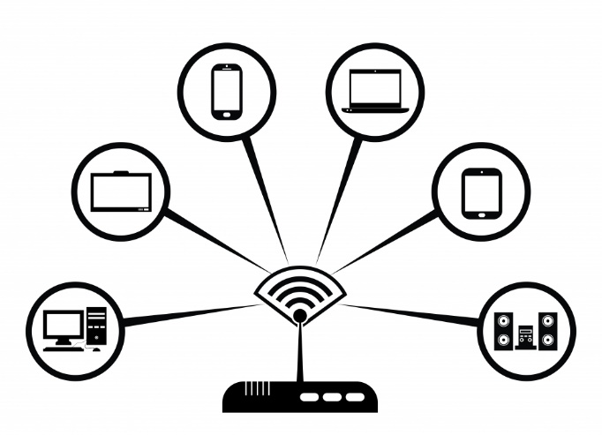

Wi-Fi is potentially more vulnerable to attack than wired networks because anyone within range of a network with a wireless network interface controller can attempt access. To connect to a Wi-Fi network, a user typically needs the network name (the *SSID*) and a password. The password is used to encrypt Wi-Fi packets to block eavesdroppers. Wi-Fi Protected Access (WPA) is intended to protect information moving across Wi-Fi networks and includes versions for personal and enterprise.

1. **GTK+ (Genome Tool kit)**

The GTK library contains a set of graphical control elements; version 3.22.16 contains 186 active and 36 deprecated widgets. GTK is an object-oriented widget toolkit written in the programming language C; it uses G Object,that is the G-Lib object system, for the object orientation. While GTK is mainly for windowing systems based on X11 and Wayland, it works on other platforms, including Microsoft Windows (interfaced with the Windows API), and macOS (interfaced with Quartz). There is also an HTML5 back-end named Broadway.

GTK can be configured to change the look of the user interface drawn; this is done using different display engines. Several display engines exist which try to emulate the look of the native widgets on the platform in use.

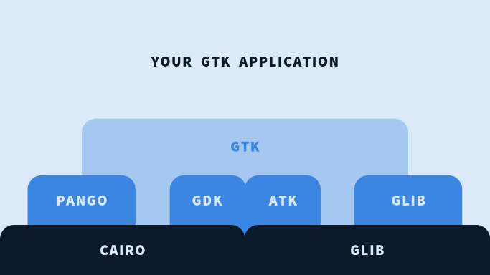

Overview of GTK and its libraries.

Glib:- it is a low-level core library that forms the basis of GTK. It provides data structure handling for C, portability wrappers and interfaces for such run-time functionality as an event loop, threads, dynamic loading and an object system.

Pango:- it is a library for layout and rendering of text with an emphasis on internationalization. It forms the core of text and font handling for GTK

Cairo:- it is a library for 2D graphics with support for multiple output devices (including the X Window System, Win32) while producing a consistent output on all media while taking advantage of display hardware acceleration when available.

# GdkPixbuf:- it is a library for loading graphical assets like icons in various formats, like PNG, JPEG, and GIF.

ATK:- it is a library for a set of interfaces providing accessibility. By supporting the ATK interfaces, an application or toolkit can be used with tools such as screen readers, magnifiers, and alternative input devices.

SOCKET PROGRAMMING

If we are creating a connection between client and server using TCP then it has few functionality like, TCP is suited for applications that require high reliability, and transmission time is relatively less critical. It is used by other protocols like HTTP, HTTPs, FTP, SMTP, Telnet .TCP rearranges data packets in the order specified. There is absolute guarantee that the data transferred remains intact and arrives in the same order in which it was sent. TCP does Flow Control and requires three packets to set up a socket connection, before any user data can be sent. TCP handles reliability and congestion control. It also does error checking and error recovery. Erroneous packets are retransmitted from the source to the destination.

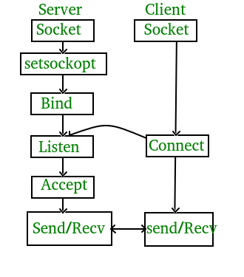

1. **The Network View**

# Results

.

# Conclusion:

In this paper, the precision of the data delivered was observed to be 99% up to the mark and resolutions of the data. The system is robust to the data and is sufficient enough to deliver the data with correct format and order of the format.

1. **References:-**