Caminalcules and Reconstructing Phylogenetic Trees

The evidence gathered by Darwin, and thousands of other biologist since then, indicates that all organisms are descended from a common ancestor. In the almost unimaginable span of time since the first organisms arose (about 3.5 billion years) life has gradually diversified into the myriad forms we see today.

As a consequence of Darwin's work it is now recognized that taxonomic classifications reflect evolutionary history. For example, Linnaeus put humans and wolves in the class Mammalia within the phylum Chordata because they share certain characteristics (e.g. backbone, hair, homeothermy, etc.). We now know that this similarity is not a coincidence; both species inherited these traits from the same common ancestor. In general, the greater the resemblance between two species, the more recently they diverged from a common ancestor. Thus, when we say that the human and wolf are more closely related to each other than either is to the honeybee we mean that they share a common ancestor that is not shared with the honeybee.

Another way of showing the evolutionary relationship between organisms is in the form of a phylogenetic tree (Gk. phylon, stock, tribe + genus, birth, origin):

The vertical axis in Figure 2 represents time. The point at which two lines separate indicates when a particular lineage split. For example, we see that mammals diverged from reptiles about 150 million years ago. The most recent common ancestor shared by mammals and reptiles is indicated by the point labeled A.
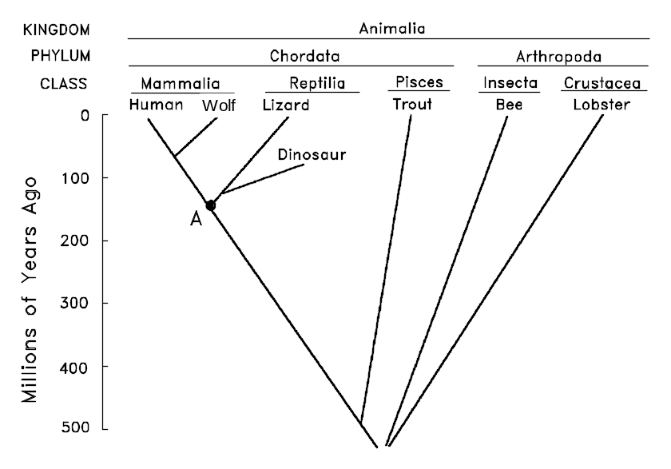
Figure 2
Several types of evidence can elucidate the evolutionary relationship between organisms. One approach is to compare living species. The greater the differences between them, the longer ago they presumably diverged. There are, however, pitfalls with this approach. For example, some species resemble each other because they independently evolved similar structures in response to similar environments or ways of life, not because they share a recent common ancestor. This is called convergent evolution because distantly related species seem to converge in appearance (become more similar). Examples of convergent evolution include the wings of bats, birds and insects, or the streamlined shape of whales and fish. At first glance it might appear that whales are a type of fish, but this resemblance is superficial, resulting from the fact that whales and fish have adapted to the same environment. The presence of hair, the ability to lactate and homeothermy clearly demonstrate that whales are mammals. Thus, phylogenetic biologists must take into account a many features, not just a single one.

The fossil record can also be helpful for constructing phylogenetic trees. For example, bears were once thought to be a distinct group within the order Carnivora. Recently discovered fossils, however, show that they actually diverged from the Canidae (wolves, etc.) fairly recently. The use of fossils is not without its problems, however. The most notable of these is that the fossil record is incomplete. This is more of a problem for some organisms than others. For example, organisms with shells or bony skeletons are more likely to be preserved than those without hard body parts.

In preparing or analyzing a phylogenetic tree, traits that cause branching or otherwise denote a separation from the common ancestor are considered derived character states. The original trait in the clade’s common ancestor is considered the ancestral character state. Each change in state is often represented by a hash mark, as illustrated in the figure to the right. Whether a trait is considered derived or ancestral depends on the group under consideration. For example, trait x is considered the derived state for the clade containing species G and D, but is considered the ancestral state for species D.
D
G
B
Trait x
Trait y

The Classification and Evolution of Artificial Organisms

You will develop a taxonomic classification and phylogenetic tree for a group of imaginary organisms called Caminalcules after the taxonomist Joseph Camin who devised them. Pictures of the 14 "living" and 58 "fossil" species that you will use are attached. Take a look at the pictures and note the variety of appendages, shell shape, color pattern, etc. Each species is identified by a number rather than a name. For fossil Caminalcules there is also a number in parentheses indicating the geological age of each specimen in millions of years. Most of the fossil Caminalcules are extinct, but you will notice that a few are still living (e.g. species #24 is found among the living forms but there is also a 2 million year old fossil of #24 in our collection).

We do these exercises with artificial organisms so that you will approach the task with no preconceived notion as to how they should be classified. This means that you will have to deal with problems such as convergent evolution just as a taxonomist would. With real organisms you would probably already have a pretty good idea of how they should be classified and thus miss some of the benefit of the exercise.

After you reconstruct the Caminalcule phylogeny. Try the same exercise with real organisms.

https://media.hhmi.org/biointeractive/click/shells_online/index.html

Procedures:
Carefully examine the fourteen living species and note the many similarities and differences between them. Each species is identified by a number rather than a name. Note that the Caminalcules are numbered at random; the numbers provide no clues to evolutionary relationships.

Construct a phylogenetic tree based only on your examination of the 14 living species.

First, collect morphological feature data: Carefully examine the individuals from each species and note the similarities and differences in features among them. The challenge is to identify morphological traits that are homologous across these species but that have variable states. In your notebook write out a table like the one below with possible feature traits, then score each species for presence or absence of each character (0 or 1, + or -, yes or no, etc).
A data table with some possible characters is attached. You are encouraged to identify additional characters. Score the character state (present/absent) for each species.

 | Features
Species | eyes | appendages
3
28
24
D
G
B
Trait x
Second, construct a phylogenetic tree indicating the evolutionary relationships among these species using the feature traits in your table. Base your phylogenetic tree on clades with shared derived characters. Mark in your tree where character states likely evolved. Your diagram might look something like the diagram to the right, where species are denoted with upper-case letters and character traits with lower-case letters. Note that branching should involve only two lines at a time. You may find it helpful to cut out the Caminalcules and work out the tree by rearranging the species. Work to find the most parsimonious tree, which is the best supported hypothesis for the relationships among these organisms. Calculate the tree score for your phylogeny.
There is only one correct phylogenetic tree.

LIVING CAMINALCULES
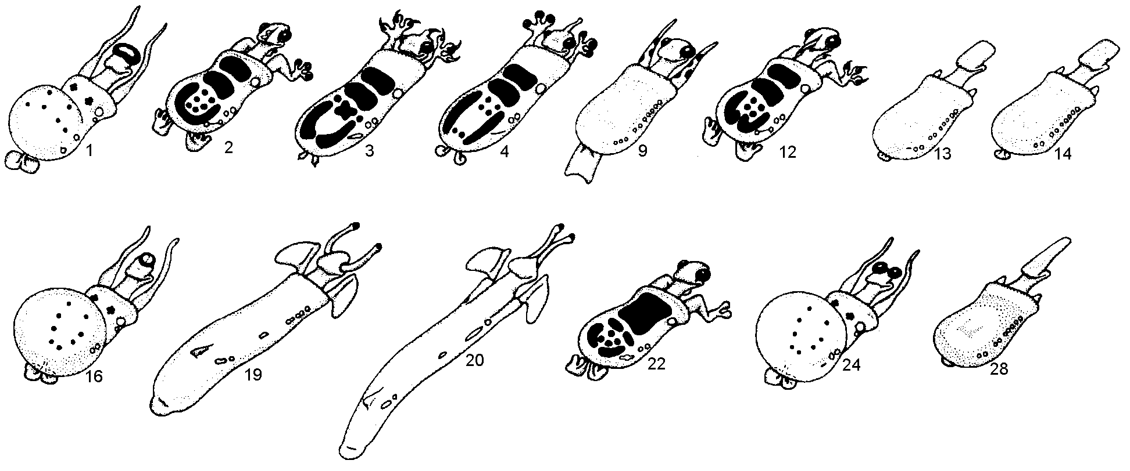
FOSSIL CAMINALCULES
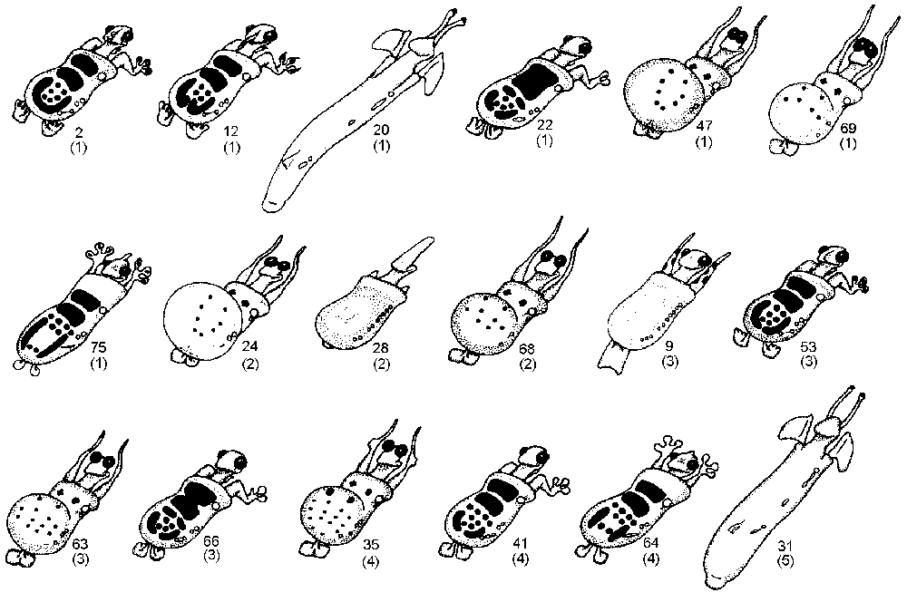(numbers in parentheses indicate age in millions of years)

FOSSILS (continued)
