FORECASTING ROAD ACCIDENTS PROJECT: WRITEUP
NAME – SOUMYA BANERJEE

This document outlines a road accident forecasting and data exploration project.
This project does the following
1) Data acquisition
2) Data munging (SQL like queries)
3) Data Exploration
4) Basic sanity check and basic verification of data
5) Forecasting using machine learning techniques
6) Documentation
7) Code base (work of this author - Soumya Banerjee) to implement a proof of concept.
8) Dynamic user interface to allow users to explore the data and perform forecasting.

Data
We use accident data from the Australian government in the state of Victoria [1].

Methods and Tools
I used custom-built python and R scripts to acquire the data, perform data munging and apply machine learning techniques. I used ARIMA (Auto-Regressive Integrated Moving Average model) and random forests to build a predictive model of accidents.

Plots
Here we show some basic plots from our implemented proof of concept.
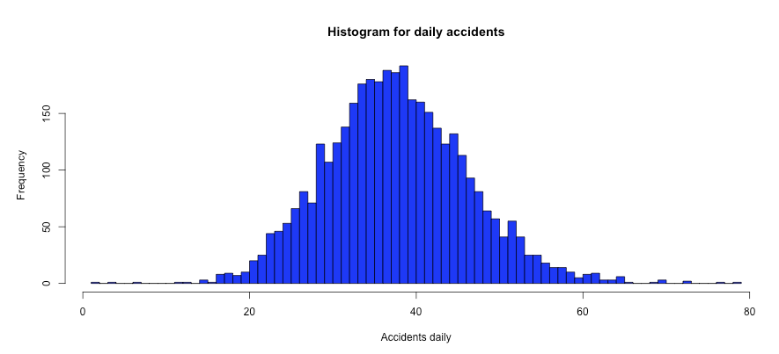
Figure 1. Histogram of accidents daily.

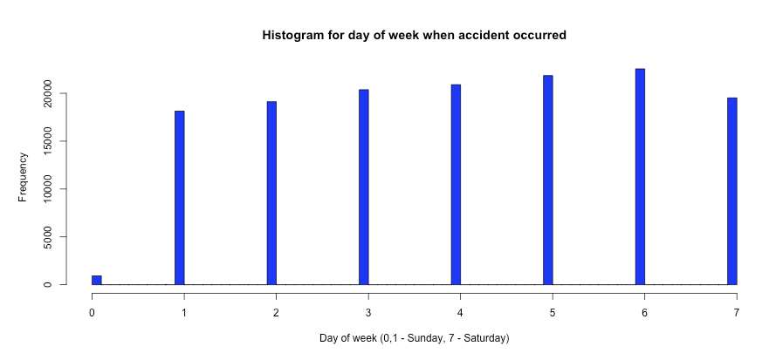
Figure 2. Histogram of accidents by day of week.

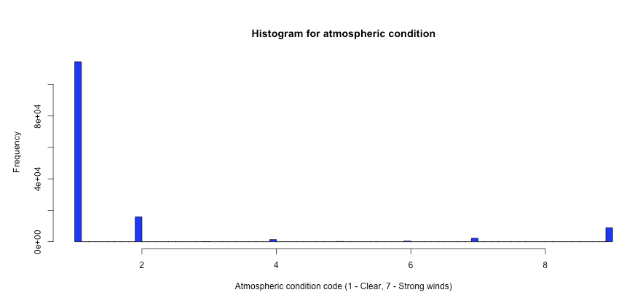
Figure 3. Histogram of accidents by road condition.

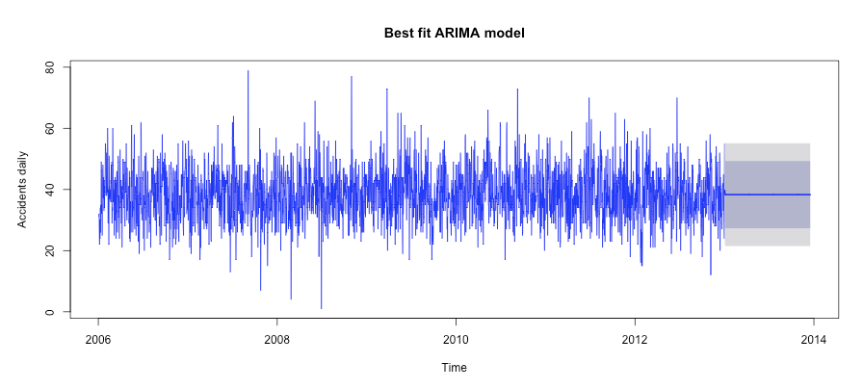
Figure 4. Forecasting road accidents using machine learning algorithms (ARIMA).

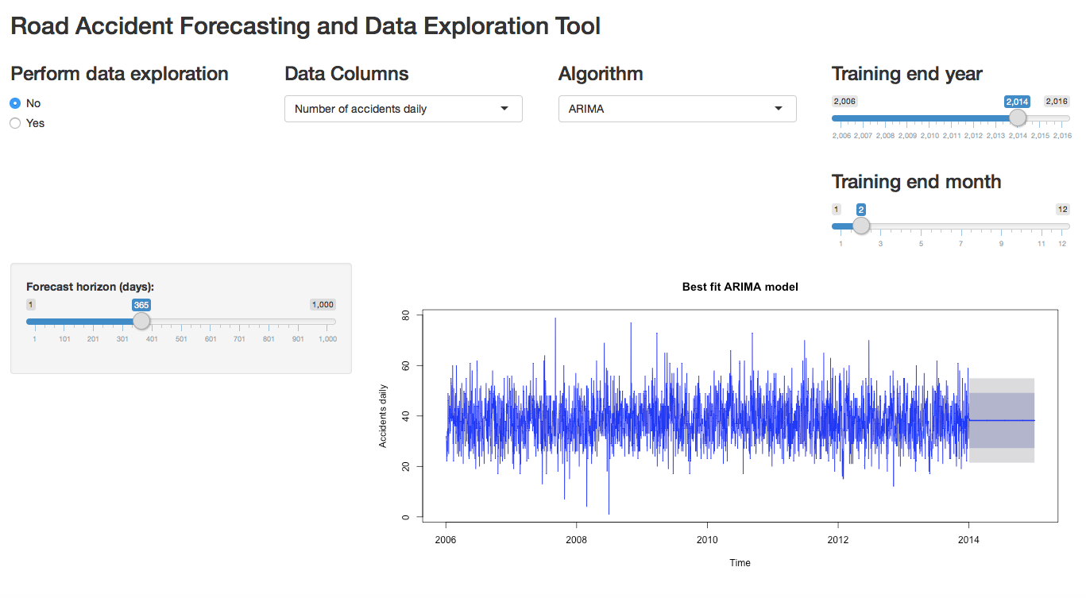
Figure 5. Screenshot of dynamic user interface to allow users to explore the data and perform forecasting.

Interpretation
Here we outline our preliminary interpretation of the data.
1) Day of week is a very good predictor (as shown by Fig. 2 and also by a random forests model).
2) Road condition is a weaker predictor (as shown by Fig. 3 and also by a random forests model).
We may be able to conclude preliminarily that simple models like ARIMA (Auto-Regressive Integrated Moving Average model) do a good job predicting and forecasting road accidents in Victoria.
It would also be fruitful to look at light conditions or road intersections and road types (highways, intersections, etc).

References
1) Database of road accidents in the state of Victoria, Australia. URL https://www.data.vic.gov.au/data/dataset/crash-stats-data-extract, Last accessed 1st May, 2016

