AN OPEN SOURCE MAPPING PROJECT: INTERPRETATION
NAME – SOUMYA BANERJEE

This document outlines the interpretation and basic verification of an open source mapping project.
This project does the following
1) Data acquisition
2) Data munging
3) Plotting maps of location of individuals in a particular region
4) Documentation
5) Basic sanity check and basic verification of data
6) Code base (work of this author - Soumya Banerjee) to implement a proof of concept and basic verification

Data
We use data from the SNAP dataset [1].

Methods and Tools
We used custom-built python and UNIX shell scripts to acquire the data and perform data munging. All statistical analysis was performed in MATLAB.

Plots
Here we show some basic plots from our implemented proof of concept.
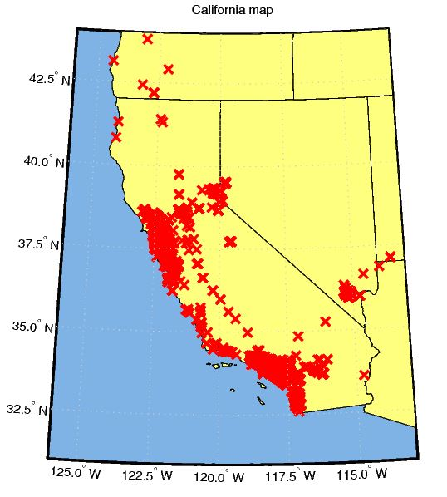
Figure 1. Plot of total aggregation in a particular region/zone. We focus on a region in California, Nevada and Oregon.

Interpretation and Basic Sanity Check
Here we outline our preliminary interpretation of the data and a basic verification.
For the basic sanity check and verification of data, we focus on a region in California, Nevada and Oregon (see Fig. 1).
The regions in the map roughly correspond to large cities in California (Los Angeles and San Francisco), a large city in Nevada (Las Vegas) and a smaller town (Reno). We also observe aggregations in a small city in Oregon (Medford).
It is interesting to observe the following patterns of usage of landmarks and notable recreational facilities and national parks –
1) We observed large aggregations in the Lake Tahoe region (California and Nevada) consistent with individuals aggregating for recreational purposes (Fig. 1). It would be interesting to ask (and follow-on studies should focus on this) if there are connected communities and friends that together visit these recreational facilities.
2) We see a few individuals in Death Valley National Park and Yosemite National Park (Fig. 1).
The results are consistent with the use of recreational facilities and landmarks by individuals using the social network. This serves as a first step and rough verification of the data.

References
1) {SNAP}: A general purpose network analysis and graph mining library in {C++} (2011). URL http://snap.stanford.edu/data/loc-gowalla.html, Last accessed June 19, 2015

