My perspective of the problem:
The assignment is about finding the function (f) in y = f(x) to fit the data. This involves the classification task. From the given inputs, there is a pair of data file that contains both observed and ground truth. While the other two observed files, do not contain the ground truth.

Tasks:
- First task is to find the classification model that fits and given sample data set.
- Estimate the positions of the emitter.

Solution steps:

Following is the github page (radar_data_classifier) that describes the code and instruction to setup the environment uv environment and execute the code.

Note: Due to time-bound, I could not test the code in other device. Please let me know if any issues during execution.

Timeline: Observations made during model building
- - Currently inputs are in .xlsx format, which is good for few data points. However, with increase in file data, its better to move to .csv format for better efficient processing of the data.
- - Loaded the first observation data and used DBSCAN classifier to cluster the data. After doing some experiment with eps and min_sample values, it is found that the (eps=0.37, min_samples=10) resulted in a single cluster match. That is, cluster 10 in ground truth match with the cluster as shown in the first table (image attach below). However, the first three clusters in the ground truth got merged to a single group in the model. Need further attention to tune the model. I will check it again, post completion of the scripting of full code.
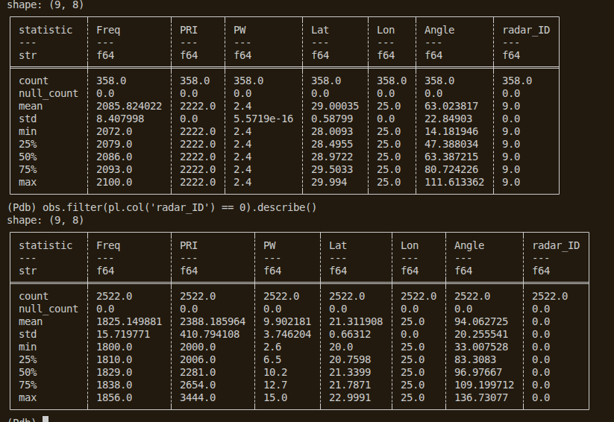

Important note:
- Few of the folders/files won’t be committed to git. However for simplicity to share the assignment and run the script, I am dumping all the inputs, outputs, and data files to the git. Please let me know if you face difficulty in fetching the repository (radar_data_classifier).

Further works:
- - Refractor the code by making it in modular format.
- - At this point, I am using uv package manager. It can be easily migrated to container (docker), if required.
- - Other classification models are yet to assessed.
- - If the data is massive, it can be restructured to run process in GPUs using JAX, Pytorch, and/or other tools.
- - If code performance matters, then the input format needs to be in csv, thereby, massive parallel execution can be performed.
- - Model parameters tuning is yet to be done.

