PHASE 5 – PROJECT DEVELOPMENT

Development Platform

ServiceNow

Development Tool

Flow Designer

Step 1 – Create the Flow
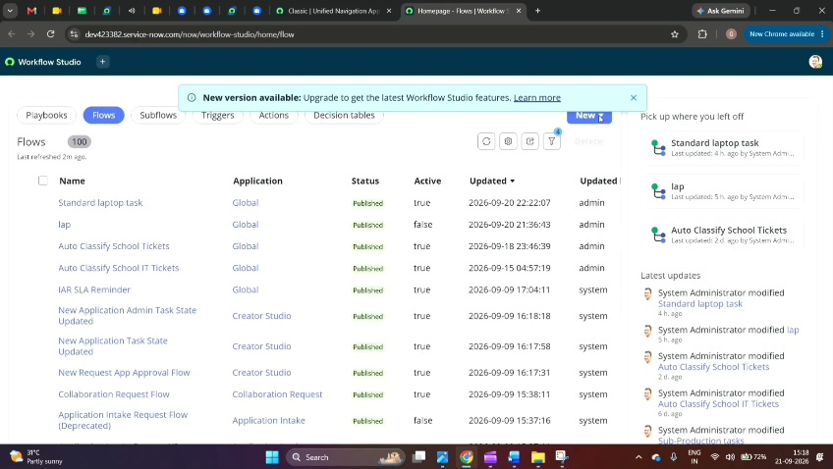
1. Open ServiceNow.
2. Click All.
3. Search for Flow Designer.
4. Open Flow Designer under Process Automation.
5. Click New.
6. Select Flow.
7. Enter Flow Name as "Standard Laptop Task".
8. Select Application as Global.
9. Select Run As as System User.
10. Click Submit.

Step 2 – Configure Trigger
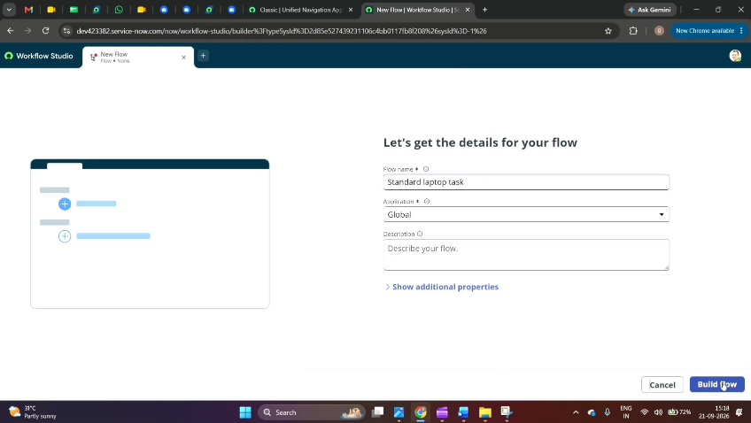
1. Click Add a Trigger.
2. Search for Service Catalog.
3. Select Service Catalog.
4. Click Done.

Step 3 – Configure Action
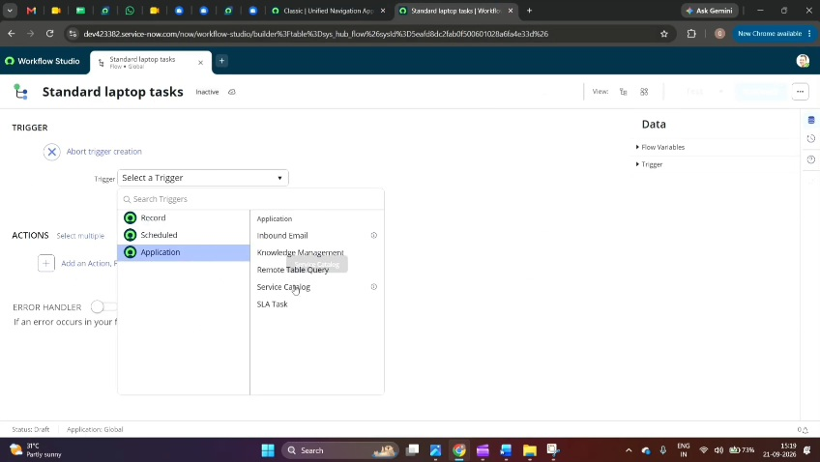
1. Under Actions, click Add an Action.
2. Search for Create Catalog Task.
3. Select Create Catalog Task.
4. Set Action as Create Catalog Task.
5. Drag and drop the Requested Item Record into Request Item.
6. The Table will be automatically populated as Catalog Task.
7. Enter Short Description as:
"Laptop need to Configured"
8. Add the Description field.
9. Enter:
"Laptop need to Configured"
10. Set Assignment Group as Hardware.
11. Set Approval as Approved.
12. Leave the remaining fields as default.
13. Click Done.
14. Save the Flow.
15. Activate the Flow.

Step 4 –Assign Flow to Standard Laptop
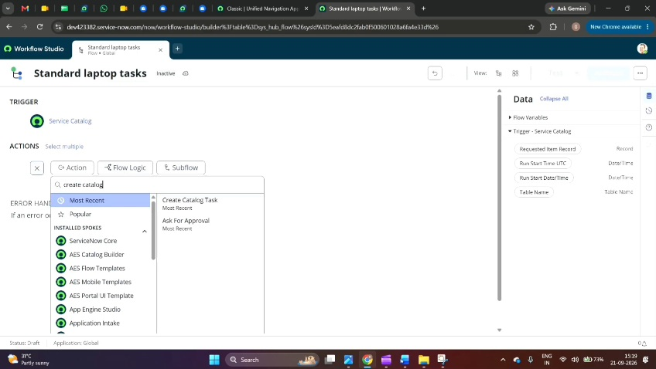
1. Open ServiceNow.
2. Click All.
3. Search for Maintain Items.
4. Open Maintain Items.
5. Search for Standard Laptop.
6. Open the Standard Laptop record.
7. Select Process Engine.
8. Remove the remaining automations.
9. Add the created Flow.
10. Select "Standard Laptop Task".
11. Save the record.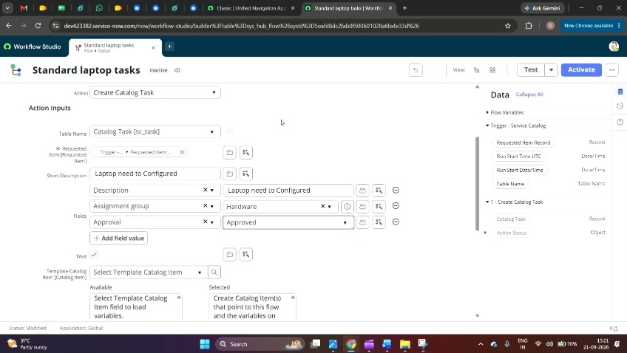

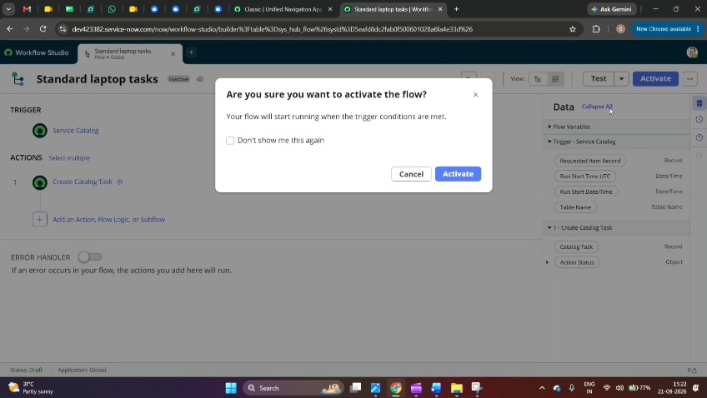

Development Output

A working ServiceNow Flow Designer automation is created for the Standard Laptop procurement process.

The Flow automatically creates a Catalog Task after approval and assigns it to the Hardware group.

