PHASE 6 – PROJECT TESTING

Testing Objective

The objective of testing is to verify that the Standard Laptop request correctly triggers the Flow Designer automation and creates the required Catalog Task.

Test Cases
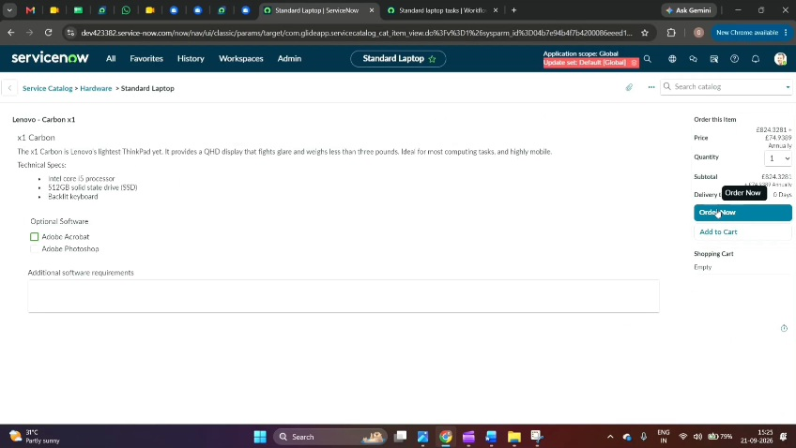
Test Case| Expected Result
Open Service Catalog| Service Catalog should open successfully
Select Standard Laptop| Standard Laptop item should be available
Place the request| Request should be created
Open request status| Request status should be displayed
Approve the request| Request should be approved
Open Requested Item| Requested Item should be displayed
Check Catalog Tasks| Catalog Task should be created
Check Short Description| "Laptop need to Configured" should be displayed
Check Assignment Group| Hardware should be displayed
Check task status| Updated task status should be displayed

Testing Procedure
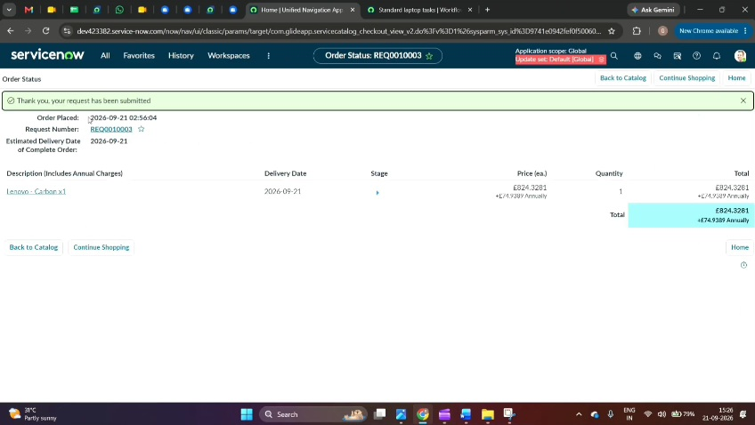
1. Open ServiceNow Service Catalog.
2. Select Hardware.
3. Select Standard Laptop.
4. Click Order Now.
5. Open the order status.
6. Open the Request Number.
7. Go to the Approvers section.
8. Approve the request.
9. Open the Requested Item.
10. Scroll to the Catalog Tasks section.
11. Open the Catalog Task.
12. Verify the Short Description and Assignment Group.

Expected Testing Result
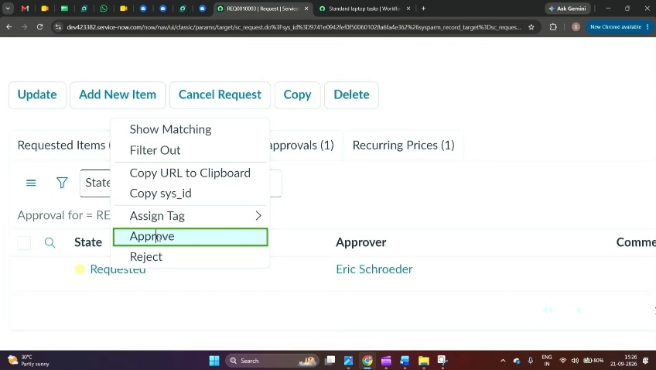
The approved Standard Laptop request should create a Catalog Task with the required configuration details and assign the task to the Hardware group.
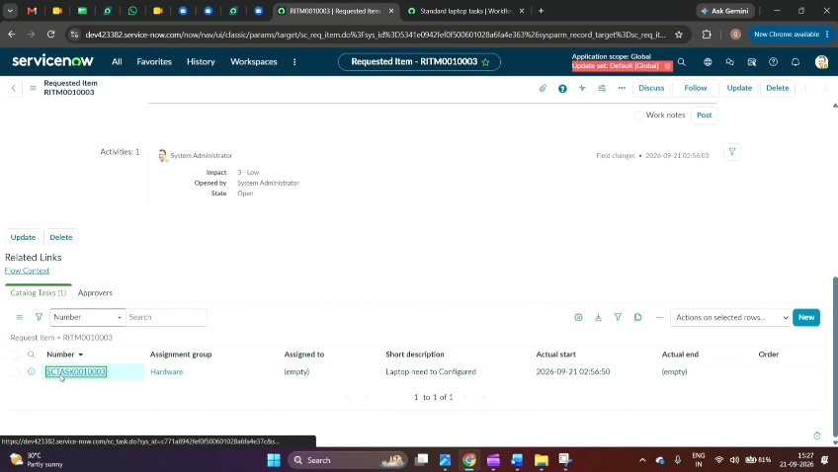
Conclusion

The testing confirms whether the configured Flow Designer automation performs the expected procurement workflow.

