PHASE 7 – PROJECT DOCUMENTATION

Project Title

Streamlining IT Procurement: Automating Standard Laptop Orders with Flow Designer

Project Overview

This project uses ServiceNow Flow Designer to automate the standard laptop procurement process.

Problem Statement

Manual activities in standard laptop procurement can result in delays and inefficient resource allocation.

Objective

The objective is to automate the creation and assignment of laptop configuration tasks after the service request is approved.

Technology Used

- ServiceNow
- Flow Designer
- Service Catalog

System Workflow

Standard Laptop Request
→ Approval
→ Flow Trigger
→ Create Catalog Task
→ Hardware Assignment
→ Laptop Configuration

Key Features

- Standard Laptop request
- Service Catalog
- Approval process
- Automated Flow
- Automatic Catalog Task creation
- Hardware group assignment
- Request status tracking

Development

A Flow named "Standard Laptop Task" is created in Flow Designer. The flow uses a Service Catalog trigger and the Create Catalog Task action.

The task contains the required description and is assigned to the Hardware group.

Testing

The workflow is tested by placing a Standard Laptop request, approving it and verifying the generated Catalog Task.

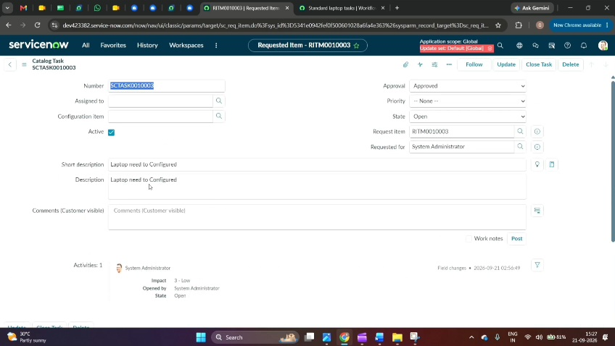
Final Output

The final output is an automated ServiceNow procurement workflow that creates and assigns a laptop configuration task after approval.

Benefits

1. Reduces manual intervention.
2. Reduces processing delays.
3. Provides consistent task assignment.
4. Improves IT procurement efficiency.
5. Helps reduce user waiting time.

