NEELIMA PATNAIK

SOUTHER NEW HAMSHIE UNIVERSITY

5-3 Major Activity: Analyzing Queries

10/5/2020

Write SQL commands that **capture specific, usable data** that can be used in your analysis.

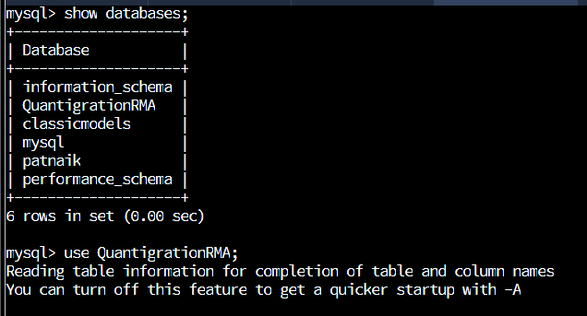

* **Analyze the results of queries** to identify specific information that can be presented in your summary.
  1. Sales by region:
     1. Analyze sales by state to determine where the company has the largest customer base.

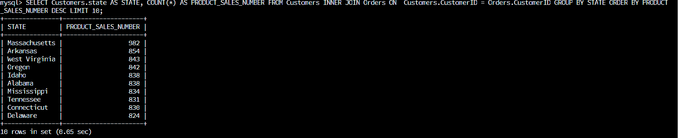

According to above results shows that there are 982 sales in Massachusetts which is highest sale as compare to other states.

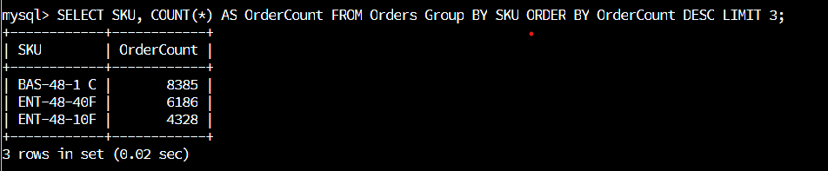

As per the above result there are three products sold and the description is listed below.

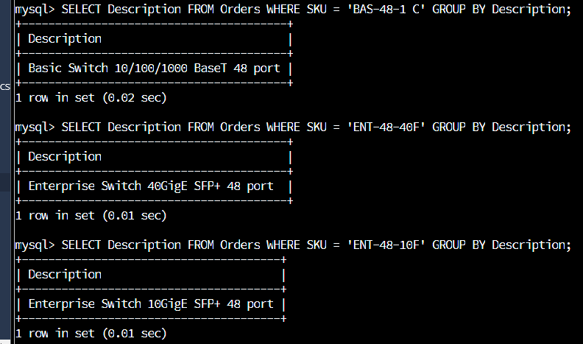

* + - * Southeastern states to include in your analysis: Virginia, North Carolina, South Carolina, and Georgia

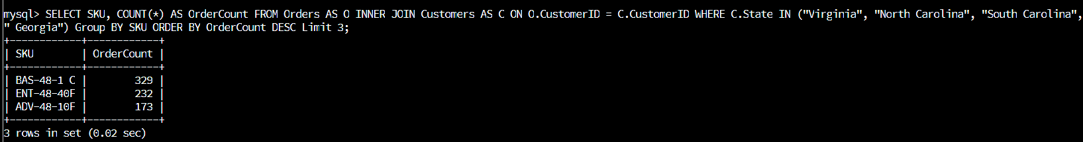

Above there are top three products sold in South eastern region of the United states are:

BAS-48-1C and the order count(units) are 329.

ENT-48-40F and the order count (units) are 232.

ADV-48-10F and the order count (units) are 173.

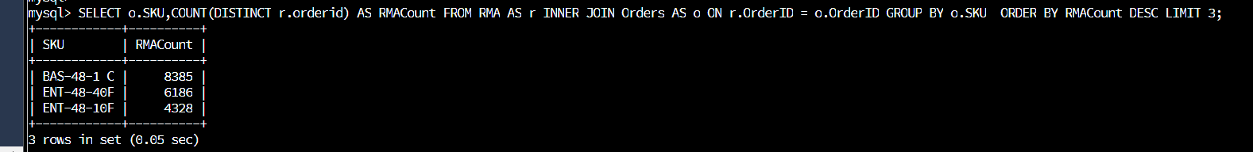

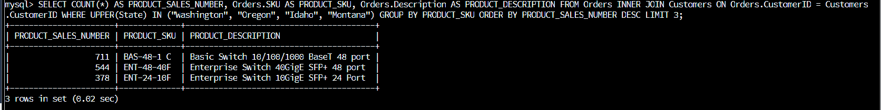

As per the result in the database, I found out that Massachusetts had the largest customers with 982. I found that the top three products sold in United states are as follows: ( Basic Switch 10/100/100 BaseT 48 port (BAS-48-1 C) with order count 8385, Enterprise Switch 40GigE SFP+48port (ENT-48-40F) with the order count 6186 and Enterprise Switch 10GigE SFP+ 24Port (ENT-48-10F) order count is 4328.

As per the last screen shot, in the Northwest region of the United States which includes Washington, Oregon, Idaho, and Montana, the top three products sold were Basic Switch 10/100/1000 BaseT 48 port' with 711 number of sales, Enterprise Switch 40GigE SFP+ 48 port with 544 number of sales and Basic Switch 10/100/1000 BaseT 8 port with 378 number of sales

The most return product as per the database is 10/100/100 BaseT 48 port (BAS-48-1 C) which is 8385 units.

The second most returned is Enterprise Switch 40GigE SFP+48port (ENT-48-40F) which 6186.

The third most returned product is Enterprise Switch 10GigE SFP+ 24Port (ENT-48-10F) which is 4328 units.

As per the above data base the sale rate is less than returned rate.