# DAD 220 Analysis and Summary

Neelima Patnaik

Replace the bracketed text in this template with your responses to the Module Five Activity for submission, grading, and feedback. Rename this document by adding your last name to the file name before you submit.

1. **Analyze the data** you’ve been provided with to **identify themes**:
   1. Which parts are being replaced most?

As per the records below, fuel Tank replaced most.

* + 1. 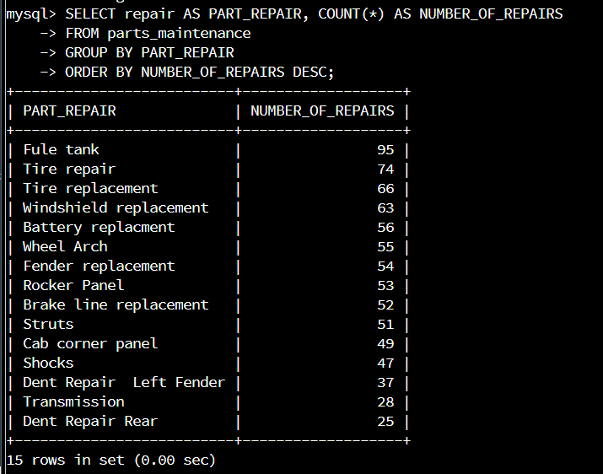
  1. Is there a region of the country that experiences more part failures and replacements than others?
     1. Identify region:
        1. 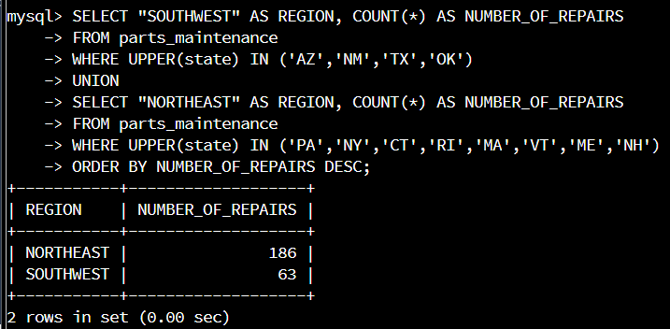

As per the above data it shows that North East has the greatest number of repairs.

* + 1. How might the fleet maintenance team use the information to update its maintenance schedule?
       1. This data will help the flee maintenance team has to figure to send the number of mechanics required to fix the issues to North East region.
  1. Which parts are being replaced most due to corrosion or rust?
     1. 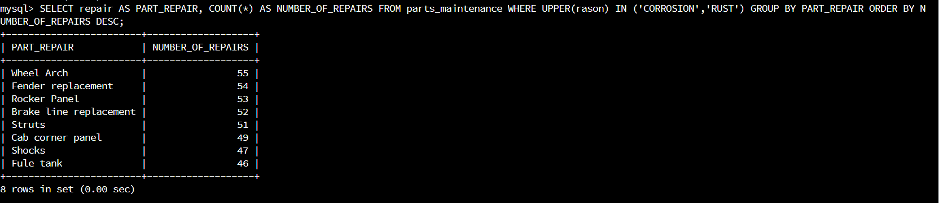

As per the data Wheel Arch is the most repaired part.

* 1. Which parts are being replaced most because of mechanical failure or accident, like a flat tire or rock through the windshield?
     1. Flat tires are being replace the most of mechanical failure or accident.

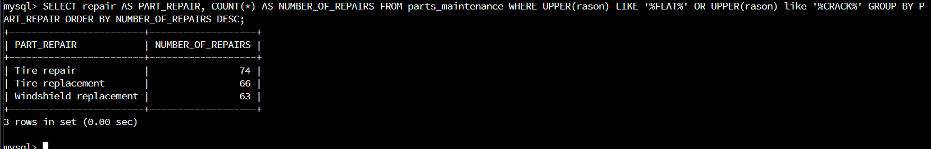

1. **Write a brief summary of your analysis** using nontechnical language**.**
   1. Northeast region has the greatest number of repairs as per the data. The parts most repaired or replaced is wheel arc and the flat tires being replaced the most of mechanical failure or accident.
2. **Outline the approach** that you took to conduct the analysis.
   1. What queries did you use to identify trends or themes in the data?

These are the commands that I used to identify trends or themes in the data.

USE patnaik;

CREATE TABLE parts_maintenance (

vechile_id VARCHAR(20),

state VARCHAR(2),

repair VARCHAR(50),

rason VARCHAR(50),

year INT,

make VARCHAR(200),

body_type VARCHAR(50)

);

LOAD DATA INFILE '/home/codio/workspace/FleetMaintenanceRecords.csv'

INTO TABLE parts_maintenance

FIELDS TERMINATED BY ','

ENCLOSED BY '"'

LINES TERMINATED BY '\n'

IGNORE 1 ROWS;

SELECT DISTINCT(repair) FROM parts_maintenance;

SELECT DISTINCT(reason) FROM parts_maintenance;

SELECT repair AS PART_REPAIR, COUNT(*) AS NUMBER_OF_REPAIRS

FROM parts_maintenance

GROUP BY PART_REPAIR

ORDER BY NUMBER_OF_REPAIRS DESC;

SELECT "SOUTHWEST" AS REGION, COUNT(*) AS NUMBER_OF_REPAIRS

FROM parts_maintenance

WHERE UPPER(state) IN ('AZ','NM','TX','OK')

UNION

SELECT "NORTHEAST" AS REGION, COUNT(*) AS NUMBER_OF_REPAIRS

FROM parts_maintenance

WHERE UPPER(state) IN ('PA','NY','CT','RI','MA','VT','ME','NH')

ORDER BY NUMBER_OF_REPAIRS DESC;

SELECT repair AS PART_REPAIR, COUNT(*) AS NUMBER_OF_REPAIRS

FROM parts_maintenance

WHERE UPPER(rason) IN ('CORROSION','RUST')

GROUP BY PART_REPAIR

ORDER BY NUMBER_OF_REPAIRS DESC;

SELECT repair AS PART_REPAIR, COUNT(*) AS NUMBER_OF_REPAIRS

FROM parts_maintenance

WHERE UPPER(rason) LIKE '%FLAT%' OR UPPER(rason) like '%CRACK%'

GROUP BY PART_REPAIR

ORDER BY NUMBER_OF_REPAIRS DESC;

* 1. What are the benefits of using these queries to retrieve the information in a way that allows you to provide valuable information to your stakeholders?
     1. These queries find and create table and information on information to count them automatically and also easy to read the information. In some cases, it is useful to find data to view and compare the other data.

1. Lastly, **identify how the functions in the analysis tool** allowed you to organize the data and retrieve records quickly so that they demonstrated what you wanted.
   1. It allows me to provide sort the data. Easy to read and count. It helpful to review and listing only certain attributes. It helpful to avoid unwanted data.