Software Engineering
Software Requirements Specification
(SRS) Document

For

Online Food Ordering System

Prepared By

NEELAM YADAV (BE COMP C -59)
PREETI VERMA (BE COMP C-70)

COMPUTER ENGINEERING
DEPARTMENT
Thakur College Of Engineering and Technology

Revisions

Version | Primary Author(s) | Description of Version | Date Completed
Final Draft | Team | All sections being Filled | 09-10-2022

Review & Approval
Requirements Document Approval History
Approving Party | Version Approved | Signature | Date
 | 1.0

Requirements Document Review History
Reviewer | Version Reviewed | Signature | Date
 | 1.0

Contents

1. Introduction 3
2. General Description 3
3. Functional Requirements 4
4. Interface Requirements 5
4.1 User Interfaces 5
4.2 Hardware Interfaces 5
5. Performance Requirements 5
6. Other non-functional attributes 6
6.1 Security 6
6.2 Binary Compatibility 6
6.3 Reliability 6
6.4 Portability 6
6.5 Reusability 6
6.6 Application Affinity/Compatibility 7
6.7 Serviceability 7
7. Operational Scenarios 7
8. Preliminary Use Case Models and Sequence Diagrams 8
8.1 Data Flow Diagram…………………………………………………………………… ...8
8.2 Use Case Diagram……………………………………………………………………….9
9. Updated Schedule 10
10. Updated Budget 10
11. Appendices 10
11.1 Definitions, Acronyms, Abbreviations 10

1. Introduction
  - Introduction
The purpose of this document is to define and describe the requirements of the project and to spell out the system’s functionality and its constraints.

  - Scope of this Document
This web application that provides an platform for ordering various food items. Also it consists of services such as food delivery , feedback system for customers feedback , Online payment system , Also User can search food items and compare its prices with other restaurant. Administrator has rights to cancel order, payment and add restaurant , update restaurant details , food items etc.

  - Product Scope
Scope of this project is very broad compared to manual system of food ordering
- You can sit at your place and order food from restaurant which is located far enough from your place.
- As it is an web application you can use it anywhere and order food online using this web application.
- It has information about various restaurant and food items with its price.
- This web application also has online payment, user can choose from various payment options.

2. General Description
2.1 Product Functions
The functions are divided according to the user types such as:-
- Administrator: It has rights such as adding restaurant details , updating food items list and its prices, cancel order, cancel payment, handling database.
- User/Customer : Order food through this web application

2.2 User Characteristics
The various users of this app are classified into two types:-
- Customer
- Restaurant Owners

This app requires the user to have characteristics such as the user should be able to read English and should have previous experience of using app. If not, the candidate will be instructed about the basic usage of the app.

2.3 User Problem Statement

If we consider manual food ordering at a particular restaurant, there is always a waiting period to get a seat for having food at restaurant. Also, it is a slow and time requiring process. So, there is a need of a system that can help user order food within a spare of time.

2.4 User Documentation
The product will include a user manual. The user manual will include product overview, complete configuration of the required software and hardware,technical details and contact information which will include email address.

2.6 General Constraints

Constraints include an easy to use interface for the program through forms, a Windows platform or, at bare minimum, a Mac with internet and web browser for Mac installed.

3. Functional Requirements
This section gives a functional requirement that applicable to the On-Line Examination system.There are Four sub modules in this phase.
3.1. User module.
- User should be able to login/Signup
- User Should be able to order food online through the website.
- User Should be able to do payment online.

3.2. Administrator module.
- Administrator should be able to manage and access the database
- Administrator should be able to update restaurant details and food items.
- Administrator should be able to cancel and update food orders
- Administrator should be able to manage payment transactions.
3.3. Payment Module
- Payment options should be available to the user
- Payment process should not take much longer.
- User should be able to see successful payment acknowledgement.

4. Interface Requirements
4.1 User Interfaces
- 4.1.1 GUI

Registration /Sign Up Screen:
Various fields available on this screen will be:-
- Login Name
- Email Id
- Password

Login Screen:
Various fields available on this screen will be:-

- Email Id/Name
- Password

Restaurants Name list Screen:
Various fields available on this screen will be:-

- Restaurant Name
- Closed/ open
- Address / Contact Number
- Rating

Search bar Screen:
Various fields available on this screen will be:-

- Search by restaurant name
- Search particular food item

Payment Screen:
Various fields available on this screen will be:-

- Name
- Mobile number
- Payment option

4.2 Hardware Interfaces
The program (Access) uses the hard disk. Access to the hard drive and other hardware is managed by the operating system and Access.

5. Performance Requirements
The database is designed to be operated through Microsoft SQL Server, thus no additional system requirements exist, except for a negligible amount of hard drive space to store the database.

500 MHz processor or higher
256MB RAM or higher
1.5GB Available Hard Drive Space
There is also Access Available for Mac OS X, the clients have not stated a need thus far.

6. Other non-functional attributes
.

6.1 Security

The system shall be designed with a level of security appropriate for the sensitivity of information enclosed in the database. More interaction is needed with client about the volatility of the information. Since there is no obvious information that is of a high security level such as credit card information, the only requirements that could be implemented are encrypting the database and/or making the database password-protected, by user’s request.

6.2 Binary Compatibility

This system will be compatible with any computer that has the internet, and will be designed with more than one computer in mind.

6.3 Reliability

Reliability is one of the key attributes of the system. Back-ups will be made regularly so that restoration with minimal data loss is possible in the event of unforeseen events. The system will also be thoroughly tested by all team members to ensure reliability.

6.4 Portability

The system shall be designed in a way that shall allow it to be run on multiple computers with websites.

6.5 Reusability

The system should be designed in a way that allows the database to be re-used regularly for the storing customers order details for future use.

6.6 Application Affinity/Compatibility

This system requires the internet with the web browser, as it operates primarily through as a web application .

6.7 Serviceability

The maintenance of the system should be able to be sufficiently performed by any person with a basic understanding of MERN Stack .

7. Operational Scenarios
Scenario A: Initial Item Definitions
The user shall enter the information about the items into the database for its initial construction and evolution. The fields will be completed via a form that will manipulate the data.

Scenario B: Customer Check-out
The user shall be able to enter information about the particular item they want to order , and their order information will be stored in a section called order history for future reference.

Scenario C: Database Maintenance
The administrator may want to alter/delete information after the food order is successful, In this case they will need to be able to remove the data that has been entered.

8. Preliminary Use Case Models and Sequence Diagrams
This section presents a list of the fundamental sequence diagrams and use cases that satisfy the system’s requirements. The purpose is to provide an alternative, "structural" view of the requirements stated above and how they might be satisfied in the system.
8.1 Data flow diagram

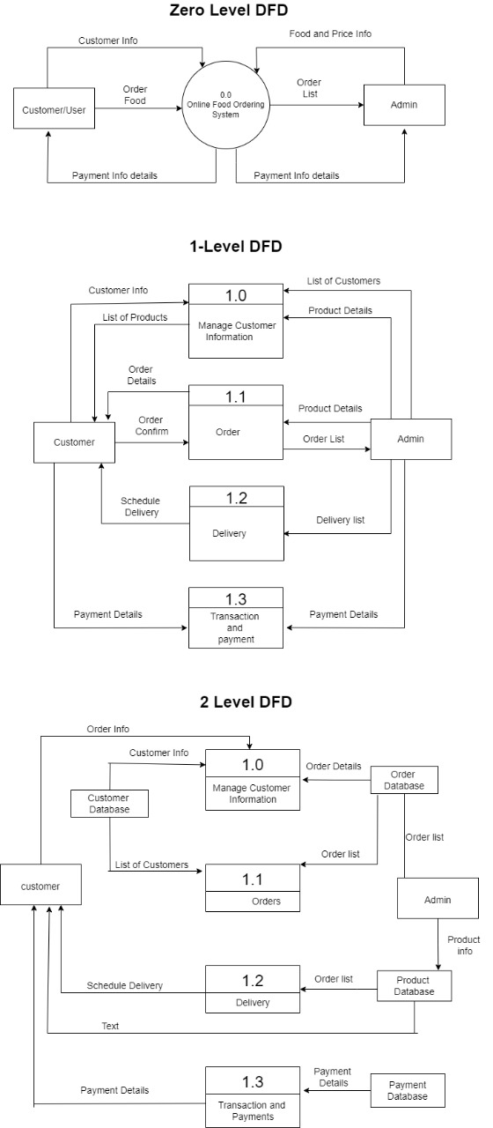
8.2 Use Case Diagram
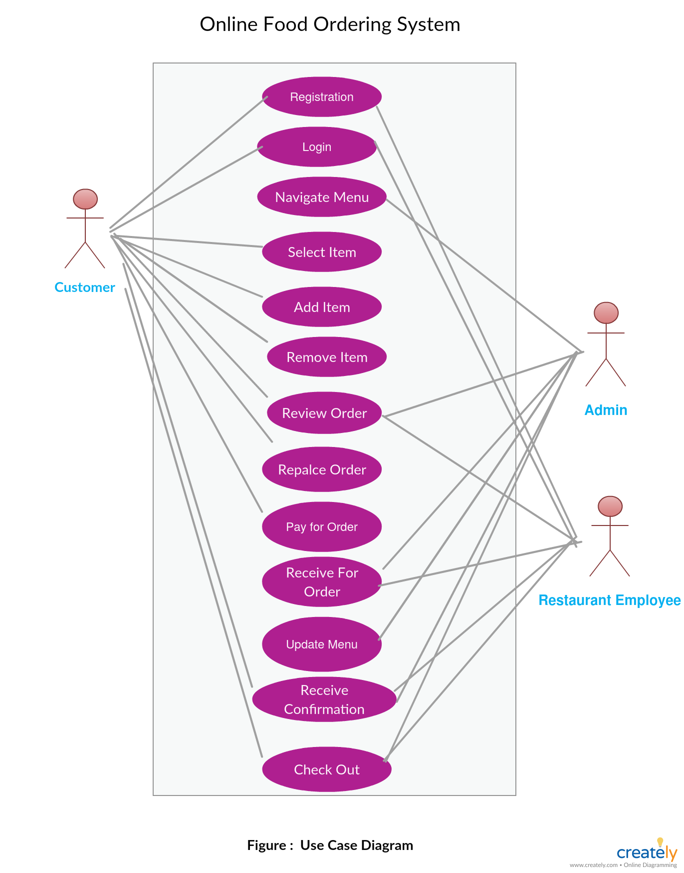

9. Updated Schedule
The updated PERT/GANTT chart is attached at the end of the document

10. Updated Budget
An updated budget is attached at the end of this document

11. Appendices
11.1 Definitions, Acronyms, Abbreviations
IDANRV- Intellectual Disabilities Agency of the New River Valley

