Predictive Pulse: Harnessing Machine Learning for Blood Pressure Analysis

Predictive Pulse is an AI-powered clinical decision-support system designed to analyze patient data and predict blood pressure stages using supervised machine learning. The solution integrates a Logistic Regression model with a Flask-based web application, enabling healthcare professionals to perform rapid hypertension risk assessment, visualize results, and receive guideline-based recommendations at the point of care

1. Project Overview
1.1 Clinical Motivation
Hypertension is one of the leading modifiable risk factors for cardiovascular morbidity and mortality worldwide. Early detection of hypertension stages (Normal, Stage-1, Stage-2, Hypertensive Crisis) is crucial for preventing stroke, myocardial infarction, and chronic kidney disease. Traditional blood pressure screening is often reactive rather than proactive, and clinical staff are frequently overloaded with interpreting multiple risk factors in limited time.
Predictive Pulse addresses this gap by providing:
- Automated, multi-factor risk stratification combining demographics, clinical history, symptoms, and lifestyle.
- Interpretable predictions mapped to standard blood pressure stages.
- Personalized recommendations aligned with guideline-based management.
1.2 Objectives
The primary objectives of this project are:
- To build and evaluate multiple supervised ML models that classify patients into:
  - Normal
  - Hypertension (Stage-1)
  - Hypertension (Stage-2)
  - Hypertensive Crisis
- To select a clinically suitable model based on accuracy, generalization, and interpretability.
- To deploy the selected model via a user-friendly Flask web application that:
  - Accepts patient inputs through an online form.
  - Encodes and scales features consistently with offline preprocessing.
  - Returns prediction, confidence, and tailored clinical recommendations.

2. Use-Case Scenarios
2.1 Scenario 1: Hypertensive Patient Monitoring
A patient with diagnosed hypertension visits a clinic equipped with the Predictive Pulse system. The clinician or nurse enters:
- Demographics (Gender, Age group)
- Family history
- Current medication status
- Symptom severity (e.g., shortness of breath, vision changes, nosebleeds)
- Time since diagnosis
- Blood pressure ranges (Systolic and Diastolic)
- Diet control status
The system instantly returns:
- Predicted stage (e.g., “Hypertension (Stage-2)”)
- Confidence score
- Risk color code (green/amber/orange/red)
- Listed clinical recommendations (e.g., “Daily BP monitoring”, “Urgent physician consultation”)
This supports clinicians in adjusting medication, scheduling follow-ups, and intensifying monitoring where required.
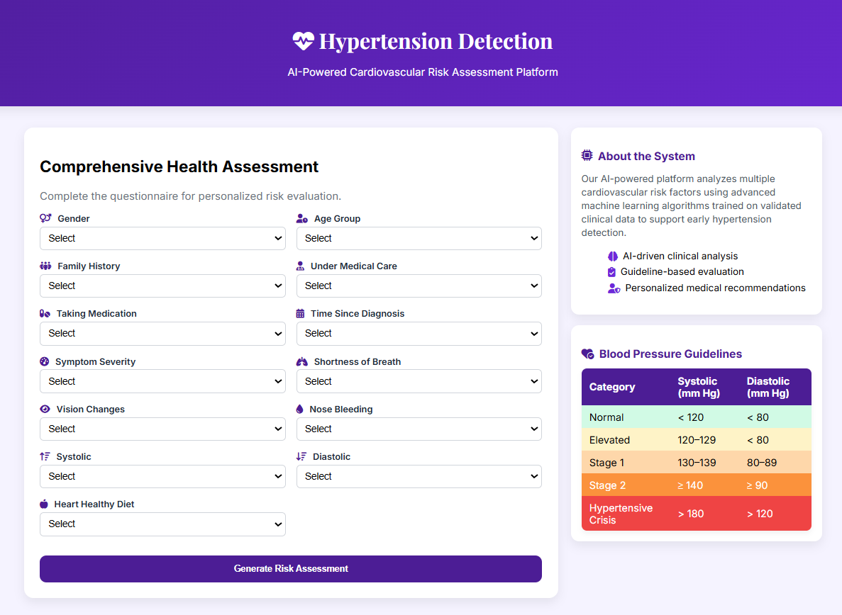

2.3 Scenario 3: Emergency Department Triage
In an emergency department:
- A triage nurse rapidly enters vital signs and key symptoms.
- The model identifies patients in Hypertensive Crisis with a red risk category.
- The interface highlights EMERGENCY with explicit actions such as “Seek immediate medical attention” and “Monitor for stroke/heart attack signs”.
This supports safe and rapid prioritization of patients requiring immediate intervention.
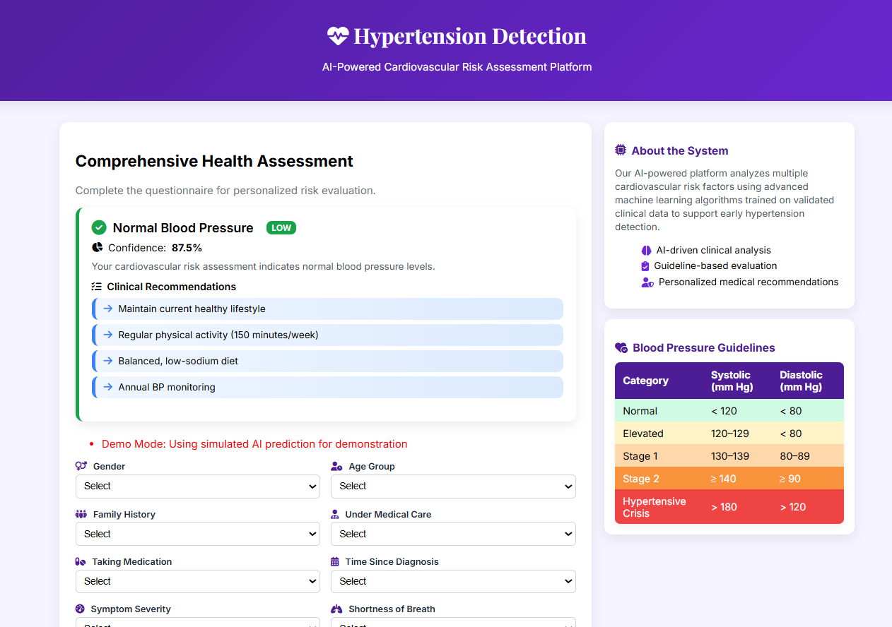

2.3 Scenario 3: Emergency Department Triage
In an emergency department:
- A triage nurse rapidly enters vital signs and key symptoms.
- The model identifies patients in Hypertensive Crisis with a red risk category.
- The interface highlights EMERGENCY with explicit actions such as “Seek immediate medical attention” and “Monitor for stroke/heart attack signs”.
This supports safe and rapid prioritization of patients requiring immediate intervention.

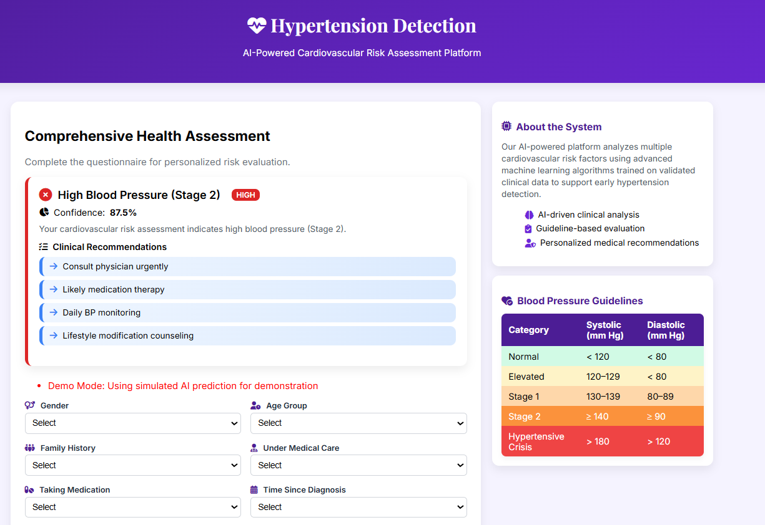

3. Dataset and Features
3.1 Dataset Description
The dataset consists of structured patient records with the following categories:
- Demographic Attributes
  - Gender (Male/Female)
  - Age Group (18–34, 35–50, 51–64, 65+)
- Clinical History & Status
  - Family history of hypertension (Yes/No)
  - Under medical care (Yes/No)
  - Taking antihypertensive medication (Yes/No)
  - Time since diagnosis (<1 Year, 1–5 Years, >5 Years)
- Symptom Features
  - Symptom severity (Mild, Moderate, Severe)
  - Shortness of breath (Yes/No)
  - Vision changes (Yes/No)
  - Nose bleeding (Yes/No)
- Blood Pressure Ranges
  - Systolic: 100–110, 111–120, 121–130, 130+
  - Diastolic: 70–80, 81–90, 91–100, 100+
- Lifestyle Indicator
  - Heart-healthy diet / controlled diet (Yes/No)
- Target Variable
  - Stages: NORMAL, HYPERTENSION (Stage-1), HYPERTENSION (Stage-2), HYPERTENSIVE CRISIS
Data is loaded from a CSV file:
- import numpy as np
- import pandas as pd
- data = pd.read_csv("patient_data.csv")
- print(data.head())

4. Data Preprocessing Workflow
4.1 Missing Values and Quality Checks
Initial missing value analysis shows no null values in the raw dataset:

- print(data.isnull().sum())

Subsequent mapping and cleaning steps may introduce NaNs (e.g., from unmapped categories), which are handled by dropping incomplete rows before model training:
- data_clean = data.dropna()
4.2 Data Cleaning and Standardization
Common issues (typos, inconsistent labels, spacing) are corrected:
- data.rename(columns={"C": "Gender"}, inplace=True)

- data['TakeMedication'] = data['TakeMedication'].replace({'Yes ': 'Yes'})
- data['Severity'] = data['Severity'].replace({'Sever': 'Severe'})
- data['NoseBleeding'] = data['NoseBleeding'].replace({'No ': 'No'})
- data['Systolic'] = data['Systolic'].replace({'121- 130': '121 - 130'})
- data['Stages'] = data['Stages'].replace({
- 'HYPERTENSION (Stage-2).': 'HYPERTENSION (Stage-2)'
- })
- data['Diastolic'] = data['Diastolic'].replace({'130+': '100+'})

Duplicate rows are identified and removed to avoid bias

- print("Duplicates:", data.duplicated().sum())
- data.drop_duplicates(inplace=True)

4.3 Categorical Encoding
4.3.1 Nominal Features
Nominal (unordered) features are mapped to 0/1:
- nominal_features = [
- 'Gender', 'History', 'Patient', 'TakeMedication',
- 'BreathShortness', 'VisualChanges', 'NoseBleeding', 'ControlledDiet'
- ]

- for col in nominal_features:
- if set(data[col].dropna().unique()) == {'Yes', 'No'}:
- data[col] = data[col].map({'No': 0, 'Yes': 1})
- elif col == 'Gender':
- data[col] = data[col].map({'Male': 0, 'Female': 1})
4.3.2 Ordinal Features
Ordinal (ordered) features preserve ranking:
- ordinal_features = [c for c in data.columns if c notin nominal_features]
- ordinal_features.remove('Stages')

- data['Age'] = data['Age'].map({
- '18-34': 1, '35-50': 2, '51-64': 3, '65+': 4
- })
- data['Severity'] = data['Severity'].replace({
- 'Mild': 0, 'Moderate': 1, 'Severe': 2
- })
- data['Whendiagnoused'] = data['Whendiagnoused'].map({
- '<1 Year': 1, '1 - 5 Years': 2, '>5 Years': 3
- })
- data['Systolic'] = data['Systolic'].map({
- '100 - 110': 0, '111 - 120': 1, '121 - 130': 2, '130+': 3
- })
- data['Diastolic'] = data['Diastolic'].map({
- '70 - 80': 0, '81 - 90': 1, '91 - 100': 2, '100+': 3
- })
- data['Stages'] = data['Stages'].map({
- 'NORMAL': 0,
- 'HYPERTENSION (Stage-1)': 1,
- 'HYPERTENSION (Stage-2)': 2,
- 'HYPERTENSIVE CRISIS': 3
- })

4.4 Feature Scaling
Min-Max scaling is applied to ordinal variables to normalize value ranges:
- from sklearn.preprocessing import MinMaxScaler

- scaler = MinMaxScaler()
- data[ordinal_features] = scaler.fit_transform(data[ordinal_features])

5. Exploratory Data Analysis (EDA)
5.1 Descriptive Statistics
- data.describe()
The statistics confirm that:
- Features are correctly normalized between 0 and 1.
- There is healthy variance across predictors.

5.2 Visualizations
5.2.1 Gender Distribution
- import matplotlib.pyplot as plt
- import seaborn as sns

- plt.figure(figsize=(8, 4))
- ax = sns.countplot(data=data, x="Gender", palette="Set2")
- ax.set_xticks([0, 1])
- ax.set_xticklabels(['Male', 'Female'])
- plt.title("Gender Distribution")
- plt.xlabel("Gender")
- plt.show()
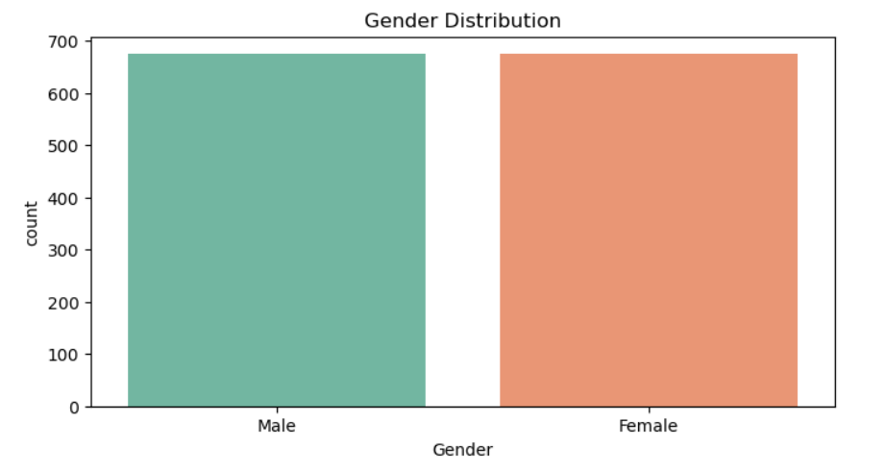
A corresponding pie chart can further illustrate balance:
- gender_counts = data['Gender'].value_counts()
- plt.figure(figsize=(5, 5))
- plt.pie(
- gender_counts,
- labels=['Male', 'Female'],
- autopct='%1.1f%%',
- colors=['#66b3ff', '#99ff99'],
- startangle=90
- )
- plt.title("Gender Distribution (Pie Chart)")
- plt.axis('equal')
- plt.show()
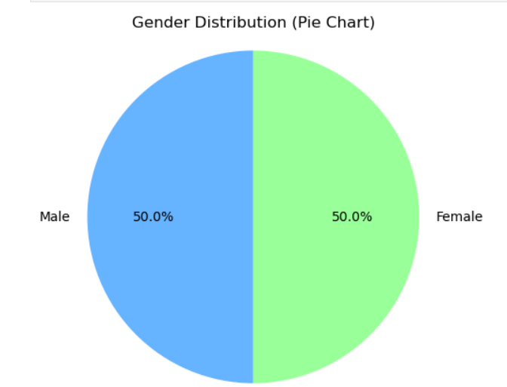
5.2.2 Hypertension Stage Distribution
- plt.figure(figsize=(8, 4))
- ax = sns.countplot(data=data, x="Stages", palette="coolwarm")
- ax.set_xticks([0, 1, 2, 3])
- ax.set_xticklabels([
- 'Normal',
- 'Hypertension (Stage 1)',
- 'Hypertension (Stage 2)',
- 'Hypertensive Crisis'
- ], rotation=30)
- plt.title("Hypertension Stages Distribution")
- plt.xlabel("Hypertension Stage")
- plt.ylabel("Count")
- plt.show()
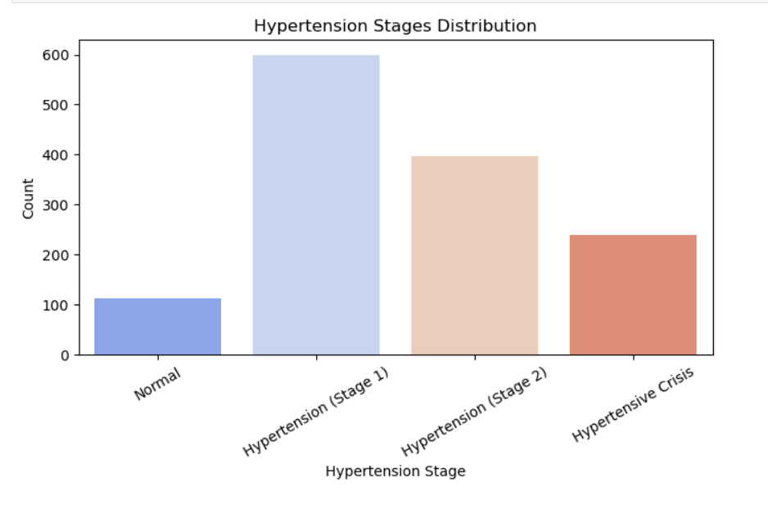
5.2.3 Systolic–Diastolic Correlation
To compute numeric midpoints for BP ranges:

- def range_to_midpoint(val):
- if isinstance(val, str):
- if "-" in val:
- start, end = val.split("-")
- return (float(start.strip()) + float(end.strip())) / 2
- elif "+" in val:
- return float(val.replace("+", "").strip())
- else:
- try:
- return float(val.strip())
- except:
- return np.nan
- elif isinstance(val, (int, float)):
- return val
- else:
- return np.nan

- data['Systolic_num'] = data['Systolic'].apply(range_to_midpoint)
- data['Diastolic_num'] = data['Diastolic'].apply(range_to_midpoint)

- plt.figure(figsize=(6, 4))
- sns.heatmap(
- data[['Systolic_num', 'Diastolic_num']].corr(),
- annot=True,
- cmap="Blues"
- )
- plt.title("Correlation between Systolic & Diastolic")
- plt.show()

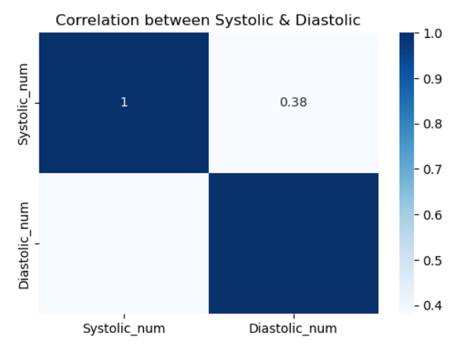

5.2.4 Pairplot Across Stages
- g = sns.pairplot(
- data[['Systolic_num', 'Diastolic_num', 'Stages']],
- hue='Stages',
- diag_kind='kde',
- palette="husl",
- height=3
- )

- legend_labels = [
- 'Normal',
- 'Hypertension (Stage 1)',
- 'Hypertension (Stage 2)',
- 'Hypertensive Crisis'
- ]

- for text, label in zip(g._legend.texts, legend_labels):
- text.set_text(label)

- g._legend.set_bbox_to_anchor((1.10, 0.7))
- g._legend.set_title("Stages")
- plt.subplots_adjust(top=0.9, right=0.8)
- g.fig.suptitle(
- "Pairplot: Systolic vs Diastolic across Hypertension Stages",
- y=0.95,
- fontsize=14
- )
- plt.show()
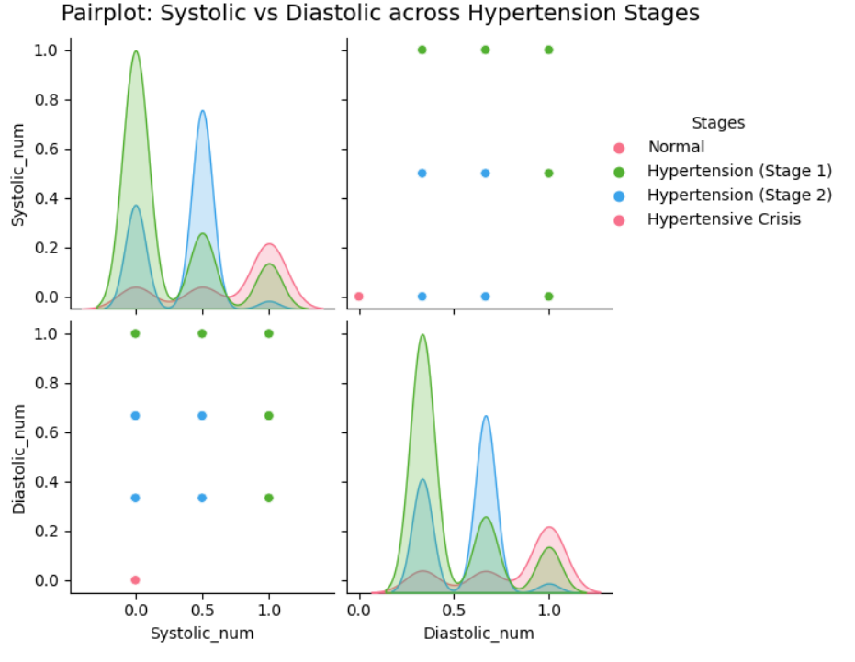
6. Model Development
6.1 Train–Test Split
- from sklearn.model_selection import train_test_split

- data_clean = data.dropna()
- X = data_clean.drop('Stages', axis=1)
- y = data_clean['Stages']

- X_train, X_test, y_train, y_test = train_test_split(
- X, y, test_size=0.2, random_state=42
- )

6.2 Models Trained
The following models were trained and compared:
- Logistic Regression
- Decision Tree
- Random Forest
- Support Vector Machine (SVM)
- K-Nearest Neighbors (KNN)
- Ridge Classifier
- Naive Bayes (GaussianNB)
Example code for training and evaluation:
- from sklearn.linear_model import LogisticRegression, RidgeClassifier
- from sklearn.tree import DecisionTreeClassifier
- from sklearn.ensemble import RandomForestClassifier
- from sklearn.svm import SVC
- from sklearn.neighbors import KNeighborsClassifier
- from sklearn.naive_bayes import GaussianNB
- from sklearn.metrics import accuracy_score, classification_report, confusion_matrix

- accuracy = {}

- # Logistic Regression
- logreg = LogisticRegression()
- logreg.fit(X_train, y_train)
- y_pred = logreg.predict(X_test)

- print("Logistic Regression:")
- print("Accuracy:", accuracy_score(y_test, y_pred))
- print("Classification Report:\n", classification_report(y_test, y_pred))
- print("Confusion Matrix:\n", confusion_matrix(y_test, y_pred))

- accuracy['Logistic Regression'] = accuracy_score(y_test, y_pred)
Similar code blocks are executed for DecisionTree, RandomForest, SVM, KNN, RidgeClassifier, and GaussianNB.
6.3 Model Performance Summary
Observed Accuracies (on test set):
Algorithm | Approx. Accuracy | Assessment | Selection
Decision Tree | 100% | Overfitting risk | ❌
Random Forest | 100% | Overfitting risk | ❌
SVM | ≈ 99.3% | Excellent | ⚠ Considered
KNN | ≈ 99.6% | Excellent | ⚠ Considered
Logistic Regression | ≈ 95.5% | Excellent, Stable | ✅ Selected
Ridge Classifier | ≈ 91.8% | Good | ⚠ Considered
Naive Bayes | ≈ 86.2% | Moderate | ⚠ Considered
Reason for Selecting Logistic Regression:
- High accuracy (~95.5%) with good generalization.
- Interpretable coefficients, aligning with clinical reasoning.
- Less prone to overfitting compared to tree-based methods that achieved “too perfect” performance.
- More suitable for real-world deployment in healthcare decision support, where interpretability and stability often outweigh marginal accuracy gains.

7. Model Serialization
The selected Logistic Regression model is saved using joblib:
- import joblib

- joblib.dump(logreg, r"HYPERTENSION PREDICTION\model\logreg.pkl")
- print("Model saved as logreg.pkl")
The serialized model is later loaded by the Flask application to serve predictions in real time.
8. Flask Web Application
8.1 Backend (app.py)
Below is a cleaned and ready-to-use version of your Flask backend (adjust secret_key and paths as needed):
python
- from flask import Flask, render_template, request, flash
- import joblib
- import numpy as np
- import random
- import os

- app = Flask(__name__)
- app.secret_key = 'your-secret-key-change-in-production'

- # Load trained model with error handling
- try:
- model = joblib.load("logreg.pkl")
- except FileNotFoundError:
- print("Warning: Model file not found. Using dummy predictions.")
- model = None

- # Mapping numeric prediction to stage
- stage_map = {
- 0: 'NORMAL',
- 1: 'HYPERTENSION (Stage-1)',
- 2: 'HYPERTENSION (Stage-2)',
- 3: 'HYPERTENSIVE CRISIS'
- }

- # Medical-grade color mapping
- color_map = {
- 0: '#108981', # Normal green
- 1: '#F59E0B', # Stage 1 amber
- 2: '#F97316', # Stage 2 orange
- 3: '#EF4444' # Crisis red
- }

- # Recommendations
- recommendations = {
- 0: {
- 'title': 'Normal Blood Pressure',
- 'description': 'Your cardiovascular risk is within normal range.',
- 'actions': [
- 'Maintain current healthy lifestyle',
- 'Regular physical activity (≥150 minutes/week)',
- 'Balanced, low-sodium diet',
- 'Annual blood pressure monitoring'
- ],
- 'priority': 'Low Risk'
- },
- 1: {
- 'title': 'Stage 1 Hypertension',
- 'description': 'Mild elevation detected requiring lifestyle modifications.',
- 'actions': [
- 'Consult healthcare provider',
- 'Adopt DASH diet plan',
- 'Increase physical activity',
- 'Monitor blood pressure bi-weekly'
- ],
- 'priority': 'Moderate Risk'
- },
- 2: {
- 'title': 'Stage 2 Hypertension',
- 'description': 'Significant hypertension requiring medical intervention.',
- 'actions': [
- 'Consult physician urgently',
- 'Likely initiation of medication therapy',
- 'Daily blood pressure monitoring',
- 'Lifestyle modification counseling'
- ],
- 'priority': 'High Risk'
- },
- 3: {
- 'title': 'Hypertensive Crisis',
- 'description': 'CRITICAL: Requires emergency medical care.',
- 'actions': [
- 'Seek immediate emergency medical attention',
- 'Call emergency services if symptomatic',
- 'Monitor for stroke/heart attack signs',
- 'Prepare current medication list for clinicians'
- ],
- 'priority': 'EMERGENCY'
- }
- }

- @app.route('/')
- def home():
- return render_template('index.html')

- @app.route('/predict', methods=['POST'])
- def predict():
- try:
- required_fields = [
- 'Gender', 'Age', 'History', 'Patient', 'TakeMedication',
- 'Severity', 'BreathShortness', 'VisualChanges', 'NoseBleeding',
- 'Whendiagnosed', 'Systolic', 'Diastolic', 'ControlledDiet'
- ]

- form_data = {}
- for field in required_fields:
- value = request.form.get(field)
- ifnot value:
- flash(f"Please complete all required fields: {field.replace('_', ' ')}", "error")
- return render_template('index.html')
- form_data[field] = value

- # Encoding consistent with training
- try:
- encoded = [
- 0 if form_data['Gender'] == 'Male' else 1,
- {'18-34': 1, '35-50': 2, '51-64': 3, '65+': 4}[form_data['Age']],
- 1 if form_data['History'] == 'Yes' else 0,
- 1 if form_data['Patient'] == 'Yes' else 0,
- 1 if form_data['TakeMedication'] == 'Yes' else 0,
- {'Mild': 0, 'Moderate': 1, 'Severe': 2}[form_data['Severity']],
- 1 if form_data['BreathShortness'] == 'Yes' else 0,
- 1 if form_data['VisualChanges'] == 'Yes' else 0,
- 1 if form_data['NoseBleeding'] == 'Yes' else 0,
- {'<1 Year': 1, '1-5 Years': 2, '>5 Years': 3}[form_data['Whendiagnosed']],
- {'100-110': 0, '111-120': 1, '121-130': 2, '130+': 3}[form_data['Systolic']],
- {'70-80': 0, '81-90': 1, '91-100': 2, '100+': 3}[form_data['Diastolic']],
- 1 if form_data['ControlledDiet'] == 'Yes' else 0
- ]
- except KeyError as e:
- flash(f"Invalid selection detected: {str(e)}", "error")
- return render_template('index.html', form_data=form_data)

- # Manual scaling (mirroring training preprocessing)
- scaled_encoded = encoded.copy()
- scaled_encoded[1] = (encoded[1] - 1) / 3 # Age
- scaled_encoded[5] = encoded[5] / 2 # Severity
- scaled_encoded[9] = (encoded[9] - 1) / 2 # When diagnosed
- scaled_encoded[10] = encoded[10] / 3 # Systolic
- scaled_encoded[11] = encoded[11] / 3 # Diastolic

- input_array = np.array(scaled_encoded).reshape(1, -1)

- # Prediction
- if model isnot None:
- prediction = int(model.predict(input_array)[0])
- try:
- confidence = float(max(model.predict_proba(input_array)[0]) * 100)
- except Exception:
- confidence = 85.0
- else:
- prediction = random.randint(0, 3)
- confidence = 87.5
- flash("Demo Mode: Using simulated AI prediction for demonstration.", "info")

- result_text = stage_map[prediction]
- result_color = color_map[prediction]
- result_recommendation = recommendations[prediction]

- # Map to risk class for UI badges
- if prediction == 0:
- risk_class = 'low-risk'
- elif prediction == 1:
- risk_class = 'moderate-risk'
- elif prediction == 2:
- risk_class = 'high-risk'
- else:
- risk_class = 'crisis-risk'

- return render_template(
- 'index.html',
- prediction_text=result_text,
- result_color=result_color,
- confidence=confidence,
- recommendation=result_recommendation,
- risk_class=risk_class,
- form_data=form_data
- )

- except Exception as e:
- print("Error:", e)
- flash("System error occurred. Please try again or contact technical support.", "error")
- return render_template('index.html')

- if __name__ == "__main__":
- app.run(debug=True, host='0.0.0.0', port=5000)

8.2 Frontend Template (templates/index.html)
Below is an structure of the HTML template .
- <!DOCTYPE html>
- <html lang="en">
- <head>
- <meta charset="UTF-8">
- <title>Hypertension Detection – Predictive Pulse</title>
- <link rel="stylesheet" href="{{ url_for('static', filename='styles.css') }}">
- </head>
- <body>
- <header>
- <h1>Hypertension Detection</h1>
- <p>AI-Powered Cardiovascular Risk Assessment Platform</p>
- </header>

- <!-- Flash Messages -->
- {% with messages = get_flashed_messages(with_categories=true) %}
- {% if messages %}
- <div class="alerts">
- {% for category, message in messages %}
- <div class="alert {{ category }}">{{ message }}</div>
- {% endfor %}
- </div>
- {% endif %}
- {% endwith %}

- <!-- Prediction Card -->
- {% if prediction_text %}
- <section class="result-card" style="border-left: 6px solid {{ result_color }};">
- <h2>Risk Assessment Result</h2>
- <p class="stage">{{ prediction_text }}</p>
- <p class="confidence">Confidence: {{ confidence|round(2) }}%</p>
- <p class="description">{{ recommendation.description }}</p>

- <h3>Clinical Recommendations</h3>
- <ul>
- {% for action in recommendation.actions %}
- <li>{{ action }}</li>
- {% endfor %}
- </ul>

- <span class="priority-badge">{{ recommendation.priority }}</span>
- </section>
- {% endif %}

- <!-- Input Form -->
- <section class="form-section">
- <h2>Comprehensive Health Assessment</h2>
- <p>Complete the questionnaire for personalized risk evaluation.</p>

- <form action="{{ url_for('predict') }}" method="post">
- <!-- Gender -->
- <label>Gender</label>
- <select name="Gender" required>
- <option value="">Select</option>
- <option value="Male" {% if form_data and form_data.Gender == 'Male' %}selected{% endif %}>Male</option>
- <option value="Female" {% if form_data and form_data.Gender == 'Female' %}selected{% endif %}>Female</option>
- </select>

- <!-- Age Group -->
- <label>Age Group</label>
- <select name="Age" required>
- <option value="">Select</option>
- <option value="18-34">18-34</option>
- <option value="35-50">35-50</option>
- <option value="51-64">51-64</option>
- <option value="65+">65+</option>
- </select>

- <!-- Repeat similar blocks for History, Patient, TakeMedication, Whendiagnosed,
- Severity, BreathShortness, VisualChanges, NoseBleeding, Systolic, Diastolic,
- ControlledDiet -->

- <button type="submit">Generate Risk Assessment</button>
- </form>
- </section>

- <section class="guidelines">
- <h2>Blood Pressure Guidelines</h2>
- <table>
- <thead>
- <tr>
- <th>Category</th>
- <th>Systolic (mm Hg)</th>
- <th>Diastolic (mm Hg)</th>
- </tr>
- </thead>
- <tbody>
- <tr><td>Normal</td><td>< 120</td><td>< 80</td></tr>
- <tr><td>Elevated</td><td>120–129</td><td>< 80</td></tr>
- <tr><td>Stage 1</td><td>130–139</td><td>80–89</td></tr>
- <tr><td>Stage 2</td><td>≥ 140</td><td>≥ 90</td></tr>
- <tr><td>Hypertensive Crisis</td><td>> 180</td><td>> 120</td></tr>
- </tbody>
- </table>
- </section>
- </body>
- </html>
You can refine the CSS to match a clinical dashboard look.

9. Conclusion and Future Scope
The Predictive Pulse system demonstrates that:
- Machine learning models can effectively classify patients into clinically relevant blood pressure stages with high accuracy.
- Logistic Regression provides a practical compromise between predictive performance and interpretability, which is critical in healthcare.
- The Flask web application enables seamless integration into clinical workflows, providing real-time assessment and recommendations.
Future Enhancements:
- Integration with real-time BP sensors and IoT devices.
- Development of mobile health (mHealth) apps for patient self-monitoring.
- Use of deep learning for temporal BP trajectories and risk forecasting.
- Validation and calibration using real hospital datasets and prospective clinical studies.

