Lab 11

1. Consider the following code fragments. For each, if there is a compiler error, identify where it occurs.  
     
   a. First fragment:  
    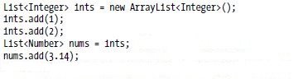  
    b. Second fragment:

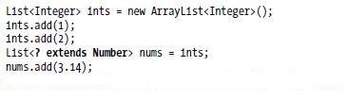

1. Draw a class diagram showing the inheritance relationships among the following types:  
     
   List<Integer>, List<Number>, List<? extends Integer>,   
   List<? extends Number>, List<? super Integer>, List<? super Number>, List<?>, List<Object>  
     
   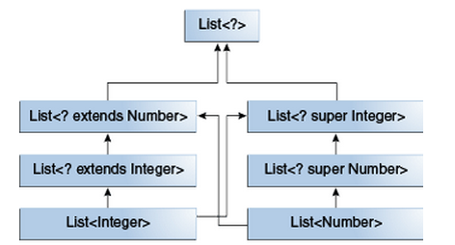

**List<Object>**

1. Recall the definition of sum given in the slides:  
    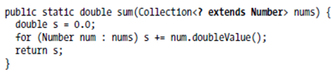
   1. Is there a compiler error in the following lines of code? If so, where?  
       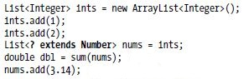
   2. Is there a compiler error in the following lines of code? If so, where?  
       