1. When to use (Rapid Application Development) RAD model? When not to use (Rapid Application Development) RAD model?
The RAD model is based on prototyping and iterative development with very less planning involved. It can be used;
- When there is a need to create a system that can be modularized in 2-3 months of time.
- It should be used if there’s high availability of designers for modeling and the budget is high enough to afford their cost along with the cost of automated code generating tools.
- RAD SDLC model should be chosen only if resources with high business knowledge are available and there is a need to produce the system in a short span of time (2-3 months).
When not to use RAD model
- RAD model cannot be used if the total budget for the project is low. Since the cost for modelling, automatic code generation etc is higher.
- RAD model can be used only if there is a strong technical team.
- RAD cannot be used for large or highly complex projects.

2. Define an ER diagram of a software Organization with all the relationship model that was discussed in the classroom

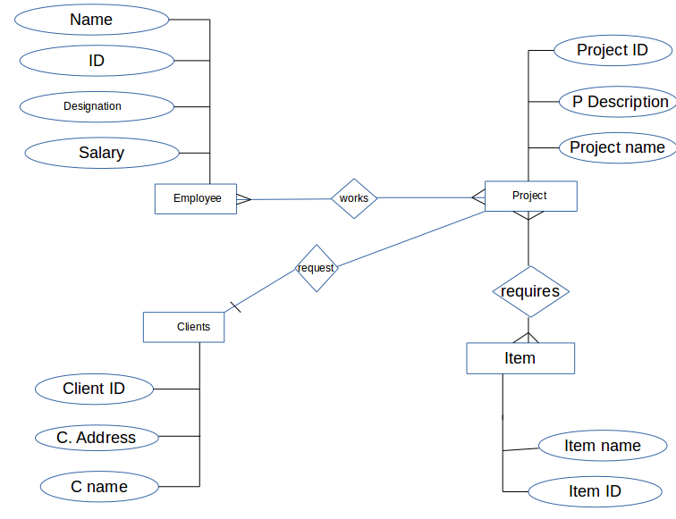

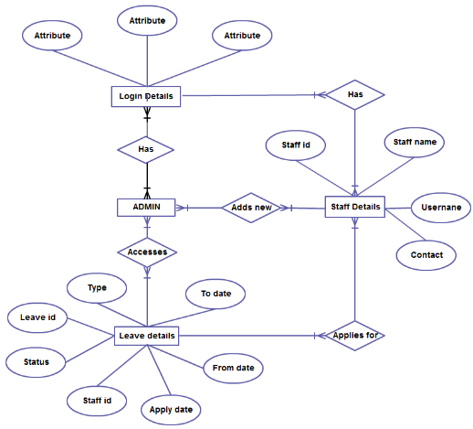
3. Describe the Entity Relationships for the following diagram.

Login Details, Leave details, Admin , Staff details are the entities.
Staff
- Staff id is the primary key.
- Many staff has differnt login that is many to many relation.
- Many staff applies for many leaves that is many to many relation.
- Staff details has staff name,user name,contacts,staff id.
Admin
- Admins can add new staffs. Many to many relation.
- Leave deatils can be accessed by Admin and is many to many relation.
- Admin has relationship with Login deatils.

Leave details: Leave deatils has the following attributes type,leave id,status,staff id,apply date,from date,to date.
- Leave ID is the primary key here
- The foreign key staff id used in this entity.

