Steps Followed to Create and Deploy the EXOSUITES Website
Requirements:
Install git
Install vs code
Create account in the git hub.
Step 1: Create Project Folder
A new folder named Research Website was created on the local computer to store all website files and resources.
Example:
Research Website
This folder serves as the main project directory.

Step 2: Open the Project in Visual Studio Code
Visual Studio Code (VS Code) was used as the development environment.
Procedure:
- Open VS Code.
- Click File → Open Folder.
- Select the Research Website folder.
- The folder is loaded into the VS Code Explorer panel.

Step 3: Create Website Files
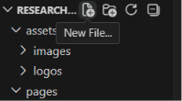
The following files were created inside the project folder:
Research Website
│
├── index.html
├── style.css
├── script.js

Purpose of Each File
- index.html → Main webpage structure.
- style.css → Website design and styling.
- script.js → Interactive functionality such as theme switching and dropdown menus.

Step 4: Create Additional Pages

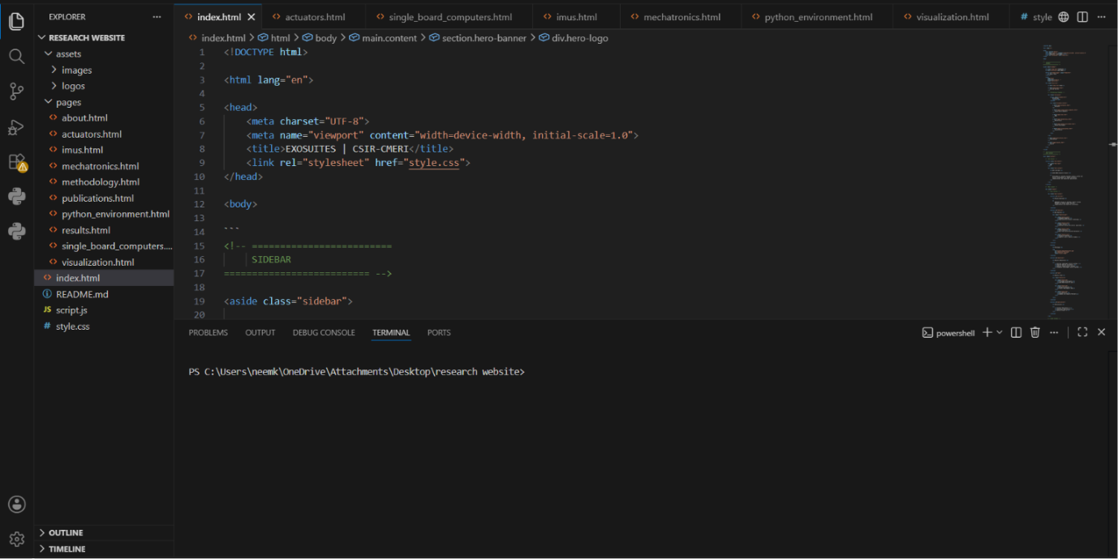
A folder named pages was created.
pages
The following files were added:
pages
│
├── about.html
├── actuators.html
├── single_board_computers.html
├── imus.html
├── mechatronics.html
├── python_environment.html
├── visualization.html
├── publications.html
└── results.html
THESE ARE IN THE FOLDER YOU CAN USE IT.
If YOU WANT TO SEE THE HTML CODE OF PARTICULAR PART, THEN FOLLOW THESE STEPS:
- Click on the html file you want
- Right click on it and selection the option
- Open in vs code, then it confirms to open in vs code
- Then confirm then you can see the HTML code.
- Follow the same for all html files.
- For script and style codes, you can just double tap on the file it gives you code.
These pages contain the detailed project documentation.
Step 5: Create Asset Folders
An assets directory was created to store images and other resources.
assets
│
└── images
Project photographs, logos, and prototype images were stored inside this folder.
Example:
assets/images/Exosuites.jpg
Step 6: Develop the Website Structure
HTML was used to create:
- Sidebar navigation
- Hero section
- Project overview
- Features section
- Objectives section
- Team section
- Publications section
- Results section
The website structure was designed to provide easy navigation between all documentation pages.

Step 7: Design the Website Using CSS
CSS was used to implement:
- Dark theme interface
- Light theme interface
- Responsive design
- Navigation menus
- Cards and sections
- Image display
- Documentation layout
The design was inspired by professional technical documentation websites.
Step 8: Add JavaScript Functionality
JavaScript was used to implement:
Theme Toggle
Allows switching between:
- Dark Mode
- Light Mode
Dropdown Navigation
Methodology menu expands to display:
- Actuators
- Single Board Computers
- IMUs
- Mechatronics
- Python Environment
- Visualization

Step 9: Test Website Locally
The website was tested using the VS Code Live Server extension.
Procedure:
- Install Live Server Extension.
- Open index.html.
- Click Go Live.
The website opens in the browser.
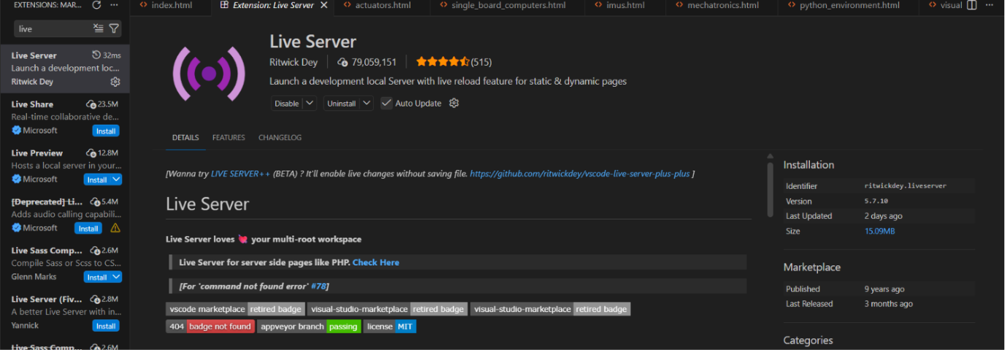
Example:
http://127.0.0.1:5500/index.html
This allows testing before deployment.

Step 10: Initialize Git Repository
Install git from chrome before running these commands.
Important option while installing is to adjust the third-party web.
Open VS Code Terminal and run:
git config --global user.name “[firstname lastname]”
Set a name that is identifiable for credit when review version history
git config --global user. Email “[valid email]”
Set an email address that will be associated with each history marker
git init
This creates a local Git repository for version control
Step 11: Add Project Files
git add .
This stages all website files for tracking.

Step 12: Create Initial Commit
git commit -m "Initial EXOSUITES website"
This saves the first version of the project.
Step 13: Create GitHub Repository
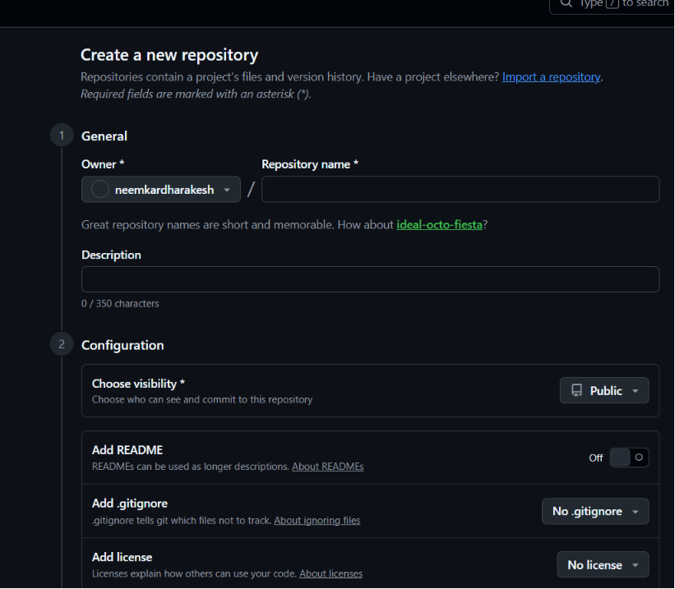
A GitHub repository named:
final demo
was created.
Repository URL:
You can find the repository URL in the code section.
https://github.com/neemkardharakesh/finaldemo

Step 14: Connect Local Repository to GitHub
git remote add origin https://github.com/neemkardharakesh/finaldemo.git
This links the local project to GitHub.

Step 15: Push Website to GitHub
Here few may be in master branch also not on main branch so we find error
If you find error while running push command then follow this:
First run git branch you will find only master branch then run these commands:
git push -u origin main - - force
git push -u origin main
git push -u origin main
The project files are uploaded to GitHub.

Step 16: Enable GitHub Pages
Procedure:
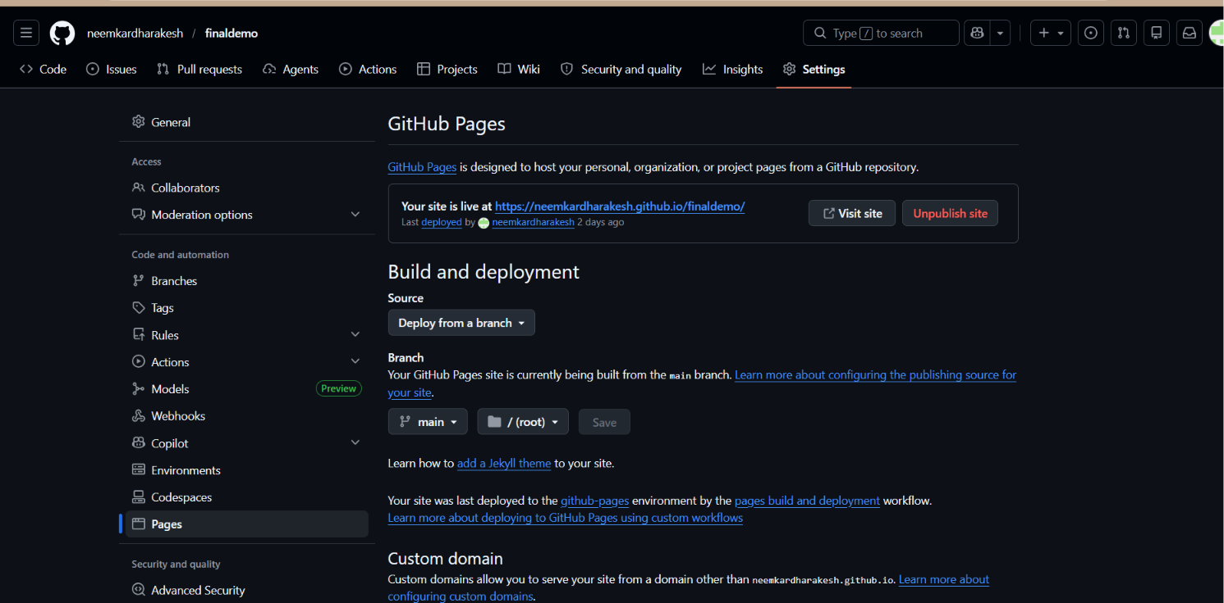
- Open Repository Settings.
- Click Pages.
- Select:
  - Source → Deploy from a Branch
  - Branch → main
  - Folder → /(root)
- Save.
GitHub automatically builds the website.

Step 17: Access the Hosted Website
The website becomes available online through GitHub Pages.
Website URL:
https://neemkardharakesh.github.io/finaldemo/

Step 18: Updating the Website
Whenever changes are made:
Save it
git add.
git commit -m "Updated website"
git pull origin main (use if any files are pushed before)
git push origin main
GitHub Pages automatically updates the hosted website within a few minutes.

Adding Images to the Website
To add images, first create a folder named assets inside the project folder. Inside assets, create another folder named images.
Research Website
│
├── index.html
├── style.css
├── script.js
│
└── assets
└── images
Place all required images inside the images folder.
Example:
assets/images/Exosuites.jpg
To display the image in index.html, use:
<img src="assets/images/Exosuites.jpg" alt="EXOSUITES Prototype">
If the HTML file is inside the pages folder, use:
<img src="../assets/images/Exosuites.jpg" alt="EXOSUITES Prototype">
The .. means “go back one folder.”
Example:
pages/about.html
needs:
<img src="../assets/images/Exosuites.jpg">
but:
index.html
needs:
<img src="assets/images/Exosuites.jpg">
To control image size using CSS:
. project-image {
width:100%;
max-width:800px;
border-radius:12px;
margin-top:20px;
}

Then in HTML:
<img src="assets/images/Exosuites.jpg"
alt="EXOSUITES Prototype"
class="project-image">
Outcome
A complete documentation-style website for the EXOSUITES (Soft Exo Walk) project was successfully developed using HTML, CSS, and JavaScript, version controlled using Git and deployed online using GitHub Pages.

Commands used in readme file in github

For bolding a text: **bold**
For headings: #heading
For bullet points: * before the sentence
Text formatting:
For italic: *italic*
For strike through: ~~strike through~~
For inline code: ‘inline code’
For adding links: [alt text] (any link)
For adding images:![alt text] (link of images and should be in jpg form)
For badges: ![alt text] (link of badges)
For gifts:! [gif] (gif link)

Table:
| features| description|
|----------|---------------| -> close the header
|speed | fast |

Use html, CSS in readme:-
<p>
<img>
<img src = “any image link”>
</p>
To align in the centre: <p align = “centre”>
For adding icons: # sun icon (windows +.)
For line by line we should use enter between the sentences
To push the files in GitHub:(commands)
- Git init
- Git status
- Git add.
- Git commit -m “commit”
- Git remote add origin <repo link>
- Git push -u origin main

If any changes made in any part of the code and it should be updated in website
Follow the steps:
- First save the edited file
- Then in terminal run git status (able to see modified file)
- Then run git add. (it adds the new updated file)
- Create commit git commit -m “updated website”
- Git push origin main (pushes to GitHub)
- Wait for 2 - 3 mins to get updated.
- In few cases git push command gives an error then first run:
- Git pull origin main
- Then run git push origin main

If you want to make changes in the Readme file, then follow the steps:
Step 1 : open repository and search for pen mark on the right of the readme text
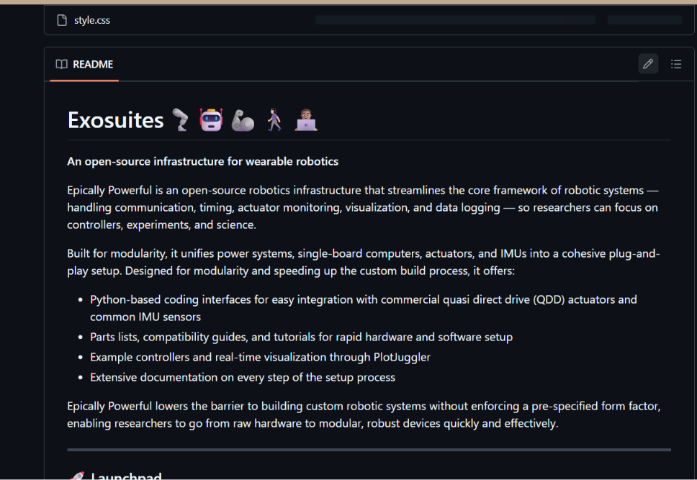
After you click the pen mark:
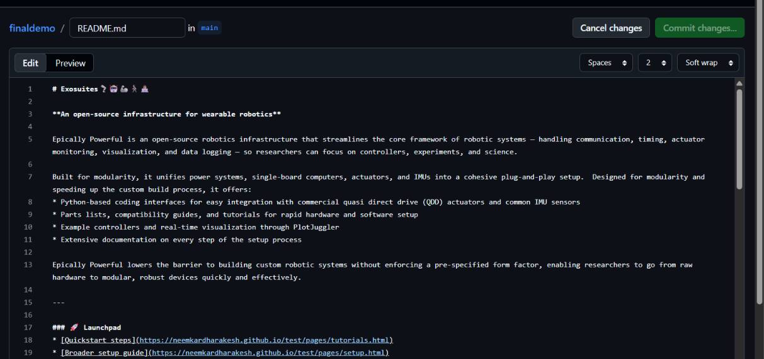
you can edit here and click on commit changes.
If you want to add any image in the readme file just drag the image to the readme file.

