DFD-MyCare(Main project)

**0th Level DFD**

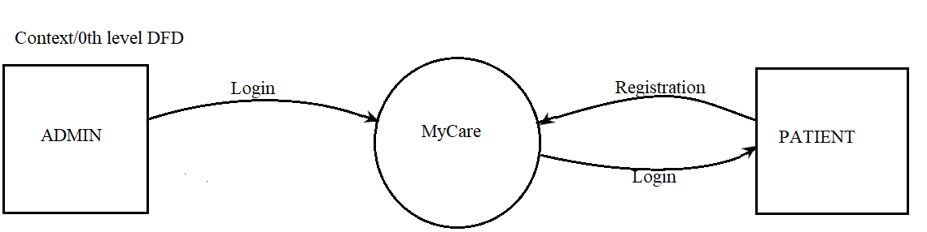

**1st Level DFD**

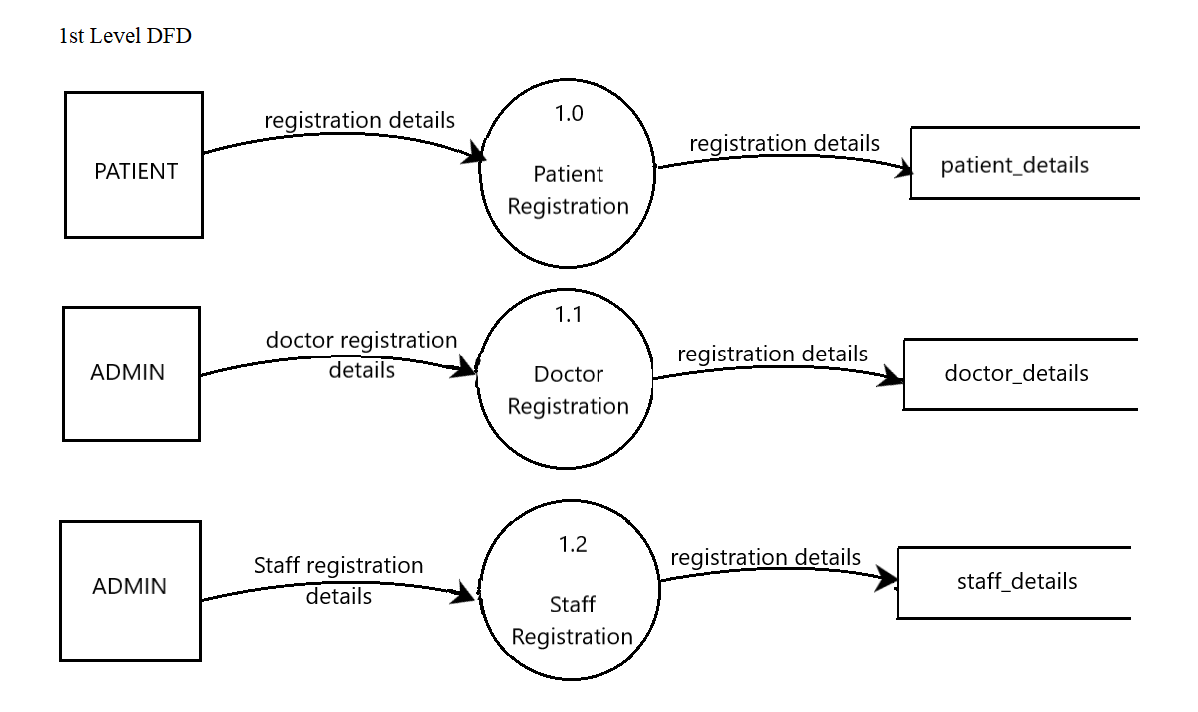

**2nd Level DFD (patient module)**

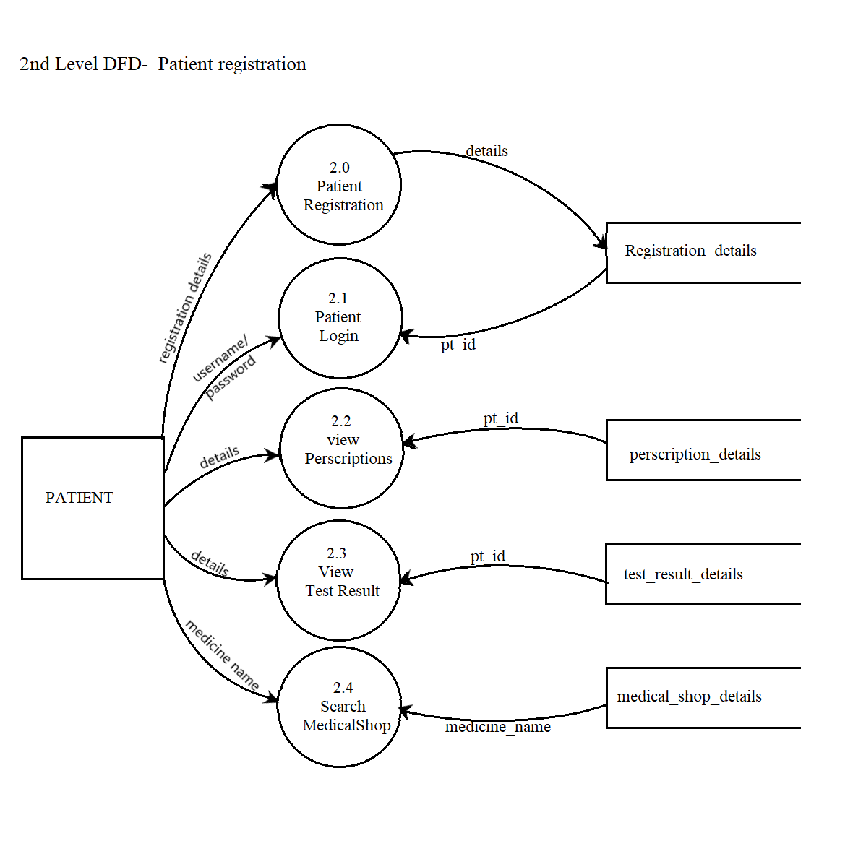

**3rd Level DFD(doctor module)**

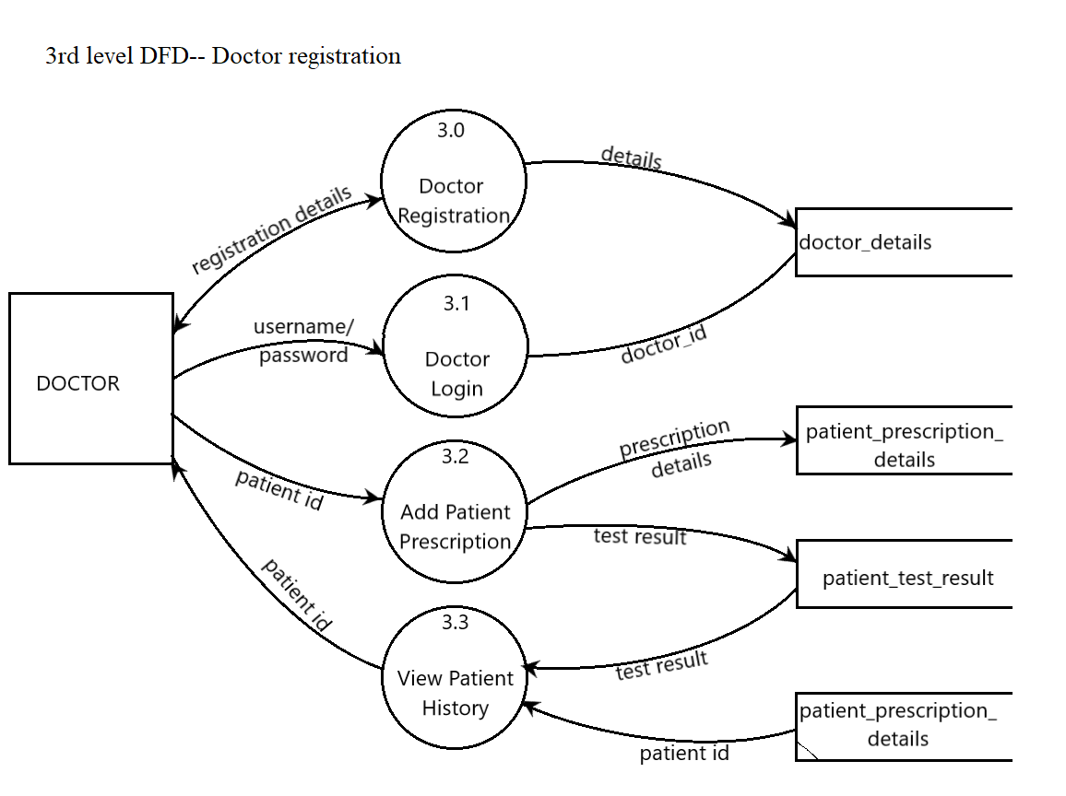

**4th Level DFD(staff module)**

