ADMIN_LOGIN_DETAILS  
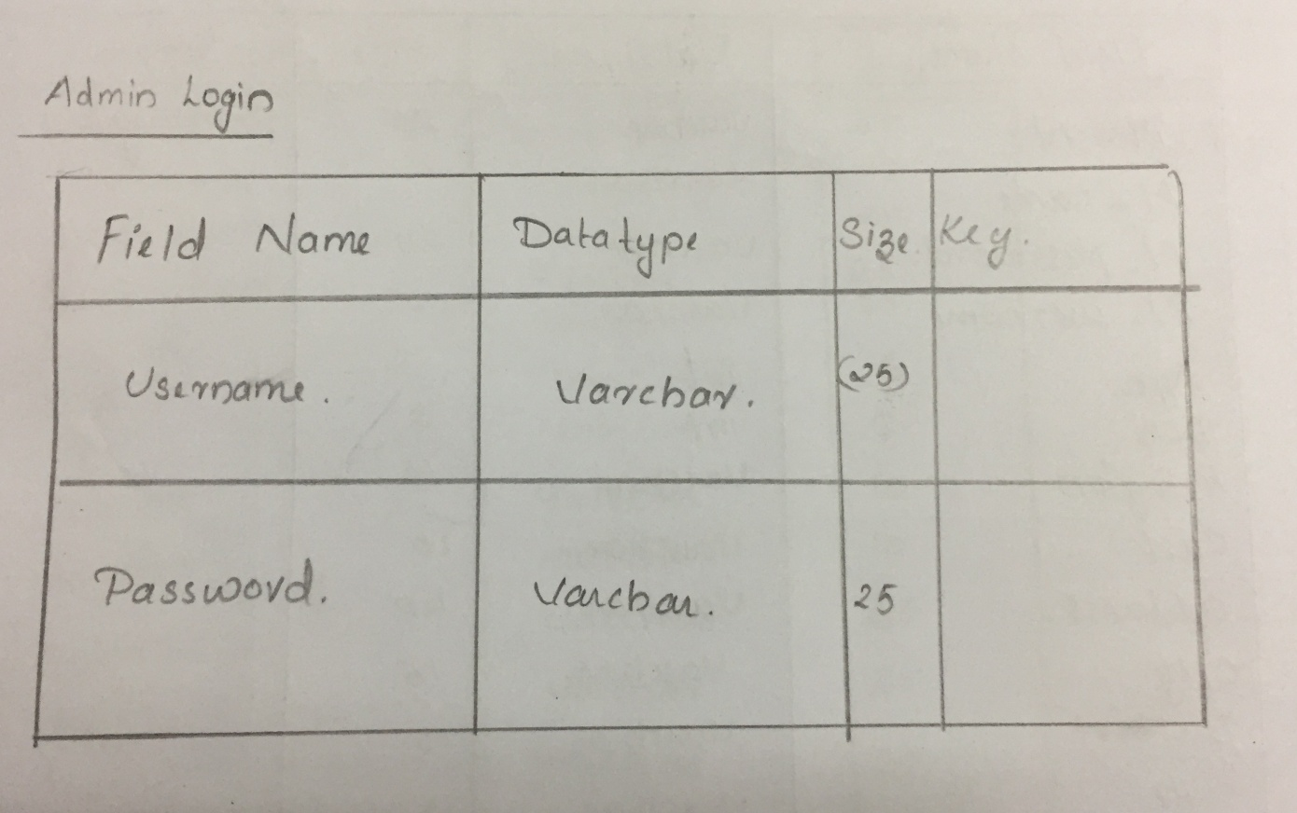  
  
  
  
DOCTOR_DETAILS  
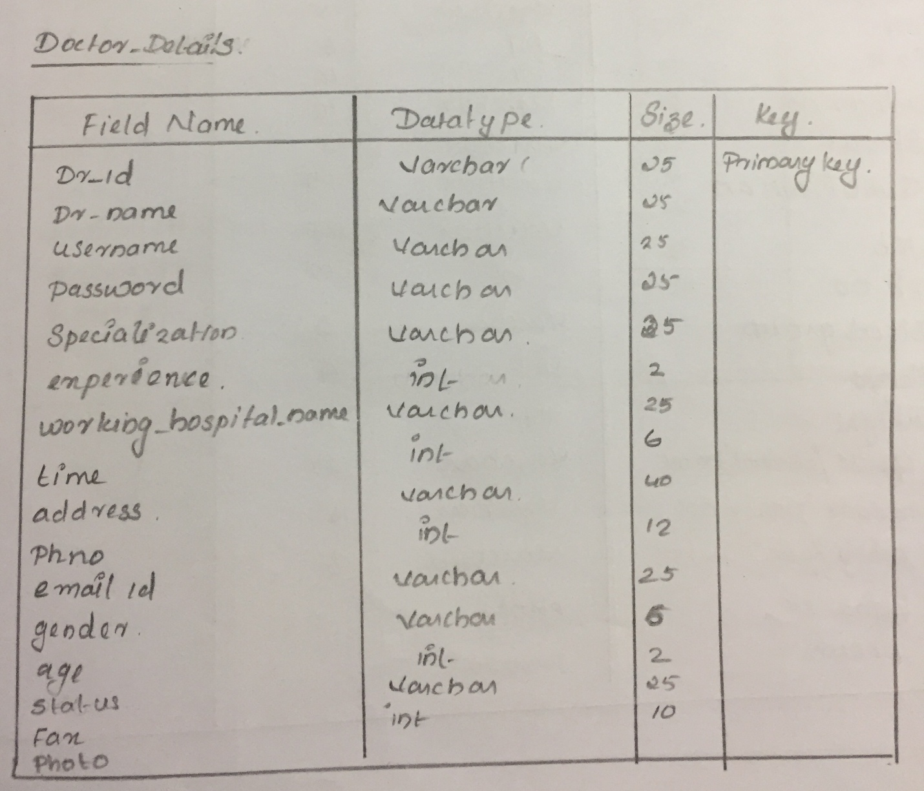MEDICALSHOP_DETAILS  
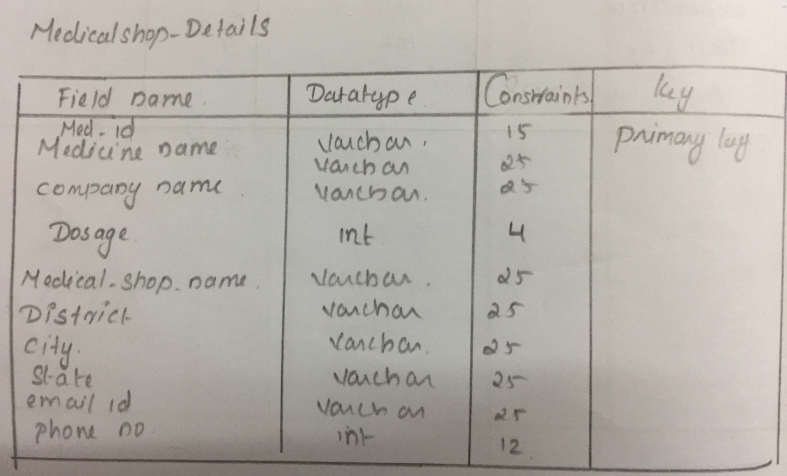  
MEDICINE_ALERT_DETAILS  
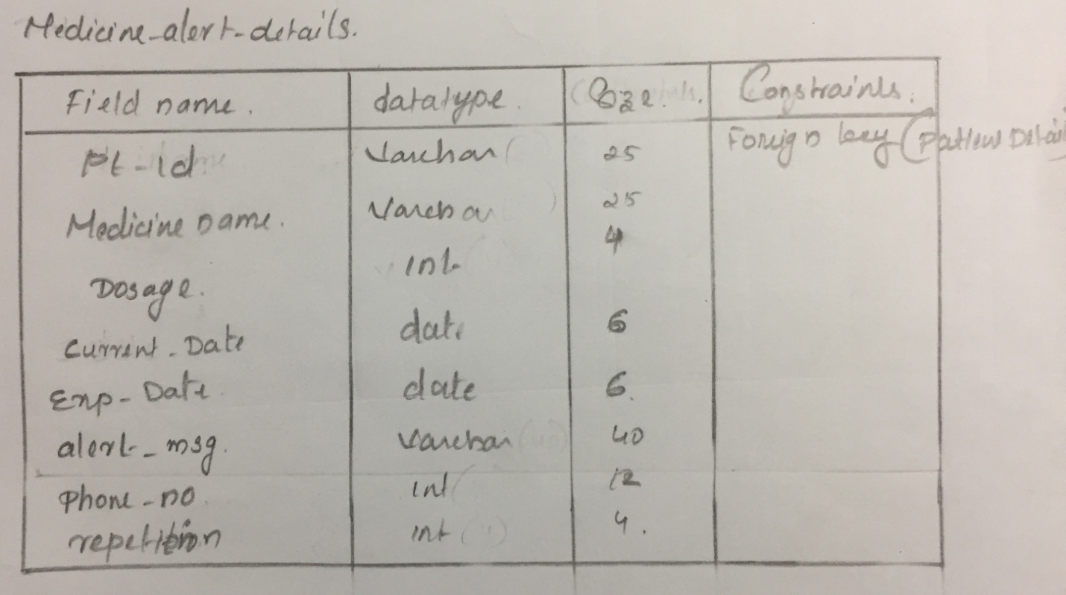  
  
  
  
  
  
  
  
  
  
  
  
  
  
PATIENT_DETAILS  
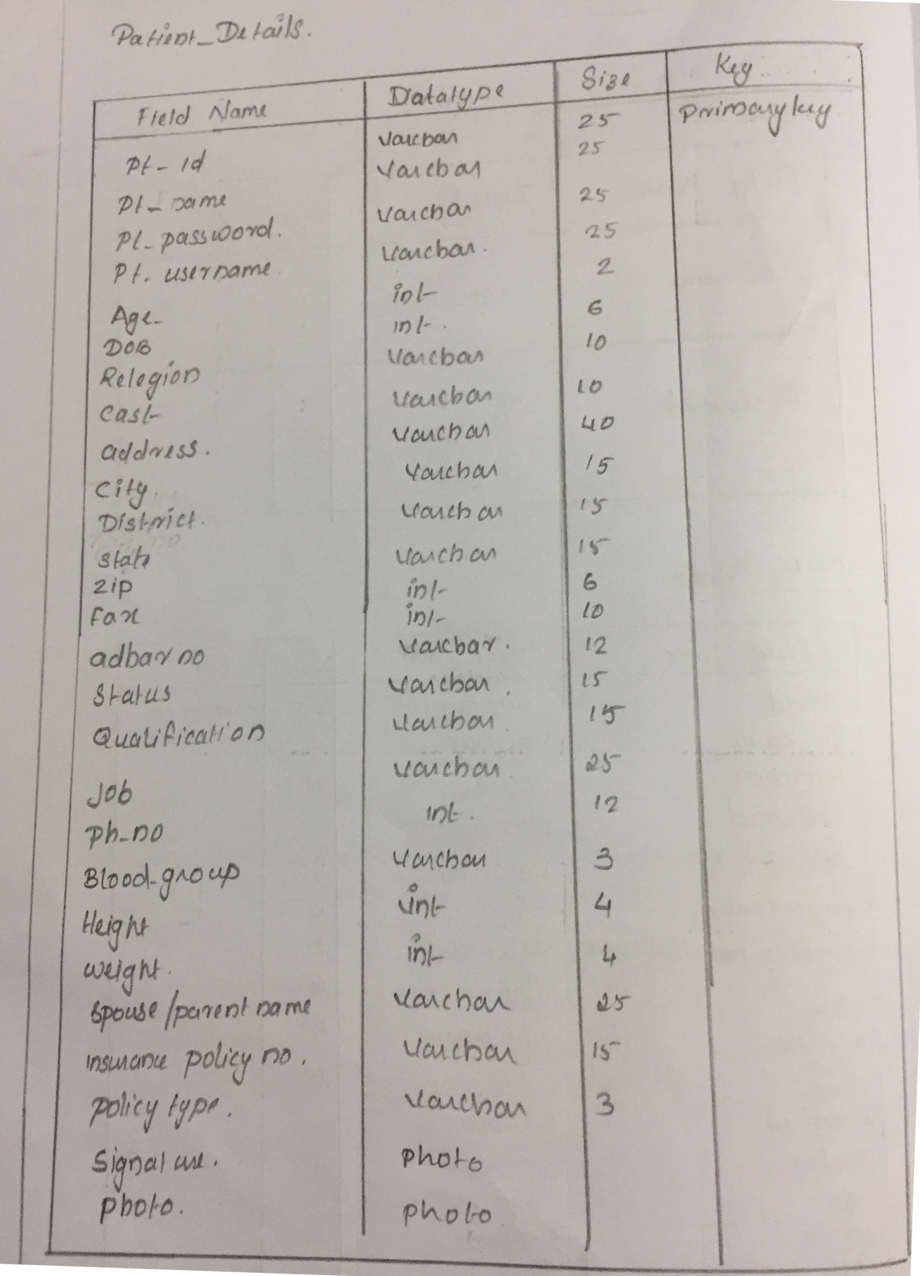  
  
  
  
PATIENT_HISTORY  
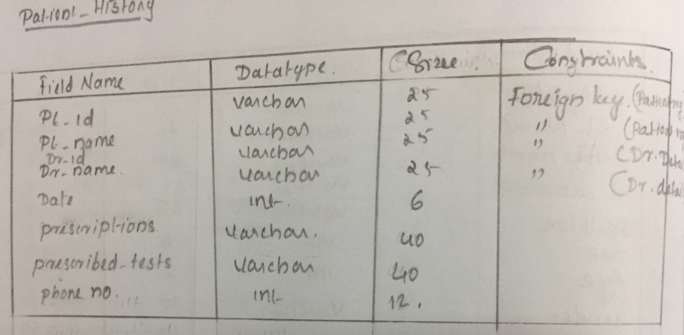  
  
  
TEST_RESULT  
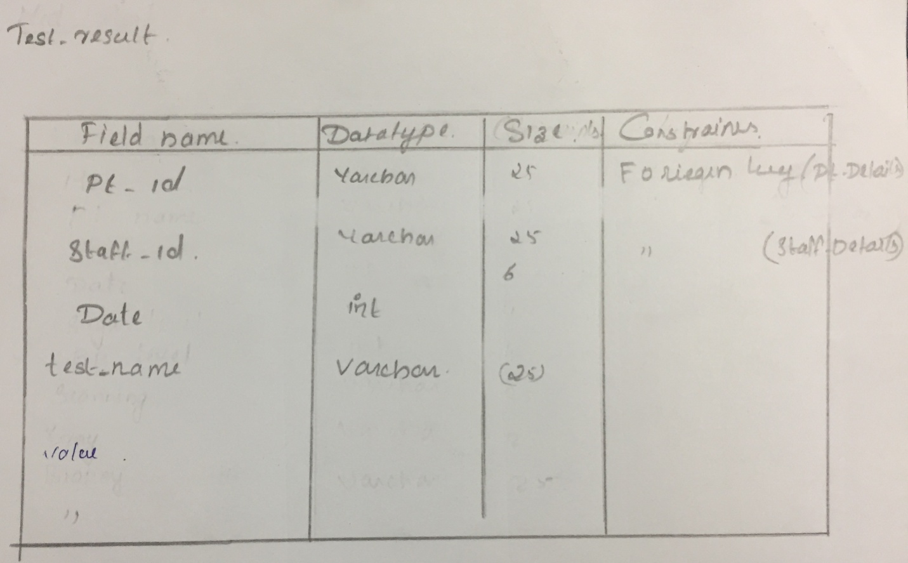

STAFF_DETAILS  
