Your Task:

Step 1 - Access the build:

The developer in your team has deployed the build to the following url:

<https://audiostack-qa-test.netlify.app/>

Step 2 - Write some manual test cases:

Produce a set of test cases that you'd use to manually test the registration form and its acceptance criteria.  
  
I have created an account on “Test rail”, written all testcases there and execute testcases also there.  
  
Please refer to this “Registration Form” project as mentioned in screenshot from test rail where all testcases and test runs have performed.  
  
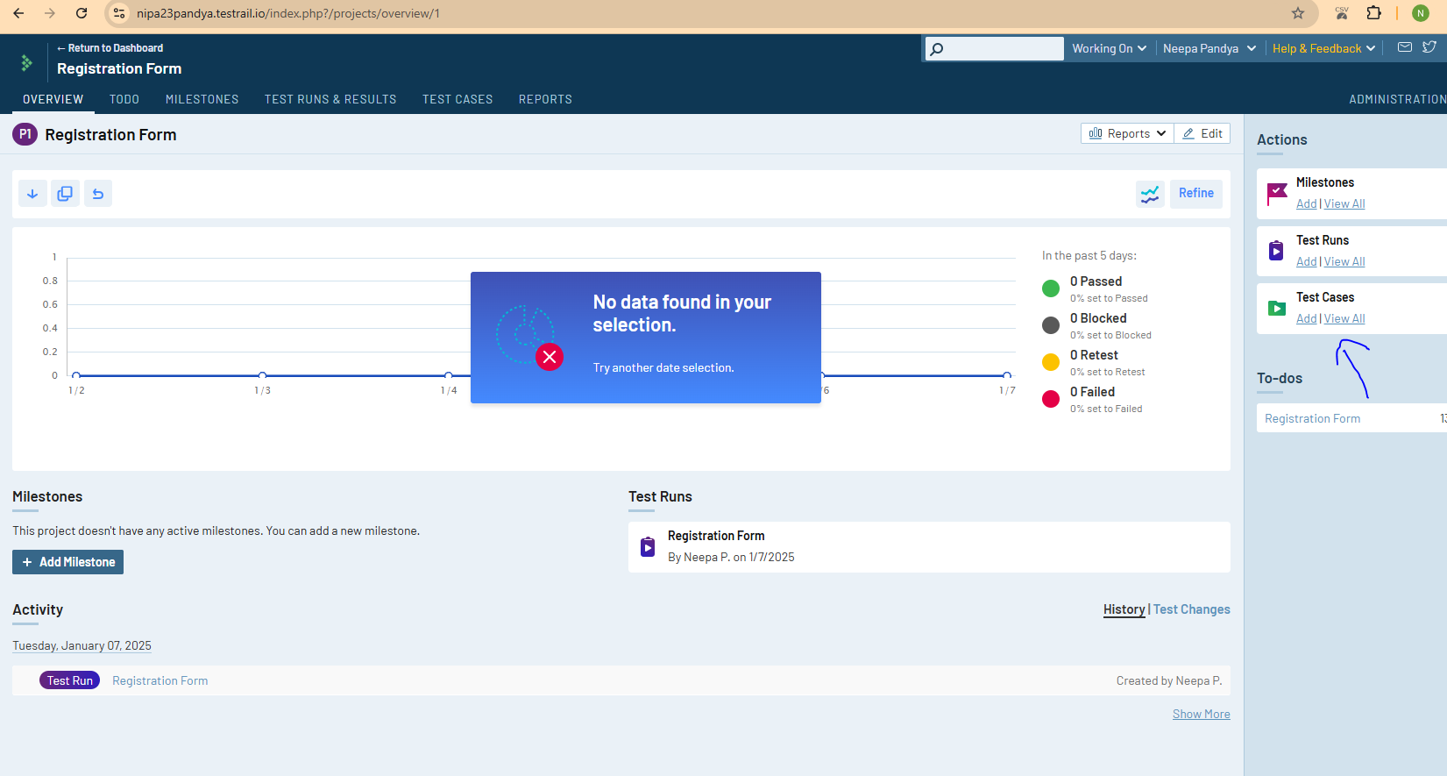  
  
Currently, I have created all functional/usability testcases based on “Acceptance Criteria.”  
I have tested manually registration form and its acceptance criteria.

I have added necessary steps, expected result, actual result, severity and added screenshots where needed.

Future reference I can make UI and Non functional testcases as well if it will add to acceptance criteria.  
  
I have run automation as well for some testcases which I think it’s necessary. I can convert more testcases to automation as well.  
  
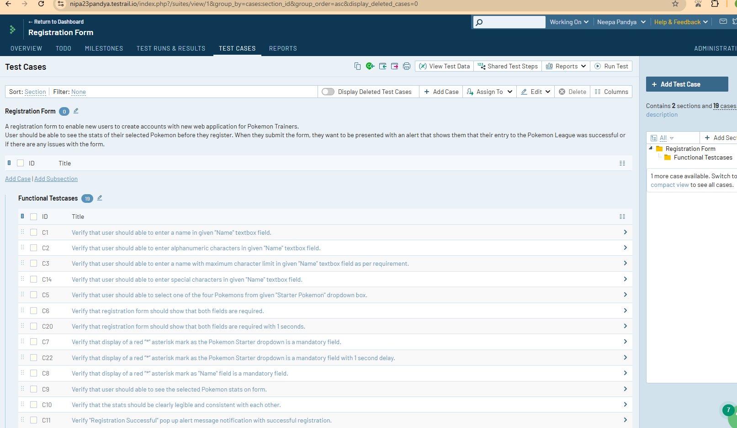

Step 3 - Execute your test plan:

Execute the test cases that you created in step 2 and note down any issues that you find detailing their severity and whether or not they are blockers for merging.  
  
  
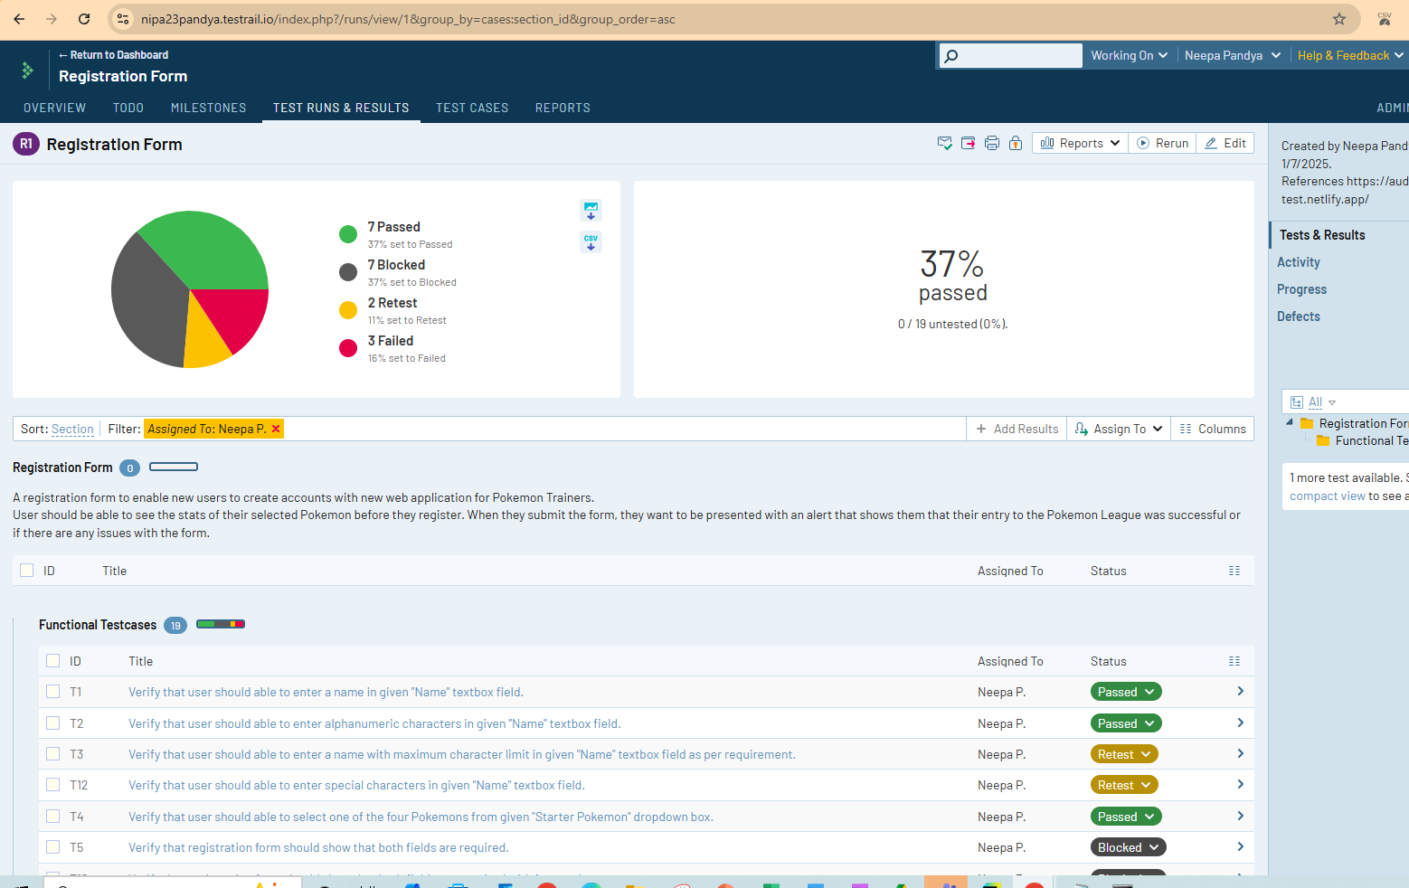

I have executed testcases as above mentioned in screenshot, please find at “Test Runs & Results” tab.

I have given detail summary of testcase result please look at test run for “Registration Form” in test rail.  
  
Short summary:

There are many problems with this “Registration Form” webpage and there are blockers testcases which I have mentioned in “Test Runs” of “Registration Form”.  
  
The form is not showing that both fields are required and still below mention things are happened:

* User is notifying about registration form was successful.
* User is not notifying about " Name" text field is mandatory field.
* User is not notifying about " Starter Pokemon" dropdown field is mandatory field in some cases.

Pikachu, Starter Pokemon has not showing their Stats details.  
  
Leave unselected starter Pokemons from given "Starter Pokemon" dropdown box and Whatever last Pokemon selected, showing their stats.

For input text box field given below observation.

* No any max limit
* No any special character’s input validation restriction
* No any restriction for lower and uppercase character
* No any restriction for alphanumeric characters

Step 4 (optional) - Automate your test plan:

Using a framework like Cypress, write automated test cases to test the build.  
  
I have automated some testcases which I have written in test rail with selenium framework and python.   
  
Please find the code in github repository <https://github.com/neepapandya23/pikachu_form> where all testcases run from “registration_main.py” file.  
  
I am more used with selenium+python so I have automated them. In the future I will automate in cypress also.

To see the output of these automated testcases, I have stored result in Task.docx file.  
Please find it in repository.