A Minor Project Report

on

**FOOD ORDERING SYSTEM**

**Under the guidance of**

**SAFIA SADRUDDIN**

Submitted By

**AKANKSHA SHIRSATH (A-62)**

**NEERAJ DUMBARE (A-66)**

**GANESH MIDIDODDI (A-69)**

**DEPARTMENT OF INFORMATION TECHNOLOGY**

**TERNA ENGINEERING COLLEGE,**

**Nerul, Navi-Mumbai**

**Acknowledgement**

This project is a huge team effort. My team and I extend our deepest gratitude and thanks to the following people who have helped us to achieve our work.

Special thanks to **Ms. Safia Sadruddin** for guiding us and helping in time when we needed most. We got to learn many things from her and it was our pleasure to work with her. My team and I extend thanks to our faculties of our college whom we have approached for academic help with regards to our project. We also thank our HOD **Ms. Vaishali Khairnar,** our **Principal Mr. L.K.Ragha** for their support and guidance.

**Table of contents**

1. **Abstract**
2. **Introduction**

**2.1 Problem Statement**

1. **Proposed System**
   1. **Comparison with existing system**
2. **System Architecture (must include diagram)**
3. **System Functionality (module wise functionality)**
4. **Database Tables**
5. **Result (Output Screenshot)**
6. **Conclusion**
7. **Future Scope**
8. **References**
9. **Abstract**

The purpose of the project is to develop food ordering system, where in the restaurants the staff make use of paper to place the order of the customer.

This system uses python as a front-end, and my-sql as backend. The frond end includes simple GUI where the manager takes the order of the customer and along with customers name and contact number. The backend my-sql is used to store the customer ordered food history along with date and time. So it can also be used to view the sum of amount that have been received. It also includes a simple calculator for cross checking.

1. **INTRODUCTION**

The food ordering system is developed to reduce the paper and manual work done by the manager or staff for taking the order for the customer. The system include some food items in button type if that is pressed it will add that item to the cart after conforming the total and name ,contact no the bill is printed. Once the bill is printed it added to the database along with the current date and time. This system uses python as a front-end, and my-sql as backend. The frond end includes simple GUI where the manager takes the order of the customer and along with customers name and contact number. The backend my-sql is used to store the customer ordered food history along with date and time. So it can also be used to view the sum of amount that have been received. It can also be used for self ordering system that need to implement the payment gateway.

It helps the restaurant to do all functionalities more accurately and faster way. Food Ordering System reduces manual works and improves efficiency of restaurant. It is helping Food Ordering to maintain the stock and cash flows and there are many more functionalities, like.

* Helps to Store records.
* Control orders and services.
* Billings.

The main goal is to maintain the restaurant's function in an effective and accurate manner and also it reduces manual entries. It is keeping proper record of the database.

* 1. **PROBLEM STATEMENT**

Many restaurants are storing their data in manual way. They have huge number of customers daily. So because large number of customers, they need the help of some features so they can maintain and store the records accurately. For managers it is difficult to view the tables, orders, reception and the counter simultaneously.

They need fully fledged software to maintain their day to day transaction, orders and also regular update on records, cash transaction, daily reports of customers etc. In the existing system, entering all the details are done manually, it is taking lots of time and also there are chances for mistakes.

1. **PROPOSED SYSTEM**

The proposed system helps in many ways. It helps to do billing very easily. Account maintenance also gets easier. They can keep track of their purchases, sales of food or particular food item, and account details etc. The software is provided with the facilities to find out the favorite food of the customer, and the seasonal foods, to add or modify and delete their orders. It helps in managing data of daily customers, managing data of daily expenses, managing record of daily order. It eliminates the drawbacks of existing system and also includes some more feature.

1) Easiness in modification of data

2) User friendly : The Proposed System is user friendly

3) No or very few paper work : The proposed system does not either require paper work or very few paper work. All the data is feted into the computer immediately and various bills can be generated through computer

* 1. **Comparison with existing system**

Many restaurants stores and maintain their day to day transactions manually.

1) Inability of modification of data : The managing huge amount of data Effectively and Efficiently for efficient results, storing the details of the customer etc. in such way that the database can be modified as not possible in current system.

2) Reducing manual work : All the transactions and the orders of the customer are stored manually. This data or record is stored by writing it in book. By storing data in the database we don't have to manage the book and thus reducing manual work.

3) Manual operator control : Manual operator control is there and leads to a lot of chaos and error.

4)Lot of paperwork : Existing system requires lot of paper work and even small transaction require many papers fill. Moreover any unnatural cause (such as fire in organization ) can destroy all the data of the organization. Loss of even single paper led to difficult situation . Because all the papers are interrelated

1. **System Architecture (must include diagram)**

**FlowChart Diagram:**

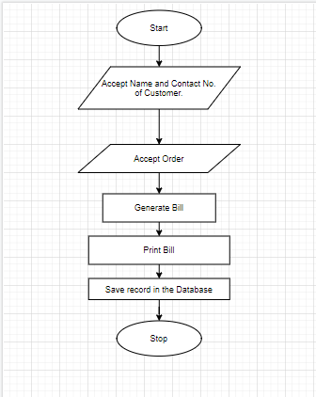

1. **System Functionality (module wise functionality)**

**Image Buttons:** These button are used to represent particular food item it is used to add the quantity of particular item.

**Total:** This is a button used to calculate the amount for particular items added into the cart. It can be crosscheck by using calculator.

**Print:** It prints the bill for the customer and as the order is conformed it added it to the database.

**Order History:** It is used to view the total customer ordered items along with date and time. It also makes the sum of amount has been received by the customers.

1. **Database Tables**

The database consist of only one table that is used to store data and to retrieve the data for viewing the order history.

**SNAPSHOT FOR THE TABLE**:

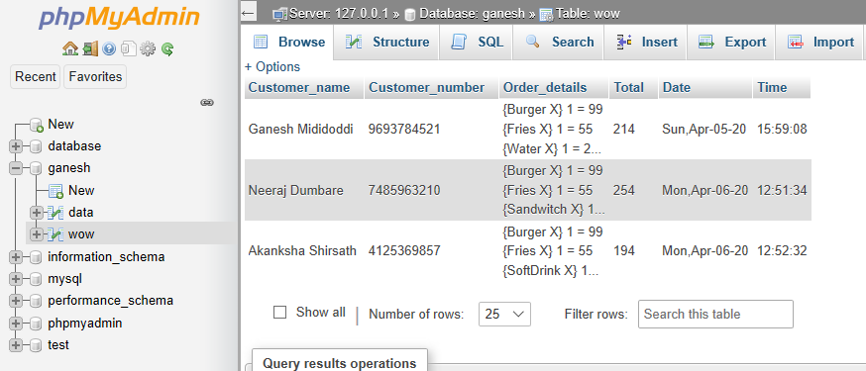

1. **Result (Output Screenshot)**

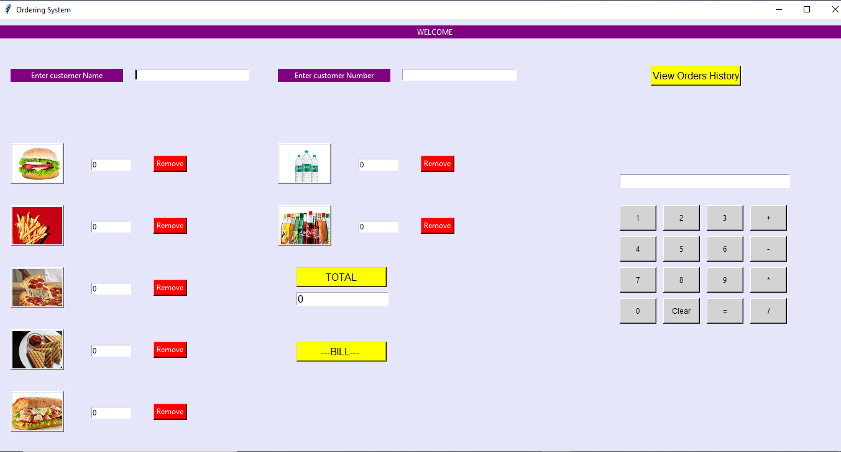

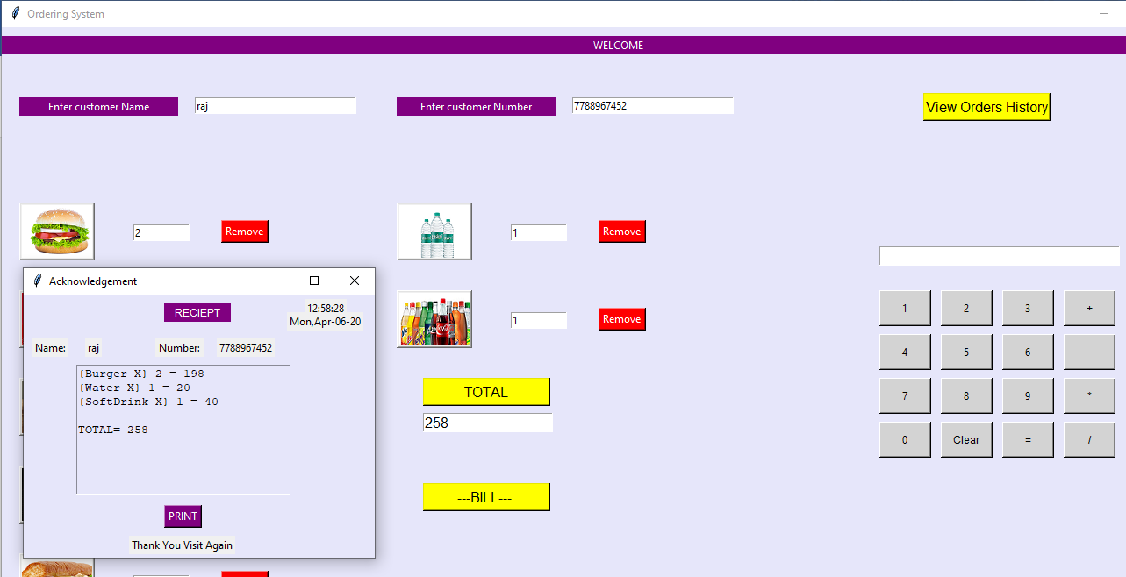

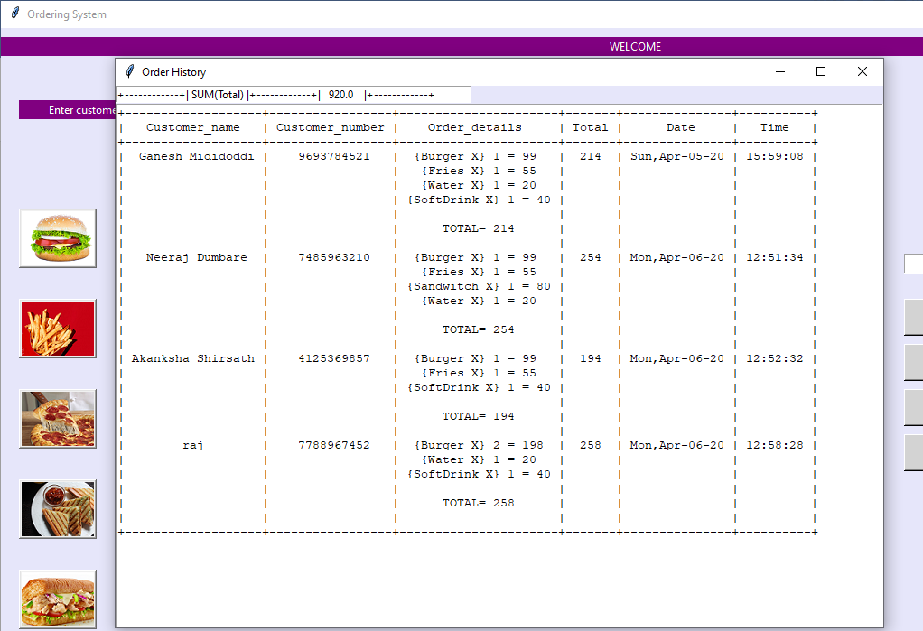

1. **Conclusion**

Our Software will be same as the other software Application which will be used by the manager to take the orders from the customers. This software builds the user interactive gui and helps to maintain the records of customer ordered history.

1. **Future Scope**

Make online based application.

Chats conversation with the manager.

Can be make self-ordering system by implementing payment gateway.

1. **References**

[**www.geeksforgeeks.com**](http://www.geeksforgeeks.com)

[**www.javatpoint.com**](http://www.javatpoint.com)

[**www.pythonlearning.com**](http://www.pythonlearning.com)

[**www.youtube.com**](http://www.youtube.com)