OPERATING SYSTEM
NOTES
BTECH –II-II SEM (R24)

UNIT – I
OPERATING SYSTEM OVERVIEW AND OPERATING SYSTEM STRUCTURES

PART-I: OPERATING SYSTEM OVERVIEW:
INTRODUCTION:
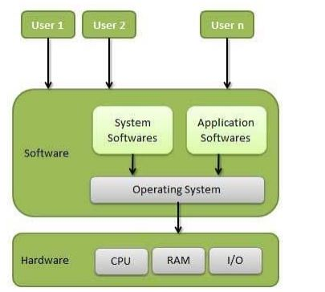
An operating System (OS) is an intermediary between users and computer hardware. It provides an environment in which a user can execute programs conveniently and efficiently. In technical terms, it is system software which manages hardware. An operating System controls the allocation of resources and services such as memory, processors, devices and information.

OBJECTIVES OF OPERATING SYSTEMS:

Let us now see some of the objectives of the operating system, which are mentioned below.
- Convenient to use: One of the objectives is to make the computer system more convenient to use in an efficient manner.
- User Friendly: To make the computer system more interactive with a more convenient interface for the users.
- Easy Access: To provide easy access to users for using resources by acting as an intermediary between the hardware and its users.
- Management of Resources: For managing the resources of a computer in a better and faster way.
- Controls and Monitoring: By keeping track of who is using which resource, granting resource requests, and mediating conflicting requests from different programs and users.
- Fair Sharing of Resources: Providing efficient and fair sharing of resources between the users and programs.

FUNCTIONS OF THE OPERATING SYSTEM:

- Resource Management: The operating system manages and allocates memory, CPU time, and other hardware resources among the various programs and processes running on the computer.
- Process Management: The operating system is responsible for starting, stopping, and managing processes and programs. It also controls the scheduling of processes and allocates resources to them.
- Memory Management: The operating system manages the computer’s primary memory and provides mechanisms for optimizing memory usage.
- Security: The operating system provides a secure environment for the user, applications, and data by implementing security policies and mechanisms such as access controls and encryption.
- Job Accounting: It keeps track of time and resources used by various jobs or users.
- File Management: The operating system is responsible for organizing and managing the file system, including the creation, deletion, and manipulation of files and directories.
- Device Management: The operating system manages input/output devices such as printers, keyboards, mice, and displays. It provides the necessary drivers and interfaces to enable communication between the devices and the computer.
- Networking: The operating system provides networking capabilities such as establishing and managing network connections, handling network protocols, and sharing resources such as printers and files over a network.
- User Interface: The operating system provides a user interface that enables users to interact with the computer system. This can be a Graphical User Interface (GUI), a Command-Line Interface (CLI), or a combination of both.
- Backup and Recovery: The operating system provides mechanisms for backing up data and recovering it in case of system failures, errors, or disasters.
- Virtualization: The operating system provides virtualization capabilities that allow multiple operating systems or applications to run on a single physical machine. This can enable efficient use of resources and flexibility in managing workloads.
- Performance Monitoring: The operating system provides tools for monitoring and optimizing system performance, including identifying bottlenecks, optimizing resource usage, and analyzing system logs and metrics.
- Time-Sharing: The operating system enables multiple users to share a computer system and its resources simultaneously by providing time-sharing mechanisms that allocate resources fairly and efficiently.
- System Calls: The operating system provides a set of system calls that enable applications to interact with the operating system and access its resources. System calls provide a standardized interface between applications and the operating system, enabling portability and compatibility across different hardware and software platforms.
- Error-detecting Aids: These contain methods that include the error messages, and other debugging and error-detecting methods.

EVOLUTIONS OF OPERATING SYSTEMS:

1. Batch Operating System: A Batch Operating System is a type of operating system that does not interact with the computer directly. There is an operator who takes similar jobs having the same requirements and groups them into batches.
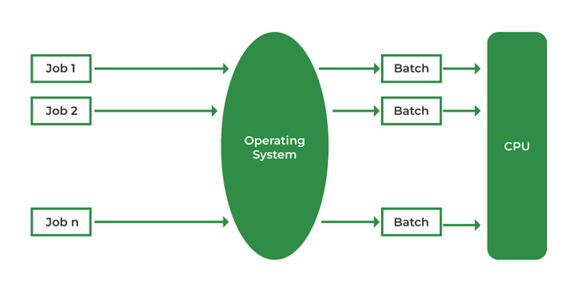
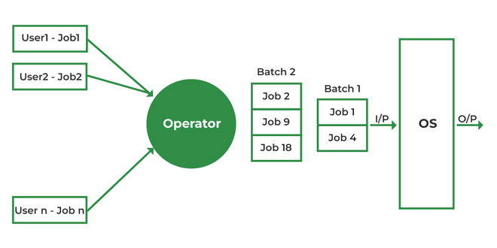
A batch processing operating system (BPOS) is designed to handle and process large volumes of data in batches, making it ideal for organizations that require efficient and rapid data processing. Unlike interactive systems, batch processing systems operate by executing a series of jobs without manual intervention, which enhances their speed and efficiency. This makes BPOS particularly suitable for businesses that consistently manage substantial data sets and need reliable, high-speed processing capabilities.

Advantages of Batch Operating System
The benefits of batch-processing operating systems include:
- Resource Efficiency: These systems improve the use of computation resources by processing jobs in groups and scheduling them during stages of resource accessibility.
- High Throughput: Batch processing systems can handle and complete a large number of tasks quickly, confirming quick turnaround times and high throughput.
- Error Reduction: Since these systems work without requiring user interference, they minimize the risk of faults that can occur with manual processing.
- Simplified Management: They restructure job management by automating the submission, scheduling, and implementation of tasks.
- Cost Efficiency: By producing well-organized use of resources and reducing processing time and errors, batch processing systems can be a cost-effective option.
- Scalability: These classifications can manage a huge number of tasks, making them scalable and appropriate for large organizations with significant data processing needs.

Disadvantages of Batch Operating System
There are many disadvantages to using batch operating systems, including:
- Limited functionality: A batch operating system can solve only simple tasks not solve more complex tasks. this can make them difficult to use for certain tasks, like managing files or software.
- Security issues: Batch operating systems are not more secure because they are not typically used for day-to-day tasks, so they are not as secure as more common operating systems. This can lead to security risks if the system is used by people who should not have access to it.
- Interruptions Batch systems can be interrupted frequently, which can lead to missed deadlines or mistakes.
- Inefficiency: Batch systems are often slow and difficult to use, which can lead to inefficiency in the workplace.
2. Multiprogramming Batch Systems:
In this the operating system picks up and begins to execute one of the jobs from memory.
Once this job needs an I/O operation, the operating system switches to another job (CPU and OS are
always busy).
Jobs in the memory are always less than the number of jobs on disk(Job Pool).
If several jobs are ready to run at the same time, then the system chooses which one to run through the
process of CPU Scheduling.
In a Non-multiprogrammed system, there are moments when the CPU sits idle and does not do any work.
In a Multiprogramming system, the CPU will never be idle and keeps on processing.
Time Sharing Systems are very similar to Multiprogramming batch systems. In fact time sharing systems
are an extension of multiprogramming systems.
In Time sharing systems the prime focus is on minimizing the response time, while in multiprogramming
the prime focus is to maximize the CPU usage.
Multiprogramming Batch Systems.

Advantages of Multi-Programming Operating System
- CPU is better utilized and overall performance of the system improves.
- It helps in reducing the response time.

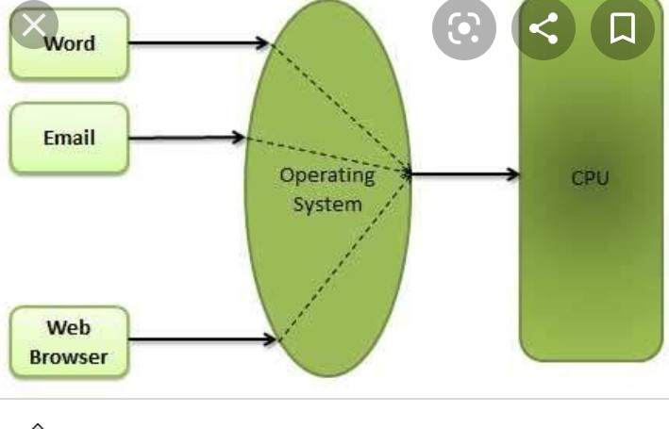
Advantages of Multi-Programming Operating System
- CPU is better utilized and overall performance of the system improves.
- It helps in reducing the response time.

3. Multi-Processing Operating System:
Multi-Processing Operating System is a type of Operating System in which more than one CPU is used for the execution of resources. It betters the throughput of the System.
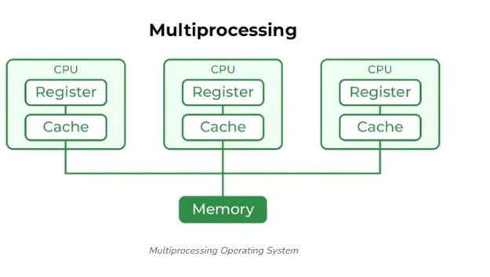

Advantages of Multi-Processing Operating System
- It increases the throughput of the system as processes can be parallelized.
- As it has several processors, so, if one processor fails, we can proceed with another processor.
4. Desktop Systems or personal computer:
Earlier, CPUs and PCs lacked the features needed to protect an operating system from user programs. PC operating systems therefore were neither multiuser nor multitasking. However, the goals of these operating systems have changed with time; instead of maximizing CPU and peripheral utilization, the systems opt for maximizing user convenience and responsiveness. These systems are called Desktop Systems and include PCs running Microsoft Windows and the Apple Macintosh. Operating systems for
these computers have benefited in several ways from the development of operating systems for mainframes.
Microcomputers were immediately able to adopt some of the technology developed for larger operating systems. On the other hand, the hardware costs for microcomputers are sufficiently low that individuals have sole use of the computer, and CPU utilization is no longer a prime concern. Thus, some of the design decisions made in operating systems for mainframes may not be appropriate for smaller systems.
5. Distributed Operating System
The motivation behind developing distributed operating systems is the availability of powerful and
In expensive microprocessors and advances in communication technology.
These advancements in technology have made it possible to design and develop distributed systems
consisting of many computers that are interconnected by communication networks. The main benefit of
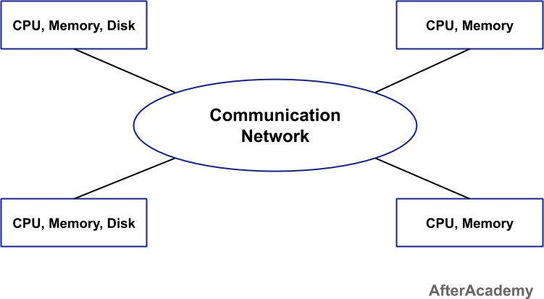
distributed systems is its low price/performance ratio.
Advantages Distributed Operating System:
● As there are multiple systems involved, users at one site can utilize the resources of systems at
other sites for resource-intensive tasks.
● Fast processing.
● Less load on the Host Machine.
Types of Distributed Operating Systems
Following are the two types of distributed operating systems used:
- Client-Server Systems
- Peer-to-Peer Systems
Client-Server Systems:
Centralized systems today act as server systems to satisfy requests generated by client systems. The
general structure of a client-server system is depicted in the figure below:

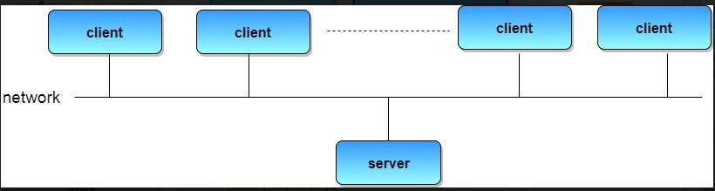
Server Systems can be broadly categorized as: Compute Servers and File Servers.
Compute Server systems provide an interface to which clients can send requests to perform an action, in
response to which they execute the action and send back results to the client.
File Server systems, provide a file-system interface where clients can create, update, read, and delete files.
Peer-to-Peer Systems:
Peer-to-peer network operating systems allow users to share resources and files located on their computers and to access shared resources found on other computers. However, they do not have a file server or a centralized management source .

Disadvantages of Distributed Operating System
- Failure of the main network will stop the entire communication.
- To establish distributed systems the language is used not well-defined yet.
- These types of systems are not readily available as they are very expensive. Not only that the underlying software is highly complex and not understood well yet.

6. Real-Time Operating System:
These types of OSs serve real-time systems. The time interval required to process and respond to inputs is very small. This time interval is called response time.Real-time systems are used when there are time requirements that are very strict like missile systems, air traffic control systems, robots, etc.

Types of Real-Time Operating Systems
- Hard Real-Time Systems: Hard Real-Time OSs are meant for applications where time constraints are very strict and even the shortest possible delay is not acceptable. These systems are built for saving life like automatic parachutes or airbags which are required to be readily available in case of an accident. Virtual memory is rarely found in these systems.
- Soft Real-Time Systems: These OSs are for applications where time-constraint is less strict.

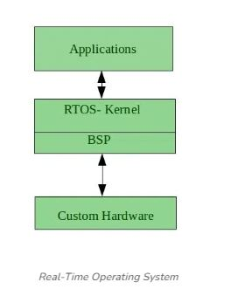

Advantages of RTOS
- Maximum Consumption: Maximum utilization of devices and systems, thus more output from all the resources.
- Task Shifting: The time assigned for shifting tasks in these systems is very less. For example, in older systems, it takes about 10 microseconds in shifting from one task to another, and in the latest systems, it takes 3 microseconds.
- Focus on Application: Focus on running applications and less importance on applications that are in the queue.
- Real-time operating system in the embedded system: Since the size of programs is small, RTOS can also be used in embedded systems like in transport and others.
- Error Free: These types of systems are error-free.
- Memory Allocation: Memory allocation is best managed in these types of systems.

Disadvantages of RTOS
- Limited Tasks: Very few tasks run at the same time and their concentration is very less on a few applications to avoid errors.
- Use heavy system resources: Sometimes the system resources are not so good and they are expensive as well.
- Complex Algorithms: The algorithms are very complex and difficult for the designer to write on.
- Device driver and interrupt signals: It needs specific device drivers and interrupts signal to respond earliest to interrupts.
- Thread Priority: It is not good to set thread priority as these systems are very less prone to switching tasks.
Examples of Real-Time Operating Systems are Scientific experiments, medical imaging systems, industrial control systems, weapon systems, robots, air traffic control systems, etc.

Clustered Operating System:
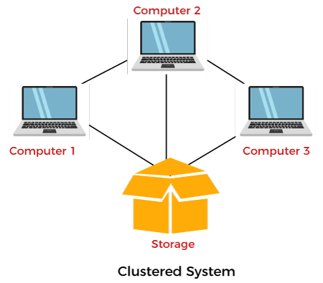
Cluster systems are similar to parallel systems because both systems use multiple CPUs. The primary difference is that clustered systems are made up of two or more independent systems linked together. They have independent computer systems and a shared storage media, and all systems work together to complete all tasks. All cluster nodes use two different approaches to interact with one another, like message passing interface (MPI) and parallel virtual machine (PVM).

Types of Clustered Operating System
There are mainly three types of the clustered operating system:
- Asymmetric Clustering System
- Symmetric Clustering System
- Parallel Cluster System

Asymmetric Clustering System
In the asymmetric cluster system, one node out of all nodes is in hot standby mode, while the remaining nodes run the essential applications. Hot standby mode is completely fail-safe and also a component of the cluster system. The node monitors all server functions; the hot standby node swaps this position if it comes to a halt.

Symmetric Clustering System
Multiple nodes help run all applications in this system, and it monitors all nodes simultaneously. Because it uses all hardware resources, this cluster system is more reliable than asymmetric cluster systems.

Parallel Cluster System
A parallel cluster system enables several users to access similar data on the same shared storage system. The system is made possible by a particular software version and other apps.

8. Handheld Operating System:
Handheld operating systems are available in all handheld devices like Smartphones and tablets. It is sometimes also known as a Personal Digital Assistant. The popular handheld device in today’s world is Android and iOS. These operating systems need a high-processing processor and are also embedded with various types of sensors.

Types of Handheld Operating Systems:
Types of Handheld Operating Systems are as follows:
- Palm OS
- Symbian OS
- Linux OS
- Windows
- Android

Advantages of Handheld Operating System:
Some advantages of a Handheld Operating System are as follows:
- Less Cost.
- Less weight and size.
- Less heat generation.
- More reliability.

Disadvantages of Handheld Operating System:
Some disadvantages of Handheld Operating Systems are as follows:
- Less Speed.
- Small Size.
- Input / Output System (memory issue or less memory is available).

Advantages
Various advantages of Clustered Operating System are as follows:
1. High Availability
Although every node in a cluster is a standalone computer, the failure of a single node doesn't mean a loss of service. A single node could be pulled down for maintenance while the remaining clusters take on a load of that single node.
2. Cost Efficiency
When compared to highly reliable and larger storage mainframe computers, these types of cluster computing systems are thought to be more cost-effective and cheaper. Furthermore, most of these systems outperform mainframe computer systems in terms of performance.
3. Additional Scalability
A cluster is set up in such a way that more systems could be added to it in minor increments. Clusters may add systems in a horizontal fashion. It means that additional systems could be added to clusters to improve their performance, fault tolerance, and redundancy.
4. Fault Tolerance
Clustered systems are quite fault-tolerance, and the loss of a single node does not result in the system's failure. They might also have one or more nodes in hot standby mode, which allows them to replace failed nodes.
5. Performance
The clusters are commonly used to improve the availability and performance over the single computer systems, whereas usually being much more cost-effective than the single computer system of comparable speed or availability.
6. Processing Speed
The processing speed is also similar to mainframe systems and other types of supercomputers on the market.

Disadvantages
Various disadvantages of the Clustered Operating System are as follows:
1. Cost-Effective
One major disadvantage of this design is that it is not cost-effective. The cost is high, and the cluster will be more expensive than a non-clustered server management design since it requires good hardware and a design.
2. Required Resources
Clustering necessitates the use of additional servers and hardware, making monitoring and maintenance difficult. As a result, infrastructure must be improved.
3. Maintenance
It isn't easy to system establishment, monitor, and maintenance this system.

OPERATING SYSTEM STRUCTURE:

Overview
An operating system is a design that enables user application programs to communicate with the hardware of the machine. The operating system should be built with the utmost care because it is such a complicated structure and should be simple to use and modify. Partially developing the operating system is a simple approach to accomplish this. Each of these components needs to have distinct inputs, outputs, and functionalities.
This article discusses many sorts of structures that implement operating systems, as listed below, as well as how and why they work. It also defines the operating system structure.
- Simple Structure
- Monolithic Structure
- Layered Approach Structure
- Micro-Kernel Structure
- Exo-Kernel Structure
- Virtual Machines

1. Simple Structure:
It is the most straightforward operating system structure, but it lacks definition and is only appropriate for usage with tiny and restricted systems. Since the interfaces and degrees of functionality in this structure are clearly defined, programs are able to access I/O routines, which
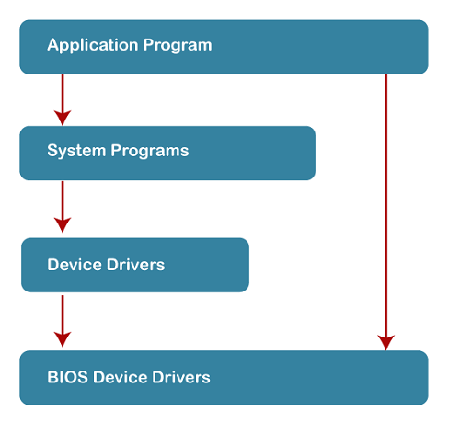
may result in unauthorized access to I/O procedures.

Advantages of Simple Structure:
- It is easy to develop as it contains only a few interfaces and levels.
- It executes faster because there are fewer layers between the hardware and applications.
- Direct access to hardware provides faster operations.
- Minimal consumption of system resources as the structure is very simple.
- Light in weight hence suitable for small or even embedded systems.
Disadvantages of Simple Structure:
- As these components are not distinctly separated, making any change or upgrade in the system is considerably harder to achieve.
- All things are connected, and therefore, debugging is quite hectic; finding the error is very hard.
- Due to the lack of data abstraction, a security vulnerability is a strong possibility.
- It does not scale well to larger, more complex systems. Adding new features is particularly challenging in this architecture.
- One failure in one part might bring down the whole system.

2. MONOLITHIC STRUCTURE:
The monolithic operating system controls all aspects of the operating system's operation, including file management, memory management, device management, and operational operations.
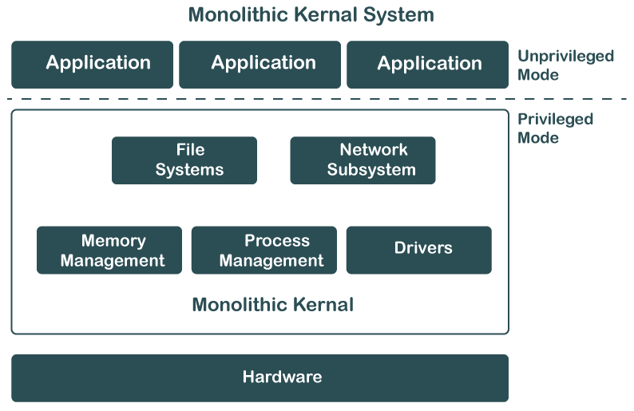

Advantages of Monolithic Structure:
- Because everything is packed into one big kernel, there is no need for multi-layer complexities. Hence, the design and bringing into practice of such a system is relatively easy.
- As long as all the components run in the same memory space, there is no need to have inter-process communication or to perform context switching between layers; thus, execution is faster.
- Direct access to hardware and little additional-abstraction overhead result in high performance.
- Development can thus be easier as developers have to deal with one codebase only, and no interactions among various layers or modules need to be considered.
Disadvantages of Monolithic Structure:
- Fault in any single component has the potential to bring down the whole system since there is no isolation between different parts.
- This can be a hard and unsafe task, as changes in one part of the system may accidentally filter out into another part.
- Since the components are more interdependent, debugging is also more complex and always requires heavy testing and testing-related activities.
- This is an issue where scaling up or adjusting to the latest trends in a system involves significant changes in the kernel.

3. LAYERED STRUCTURE:
The OS is separated into layers or levels in this kind of arrangement. Layer 0 (the lowest layer) contains the hardware, and layer 1 (the highest layer) contains the user interface (layer N).
- The model, in this respect, uses the functions' availability through the layer below it. For example, memory management may have to rely on process scheduling, while higher layers use it here with respect to user interaction.
- This approach also introduces abstraction between layers, whereby the system is also easier to manage and debug. In case any issue arises, testing and debugging can be performed at lower layers before going onto higher layers
The functionalities of each layer are separated in this method, and abstraction is also an option. Because layered structures are hierarchical, debugging is simpler, therefore all lower-level layers are debugged before the upper layer is examined. As a result, the present layer alone has to be reviewed since all the lower layers have already been examined.
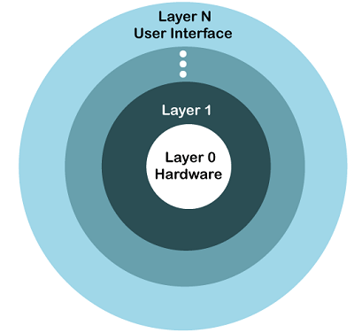
The image below shows how OS is organized into layers:
Advantages of Layered Structure:
- Development, maintenance, and understanding are much easier, as every layer is assigned a specific role.
- It can isolate problems in individual layers because testing and debugging would be less demanding.
- Sensitive operations can be confined to specific layers; thus, unauthorized access can be minimized to such layers because the concerns have been clearly separated.
- Modifying or updating one layer will not affect other independent layers directly; thus, upgrading or fixing could be done more easily.
- With layers, basic operations can be entrusted to lower layers, and hence, the layers above need not be concerned with the minute details, thereby reducing the complexity of the overall management.
Disadvantages of Layered Structure:
- The layered approach adds delays due to the fact that data and commands must pass through several layers, thus slowing down the system in general.
- Designing a properly working layered structure requires forethought and iron discipline for proper interaction between different layers.
- Layers are generally dependent on lower layers; thus skipping layers and directly accessing the lower-level functionalities becomes harder, hence reducing flexibility in many systems.
- System performance optimization becomes challenging due to the extra abstractions introduced by the layers, which harden the tuning of individual parts of the system to make them run more effectively.
- Unless the lower-layer design is lousy or inefficient, the whole system will suffer since the higher layer depends on them for functionality.

MICRO-KERNEL STRUCTURE:
The operating system is created using a micro-kernel framework that strips the kernel of any unnecessary parts. Systems and user applications are used to implement these optional kernel components. So, Micro-Kernels is the name given to these systems that have been developed.
The Micro-Kernel Structure minimizes the functions handled by the kernel, delegating most services to user-level applications. The micro-kernel itself only handles core functions, such as memory management, process scheduling, and basic communication between processes.
- By stripping away unnecessary services from the kernel, the system becomes more secure and reliable. If a service crashes, it doesn’t affect the entire system.
- Micro-kernels are common in modern OS architectures like macOS and QNX, as they allow for easier updates and better system resilience.
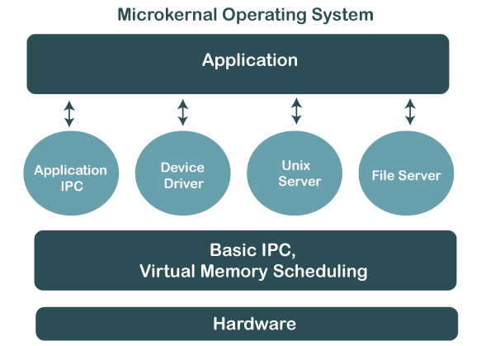
The image below shows the Micro-Kernel Operating System Structure:
Advantages of Micro-Kernel Structure:
- The just necessary services running in the kernel ensure that user service failures don't crash the whole system.
- It isolates the services from the kernel, thus minimizing the possibility of compromising the system since every service operates independently of the other.
- Smaller kernels are easier to operate and alter. Hence, updating and bug fixes are less challenging.

Disadvantages of Micro-Kernel Structure:
- The inter-process communication between kernel and user services introduces additional overhead and hence is slower as compared to the monolithic approach.
- In a micro-kernel, the separation of services must be done very carefully, which may complicate the initial development process.
- Context switches are more frequent between user space and kernel space in this approach; hence, performance would be slower in highly loaded conditions.
OPERATING SYSTEM SERVICES:
● Program execution
● I/O operations
● File System manipulation
● Communication
● Error Detection
● Resource Allocation
● Protection
Program execution:
Operating systems handle many kinds of activities from user programs to system programs like printer
spooler, name servers, file server, etc. Each of these activities is encapsulated as a process.
A process includes the complete execution context (code to execute, data to manipulate, registers, OS
resources in use). Following are the major activities of an operating system with respect to program
management −
● Loads a program into memory.
● Executes the program.
● Handles program&#39;s execution.
● Provides a mechanism for process synchronization.
● Provides a mechanism for process communication.
● Provides a mechanism for deadlock handling.
I/O Operation:
An I/O subsystem comprises of I/O devices and their corresponding driver software. Drivers hide the
peculiarities of specific hardware devices from the users.
An Operating System manages the communication between user and device drivers.
● I/O operation means read or write operation with any file or any specific I/O device.
● Operating system provides the access to the required I/O device when required.
File system manipulation:
A file represents a collection of related information. Computers can store files on the disk (secondary
storage), for long-term storage purpose. Examples of storage media include magnetic tape, magnetic disk
and optical disk drives like CD, DVD. Each of these media has its own properties like speed, capacity,
data transfer rate and data access methods.
A file system is normally organized into directories for easy navigation and usage. These directories may
contain files and other directions. Following are the major activities of an operating system with respect
to file management −
● Program needs to read a file or write a file.
● The operating system gives the permission to the program for operation on file.
● Permission varies from read-only, read-write, denied and so on.
● Operating System provides an interface to the user to create/delete files.
● Operating System provides an interface to the user to create/delete directories.
● Operating System provides an interface to create the backup of file system.
Communication:
In case of distributed systems which are a collection of processors that do not share memory, peripheral
devices, or a clock, the operating system manages communications between all the processes. Multiple
processes communicate with one another through communication lines in the network.
The OS handles routing and connection strategies, and the problems of contention and security.
Following are the major activities of an operating system with respect to communication −
● Two processes often require data to be transferred between them
● Both the processes can be on one computer or on different computers, but are connected through
a computer network.
● Communication may be implemented by two methods, either by Shared Memory or by Message
Passing.
Error handling:
Errors can occur anytime and anywhere. An error may occur in CPU, in I/O devices or in the memory
hardware. Following are the major activities of an operating system with respect to error handling −
● The OS constantly checks for possible errors.
● The OS takes an appropriate action to ensure correct and consistent computing.

Resource Management:
In case of multi-user or multi-tasking environment, resources such as main memory, CPU cycles and
files storage are to be allocated to each user or job. Following are the major activities of an operating
system with respect to resource management −
● The OS manages all kinds of resources using schedulers.
● CPU scheduling algorithms are used for better utilization of CPU.
Protection:
Considering a computer system having multiple users and concurrent execution of multiple processes,
the various processes must be protected from each other&#39;s activities.
Protection refers to a mechanism or a way to control the access of programs, processes, or users to the
resources defined by a computer system. Following are the major activities of an operating system with
respect to protection −
● The OS ensures that all access to system resources is controlled.
● The OS ensures that external I/O devices are protected from invalid access attempts.
● The OS provides authentication features for each user by means of passwords.
PART-II: BASIC LINUX UTILITIES AND SYSTEM CALLS:
File Handling utilities:
1. mkdir
Purpose: to create a directory
Folders in Linux are called “directories”. They serve the same purpose as folders in Windows.
usage:
mkdir [directory name]
2. rmdir
Purpose: to remove a directory
With the rmdir command, you can remove a directory quickly and easily.
usage:
rmdir [directory name]
3. cp
Purpose: to make a copy of a file
Here’s one you’ll use all the time, especially if you’re making a config file backup. Let’s use that as an example. I want to make a backup of this file. If I mess something up, I can go back to the old version.
usage:
cp [file name] [new file name]
4. mv
Purpose: to move a file to another location or rename it
This one is pretty straightforward. You use it to move a file from one place to the other.
usage:
mv [file name] [new location]
5. rm
Purpose: to delete a file
We used rm earlier to remove a directory. It’s also you delete individual files.
usage:
rm [file name]
6. touch
Purpose: create an empty file
You may have noticed my “nginx.conf” was zero bytes. This is a nifty command for creating empty files. This is handy for creating a new file or testing things.
usage:
touch [file name]
7. find a file (find)
This is a powerful command for finding files in the file system.
usage:
find [path to search] -name filename

Process handling utilities:

1. ps Command
Displays a snapshot of active processes.
ps aux
- a: Shows processes from all users.
- u: Displays user-oriented information.
- x: Includes processes without a terminal.

2. top Command
Displays real-time information about processes.
top
- Press q to quit.
- Press h for help.

3. htop Command (Advanced)
An interactive and user-friendly alternative to top.
htop
- Use arrow keys to navigate.
- Press F9 to kill a process.

4. pgrep Command
Search for processes by name.
pgrep firefox
Disk Utilities:
1. Using du Command
We can check the disk space with the help of the du command. The full-form of du is "Disk Usage." The du command shows the usage of disk. The du command will show you the disk usage for specific directories in Linux.
Syntax:
$ du
2. Using the df option
The full-form of df command is "disk-free,". Using this command, we can check the used and available disk space in the Linux system.
Syntax:
$ df [optios].........FILESYSTEM.........
Display Information of File System in Bytes
If want to see the information and usage of file system in 1024-byte blocks, then we can use the '-k' option.
Syntax:
$ df -k
Display Information of File System in GB
We can use the 'df -h' option if we want to show information of all file system statistics in Gigabyte (GB).
Syntax:
$ df -h
Networking Utilities:

1. Ping
The ping command is used to check if a remote system is running or up. In short this command is used to detect whether a system is connected to the network or not.
Command:
$ ping www.geeksforgeeks.com

2. Host
This command is used to obtain network address information about a remote system connected to your network. This information usually consists of system’s IP address, domain name address and sometimes mail server also.
Command:
$ host www.google.com

3. Finger
One can obtain information about the user on its network and the who command to see what users are currently online on your system. The who command list all users currently connected, along with when, how long, and where they logged in. finger can operate on large networks, though most systems block it for security reasons.
Command:
$ finger www.geeksforgeeks.org

4. Traceroute
This command is used to track the sequence of computer networks. You can track to check the route through which you are connected to a host. mtr or xmtr tools can also be used to perform both ping and traces. Options are available for specifying parameters like the type of service (-t) or the source host (-s).

5. Netstat
This command is used to check the status of ports whether they are open, closed, waiting, and masquerade connections. Network Statistic (netstat) command displays connection information, routing table information, etc.
Command:
$ netstat

6. Tracepath
Tracepath performs a very similar function to that of traceroute command. The main difference between this command is that tracepath doesn’t take complicated options. This command doesn’t require root privileges.
Command:
$ tracepath www.geeksforgeeks.org

Filter Utilities:
1. cat : Displays the text of the file line by line.
Syntax:
cat [path]
2. head : Displays the first n lines of the specified text files. If the number of lines is not specified then by default prints first 10 lines.
Syntax:
head [-number_of_lines_to_print] [path]
3. tail : It works the same way as head, just in reverse order. The only difference in tail is, it returns the lines from bottom to up.
Syntax:
tail [-number_of_lines_to_print] [path]
4. sort : Sorts the lines alphabetically by default but there are many options available to modify the sorting mechanism. Be sure to check out the main page to see everything it can do.
Syntax:
sort [-options] [path]
5. uniq : Removes duplicate lines. uniq has a limitation that it can only remove continuous duplicate lines(although this can be fixed by the use of piping). Assuming we have the following data.
Syntax:
uniq [options] [path]
6. wc : wc command gives the number of lines, words and characters in the data.
Syntax:
wc [-options] [path]
Backup utilities:

Tar:
Used to backup/restore files to a tape drive. Tar can be used to archive a group of files into another file or more commonly to write/restore a group of files to a tape drive.
Options | Description
c | create a archive (write to tape)
t | display files on archive (view only)
x | extract from archive (read from tape and write to disk)
v | verbose – display filenames
z | compress files (using gzip)
f | device name or file name to write to
directory or file | directory or file to use
Note: The following examples assume the device name of your tape drive is /dev/st0.
Command | What it does
tar cvf /dev/st0 / | backup the entire system to tape
tar cvzf /dev/st0 /bin | only backup the /bin directory to tape and compress
tar tvf /dev/st0 | view the contents of a tape
tar xvf /dev/st0 | restore the entire contents of the tape
tar xvf /dev/st0 /etc/sendmail.cf | only restore the file ‘/etc/sendmail.cf’ from tape
tar xvzf /dev/st0 /bin | restore and uncompress the directory /bin from tape
top of page

mt
The mt command can be used to erase, retension or to set compression mode.
Note: The following examples assume the device name of your tape drive is /dev/st0.
Command | What it does
/usr/sbin/mt -f /dev/st0 retension | Retension
/usr/sbin/mt -f /dev/st0 erase | Erase
/usr/sbin/mt -f /dev/st0 datcompression | Turn compress on

System Calls :
A system call is a way for a user program to interface with the operating system. The program requests several services, and the OS responds by invoking a series of system calls to satisfy the request. A system call can be written in assembly language or a high-level language like C or Pascal. System calls are predefined functions that the operating system may directly invoke if a high-level language is used.

What is a System Call?
A system call is a method for a computer program to request a service from the kernel of the operating system on which it is running.
A system call is a method of interacting with the operating system via programs. A system call is a request from computer software to an operating system's kernel.
The Application Program Interface (API) connects the operating system's functions to user programs. It acts as a link between the operating system and a process, allowing user-level programs to request operating system services.
The kernel system can only be accessed using system calls. System calls are required for any programs that use resources.
User vs Kernel Mode: In user mode, programs can't directly access hardware resources; they request through system calls the operations in kernel mode.
System calls to preserve the security of the system through its accessibility resources, which an OS can get. This is because system calls mainly limit the direct hardware control to the OS.

Why do you need system calls in Operating System?
There are various situations where you must require system calls in the operating system. Following of the situations are as follows:
- It is must require when a file system wants to create or delete a file.
- Network connections require the system calls to sending and receiving data packets.
- If you want to read or write a file, you need to system calls.
- If you want to access hardware devices, including a printer, scanner, you need a system call.
- System calls are used to create and manage new processes.
- They allow system programs to exercise control over hardware devices-for example, to set parameters or to read status.
- They enforce access controls and permissions to protect system resources.
- Used for inter-process communication and coordination.
- System calls provide mechanisms for accessing status information and configuration data about the system.

Types of System Calls
There are commonly five types of system calls. These are as follows:
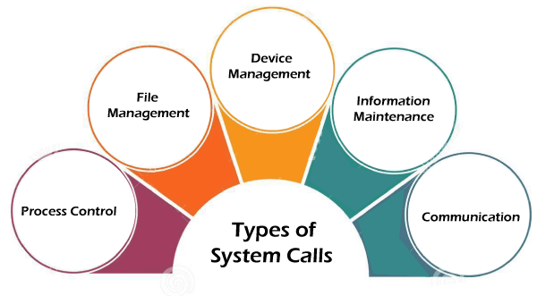
- Process Control
- File Management
- Device Management
- Information Maintenance
- Communication
Now, you will learn about all the different types of system calls one-by-one.

1. Process Control
Process control is the system call that is used to direct the processes. Some process control examples include creating, load, abort, end, execute, process, terminate the process, etc.
Here's a closer look at how it all works out:
- Process Creation: Every time you start a new application, an operating system calls into life and assigns it a process. It then assigns it a unique process ID and gives it all the required resources, such as memory, that will enable it to begin its start-up.
- Scheduling of Processes: The operating system needs to decide which process gets its turn with the CPU. It achieves this with scheduling algorithms—kind of like making sure every person in line gets their turn at the checkout. This keeps things moving without waiting, whether it is a first-come-first-served approach or prioritizing specific tasks.
- Process Execution: After a process is born, it's time to run the program. OS swaps between processes, ensuring that your computer is multitasking. Imagine jugglers tossing balls: every time one goes to the floor, another snatched off the return in mid-air. That is how the CPU manages all sorts of processes!
- Suspension and Resumption: At other times, processes are suspended to free up resources or let other more important processes run. The system saves its state so it can pick up right where it left off when resumed, just like hitting the pause button in a video game.
- Process Termination: Every process eventually needs to terminate-it either finishes its work or an error occurs. In the case of an OS, it simply deallocates that resource from memory and gets rid of it, making everything neat and clean.
- Inter-process Communication (IPC): Processes sometimes need to communicate with other processes. To achieve this, the OS has facilities like message passing or shared memory. Think of two friends texting each other; that's the way processes communicate.
- Synchronization: Sometimes, processes desire to share resources - files or memory, for example. However, if they all wish to access a resource simultaneously, things may become somewhat unravelled. So, in order to prevent this kind of chaos, the OS uses tools such as semaphores and mutexes, which are in charge of orchestrating everything smoothly so that no such conflict might arise.
- Deadlock Handling: Deadlock is where the processes are deadlocked, waiting for each other's resources, people holding doors open for one another, and neither can get through. The OS has strategies to avoid or resolve these situations, ensuring that no process is deadlocked for an indefinite amount of time.

2. File Management
So, File Management basically refers to how your computer handles the organization and manipulation of files. It is rather like storing your physical documents in a drawer: each file has to be created, opened, edited, and perhaps sometimes even trashed. The OS takes care of everything behind the scenes.
Alright, let's break it down a bit:
- Creating Files: Each time you save a new document or program, your computer creates a file. It gives it a location on the hard drive or other storage - much the way you might put a paper file into a folder.
- Opening Files: To look at or edit a file, you open it. The operating system will retrieve it so that you can view it or work on it.
- Reading Files: Once the file is opened, one can read what is inside. Be it a text file, an image, or anything else, the OS will call from storage to be viewed and worked with.
- Writing to Files: Every time you make a change—either by typing into a document or touching up a picture—the operating system writes those changes to the file.
- Closing Files: When you are finished with it, closing the file saves everything and marks it as not in use. It is like putting the document back in its folder when you are finished reading or modifying it.
- File Deletion: You just delete files whenever you think they should not be in your system again. The operating system would then delete them from your storage, creating more space for other things.
- Controlling Permissions: You might sometimes need to control who can access and edit some of the files. The OS allows you to set permissions for each file so that you may choose whether someone else can run, alter, or open it.

3. Device Management
Device management is a system call that is used to deal with devices. Some examples of device management include read, device, write, get device attributes, release device, etc.What device management does;
- Reading from Devices: Whenever the computer wants to read data from the device, be it reading a file off of your hard drive or input from the keyboard, the operating system handles that request. It makes sure the data is read right and then forwarded to the right place.
- Writing to Devices: whenever you need to export data to a device, such as saving the file of your report to the USB stick or just printing it, the OS takes care of it and makes sure that all the data gets written to the device in the right way.
- Getting Device Attributes: The OS can get such information about a device, say, its status or settings. For example, it can check what is available on disk or the level of the battery of a wireless mouse.
- Allocation of Resources: OS decides how many of the system resources like memory or processing power a device gets, so no device gets more than its share, and the whole thing runs without problems.
- Release Devices: The OS releases a device, that is, frees system resources allocated for that device once it has completed all its work. Essentially, it is as safe as pulling a USB drive out of the computer after you are done with it.
- Handling Interrupts: Devices often send signals to the CPU, termed as interrupts, claiming its attention. The OS handles these interruptions so that it will come to know whenever a device needs attention and deal with them in the right sequence.

4. Information Maintenance
Information maintenance is a system call that is used to maintain information. There are some examples of information maintenance, including getting system data, set time or date, get time or date, set system data, etc.. The usual information maintenance in everyday life activities are;
- Get System Data: It fetches information about the system that it actually is, such as CPU or memory usage, network status, etc. It keeps records of all the resources in use.
- Set System Data: The OS can, whenever needed, change some of the configurations associated with the systems, such as changing system behaviour, updating configurations, setting user preferences, etc.
- Retrievability of Time or Date: OS can retrieve the time and date of the system, which is used in many applications such as file timestamp, logging and scheduling.
- Setting Time or Date: The system may update the current time and date when necessary; thus, accurate times and dates can be appended to files or processes or synchronized with an external time clock.
- System logs and audits: The operating system maintains an event log and activity record of errors, system performance, or user actions. It is primarily used for debugging and monitoring the system.

5. Communication
Communication is a system call that is used for communication. There are some examples of communication, including create, delete communication connections, send, receive messages, etc.Key activities involved in communication are as follows:
- Setting Up Communication Links: OS connects two processes or devices through a communication channel. The connection may be performed using sockets, pipes, or shared memory; thus, it facilitates easy communication between these two processes or devices.
- Closing Communication Links: OS dismantles or deletes a link if its communication process is complete; resources are released, and the system is not affected.
- The OS ensures that a message or data sent by one process or system reaches the target recipient, either locally or on a network.
- Receiving Messages: The receiving process gets the data sent by another process. The OS manages the incoming messages and makes sure that it is delivered to the correct target.
- Manages the protocols of communication: The OS manages rules as well as communications protocols, which enable data to be both sent and received in appropriate formats and sequences.

Examples of Windows and Unix system calls
There are various examples of Windows and Unix system calls. These are as listed below in the table:
Here, you will learn about some methods briefly:

open()
An open() call allows a process to start accessing the file stored in the file system. As such, it can allocate resources on demand and return a file descriptor, which becomes a handle used to access or read from the file.
A number of processes could open the same file, or access to a file might be exclusive to only one process again, depending upon the design of the file system and permissions. A file open() system call needs to be performed before any reads or writes are performed on a file.

read()
It is used to obtain data from a file on the file system. It accepts three arguments in general:
- A file descriptor.
- A buffer to store read data.
- The number of bytes to read from the file.
The file descriptor of the file to be read could be used to identify it and open it using open() before reading.

wait()
In some systems, a process may have to wait for another process to complete its execution before proceeding. When a parent process makes a child process, the parent process execution is suspended until the child process is finished. The wait() system call is used to suspend the parent process. Once the child process has completed its execution, control is returned to the parent process.

write()
It is used to write data from a user buffer to a device like a file. This system call is one way for a program to generate data. It takes three arguments in general:
- A file descriptor.
- A pointer to the buffer in which data is saved.
- The number of bytes to be written from the buffer.

fork()
Processes generate clones of themselves using the fork() system call. It is one of the most common ways to create processes in operating systems. When a parent process spawns a child process, execution of the parent process is interrupted until the child process completes. Once the child process has completed its execution, control is returned to the parent process.

close()
It is used to end file system access. When this system call is invoked, it signifies that the program no longer requires the file, and the buffers are flushed, the file information is altered, and the file resources are de-allocated as a result.

exec()
When an executable file replaces an earlier executable file in an already executing process, this system function is invoked. As a new process is not built, the old process identification stays, but the new process replaces data, stack, data, head, etc.

exit()
The exit() is a system call that is used to end program execution. This call indicates that the thread execution is complete, which is especially useful in multi-threaded environments. The operating system reclaims resources spent by the process following the use of the exit() system function.

