Urban Stormwater management means to manage surface runoff. It can be applied in rural areas, but it is essential in urban areas where run-off can infiltrate because the surfaces doesn’t allow to flow liquid(impermeable).

* Traditional Stormwater management was mainly to drain high peak flows away.
* Modern approaches aim to recycle the natural water cycle, i.e to store runoff water(retention basins) for certain time to recharge ground water. And to use collected water for irrigation or household supply.

By using different stormwater management systems rainwater can be caught and slowly released into the ground, rivers, stream without causing any flooding or erosion.

* There are several techniques to manage runoff. They are divided into 2 types:
  + Storage Type devices
  + Infiltration Type devices

Storage Type devices :

**Retention pond :**

=> Retention ponds is also known as Retention basin/wet pond.

=> Retention ponds holds water all the time.

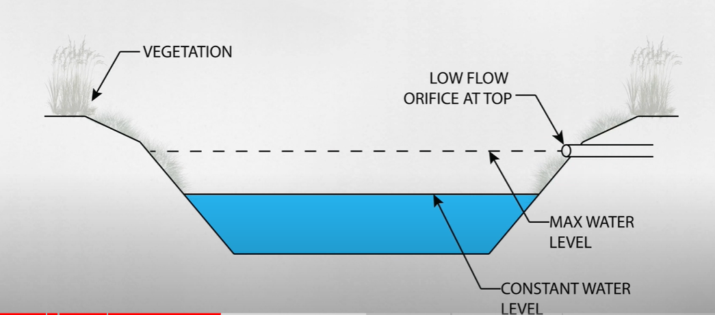

In retention pond there is always some water, and the water allowed on it is a low-flow over face.

Which is basically train pipe which slowly releases the overflow water into ground, water, rivers.

* As rain falls it will slowly rises and releases the water as needed to maintain a desired level

**Detention ponds :**

Detention ponds doesn’t have water in it at all times.

Detention ponds holds the water for a while after the rain, then releases it.

It usually covered with a vegetation.

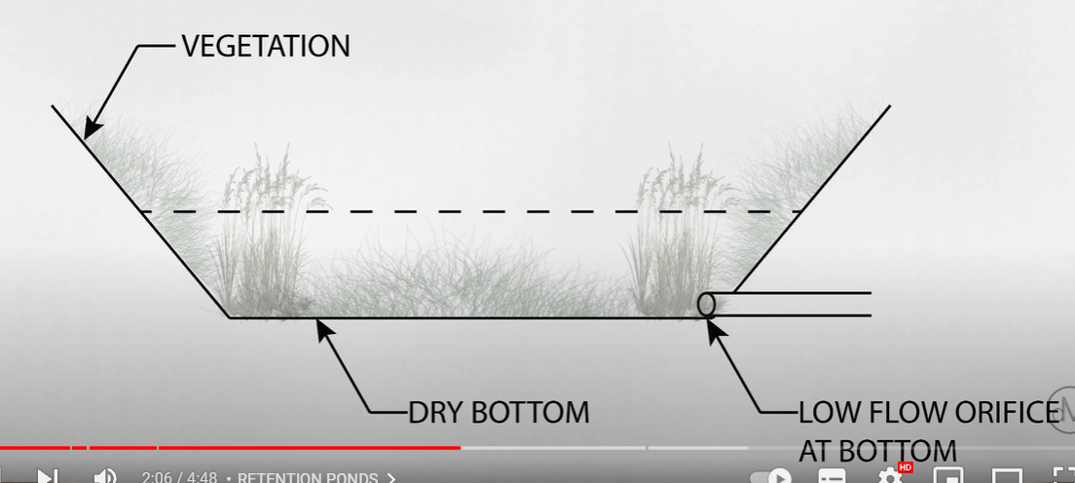

It also has a low-slow over face but It has at the bottom of the pond.

Rainwater harvesting :

* Rainwater harvesting (RWH) is the collection and storage of rain, rather than allowing it to run off.
* Rainwater is collected from a roof-like surface and redirected to a tank .

Infiltration Type devices :

Infiltration Trenches :

* They are shallow ditches ,used to slow down or reduce the process of erosion.

**Grass Filter Stripes**

Grass filter stripes are densely vegetated, uniformly graded areas that treat surface flow from adjacent impervious areas. Grass filter stripes function by slowing runoff velocities, trapping sediment and other pollutants and providing a modest infiltration.

#### Infiltration Basin

An infiltration basin (also called infiltration pond) is a facility constructed within highly permeable soils that provides temporary storage of stormwater runoff (see also [**surface groundwater recharge**](https://sswm.info/water-nutrient-cycle/reuse-and-recharge/hardwares/recharge-and-disposal/surface-groundwater-recharge)). An infiltration basin does not normally have a structural outlet (like detention basins) to discharge runoff from the stormwater quality design storm. Instead, outflow from an infiltration basin is through the surrounding soil.