**Key Technology concepts of E-commerce ecosystem**

* Packet Switching
* TCP/IP communications protocol
* Client/server computing

**Packet Switching**

* Packet switching is a method of transferring the data to a network in form of packets.
* In order to transfer the file fast and efficiently manner over the network and minimize the transmission latency, the data is broken into small pieces of variable length, called Packet.
* At the destination, all these small parts (packets) have to be reassembled, belonging to the same file.
* Packet Switching uses Store and Forward technique while switching the packets; while forwarding the packet each hop first stores that packet then forward.
* Sends packets along different communication paths as they become available.
* Each packet contains Source and destination address using which they independently travel through the network.
* More reliable as a destination can detect the missing packet.

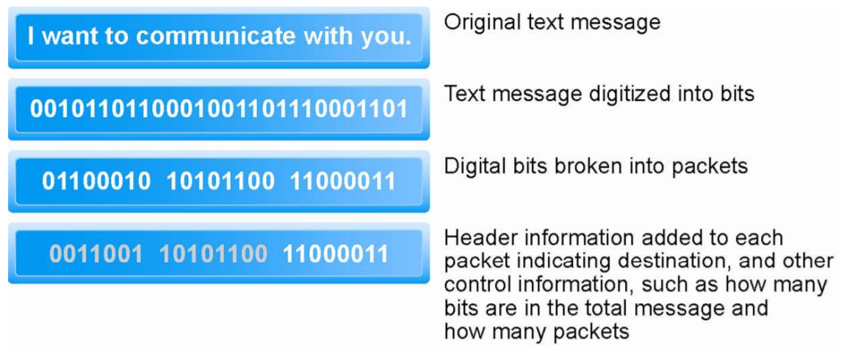

**TCP/IP**

**Transmission Control Protocol (TCP):**

* Establishes connections among sending and receiving Web computers.
* Handles assembly of packets at point of transmission, and reassembly at receiving end.

**Internet Protocol (IP):**

* Provides the Internet’s addressing scheme
* Four TCP/IP layers
  + Network interface layer
  + Internet layer
  + Transport layer
  + Application layer
* Architecture:

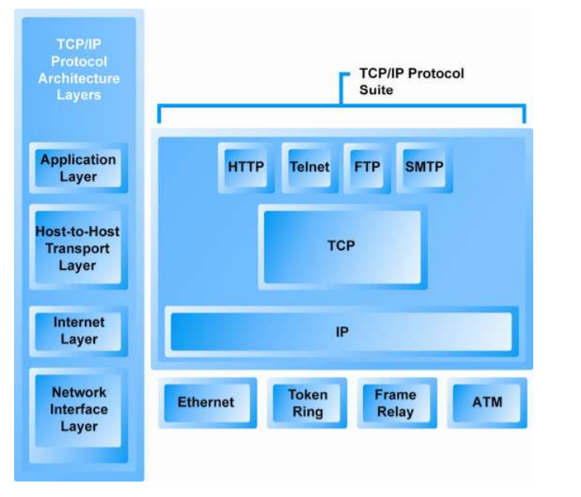

**Internet (IP) Addresses**

* A unique address that identifies the device over the network.
* IPv4:
  + 32-bit number
  + Four sets of numbers marked off by periods
* IPv6:
  + 128-bit addresses, able to handle up to 1 quadrillion addresses.
  + Due to more number of users IPv6 was introduced.
* Domain Name, DNS & Urls.
  + Domain Name: IP expressed in natural language
  + DNS: Allows numeric IP Addresses to be expressed in natural language.
  + URL: Uniform resource locator is used to uniquely identify a location of content on the web.

**Client/Server Computing**

* Powerful personal computers (clients) connected in network with one or more servers
* Servers perform common functions for the clients
  + Storing files
  + Software applications

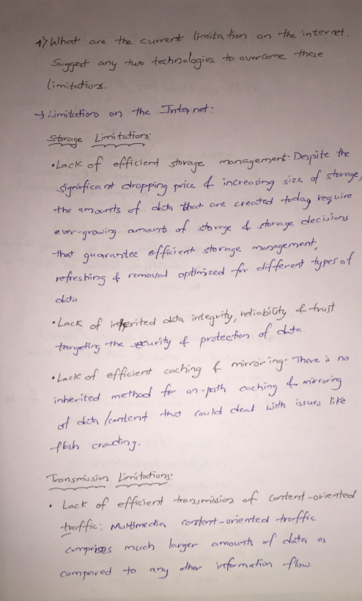

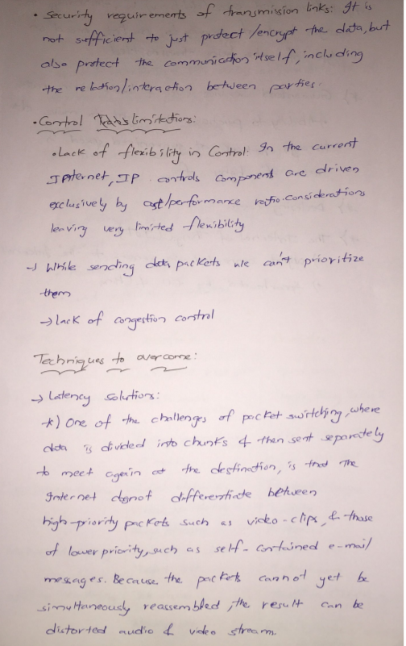

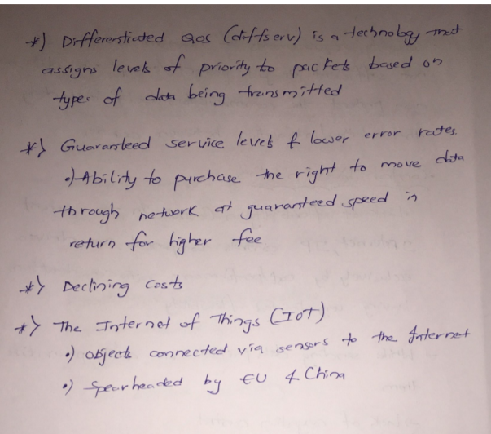

<http://vcl.iti.gr/vclNew/wp-content/uploads/2017/11/current-internet-limitations-v9.pdf>

