**IPR : Intellectual Property Rights**

-> Intellectual Property is an Idea, a design, an invention,

which can ultimately give rise to a useful product and

application.

-> Right of an inventor to derive economic benefits from his

IP, this right is called IPR.

Three main types of protection:

❖ Copyright

❖ Patent

❖ Trademark law

Patent means finding something new

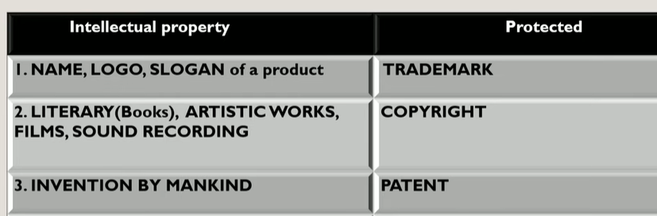

Trademark gives an official recognition to the Logo in which different companies have unique logo’s

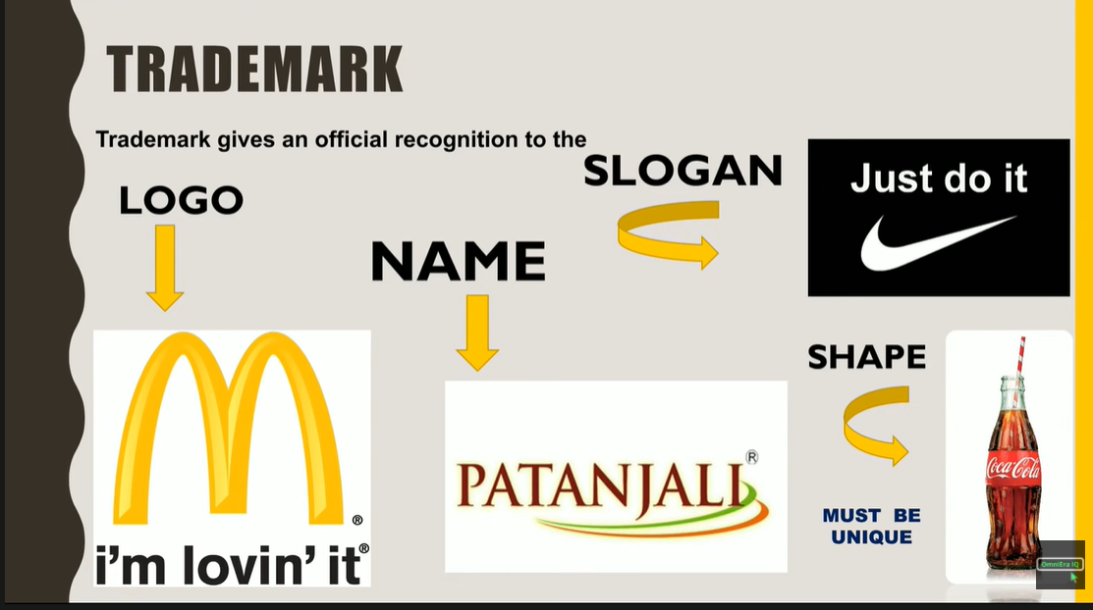

* Trademark is used to create the brand value
* To be protected from 3rd party using same name, slogan etc
* 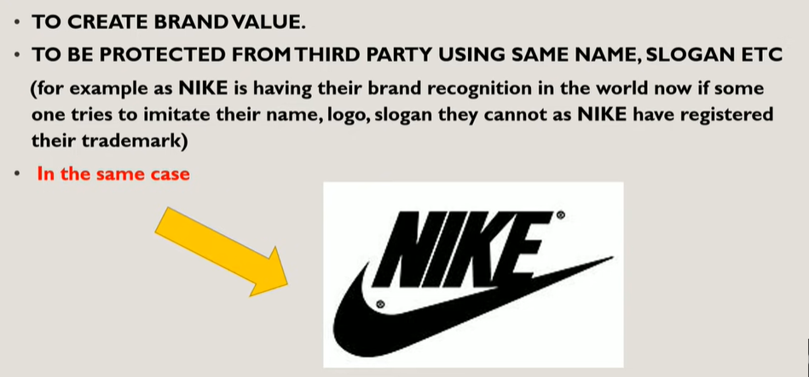

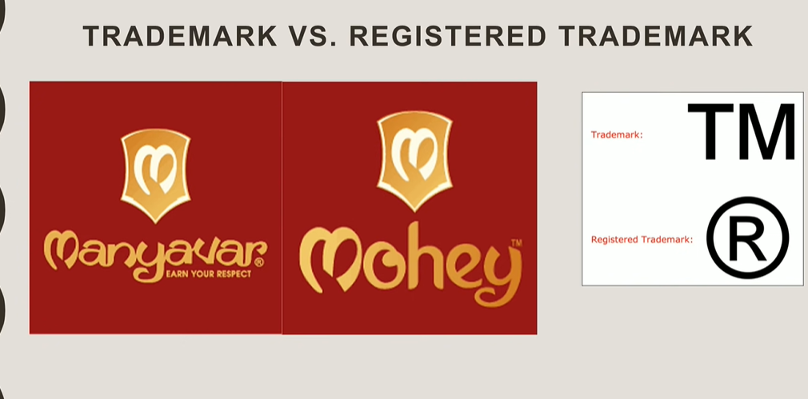

TM means that they have applied for trademark in which it takes 18-24 months to get as registered trademark

Validity for trademark and registered trademark is 10 years. After 10 years the need to re-register the trademark.

Patents:

* Patents deal with human invention.
* A right which has granted to the owner of the invention to make use, manufacture and market the invention.
* There has an invention and not a discovery.
* It has a tenure of 20 years monopoly on ideas behind an invention.
  + Machines
  + Man-made products
  + Processing methods
* Encourage inventors
* Inventions must be new
* Promotes discrimination of new techniques through licensing

Trademark:

* Identify, distinguish goods, and indicate their source.
* Trademark gives an official recognition to the Logo in which different companies have unique logo’s
* Trademark is used to create the brand value
* To be protected from 3rd party using same name, slogan etc
* TM means that they have applied for trademark in which it takes 18-24 months to get as registered trademark
* Validity for trademark and registered trademark is 10 years. After 10 years the need to re-register the trademark.
* Dilution(Behaviour) that weakens connection between trademark and product

Copyright:

* Copyright (**or author's right**) is a legal term used to describe the rights that creators have over their literary and artistic works.
* Others should not copy their idea or works, so that if anyone uses their work and copy the content then it will lead to infringement

**2. Define Privacy. Discuss Information privacy & Information rights in context of social, political and ethical issues.**

-> Privacy – the control over one's personal data

-> Information privacy is a subset of privacy.

-> Information privacy is a privacy of personal information in which the personal data is stored in computer systems.

-> Information privacy can be achieved by various methods like encryption, authentication and data masking.

-> Only the right users can get access to the information

-> For example, financial Information is sensitive.

-> The right to information privacy includes both the claim that certain information should not be collected at all.

-> and the claim of individuals to control the use of whatever information that is collected about them