1. What are the various types of social networks ? Deduct a model for business on any one type of social network based on knowledge you have acquired ?

* <https://www.techprevue.com/different-types-social-networking-sites/>

1. Discuss the various aspects considered for Profiling and Behaviour Targeting in e-commerce?
2. Describe the types of payment systems in e-commerce ? What are the alternative online payment systems, discuss ?

* <https://www.lyra.com/in/payment-methods/>
* 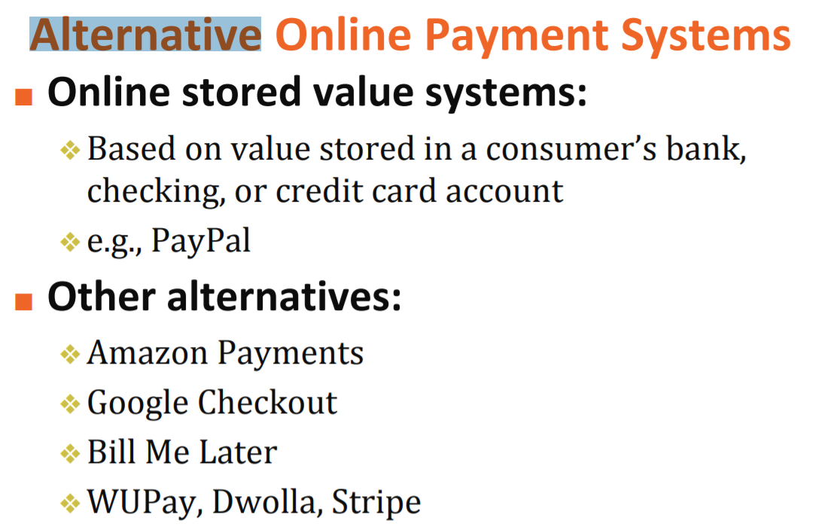
* <https://blog.shift4shop.com/5-top-alternative-payment-methods-to-offer-in-your-online-store>