***Orange Problem Solving***

***Srn: PES2UG24CS311***

***Section: D***

***Code***:

**import tkinter as tk**

**from tkinter import ttk, messagebox**

**import csv**

**def load_movies(filename):**

**movies = []**

**try:**

**with open(r"movie_dataset.csv", newline='') as csvfile:**

**reader = csv.DictReader(csvfile)**

**for row in reader:**

**row['Rating'] = float(row['Rating'])  # Convert rating to float**

**movies.append(row)**

**except FileNotFoundError:**

**messagebox.showerror("Error", f"File {filename} not found!")**

**return movies**

**def filter_movies(preferences, all_movies):**

**filtered = [**

**movie for movie in all_movies**

**if all(movie[genre] == '1' for genre in preferences)**

**]**

**return filtered**

**def recommend_movies():**

**selected_genres = [genre for genre, var in genre_vars.items() if var.get() == 1]**

**if not selected_genres:**

**messagebox.showinfo("No Preferences", "Please select at least one genre.")**

**return**

**filtered_movies = filter_movies(selected_genres, movies)**

**if not filtered_movies:**

**# If no match, show top 5 rated movies**

**filtered_movies = sorted(movies, key=lambda x: x['Rating'], reverse=True)[:5]**

**# Sort filtered movies by rating**

**filtered_movies = sorted(filtered_movies, key=lambda x: x['Rating'], reverse=True)**

**# Display results**

**output_text.delete("1.0", tk.END)**

**if filtered_movies:**

**output_text.insert(tk.END, "Top Pick:\n")**

**top_movie = filtered_movies[0]**

**output_text.insert(tk.END, f"{top_movie['Title']} ({top_movie['Release Year']}) - {top_movie['Rating']}\n\n")**

**output_text.insert(tk.END, "Recommendations:\n")**

**for movie in filtered_movies:**

**output_text.insert(tk.END, f"{movie['Title']} ({movie['Release Year']}) - {movie['Rating']}\n")**

**else:**

**output_text.insert(tk.END, "No recommendations available.")**

**# Clear preferences**

**def clear_preferences():**

**for var in genre_vars.values():**

**var.set(0)**

**output_text.delete("1.0", tk.END)**

**root = tk.Tk()**

**root.title("Movie Recommendation System")**

**heading = tk.Label(root, text="MOVIE RECOMMENDATION SYSTEM", font=("Arial", 16))**

**heading.grid(row=0, column=0, columnspan=2, pady=10)**

**genre_frame = tk.LabelFrame(root, text="Select Genres", padx=10, pady=10)**

**genre_frame.grid(row=1, column=0, padx=10, pady=10)**

**genres = ["Action", "Romance", "Sci-Fi", "Comedy", "Drama", "Animation"]**

**genre_vars = {genre: tk.IntVar() for genre in genres}**

**for i, genre in enumerate(genres):**

**chk = tk.Checkbutton(genre_frame, text=genre, variable=genre_vars[genre])**

**chk.grid(row=i // 2, column=i % 2, sticky="w")**

**btn_frame = tk.Frame(root)**

**btn_frame.grid(row=2, column=0, pady=10)**

**recommend_btn = ttk.Button(btn_frame, text="Recommend", command=recommend_movies)**

**recommend_btn.grid(row=0, column=0, padx=5)**

**clear_btn = ttk.Button(btn_frame, text="Clear", command=clear_preferences)**

**clear_btn.grid(row=0, column=1, padx=5)**

**output_frame = tk.LabelFrame(root, text="Recommendations", padx=10, pady=10)**

**output_frame.grid(row=1, column=1, rowspan=2, padx=10, pady=10)**

**output_text = tk.Text(output_frame, wrap="word", width=40, height=15)**

**output_text.grid(row=0, column=0)**

**movies = load_movies("movie_dataset.csv")**

**root.mainloop()**

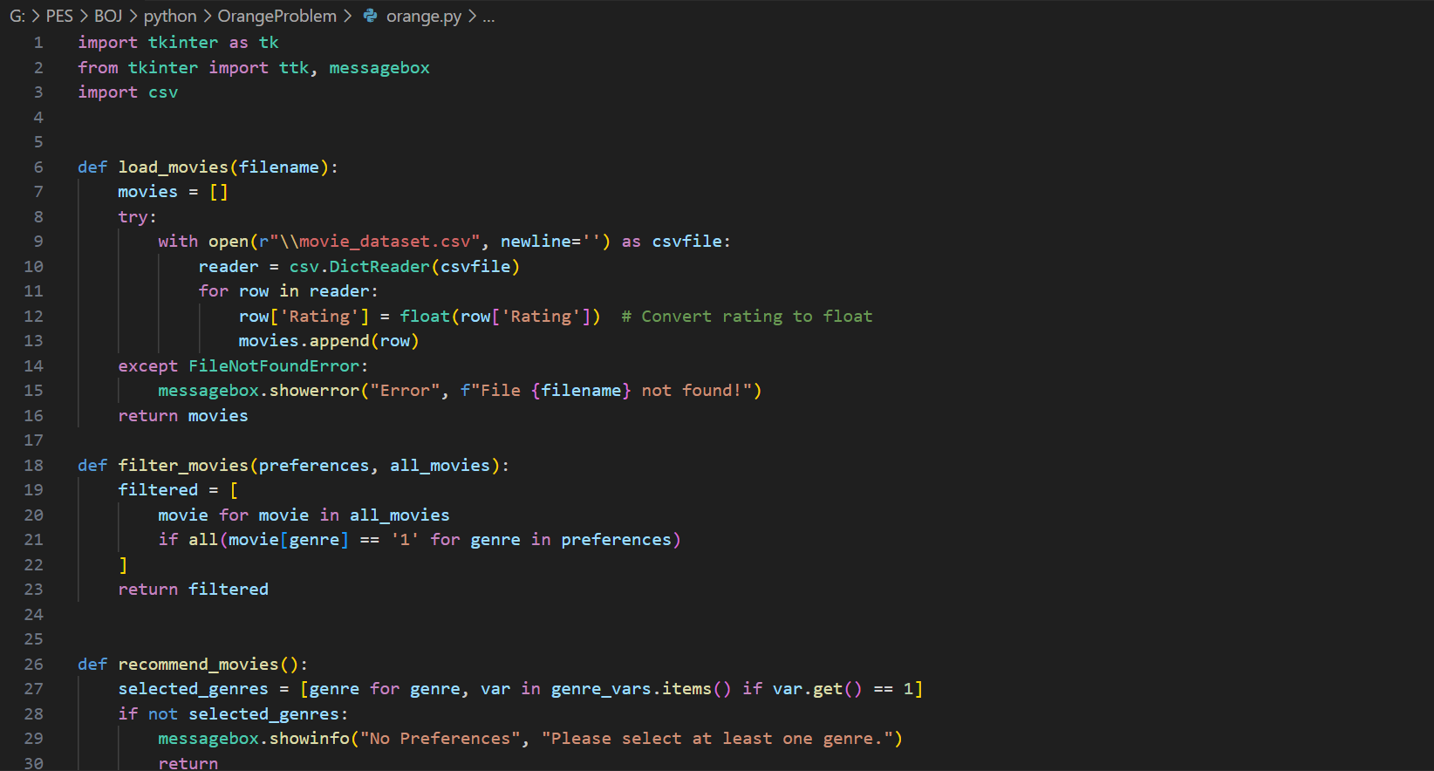

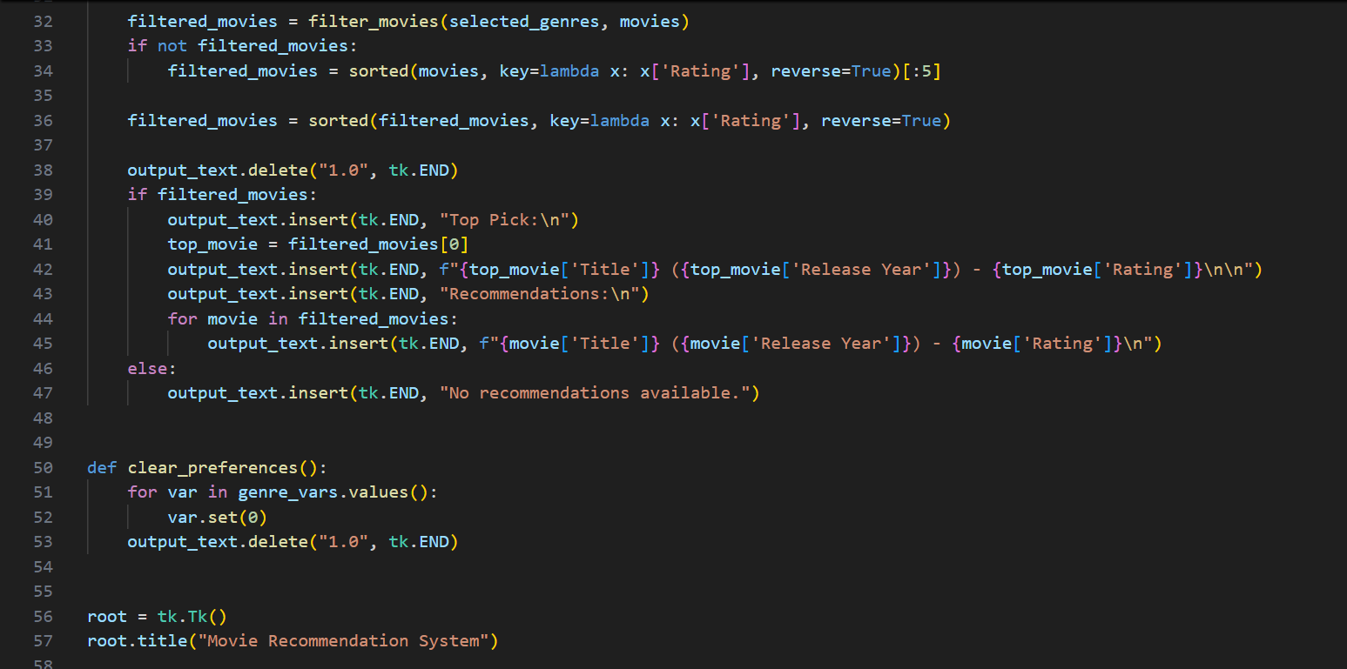

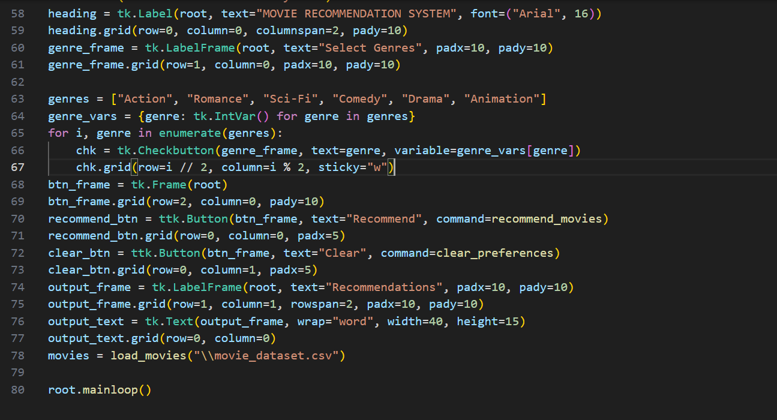

***Functions:***

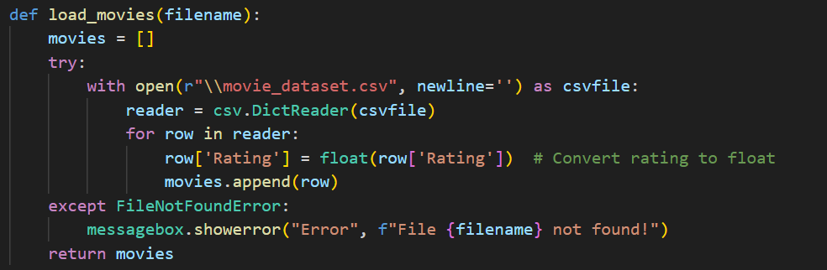

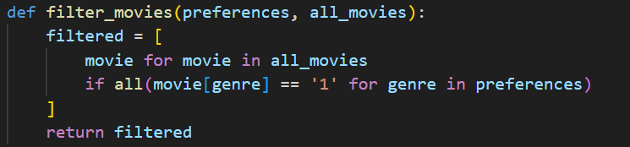

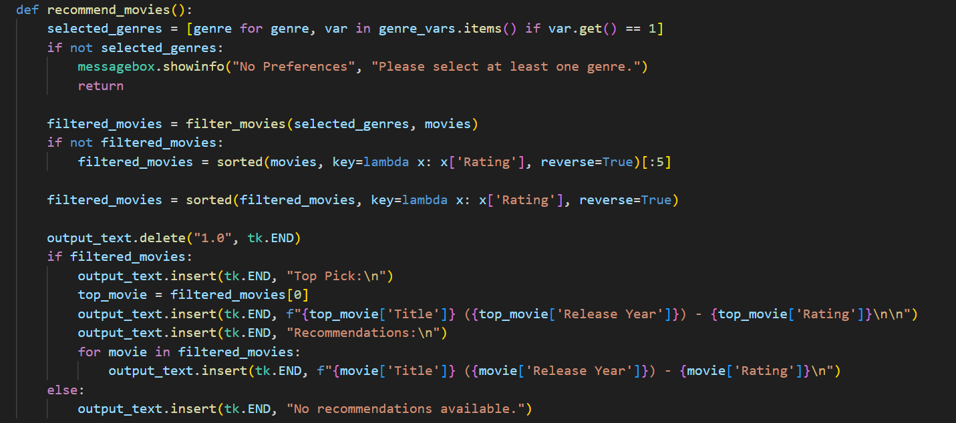

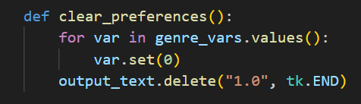

***Output***:

