Name: Neeraj R Rugi

SRN: PES2UG24CS311

1.

#include<stdio.h>

int main(){

printf("Enter The number of elements you want\n");

int len = 0;

scanf("%d", &len);

int a[len];

int out[len][2];

int temp;

int alraedy_present = 0;

int ele = 0;

printf("Enter Values: \n");

for(int i = 0; i < len; i++){

scanf("%d", &a[i]);

}

for(int i = 0; i < len; i++){

temp = a[i];

for(int j= 0; j < len;j++){

if(temp == out[j][0]){

alraedy_present = 1;

out[j][1] += 1;

break;

}

}

if(!alraedy_present){

out[ele][0] = temp;

out[ele][1] = 1;

ele++;

}

alraedy_present = 0;

}

for(int i = 0; i < ele; i++){

printf("%d Occours: %d times\n", out[i][0], out[i][1]);

}

return 0;

}

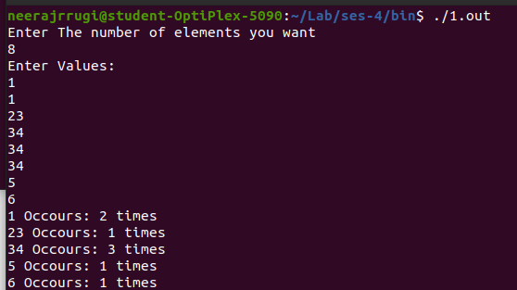

2.

#include<stdio.h>

int main(){

printf("Enter The number of elements you want\n");

int len;

scanf("%d", &len);

int a[len];

int out[len];

int temp;

int alraedy_present = 0;

int ele = 0;

printf("Enter Values: \n");

for(int i = 0; i < len; i++){

scanf("%d", &a[i]);

}

for(int i = 0; i < len; i++){

temp = a[i];

for(int j= 0; j < len;j++){

if(temp == out[j]){

alraedy_present = 1;

break;

}

}

if(!alraedy_present){

out[ele] = temp;

ele++;

}

alraedy_present = 0;

}

printf("The array after removing duplicates is: \n");

for(int i = 0; i < ele; i++){

printf("%d\n", out[i]);

}

return 0;

}

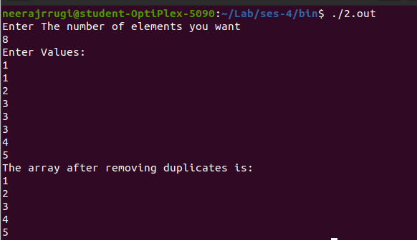

3.

#include<stdio.h>

int main(){

printf("Enter the number of rows and columns you require: \n");

int r,c;

r = 0;

c = 0;

scanf("%d %d", &r, &c);

printf("Enter the values for Array A row wise: \n");

int a[r][c], b[r][c], x[r][c];

for(int i = 0; i < r; i++){

for(int j = 0; j < c; j++){

scanf("%d", &a[i][j]);

}

}

printf("Enter the values for Array B row wise: \n");

for(int i = 0; i < r; i++){

for(int j = 0; j < c; j++){

scanf("%d", &b[i][j]);

}

}

for(int i = 0; i < r; i++){

for(int j = 0; j < c; j++){

x[i][j] = a[i][j] + b[i][j];

}

}

printf("The Matrix Sum is: \n");

for(int i = 0; i < r; i++){

for(int j = 0; j < c; j++){

printf("%d ", x[i][j]);

}

printf("\n");

}

}

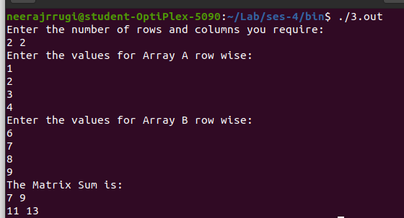

4.

#include<stdio.h>

int main(){

printf("Enter the order of the matrix \n");

int r;

scanf("%d", &r);

printf("Enter the values for Array A row wise: \n");

int a[r][r];

int p_dig =0, s_dig = 0;

int x = 0, y = r-1;

for(int i = 0; i < r; i++){

for(int j = 0; j < r; j++){

scanf("%d", &a[i][j]);

}

}

for(int i = 0; i < r; i++){

p_dig += a[i][i];

}

for(int i = 0; i < r; i++){

s_dig += a[x][y];

x++;

y--;

}

printf("The Primary diagonal Sum is: %d\n",p_dig);

printf("The Secondary diagonal Sum is: %d\n",s_dig);

}

