Name: Neeraj R Rugi
SRN: PES2UG24CS311
1.
#include<stdio.h>
int main(){
printf("Enter The number of elements you want\n");
int len = 0;
scanf("%d", &len);
int a[len];
int out[len][2];
int temp;
int alraedy_present = 0;
int ele = 0;

printf("Enter Values: \n");
for(int i = 0; i < len; i++){
scanf("%d", &a[i]);
}
for(int i = 0; i < len; i++){
temp = a[i];
for(int j= 0; j < len;j++){
if(temp == out[j][0]){
alraedy_present = 1;
out[j][1] += 1;
break;
}
}
if(!alraedy_present){
out[ele][0] = temp;
out[ele][1] = 1;
ele++;
}
alraedy_present = 0;
}
for(int i = 0; i < ele; i++){

printf("%d Occours: %d times\n", out[i][0], out[i][1]);
}
return 0;
}

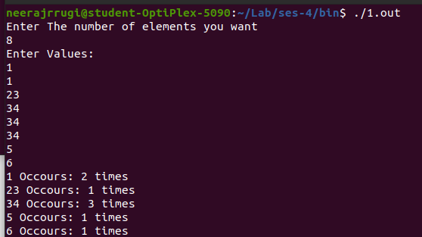

2.
#include<stdio.h>
int main(){
printf("Enter The number of elements you want\n");
int len;
scanf("%d", &len);
int a[len];
int out[len];
int temp;
int alraedy_present = 0;
int ele = 0;

printf("Enter Values: \n");
for(int i = 0; i < len; i++){
scanf("%d", &a[i]);
}
for(int i = 0; i < len; i++){
temp = a[i];
for(int j= 0; j < len;j++){
if(temp == out[j]){
alraedy_present = 1;
break;
}
}
if(!alraedy_present){
out[ele] = temp;
ele++;
}
alraedy_present = 0;
}
printf("The array after removing duplicates is: \n");
for(int i = 0; i < ele; i++){

printf("%d\n", out[i]);

}
return 0;
}

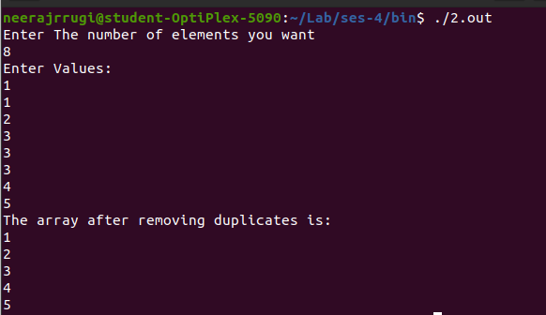

3.
#include<stdio.h>
int main(){
printf("Enter the number of rows and columns you require: \n");
int r,c;
r = 0;
c = 0;
scanf("%d %d", &r, &c);
printf("Enter the values for Array A row wise: \n");
int a[r][c], b[r][c], x[r][c];
for(int i = 0; i < r; i++){
for(int j = 0; j < c; j++){
scanf("%d", &a[i][j]);
}
}
printf("Enter the values for Array B row wise: \n");
for(int i = 0; i < r; i++){
for(int j = 0; j < c; j++){
scanf("%d", &b[i][j]);
}
}
for(int i = 0; i < r; i++){
for(int j = 0; j < c; j++){
x[i][j] = a[i][j] + b[i][j];
}
}
printf("The Matrix Sum is: \n");
for(int i = 0; i < r; i++){
for(int j = 0; j < c; j++){
printf("%d ", x[i][j]);
}
printf("\n");
}
}

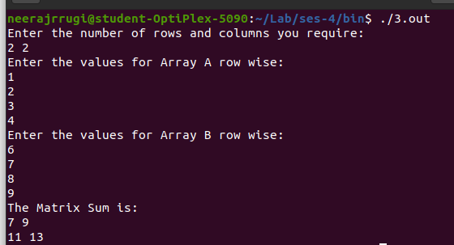

4.
#include<stdio.h>
int main(){
printf("Enter the order of the matrix \n");
int r;
scanf("%d", &r);
printf("Enter the values for Array A row wise: \n");
int a[r][r];
int p_dig =0, s_dig = 0;

int x = 0, y = r-1;
for(int i = 0; i < r; i++){
for(int j = 0; j < r; j++){
scanf("%d", &a[i][j]);
}
}
for(int i = 0; i < r; i++){
p_dig += a[i][i];
}

for(int i = 0; i < r; i++){
s_dig += a[x][y];
x++;
y--;
}

printf("The Primary diagonal Sum is: %d\n",p_dig);
printf("The Secondary diagonal Sum is: %d\n",s_dig);
}

