Name: Neeraj R Rugi
SRN: PES2UG24CS311
Week: 8
Class: F
1. Register:
a) Test-Bench File:
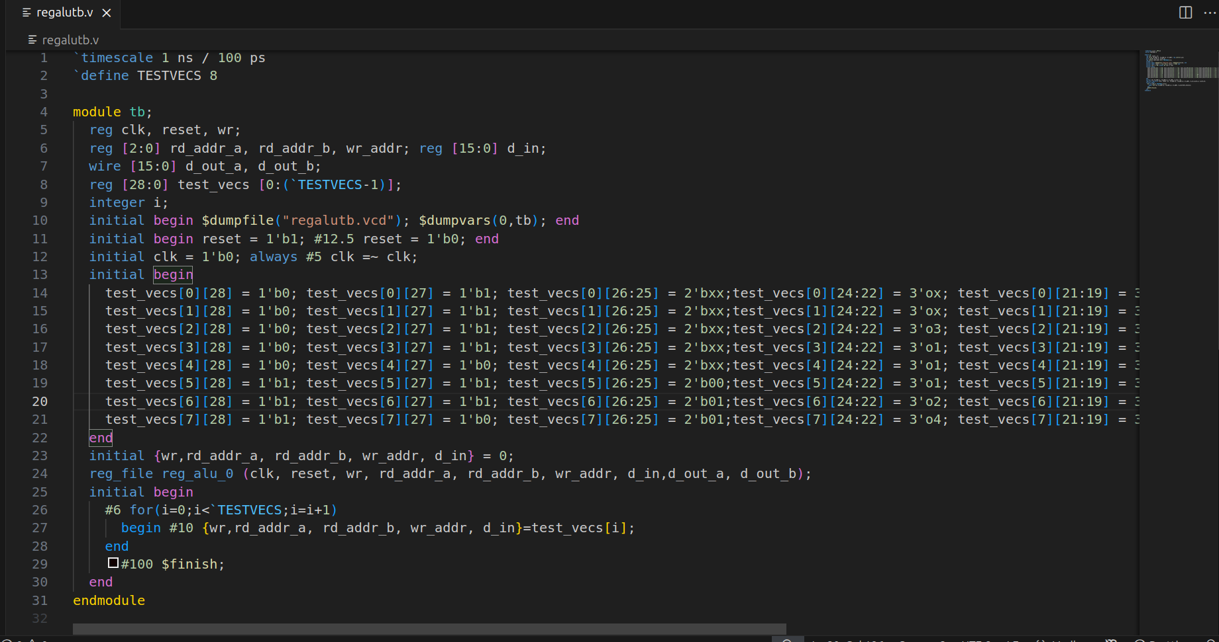
b)Register File:
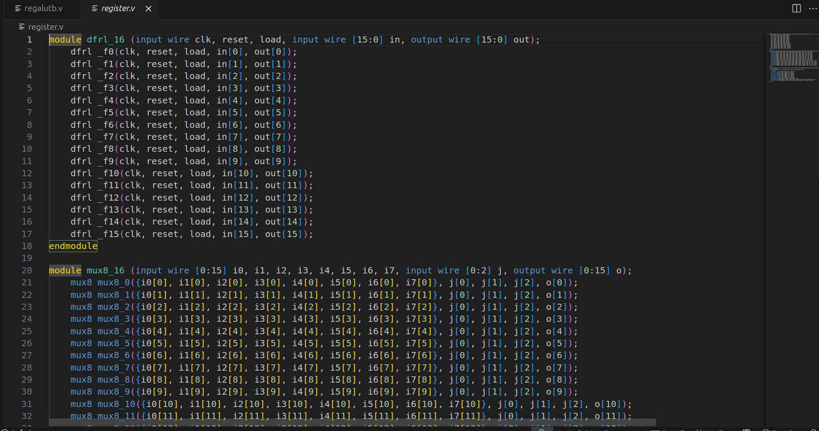
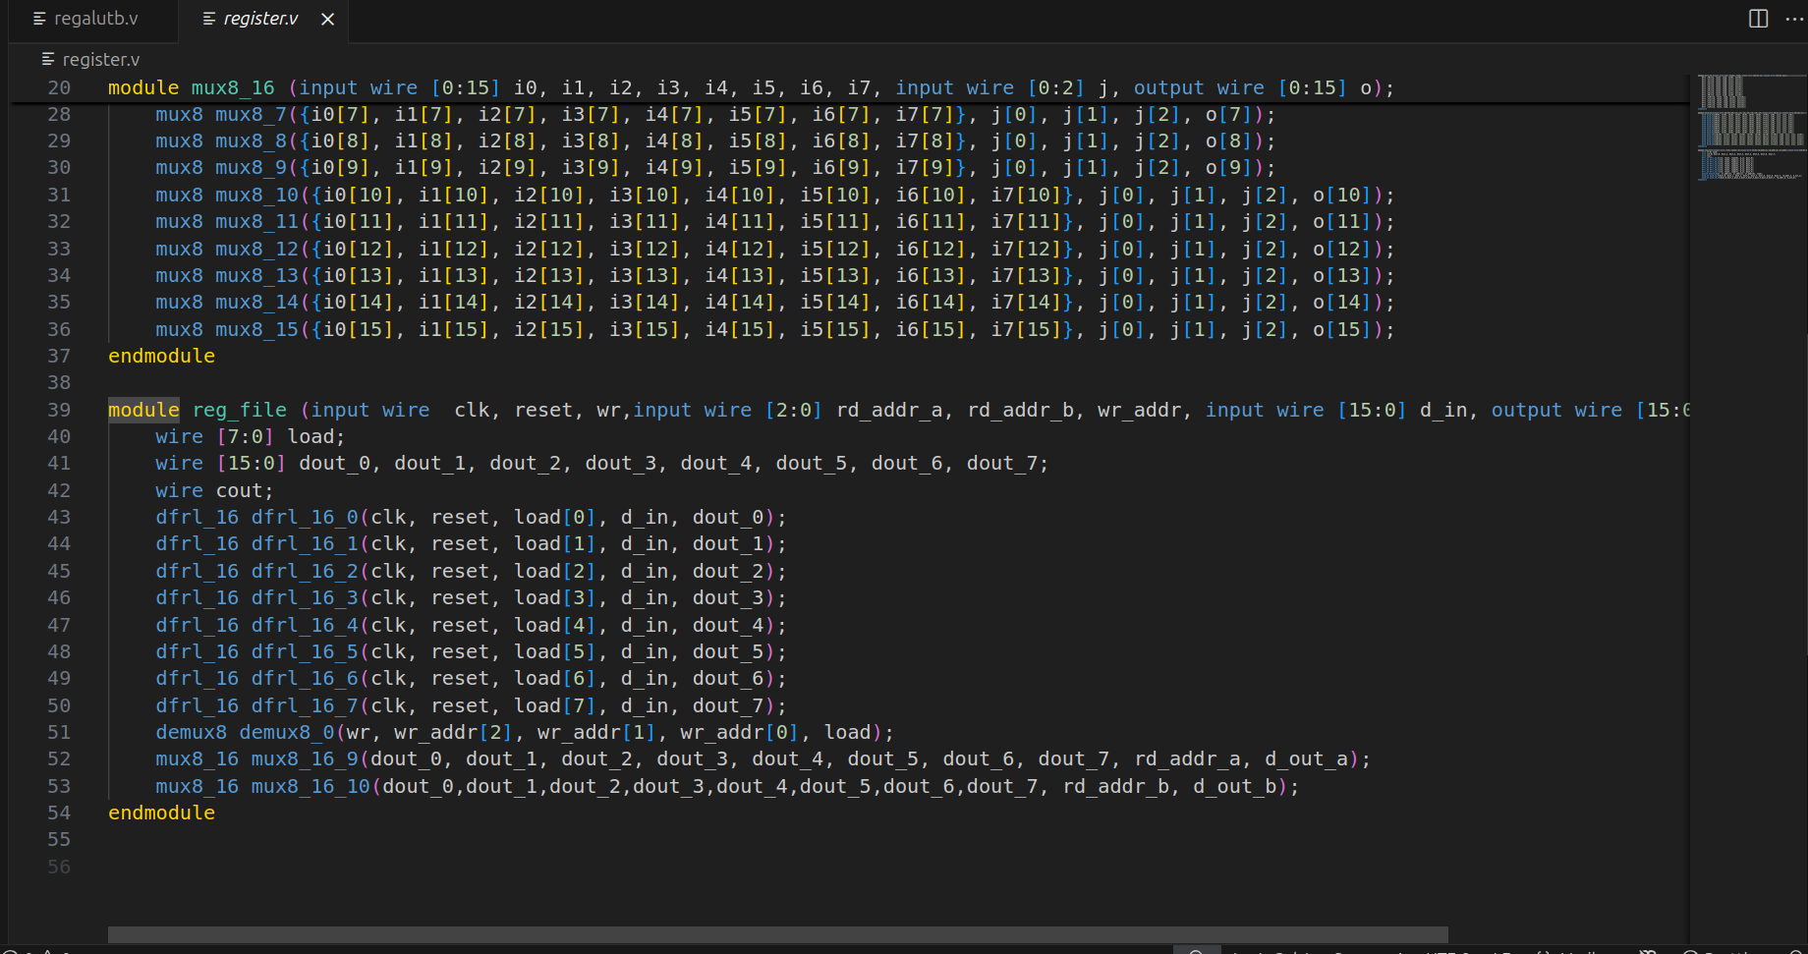

C)GtkWave:

