Digital Design and Computer Organisation Laboratory
3rd Semester, Academic Year 2025
Date:13-10-2025
Name: | SRN: | Section

Week Number: 8 Program Number:
TITLE:Register
Deliverables
- Verilog Code Screenshot
- Verilog VVP Output Screen Shot
- GTKWAVE Screenshot
- Output Table to be completed and included

Register:
Register.v:
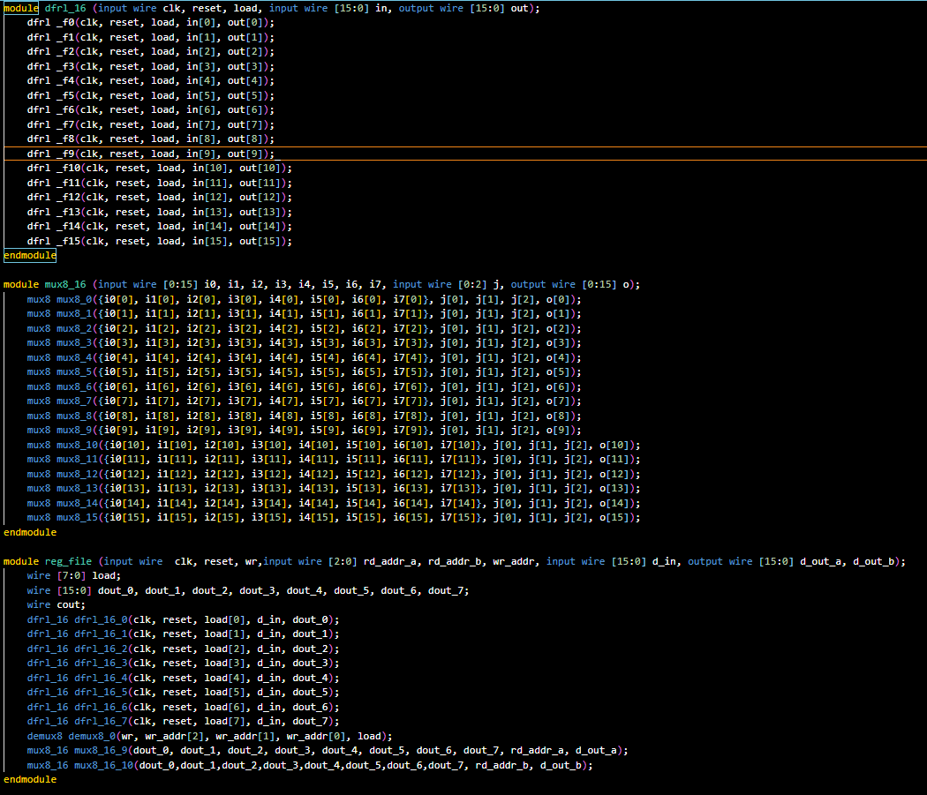
Registertb.v:
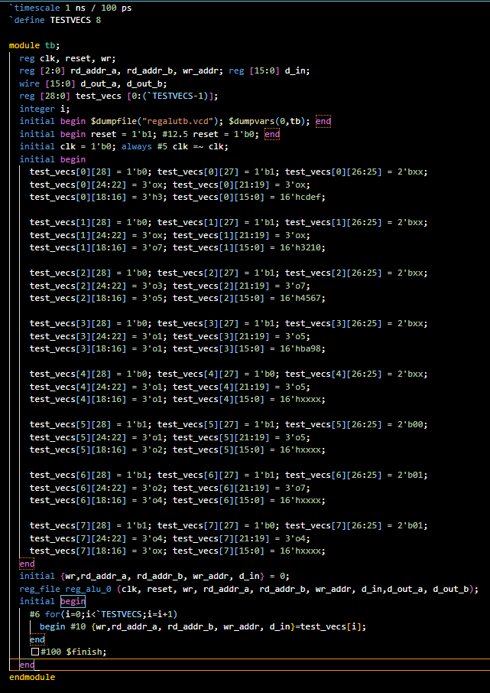
ALU.v:
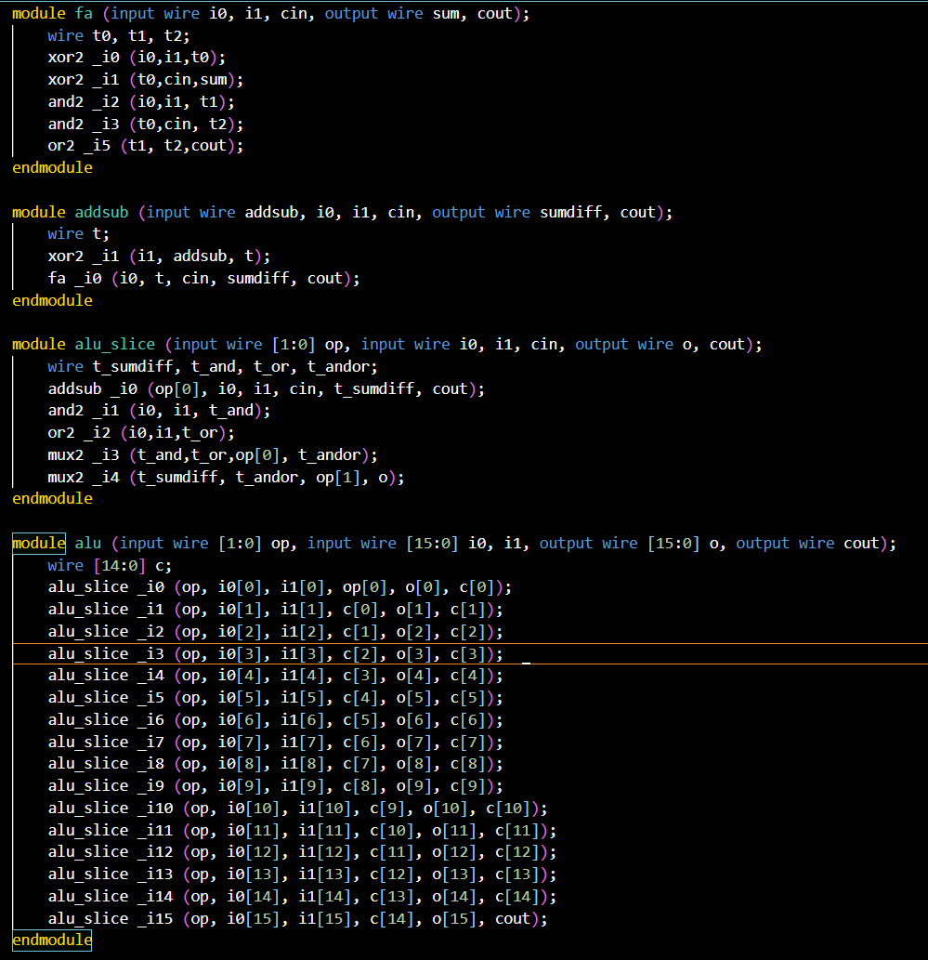
Lib.v:
