Digital Design and Computer Organisation Laboratory
3rd Semester, Academic Year 2025
Date: 8-9-2025
Name: | SRN: | Section

Week Number: 5 Program Number:
TITLE:
Deliverables
- Verilog Code Screenshot
- Verilog VVP Output Screen Shot
- GTKWAVE Screenshot
- Output Table to be completed and included

D Flip Flop:
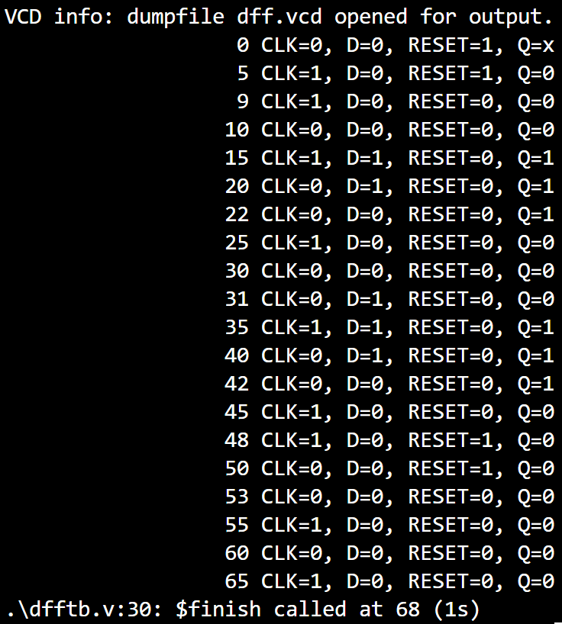
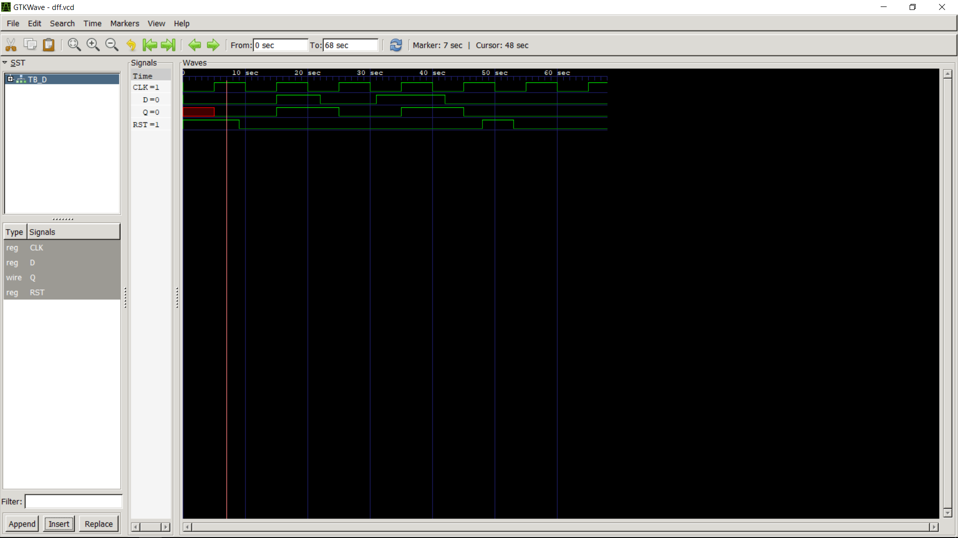

T Flip Flop:
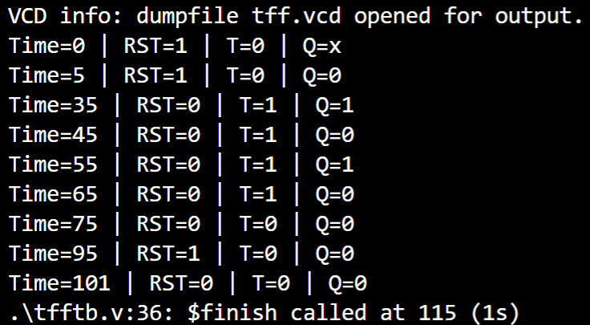
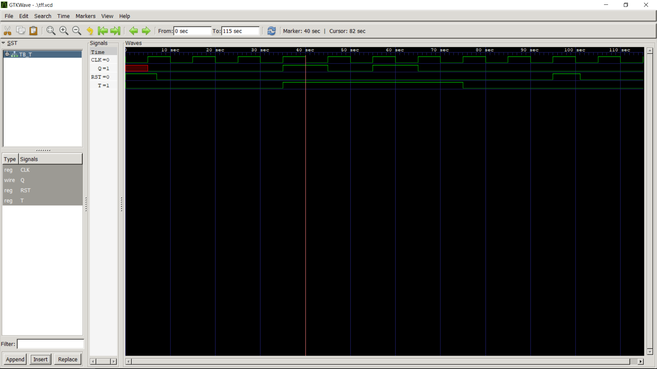

JK Flip Flop:
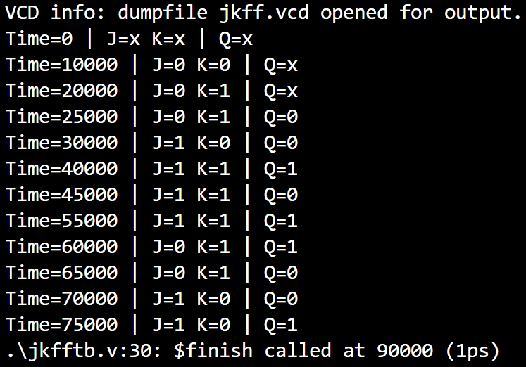
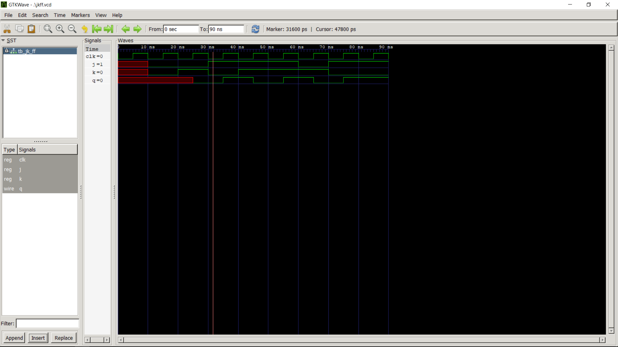

SR Flip Flop:
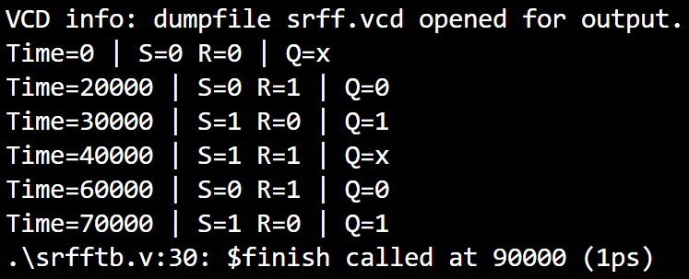
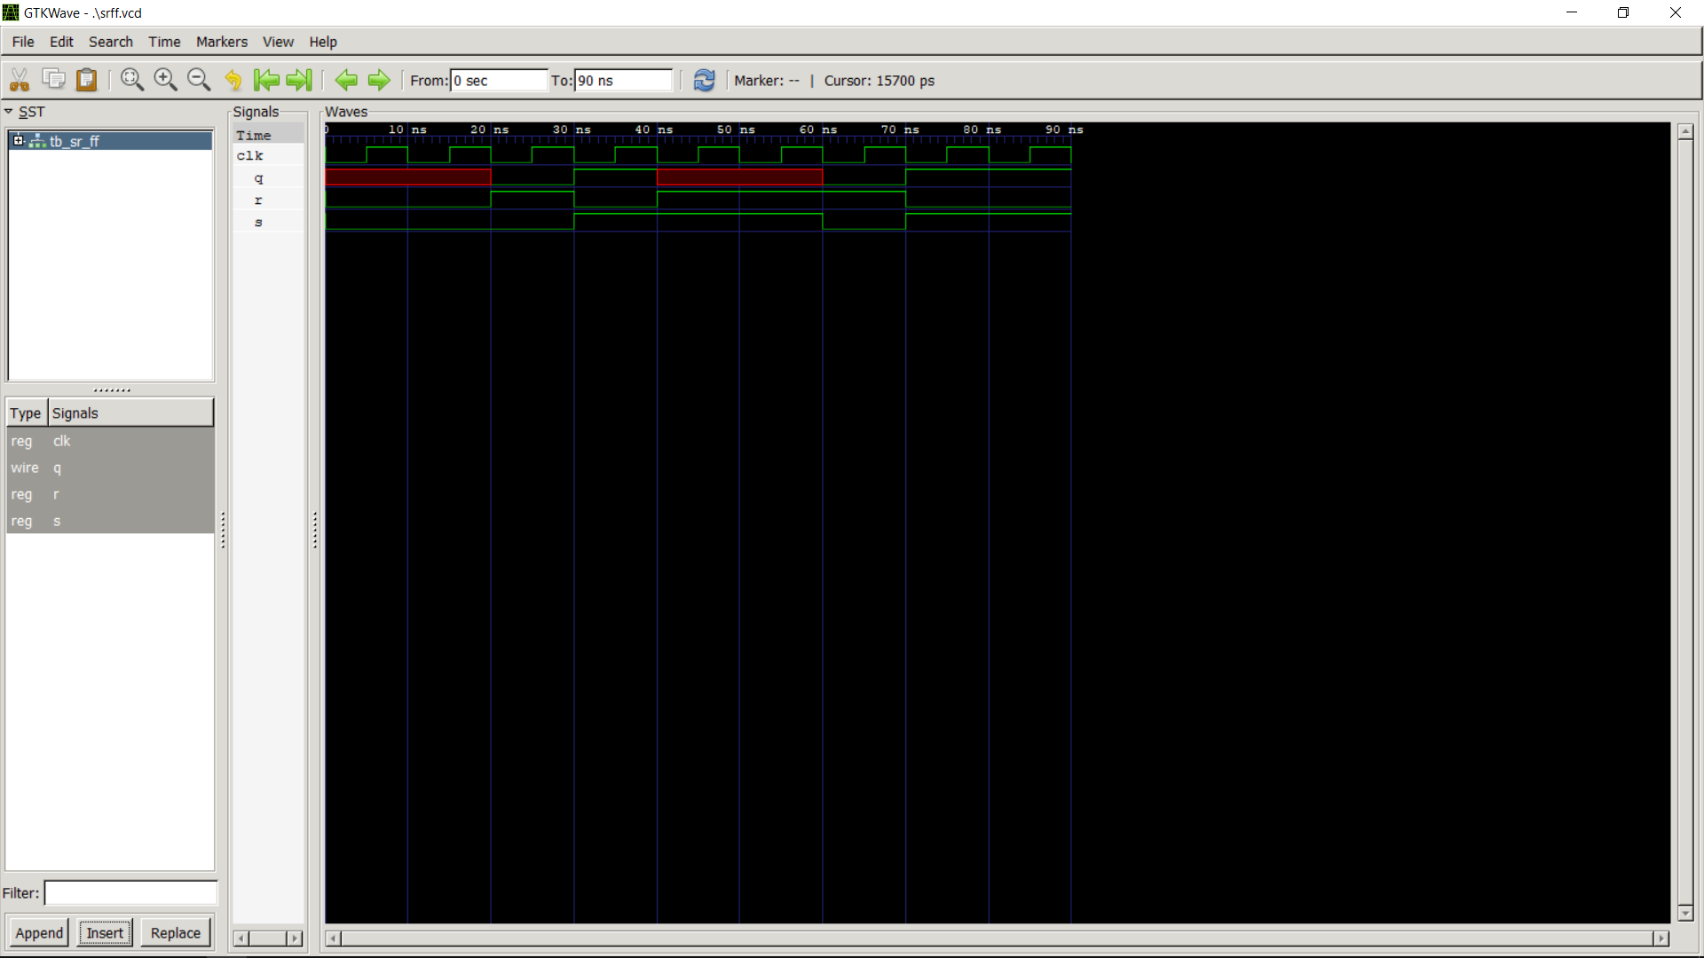

T Flip Flop to D Flip Flop:

