DDCO LAB
Sem-III
Week: 1
Section: F
SRN: PES2UG24CS311
Name: Neeraj R Rugi

1. AND Gate:
code:
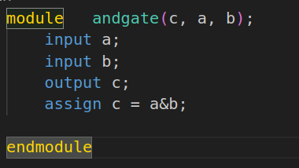

vvp:
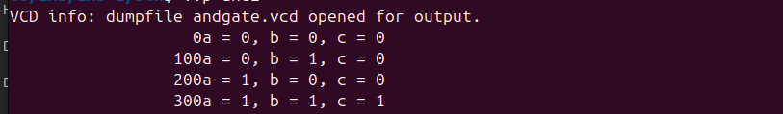
gtkwave:
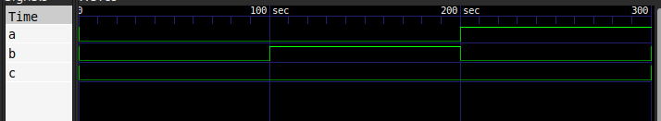

2. OR Gate:
Code:
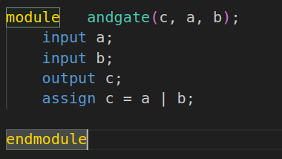

vvp:

gtkwave:
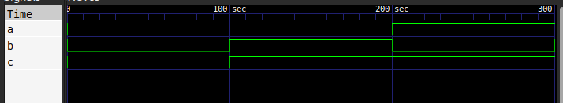

3. NOT Gate:
code:
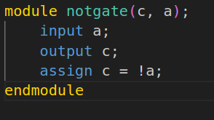

vvp:
gtkwave:
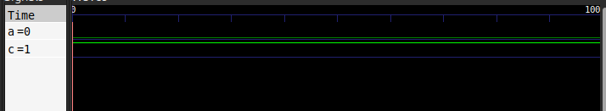

4. NAND Gate:
code:
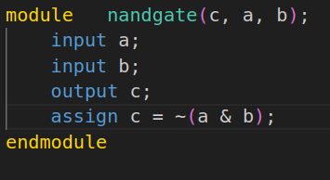

vvp:
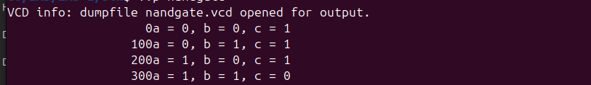
gtkwave:

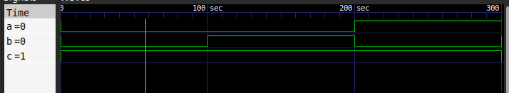

5. NOR Gate:
code:
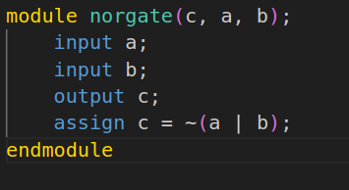

vvp:

gtkwave:
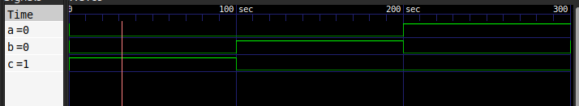

6. XOR Gate:
code:
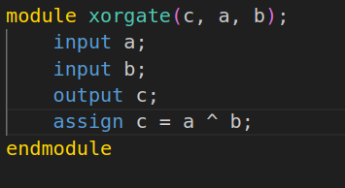

vvp:

gtkwave:
