Digital Design and Computer Organisation Laboratory
3rd Semester, Academic Year 2025
Date: 28-8-2025
Name: | SRN: | Section

Week Number: 4 Program Number: 4 and 5
TITLE:
Deliverables
- Verilog Code Screenshot
- Verilog VVP Output Screen Shot
- GTKWAVE Screenshot
- Output Table to be completed and included

2:4 Decoder:
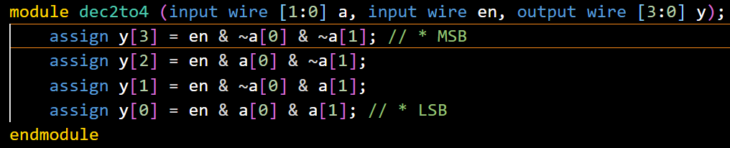
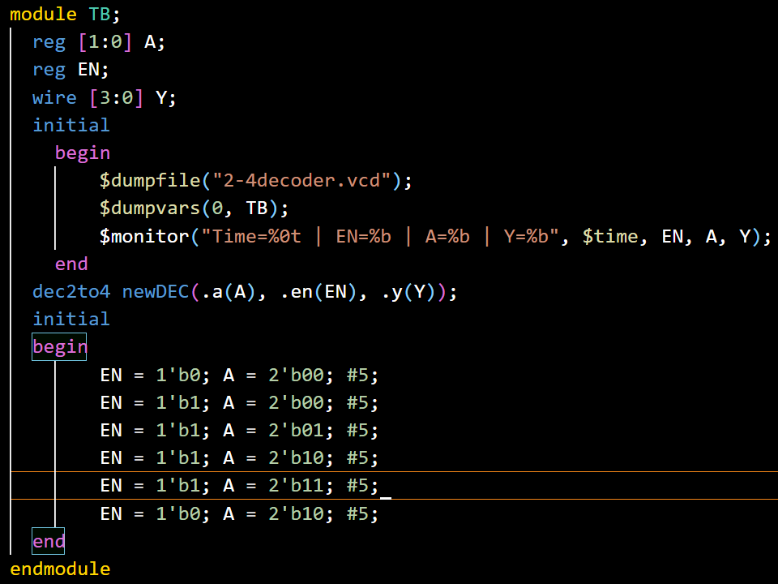
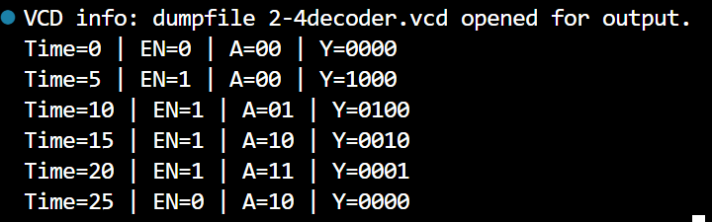
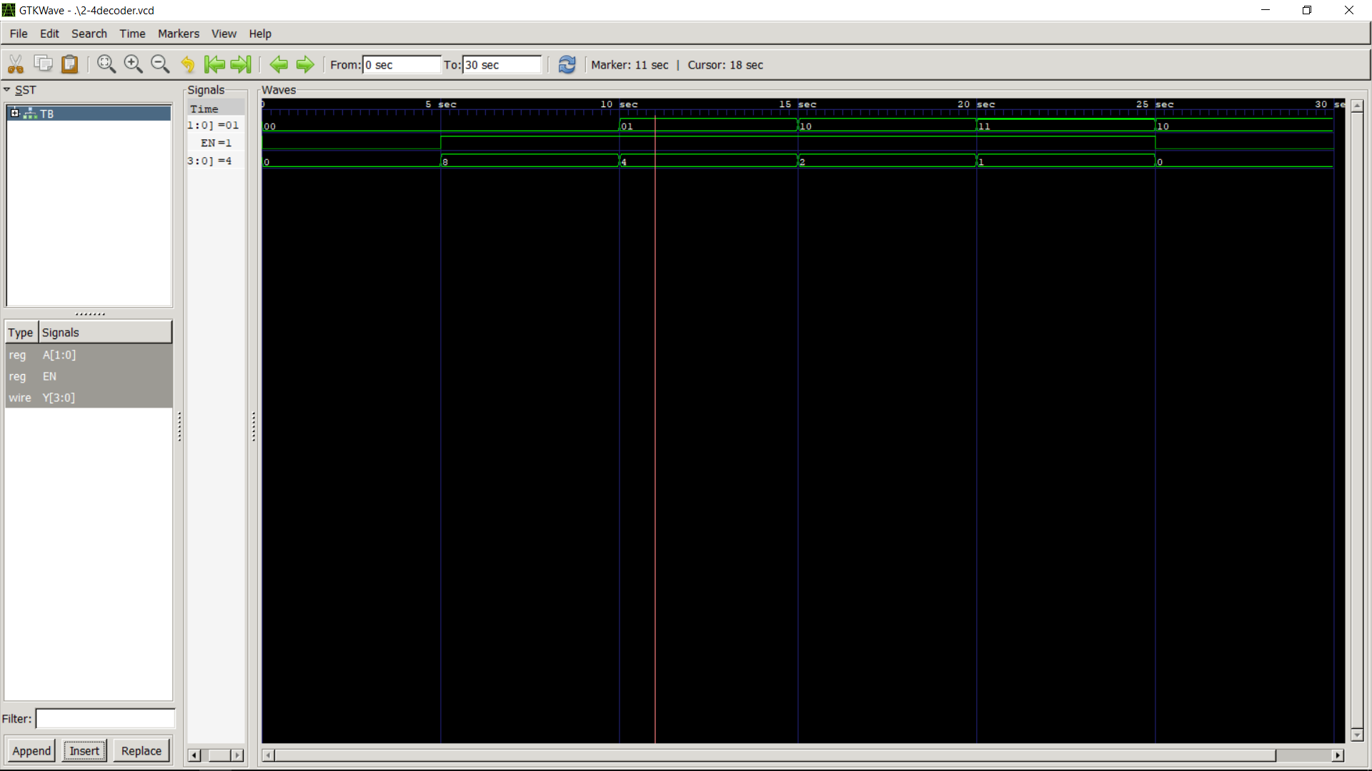

4:2 Encoder:
