Digital Design and Computer Organisation Laboratory
UE22CS251A
3rd Semester, Academic Year 2023
Date: 06-11-2023
Name: Siri N Shetty | SRN: PES2UG22CS556 | Section: J
Week#____7_______Program Number: ____1___
TITLE: Microprocessor Control Logic
- Verilog Code Screenshot (alu.v)
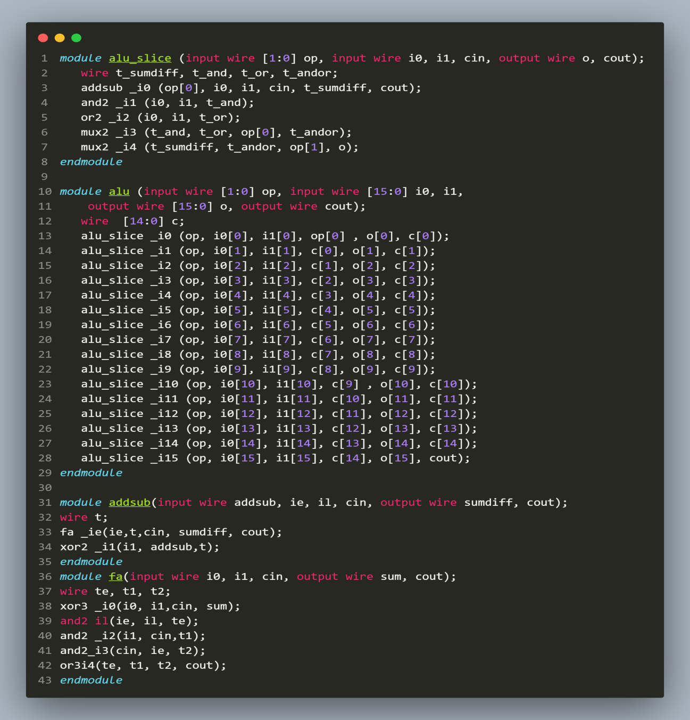
- Verilog Code Screenshot (lib.v)
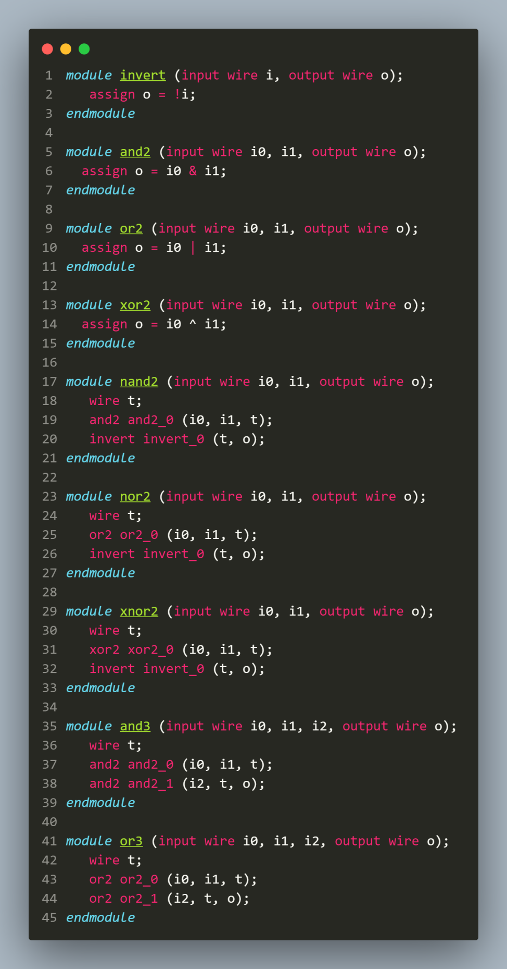
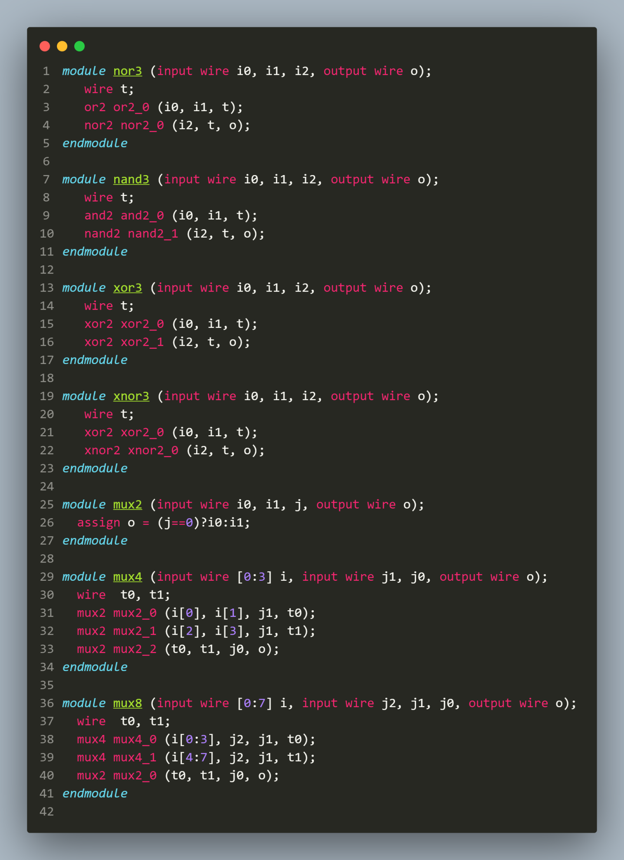
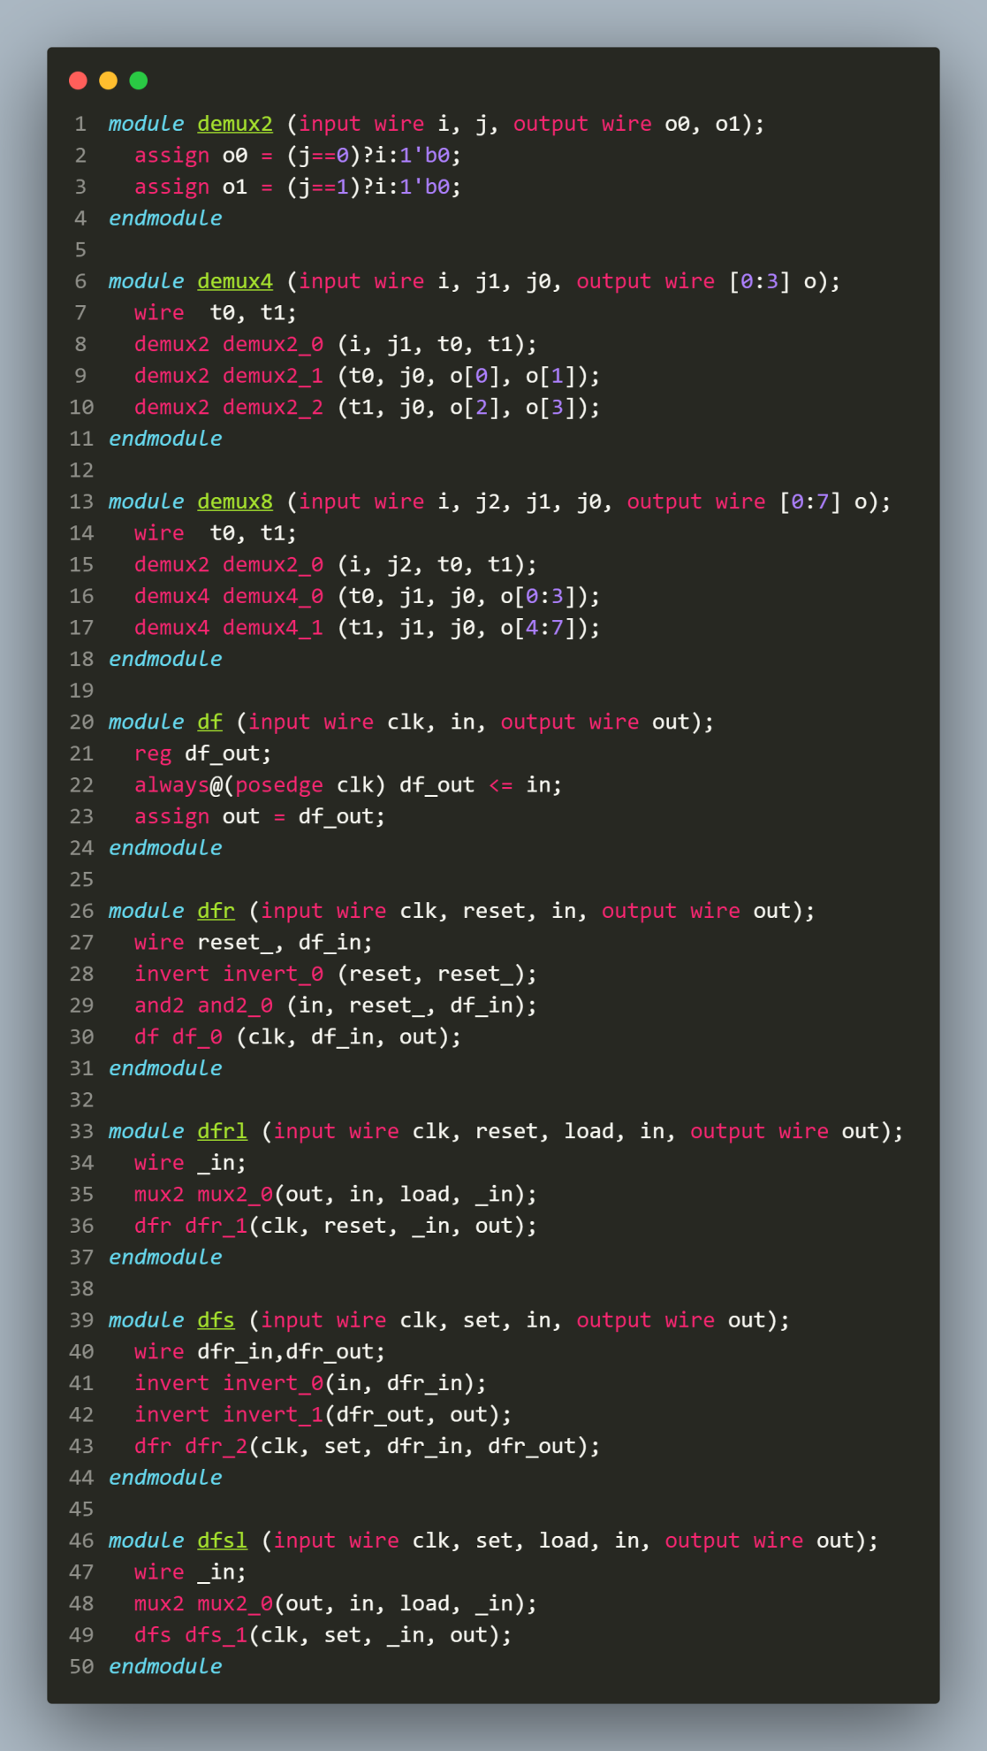
- Verilog Code Screenshot (mproc_mem.v)
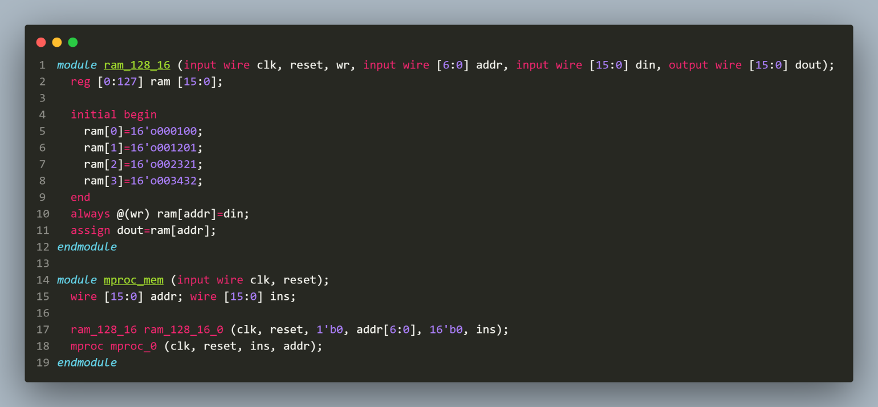
- Verilog Code Screenshot (reg_alu.v)
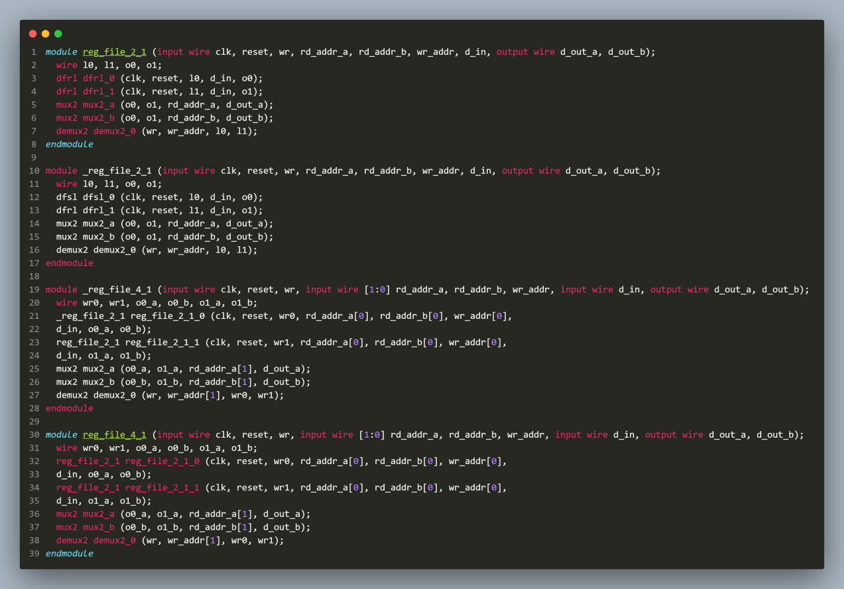
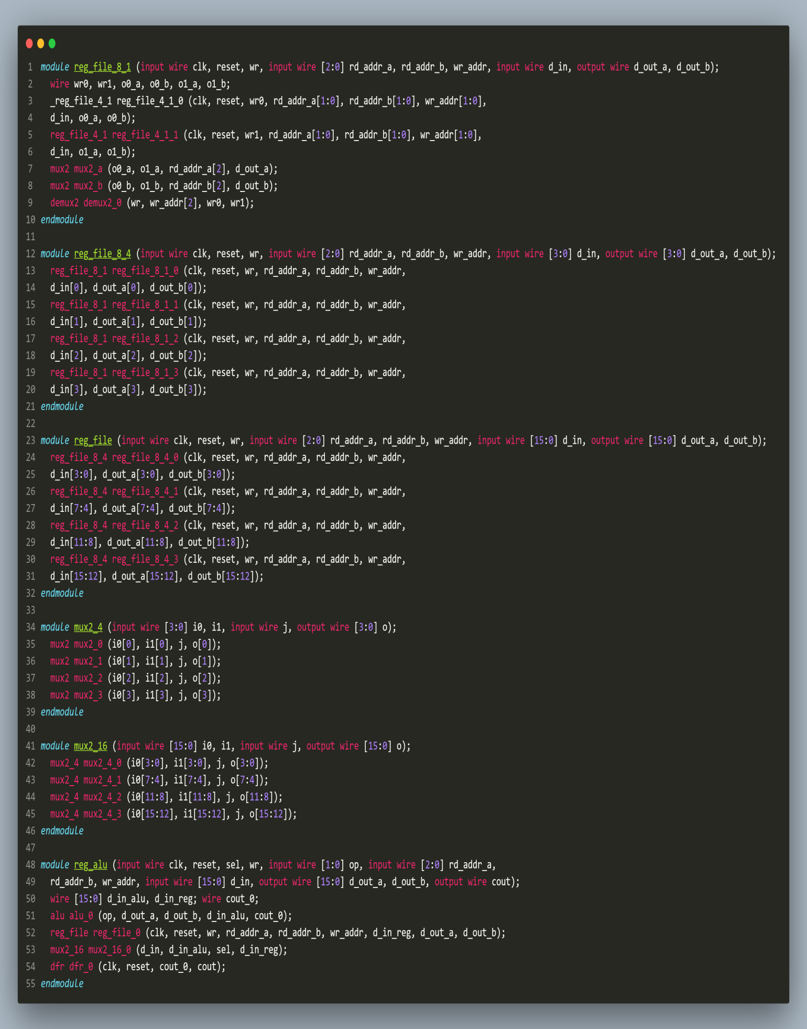
- Verilog Code Screenshot (mproc.v)
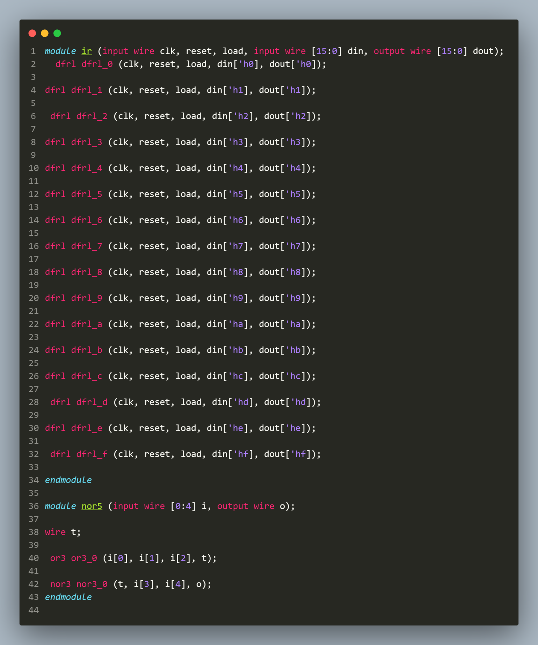
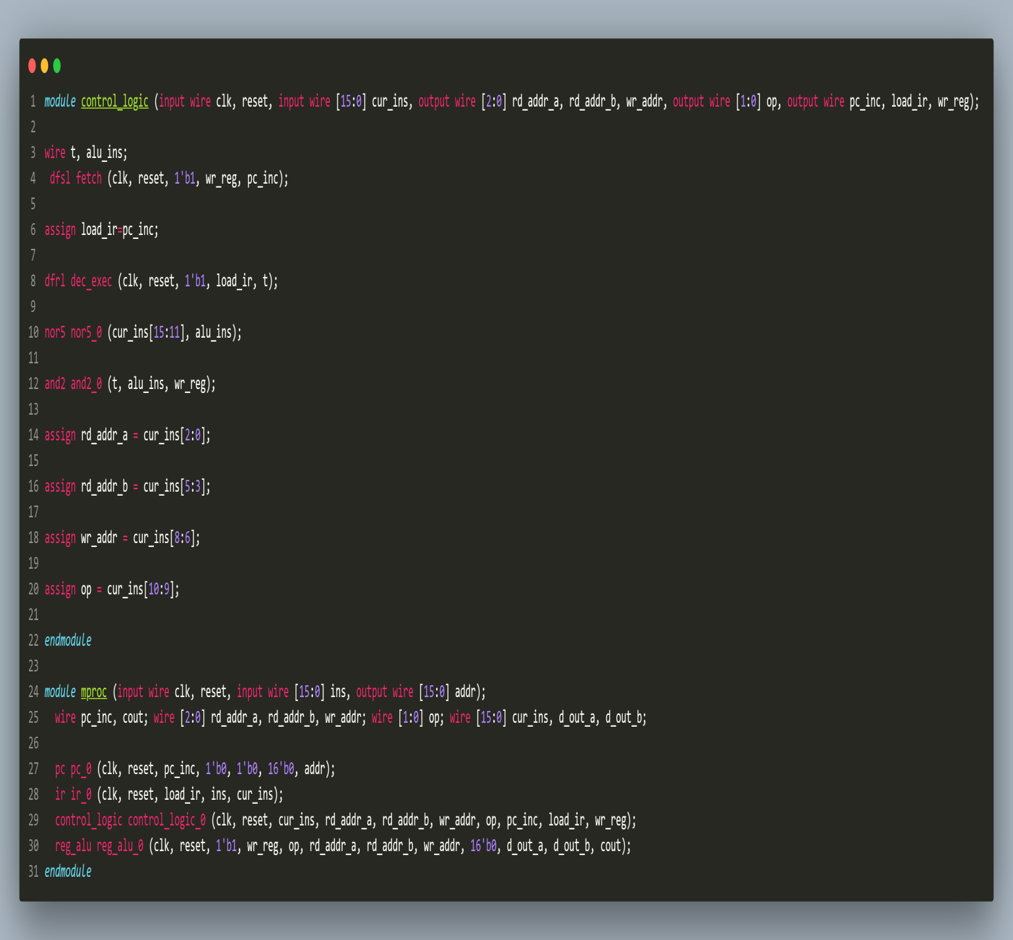

- Verilog Code Screenshot (pc.v)
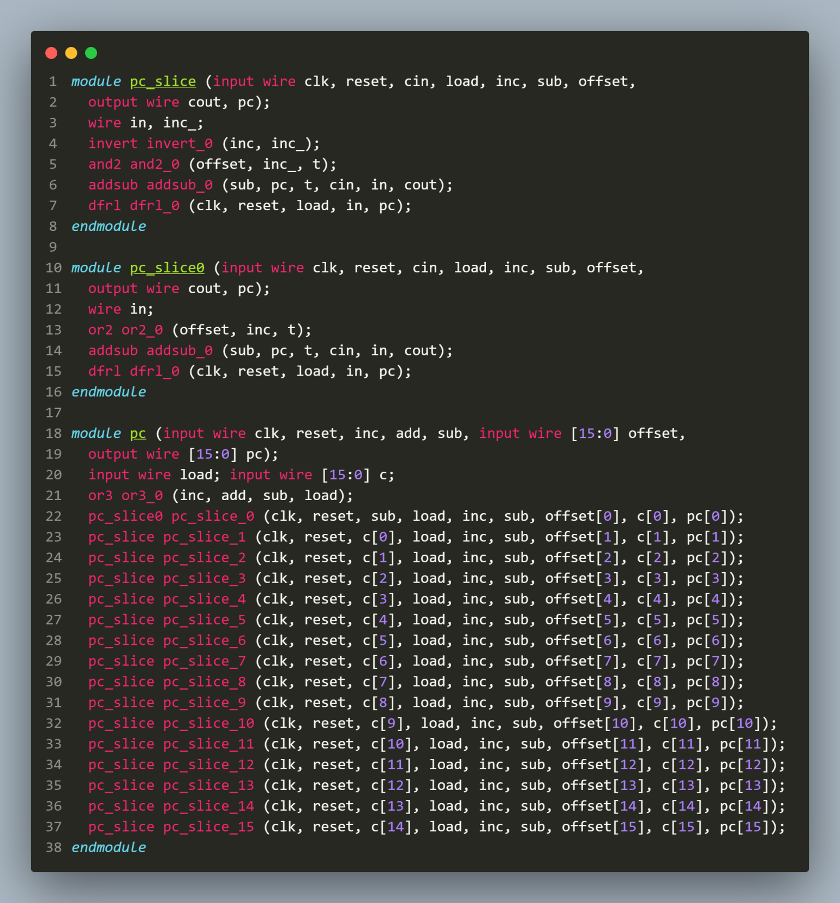

- Verilog Code Screenshot (tb_mproc_mem.v)
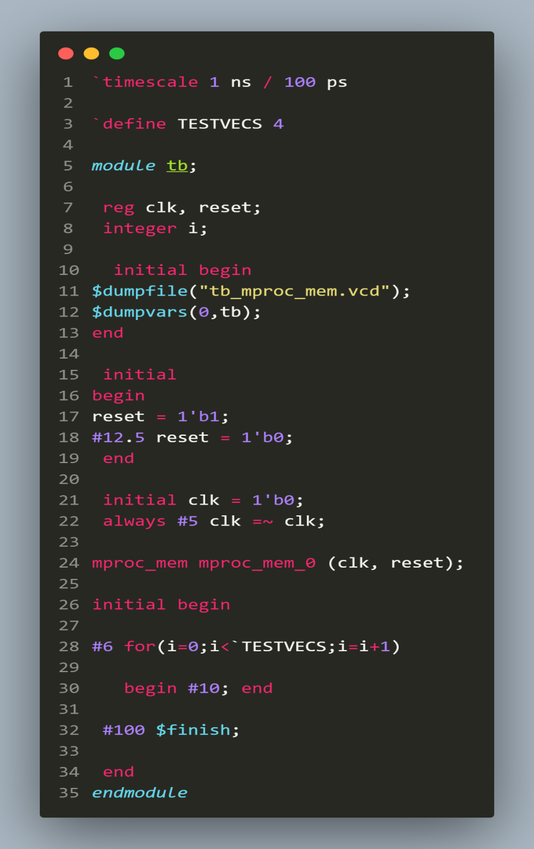
- Verilog VVP Output Screen Shot

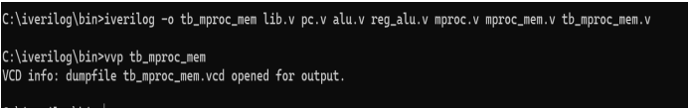

- GTKWAVE Screenshot

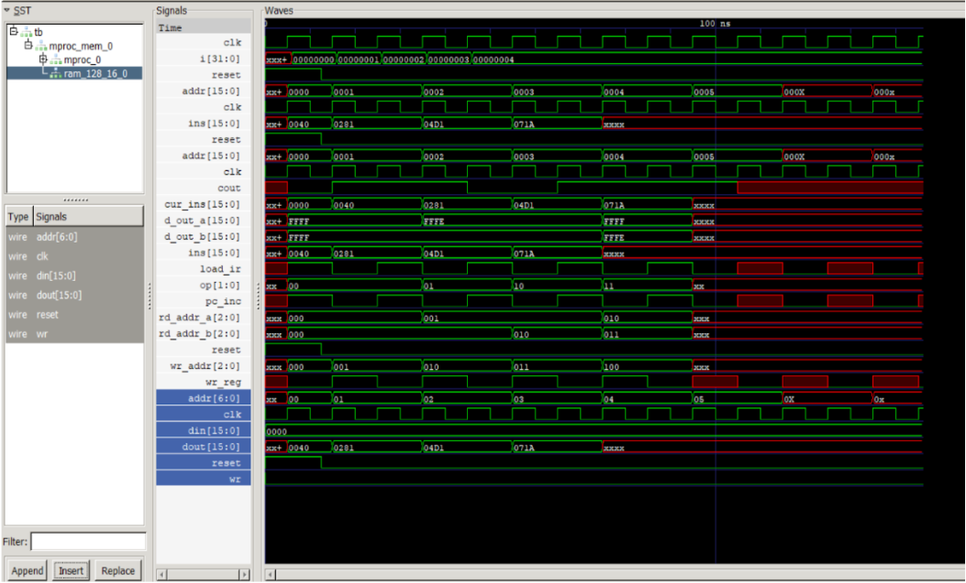

- Output Table to be completed and included
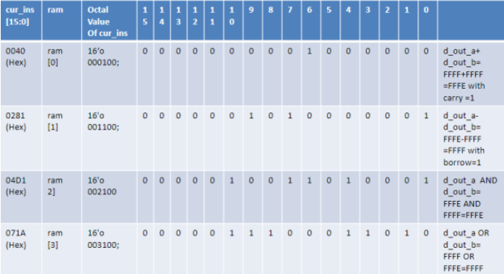

Disclaimer:
- The programs and output submitted is duly written, verified and executed by me.
- I have not copied from any of my peers or from the external resource such as internet.
- If found plagiarized, I will abide with the disciplinary action of the University.

Signature:

Name: Siri N Shetty
SRN: PES2UG22CS556
Section: J
Date: 06-11-2023
------------

