Banana Problem Solving – I
Section: F
PES2UG24CS311
Neeraj R Rugi

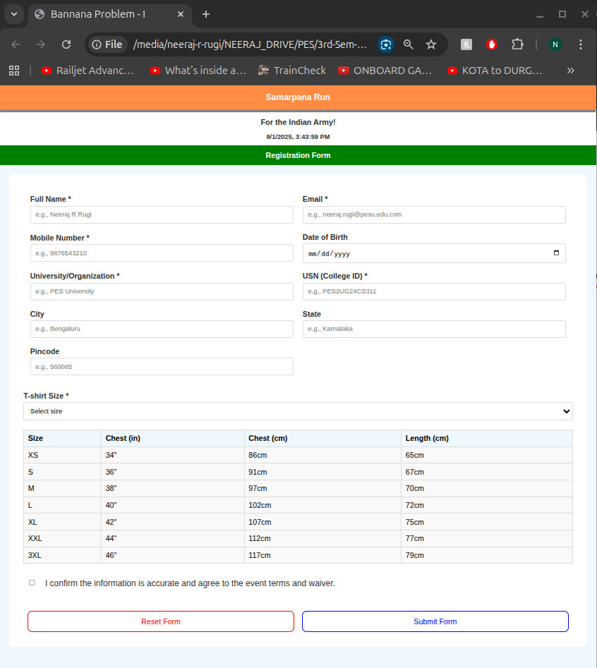
Browser Image:
Code for The Webpage:

<!DOCTYPE html>
<html lang="en">
<head>
<meta charset="UTF-8" />
<meta name="viewport" content="width=device-width, initial-scale=1.0" />
<title>Bannana Problem - I</title>
<style>
* {
margin: 0;
padding: 0;
box-sizing: border-box;
}

body {
font-family: Arial, sans-serif;
background-color: aliceblue;
}

.header {
background-color: #ff8c42;
color: white;
text-align: center;
padding: 15px;
font-size: 18px;
font-weight: bold;
}

.event-info {
background-color: white;
text-align: center;
font-weight: bold;
padding: 10px;
font-size: 14px;
color: #333;
}

.subheader {
background-color: green;
color: white;
text-align: center;
padding: 12px;
font-size: 16px;
font-weight: bold;
}

.form-container {
padding: 30px;
background-color: white;
margin: 20px;
border: 0px solid white;
border-radius: 10px;
}

.main-form-table {
width: 100%;
border-collapse: separate;
border-spacing: 10px;
}

.main-form-table td {
padding: 5px;
}

label {
display: block;
margin-bottom: 5px;
font-weight: bold;
color: #333;
}

input,select {
width: 100%;
padding: 10px;
border: 1px solid #ddd;
border-radius: 4px;
font-size: 14px;
}
.size-table {
width: 100%;
margin: 20px 0;
background-color: #f9f9f9;
border-collapse: collapse;
}

.size-table th,
.size-table td {
padding: 8px;
border: 1px solid #ddd;
}

.size-table th {
background-color: aliceblue;
font-weight: bold;
text-align: left;
}

.checkbox-table {
width: 100%;
margin: 20px 0;
}

.checkbox-table td {
padding: 10px;
vertical-align: top;
}
.checkbox-table label {
font-weight: normal;
font-size: 18px;
}

.button-table {
width: 100%;
margin-top: 30px;
}

.button-table td {
padding: 0 7.5px;
width: 50%;
}

button {
width: 100%;
padding: 12px;
border: none;
border-radius: 4px;
font-size: 16px;
}

.reset {
background-color: white;
border: 1px solid red;
border-radius: 10px;
color: red;
}

.submit {
background-color: white;
border: 1px solid blue;
border-radius: 10px;
color: blue;
}

.tshirt-section {
margin: 20px 0;
}
</style>
</head>
<body>
<div class="header">Samarpana Run</div>
<hr style="background-color: grey;height: 8px;"/>

<div class="event-info">
For the Indian Army!<br />
8/9/2025, 11:08:01 PM
</div>

<div class="subheader">Registration Form</div>

<div class="form-container">
<form id="registrationForm">
<table class="main-form-table">
<tr>
<td>
<label for="fullName">Full Name *</label>
<input
type="text"
id="fullName"
placeholder="e.g., Neeraj R Rugi"
required
/>
</td>
<td>
<label for="email">Email *</label>
<input
type="email"
id="email"
placeholder="e.g., neeraj.rugi@pesu.edu.com"
required
/>
</td>
</tr>
<tr>
<td>
<label for="mobile">Mobile Number *</label>
<input
type="tel"
id="mobile"
placeholder="e.g., 9876543210"
required
/>
</td>
<td>
<label for="dob">Date of Birth</label>
<input type="date" id="dob" />
</td>
</tr>
<tr>
<td>
<label for="university">University/Organization *</label>
<input
type="text"
id="university"
placeholder="e.g., PES University"
required
/>
</td>
<td>
<label for="usn">USN (College ID) *</label>
<input
type="text"
id="usn"
placeholder="e.g., PES2UG24CS311"
required
/>
</td>
</tr>
<tr>
<td>
<label for="city">City</label>
<input type="text" id="city" placeholder="e.g., Bengaluru" />
</td>
<td>
<label for="state">State</label>
<input type="text" id="state" placeholder="e.g., Karnataka" />
</td>
</tr>
<tr>
<td>
<label for="pincode">Pincode</label>
<input type="text" id="pincode" placeholder="e.g., 560085" />
</td>
<td></td>
</tr>
</table>

<div class="tshirt-section">
<label for="tshirtSize">T-shirt Size *</label>
<select id="tshirtSize" style="background-color: white;" required>
<option value="">Select size</option>
<option value="XS">XS</option>
<option value="S">S</option>
<option value="M">M</option>
<option value="L">L</option>
<option value="XL">XL</option>
<option value="XXL">XXL</option>
<option value="3XL">3XL</option>
</select>
</div>

<table class="size-table">
<tr>
<th>Size</th>
<th>Chest (in)</th>
<th>Chest (cm)</th>
<th>Length (cm)</th>
</tr>
<tr>
<td>XS</td>
<td>34"</td>
<td>86cm</td>
<td>65cm</td>
</tr>
<tr>
<td>S</td>
<td>36"</td>
<td>91cm</td>
<td>67cm</td>
</tr>
<tr>
<td>M</td>
<td>38"</td>
<td>97cm</td>
<td>70cm</td>
</tr>
<tr>
<td>L</td>
<td>40"</td>
<td>102cm</td>
<td>72cm</td>
</tr>
<tr>
<td>XL</td>
<td>42"</td>
<td>107cm</td>
<td>75cm</td>
</tr>
<tr>
<td>XXL</td>
<td>44"</td>
<td>112cm</td>
<td>77cm</td>
</tr>
<tr>
<td>3XL</td>
<td>46"</td>
<td>117cm</td>
<td>79cm</td>
</tr>
</table>

<table class="checkbox-table">
<tr>
<td width="20">
<input type="checkbox" id="terms" required />
</td>
<td>
<label for="terms"
>I confirm the information is accurate and agree to the event
terms and waiver.</label
>
</td>
</tr>
</table>

<table class="button-table">
<tr>
<td>
<button type="button" class="reset" onclick="resetForm()">
Reset Form
</button>
</td>
<td>
<button type="submit" class="submit">Submit Form</button>
</td>
</tr>
</table>
</form>
</div>

<script>
let date_time = new Date().toLocaleString("en-US");
let date_div = document.getElementsByClassName("event-info");
date_div[0].innerHTML = `<h3>For the Indian Army!</h3><br />${date_time}`;

function resetForm() {
document.getElementById("registrationForm").reset();
}

document.getElementById("registrationForm").addEventListener("submit", function (e) {
e.preventDefault();
const requiredFields = this.querySelectorAll("[required]");
let allValid = true;
requiredFields.forEach((field) => {
if (!field.value.trim()) {
allValid = false;
field.style.borderColor = "red";
} else {
field.style.borderColor = "#ddd";
}
});

if (allValid) {
alert(
"Registration submitted successfully! Thank you for registering for the Samarpana Run."
);
} else {
alert("Please fill in all required fields marked with *");
}
});
</script>
</body>
</html>

