**Coursework 2**

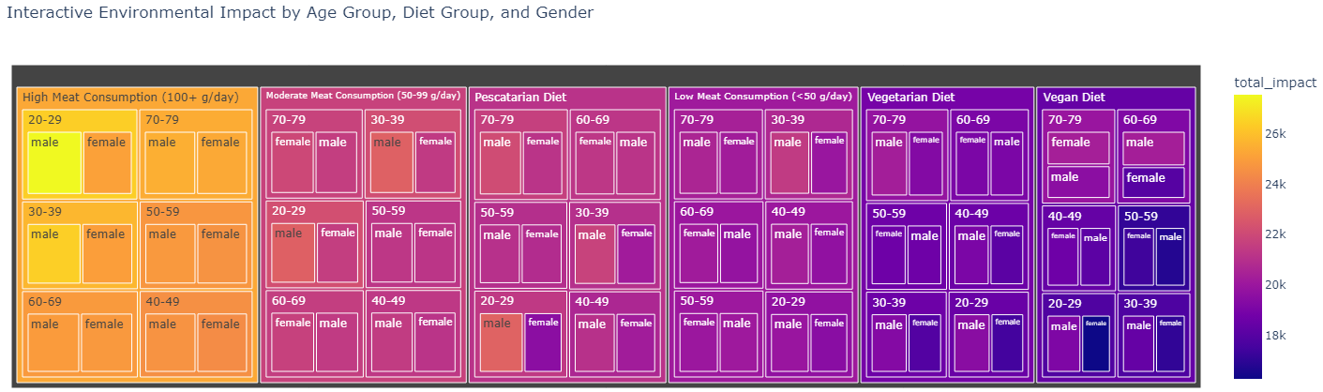

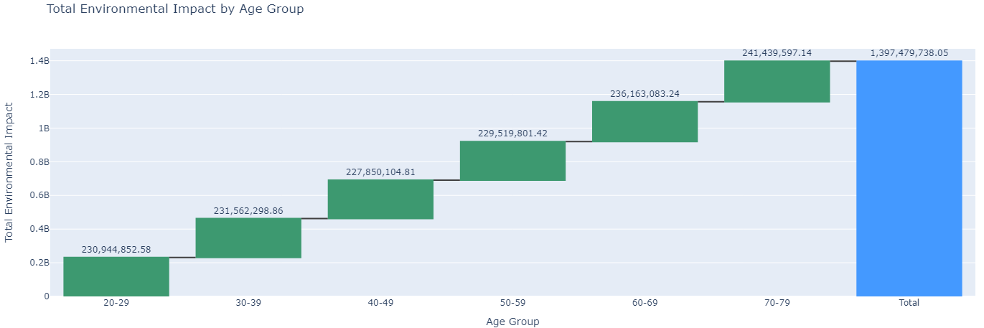

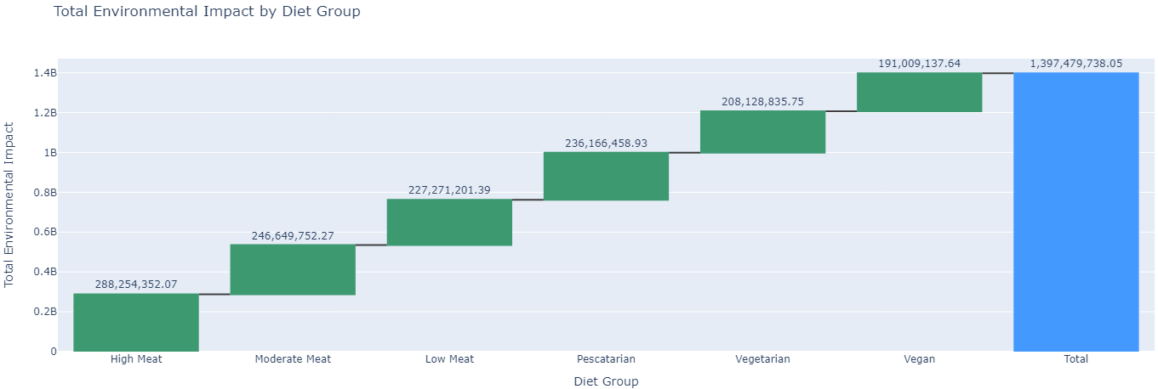

**Description of Visualisations**

The visualisations provided are two types: a treemap and two waterfall charts. These images effectively illustrate the distribution and cumulative effects of environmental impacts based on various demographic and behavioural dimensions.

**Visual Design Type:** Treemap, Waterfall Chart

**Name of Tool:** The visualisations were generated using Plotly, a versatile graphing library that supports complex, interactive visualisations in Python.

**Diet Groups:** The treemap and waterfall charts include the following diet groups:

* High Meat Consumption (100+ g/day)
* Moderate Meat Consumption (50-99 g/day)
* Low Meat Consumption (<50 g/day)
* Pescatarian Diet
* Vegetarian Diet
* Vegan Diet

**Variables:**

* Treemap Variables: Age group, sex, and diet group are used to show the hierarchical distribution of total environmental impact.
* Waterfall Chart Variables: Total environmental impact is summarised and broken down by age groups and diet groups to show the progression and summation of impacts.

**Visual Mappings:**

Treemap:

* Path/Hierarchy: Diet group > Age group > Sex
* Size: Represents the total environmental impact.
* Colour: Indicates the magnitude of the total environmental impact, providing a visual gradient where darker colours signify higher impacts.

Waterfall Chart:

* X-axis: Represents categories of age groups and diet groups sequentially.
* Y-axis: Represents the total environmental impact numerically.
* Colour: Differentiates increments (green) from total sums (blue).
* Text Labels: Show precise impact values, enhancing readability.

**Unique Observation:**

From the treemap, it is evident that higher meat consumption categories tend to occupy larger areas, indicating greater environmental impacts. This pattern is observable in the varying sizes and colour intensities across the treemap. In the waterfall charts, the stepwise accumulation of impacts highlights the significant contribution of older age groups and more meat-intensive diets to the overall environmental load. These observations are not only visual but quantitatively marked, making it easier to pinpoint specific data points.

**Data Preparation:**

* Aggregation: Data was grouped by age group and diet group, and total impacts were calculated for each group.
* Mapping: Diet group names were mapped to more descriptive labels to enhance clarity.
* Sorting and Summation: Data for waterfall charts was sorted and summed to facilitate the understanding of cumulative impacts.

**URL to Screen-Capture Demo:**

**Optional URL to Source Code:**

**Access to the Interactive Graphs:**