Q. Demonstrate the OSPF Routing in Packet Tracer.
Aim :To configure and demonstrate OSPF dynamic routing protocol between two networks using two routers in Packet Tracer.
Steps :
1.In packet tracer place 2 PCs and 2 Routers.
2.Connect Router0 with PC0 via FastEthernet0/0 using cross-copper cord and Router1 with PC1 via FastEthernet0/0 using cross-copper cord.
3.Connect both routers via FastEthernet0/1 using cross-copper cord.
4.Set the IP address and default gateway of both the PCs in IP configuration of both PCs respectively.
5.Configure OSPF routing protocol on both routers. Topology :
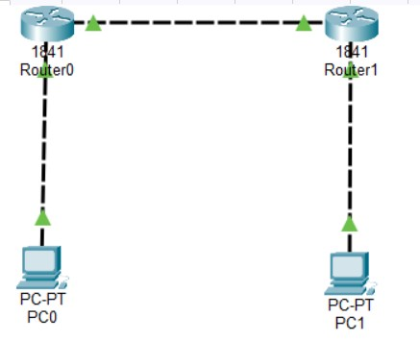

Code :
Router0 configuration :
Router>enable
Router#configure terminal
Router(config)#hostname Router0
Router0(config)#interface FastEthernet0/0
Router0(config-if)#ip address 192.168.1.1 255.255.255.0
Router0(config-if)#no shutdown
Router0(config-if)#exit
Router0(config)#interface FastEthernet0/1
Router0(config-if)#ip address 10.0.0.1 255.255.255.0
Router0(config-if)#no shutdown
Router0(config-if)#exit
Router0(config)#router ospf 1

Router0(config-router)#network 192.168.1.0 0.0.0.255 area 0

Router0(config-router)#network 10.0.0.0 0.0.0.255 area 0
Router0(config-router)#exit
Router0(config)#exit
Router0#copy running-config startup-config

Router1 configuration :
Router>enable
Router#configure terminal
Router(config)#hostname Router1
Router1(config)#interface FastEthernet0/1
Router1(config-if)#ip address 10.0.0.2 255.255.255.0
Router1(config-if)#no shutdown
Router1(config-if)#exit
Router1(config)#interface FastEthernet0/0
Router1(config-if)#ip address 172.16.1.1 255.255.255.0
Router1(config-if)#no shutdown
Router1(config-if)#exit
Router1(config)#router ospf 1
Router1(config-router)#network 10.0.0.0 0.0.0.255 area 0
Router1(config-router)#network 172.16.1.0 0.0.0.255 area 0
Router1(config-router)#exit
Router1(config)#exit
Router1#copy running-config startup-config PC0 configuration :
IP Address: 192.168.1.2
Subnet Mask: 255.255.255.0
Default Gateway: 192.168.1.1

PC1 Configuration :
IP Address: 172.16.1.2
Subnet Mask: 255.255.255.0
Default Gateway: 172.16.1.1 PC0 Command Prompt :
C:\>ipconfig
C:\>ping 192.168.1.1
C:\>ping 10.0.0.1
C:\>ping 10.0.0.2
C:\>ping 172.16.1.1
C:\>ping 172.16.1.2

PC1 Command Prompt :
C:\>ipconfig
C:\>ping 172.16.1.1
C:\>ping 10.0.0.2
C:\>ping 10.0.0.1
C:\>ping 192.168.1.1
C:\>ping 192.168.1.2

Router Verification Commands:
Router0#show ip route
Router0#show ip ospf neighbour
Router0#show ip ospf database
Router1#show ip route
Router1#show ip ospf neighbour

OUTPUT:
PC0 OUTPUT :
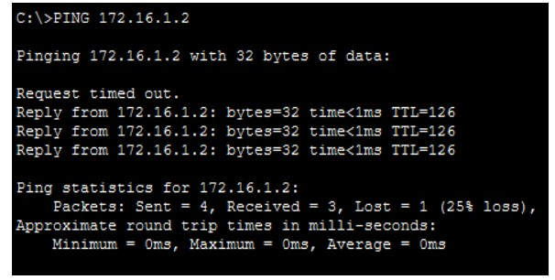

PC1 OUTPUT :

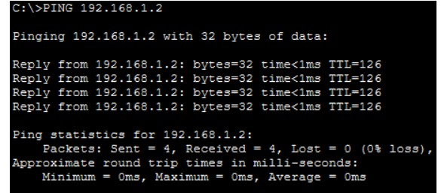

OSPF Neighbour Output:
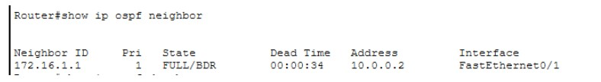
IP Route Output:
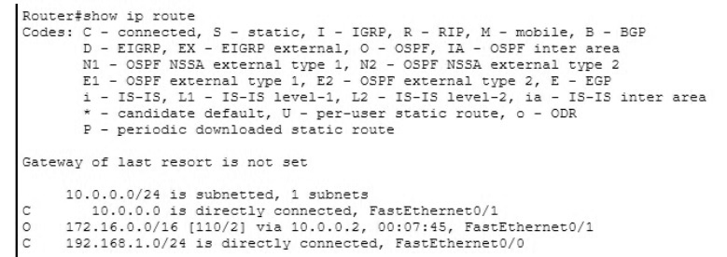

Conclusion : The above network topology has been executed successfully and OSPF dynamic routing has been demonstrated.

