STUDY OF CRYPTOGRAPHY SUBSTITUTION TECHNIQUES

AIM :- To study and Implement Substitution Techniques in a Cryptography using python to perform Encryption & Description of a message.

Program:-
def encrypt(text, shift):
result = ""
for char in text:
if char.isalpha():
base = 'A' if char.isupper() else 'a'
result += chr((ord(char) - ord(base) + shift) % 26 +
ord(base))
else:
result += char
return result
def decrypt(text, shift):
return encrypt(text, -shift)
text = input("Enter plain text: ")
shift = int(input("Enter shift value: "))
encrypted_text = encrypt(text, shift) print("Encrypted Text:", encrypted_text)
decrypted_text = decrypt(encrypted_text, shift)
print("Decrypted Text:", decrypted_text)

Output:-

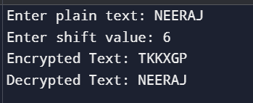
CONCLUSION :- The substitution technique replaces each letter in the plaintext with another letter based on a fixed shift value. Through this practical, we learned how Caesar Cipher works and how basic encryption and decryption are implemented in Python.

