1)what is system?

* A system is a group of units that are joined together to work in a specific routine and perform some fixed operation.
* These units could be of any nature i.e. if you are working on an electronics system then these units will be electronic components.

Similarly, if you are working on some mechanical system then these units will be mechanical equipment or machinery etc

ex-watch

[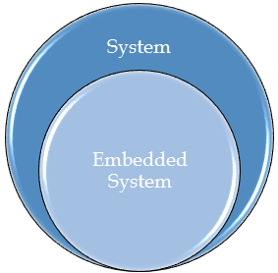](https://www.theengineeringprojects.com/wp-content/uploads/2016/10/ar8_block.png)

2)what is embedded sysytem?

* **Embedded System -** As its name suggests, Embedded means something that is attached to another thing. **Embedded System** is a computer **system embedded into an device, appliance** or a unit that is used to create any automation device or to control any machines using Micro Controller.
* Any sort of device which includes a programmable computer but itself is not intended to be a general-purpose computer”

* It includes hardware as well as software and it is a part of a larger system and is expected to function without human intervention.
* An embedded system is expected to respond, monitor as well as control external environment using sensors and actuators.
* So, basically what we are talking about is embedding a computer into an appliance and, that computer is not expected to be used for general purpose computing. Since it is embedded into an appliance, it needs to interact with the external world, so it has got analog interfaces.

3)differnce btw microprocessor and microcontrolleer?

* **Microprocessor** is a general purpose device
* General-purpose microprocessors contains
* No RAM, No ROM, No I/O ports
* **Microcontroller**
* A microcontroller is a single-chip VLSI unit (also called **microcomputer**) which, although having limited computational capabilities, possesses enhanced input/output capability and a number of on-chip functional units.
* Microcontroller has CPU (microprocessor), RAM, ROM, I/O ports, Timer
* ADC and other peripherals

Microcontrollers are particularly used in embedded systems for real-time control applications with on-chip program memory and devices

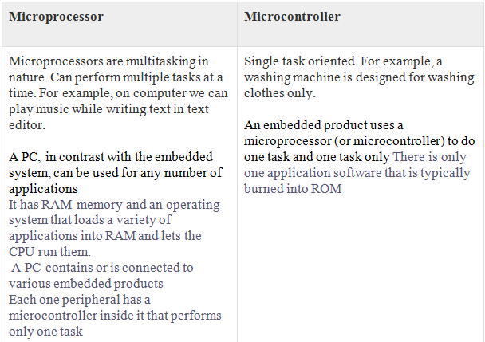

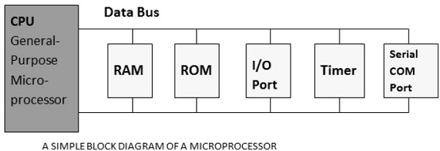

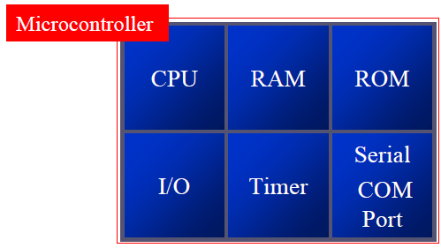

4)classification of embeded syystem?

[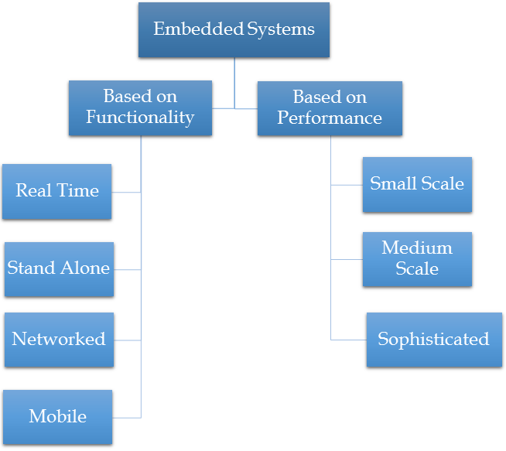](https://www.theengineeringprojects.com/wp-content/uploads/2016/10/ar8_block3.png)

Based on functions performed by embedded systems, it is divided into four types:

**Real Time**

An embedded system that gives an output within a specified amount of time is called a real-time embedded system. That is, in addition to a proper output, it adheres to time constraints as well. They can be further classified into soft real-time embedded systems and hard real-time embedded systems.

**Stand Alone**

As the name suggests, these are embedded systems that can work by themselves. In other words, they are self sufficient, and don’t require a host system or computer to function. While they will require inputs and other devices for output, the processing and work is done only by themselves. Examples include videogame consoles, music players and microwave ovens.

**Networked Embedded Systems**

* Embedded systems that are connected to a network and depend on it for their functioning are called networked embedded systems. They may or may not have smaller or less complex subsystems running to create the network. Examples include home security systems and heat sensor systems.
* These systems are connected with network that could be LAN, WAN or internet. The connection can be wireless or wired.

**Mobile Embedded Systems**

* Embedded systems meant for mobile communications are called mobile embedded systems. They include mobile phones, tablet computers and the like, and are usually categorized by functions like internet, calling, in addition to more complex functions seen in today’s smartphones. This is the class of embedded systems which is used in portable devices.
* The examples of devices are mobile phones, cameras, music players etc.

**Performance based Embedded systems**

* Based on performance of microcontroller, they are divided into three types:

**Small Scale Embedded Systems**

* If the microcontroller used in embedded system is 8 bit or 16 bit then it is classified into small scale embedded system.
* Such systems have less complex hardware and software parts and can also be operated on batteries.
* Normally such embedded system uses Arduino boards or PIC Microcontrollers or 8051 Microcontrollers etc.

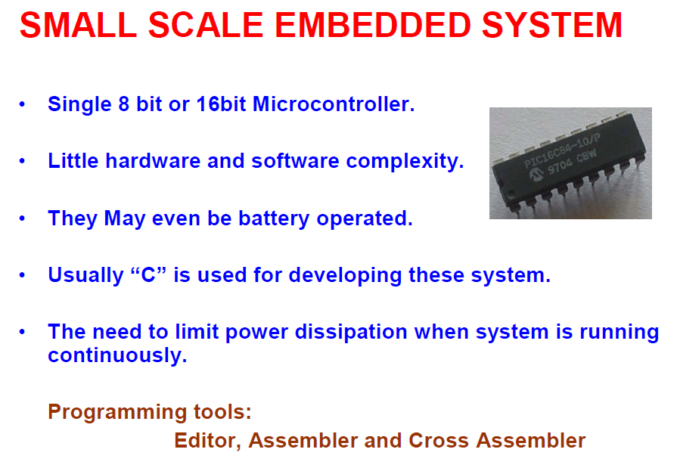

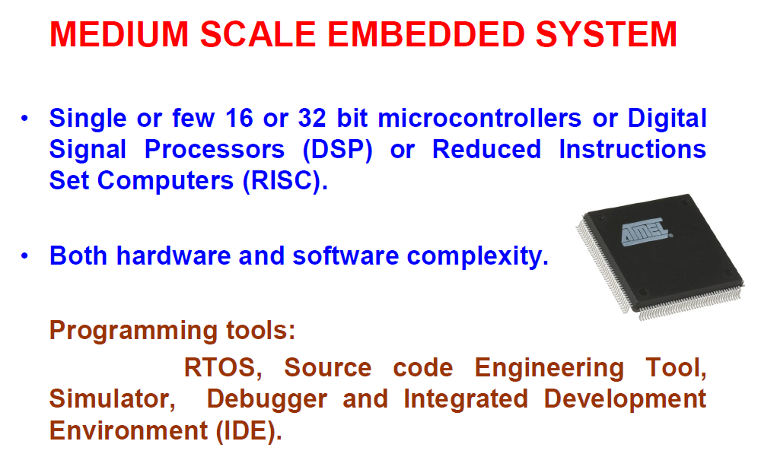

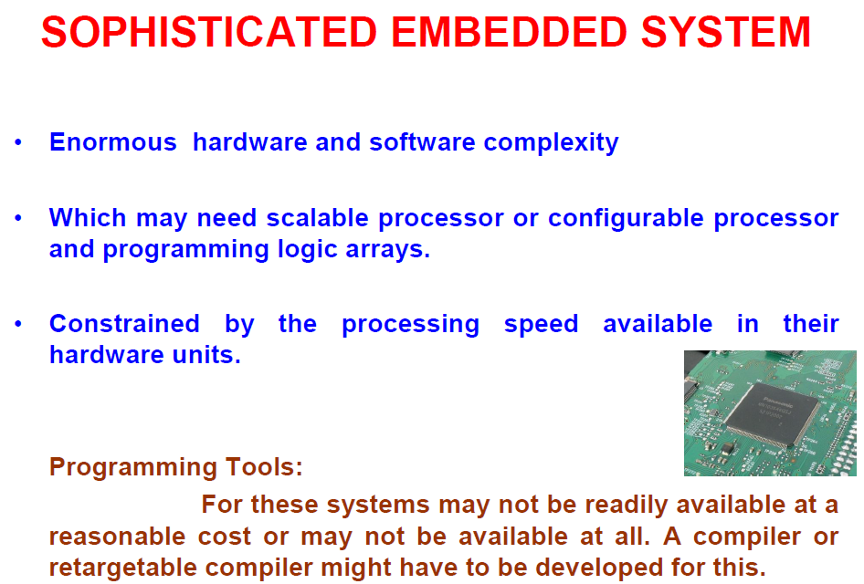

Q5)memory and its type?

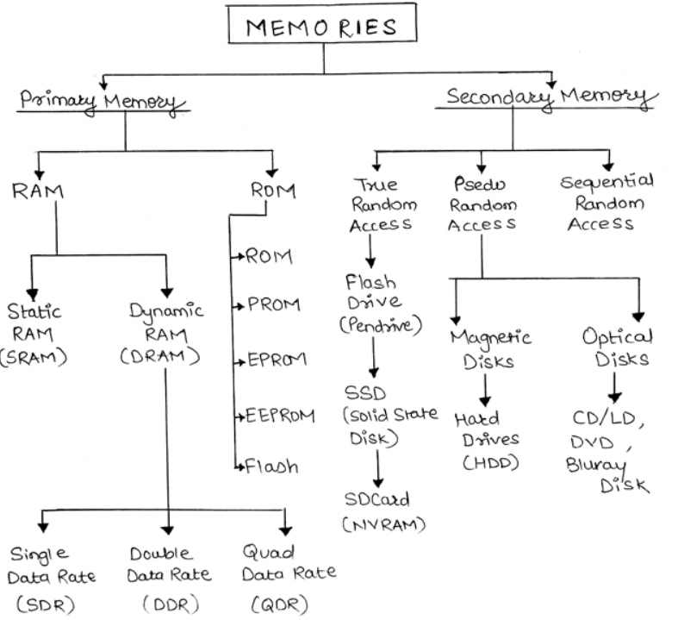

* Memory can be broadly classified into 2 types namely
  + Primary memory &
  + Secondary memory.
* The real difference between primary and secondary memories is **the speed/volatility tradeoffs.**
* Primary memory is directly addressed by the processor.

Types

* + RAM
  + ROM
  + **RAM: (Random Access Memory)** Read or write memory. It stores temporary data and stack.
  + Two most important types of RAM are
  + **SRAM**
  + **DRAM**.
  + They are both volatile memories used as primary storage on embedded systems. But each has its place in microcontroller design. The main difference between them comes from their speed/cost tradeoffs.

**types of ram**

* + **1. Static Random Access Memory (SRAM)**
  + Data is stored in the form of voltage. It is made up of flip flops. It is realized using 6 transistors. 4 transistors are part of flip flop and two transistors are for control access.
  + This is the faster of the two, **approximately 4 times faster**than the DRAM.
  + Since it needs more transistors per bit of data, it is also **more expensive** compared to DRAMs.
  + **2. Dynamic Random Access Memory (DRAM)**
  + It stores data in the form of charge. It is made up of MOS transistors. The circuit has 1 MOSFET and a capacitor.
  + The reason behind its name comes from the fact that the **data stored in this RAM needs to be refreshed every few milliseconds or else it will end up being erased**. Yes even if the power is being applied continuously the data still needs to be refreshed. This action is taken care of by a special device named **DRAM controllers.**
  + The reason behind this dynamic behavior is because of the capacitor present in its design.
  + Earlier the SRAM was called just RAMs but later after the introduction of DRAMs, the term “static” got introduced into its name in order to differentiate it from the DRAM technology!

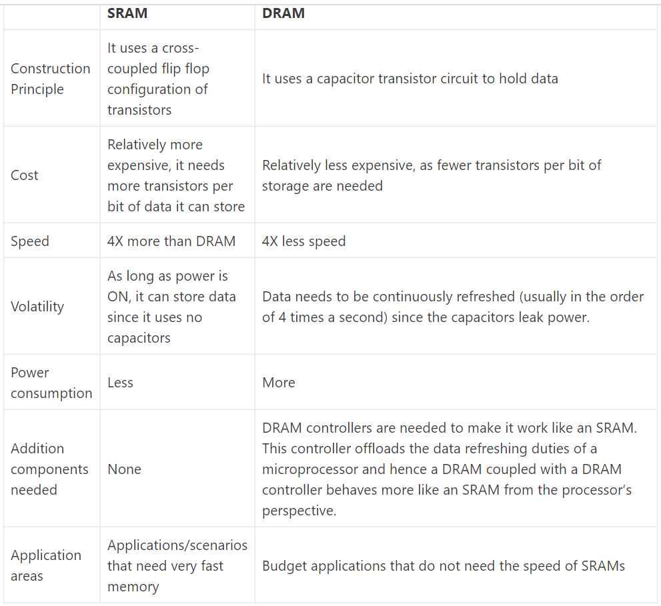

rom(read only memory)

* It stores application programs from where processor fetches instruction code. It stores codes for system booting and RTOS.
* It retains content even after system is turned off. It is a non-volatile storage memory.

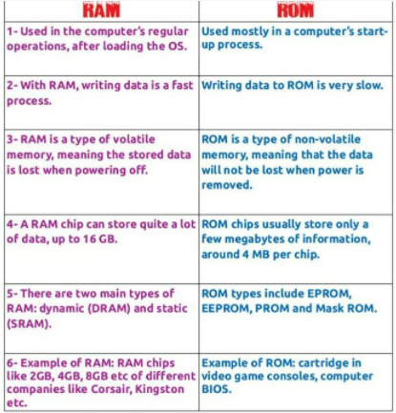

**Q6)differnce btw embedded c and c?**

* Embedded C is perhaps the most popular languages among Embedded Programmers for programming Embedded Systems.
* There are many popular programming languages like Assembly, BASIC, C++, Python etc. that are often used for developing Embedded Systems but Embedded C remains popular due to its efficiency, less development time and portability.

**C Programming**

* C language is a structure-oriented language, developed by Dennis Ritchie. It provides less memory access using the simple compiler and delivers the data efficiently according to machine instructions. They are applicable in wide ranges from embedded systems to supercomputers.

**Embedded C**

* Embedded C is an extension of the C language, which is used for developing an embedded system. The syntax is similar to C language (like the main function, functions declaration, data types declaration, loops, etc). The main difference between embedded C and standard C language are input-output addressing of hardware, fixed-point operations, and processing address spaces.
* 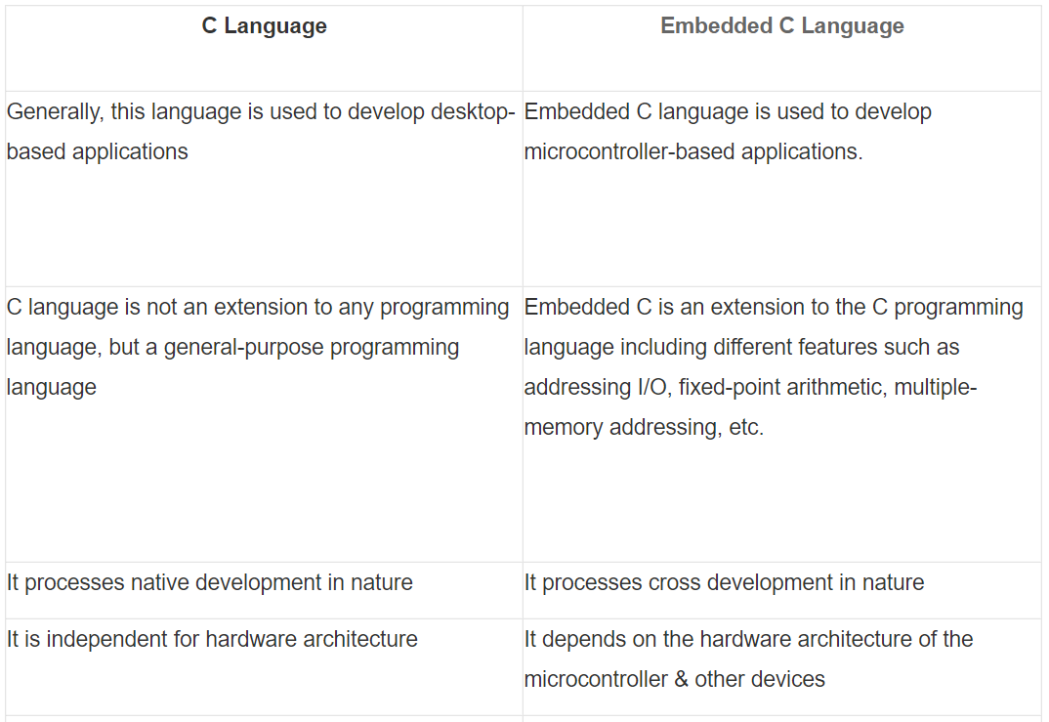

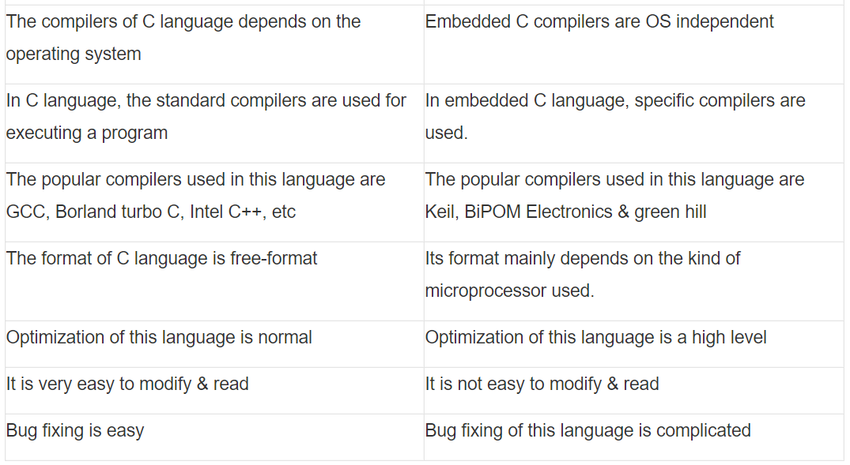

Q7)architecture of blog diagram of microprocessor and micro controller?





