Junit
Exercise 1:
Aim: To set up JUnit 4 in a Java Maven project, create a test class, and execute a simple unit test to verify the correctness of the program.
OUTPUT:
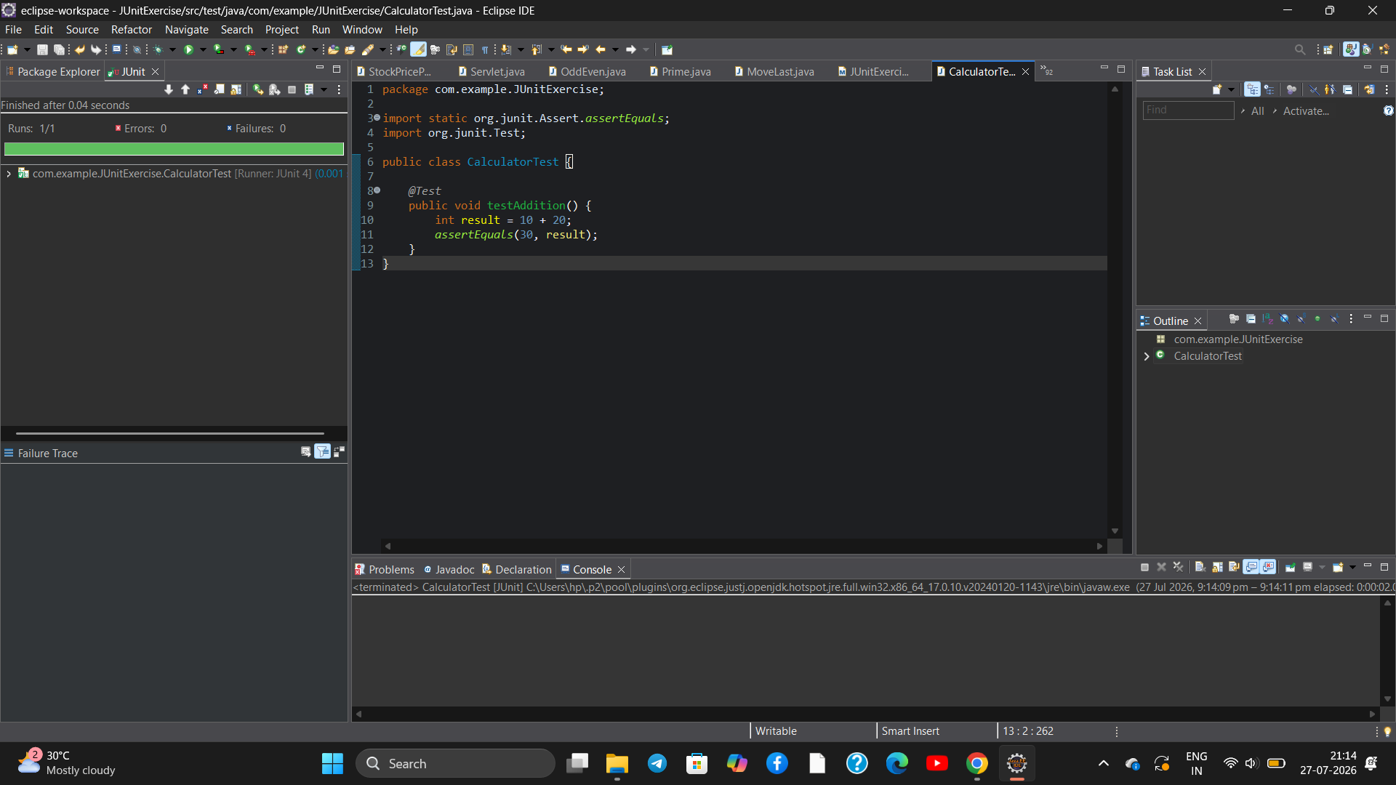
Exercise 3:
Aim: Assertions in JUnit:To use various JUnit assertions such as assertEquals(), assertTrue(), assertFalse(), assertNull(), and assertNotNull() to validate the expected results of a Java program.
OUTPUT:

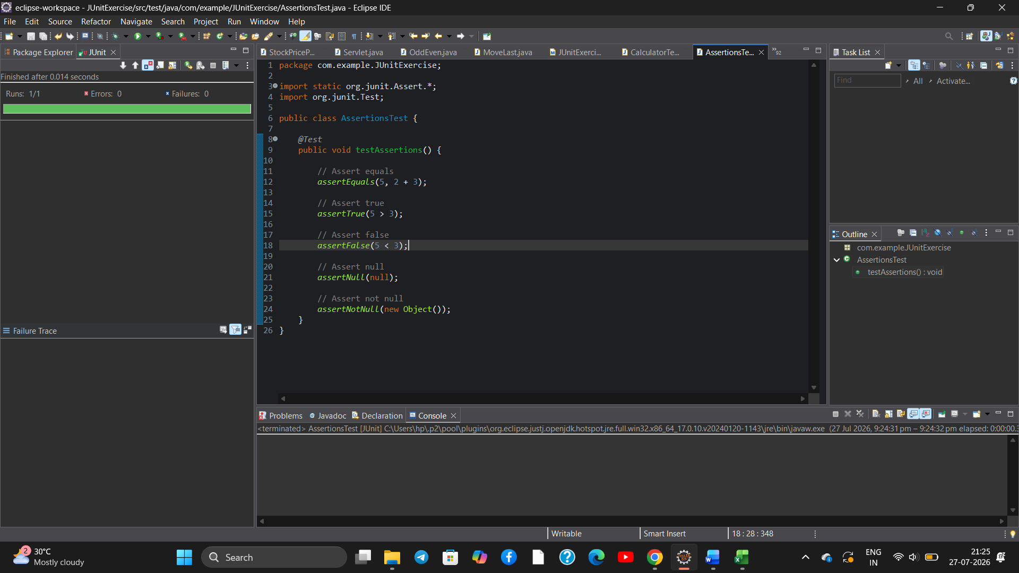
Exercise 4:
Aim :To implement the Arrange-Act-Assert (AAA) pattern and use @Before and @After annotations for setup and teardown methods in JUnit.
OUTPUT:

