Microservices
Experiment No 1:
Creating Microservices for Account and Loan
Aim:
To create two independent Spring Boot REST microservices (Account and Loan) and run them on different ports.
Software Requirements:
- Java 17
- Spring Boot 4.0.7
- Spring Tool Suite (STS)
- Maven
- Web Browser
Procedure:
- Created the Account microservice using Spring Initializr.
- Added Spring Web and Spring Boot DevTools dependencies.
- Implemented a REST API:
  - GET /accounts/{number}
- Tested the Account service on port 8080.
- Created the Loan microservice.
- Implemented a REST API:
  - GET /loans/{number}
- Changed the Loan service port to 8081 using server.port=8081.
- Ran both microservices simultaneously.
- Tested both services successfully in the browser.

Sample Output Account Service:

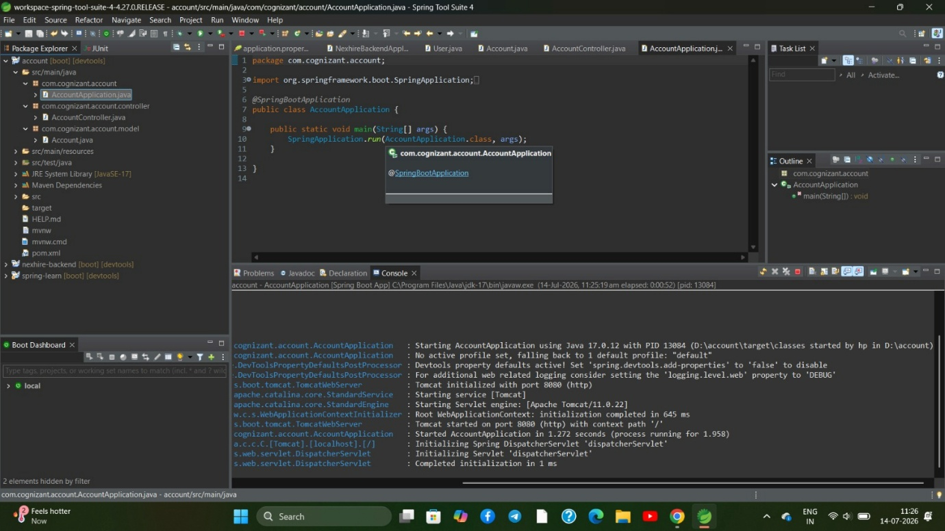
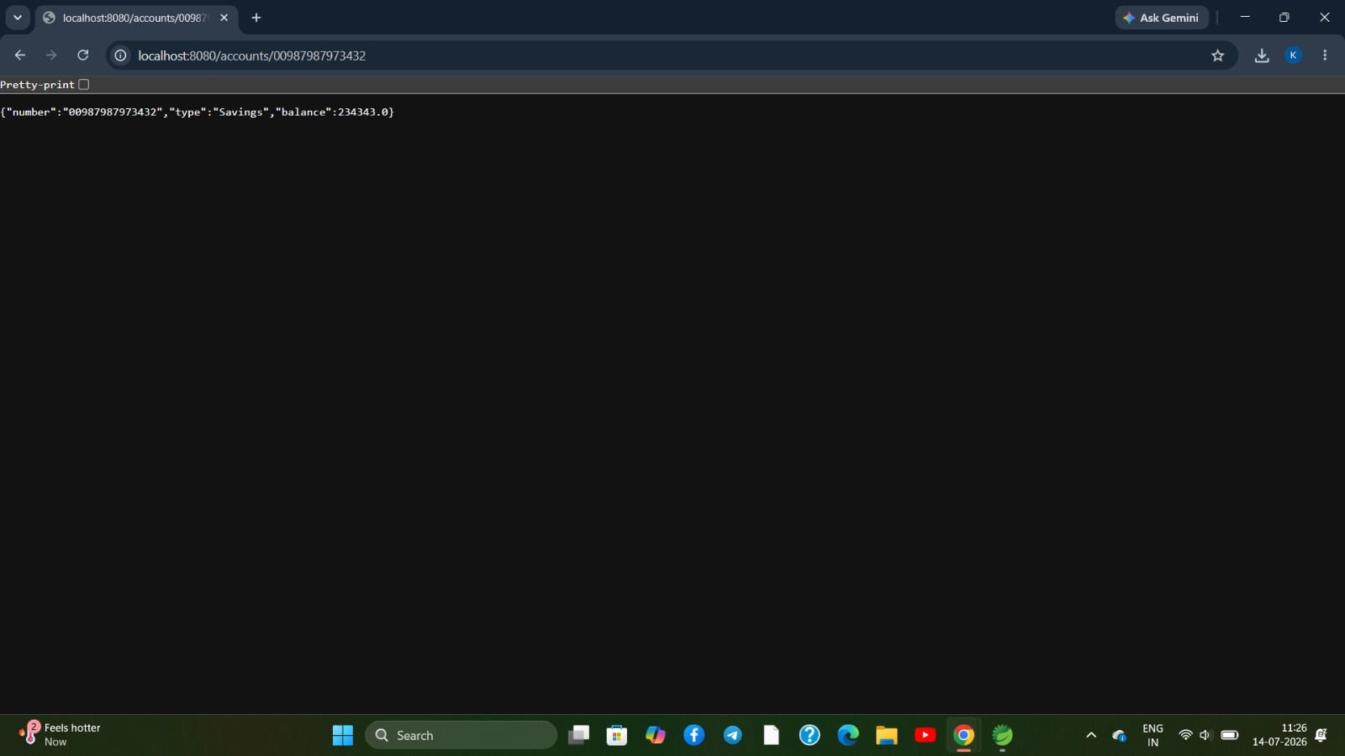

Sample Output loan Service:
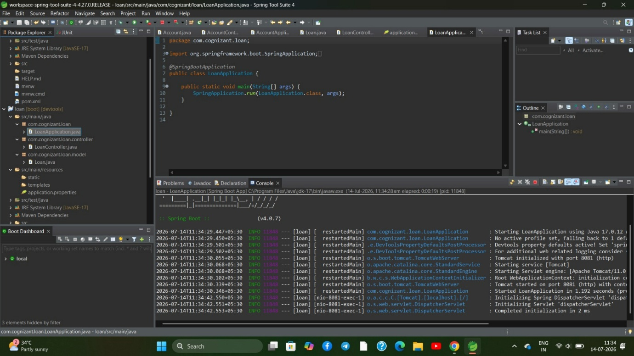

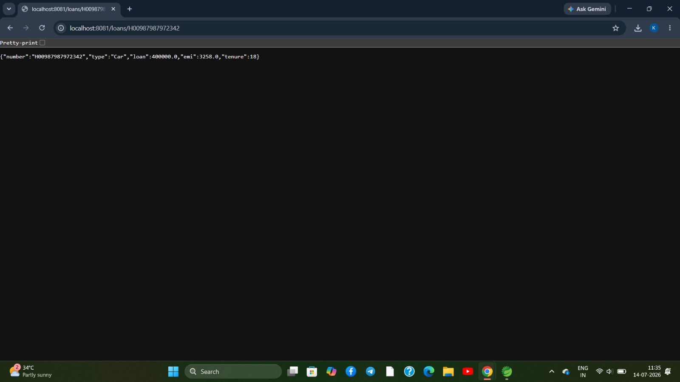
Result:
Successfully created and executed the Account and Loan microservices as independent Spring Boot applications running on different ports.
Experiment No2:
Create Eureka Discovery Server and Register Microservices:
Aim:
To create a Eureka Discovery Server and register the Account and Loan microservices with it.
Software Requirements:
- Java 17
- Spring Boot 4.0.7
- Spring Tool Suite (STS)
- Maven
- Web Browser
Procedure:
- Created a Eureka Discovery Server using Spring Initializr.
- Added the Eureka Server dependency.
- Configured application.properties with port 8761.
- Started the Eureka Discovery Server.
- Configured the Account microservice as a Eureka Client.
- Configured the Loan microservice as a Eureka Client.
- Started the Account and Loan microservices.
- Verified that both services were successfully registered in the Eureka Dashboard.

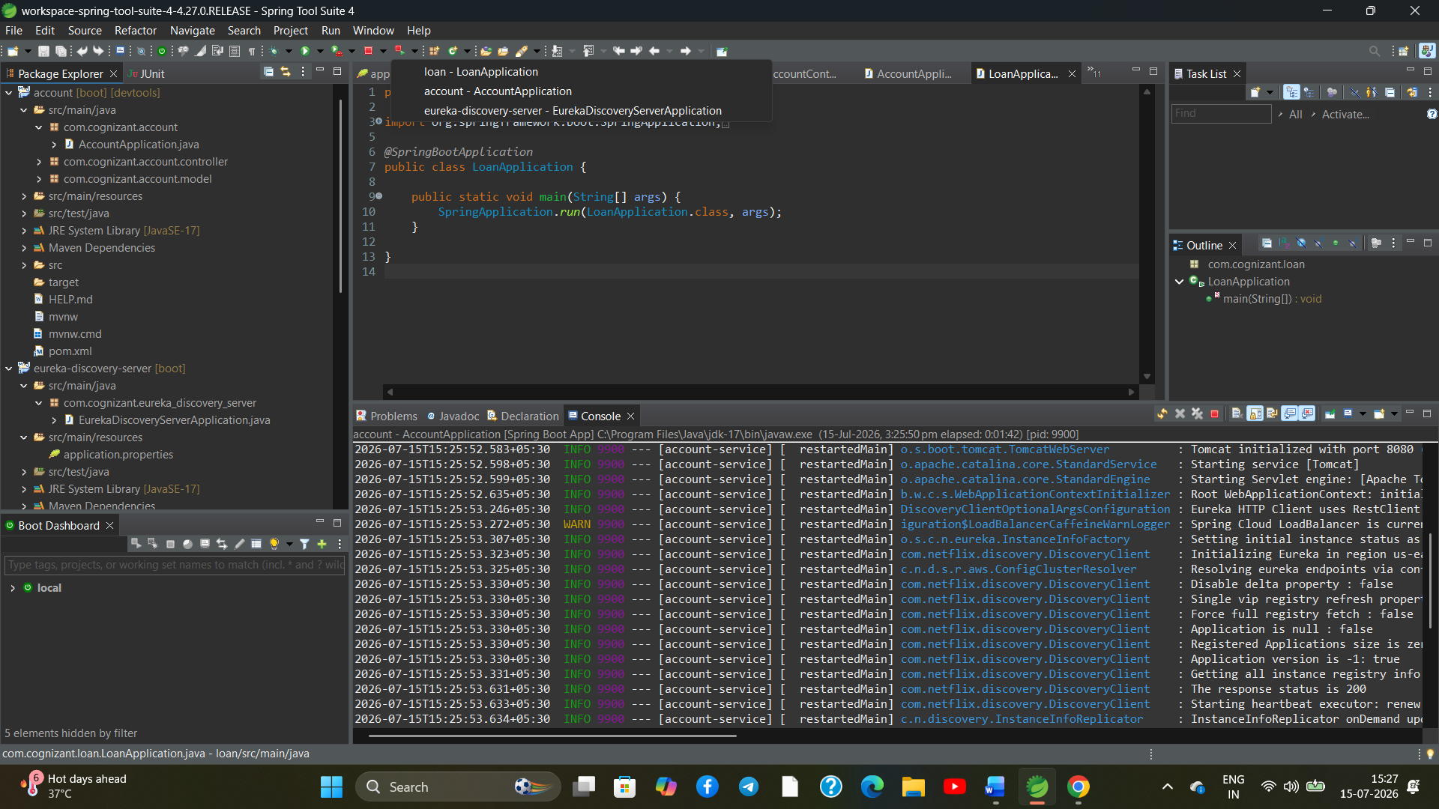
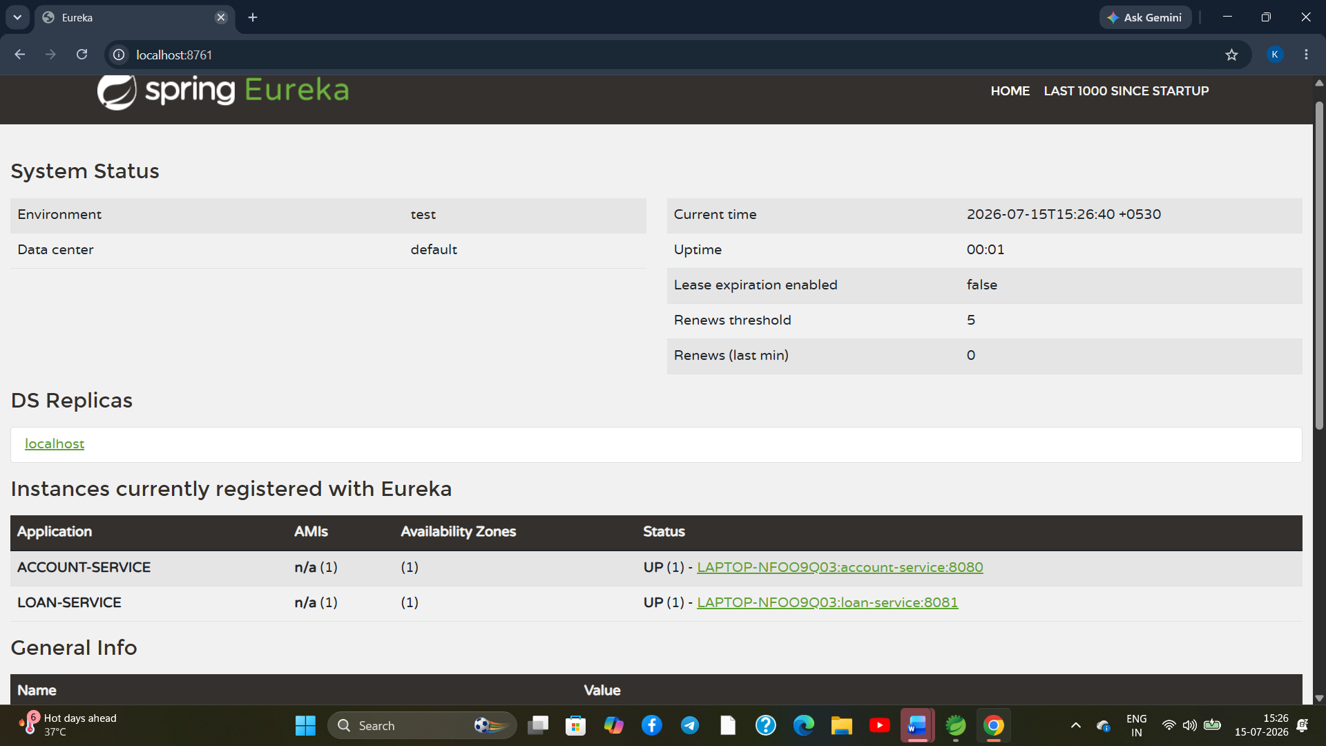
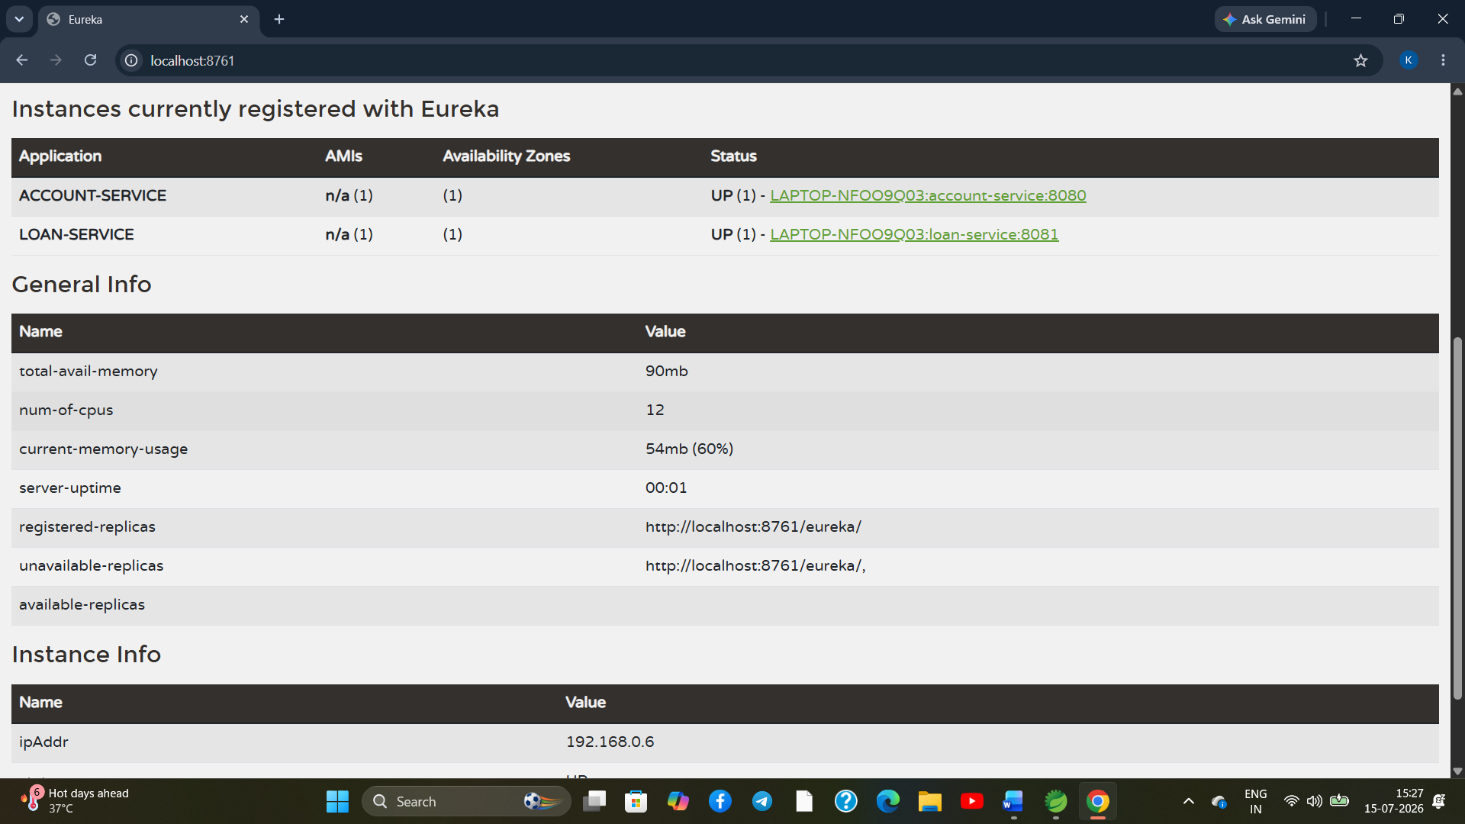
Result:
Successfully created the Eureka Discovery Server and registered the Account and Loan microservices. The services were successfully discovered and displayed with UP status in the Eureka Dashboard.

