PL/SQL
1.To implement PL/SQL control structures using loops and conditional statements.
Scenario 1: Apply Discount to Loan Interest Rates for Senior Customers:

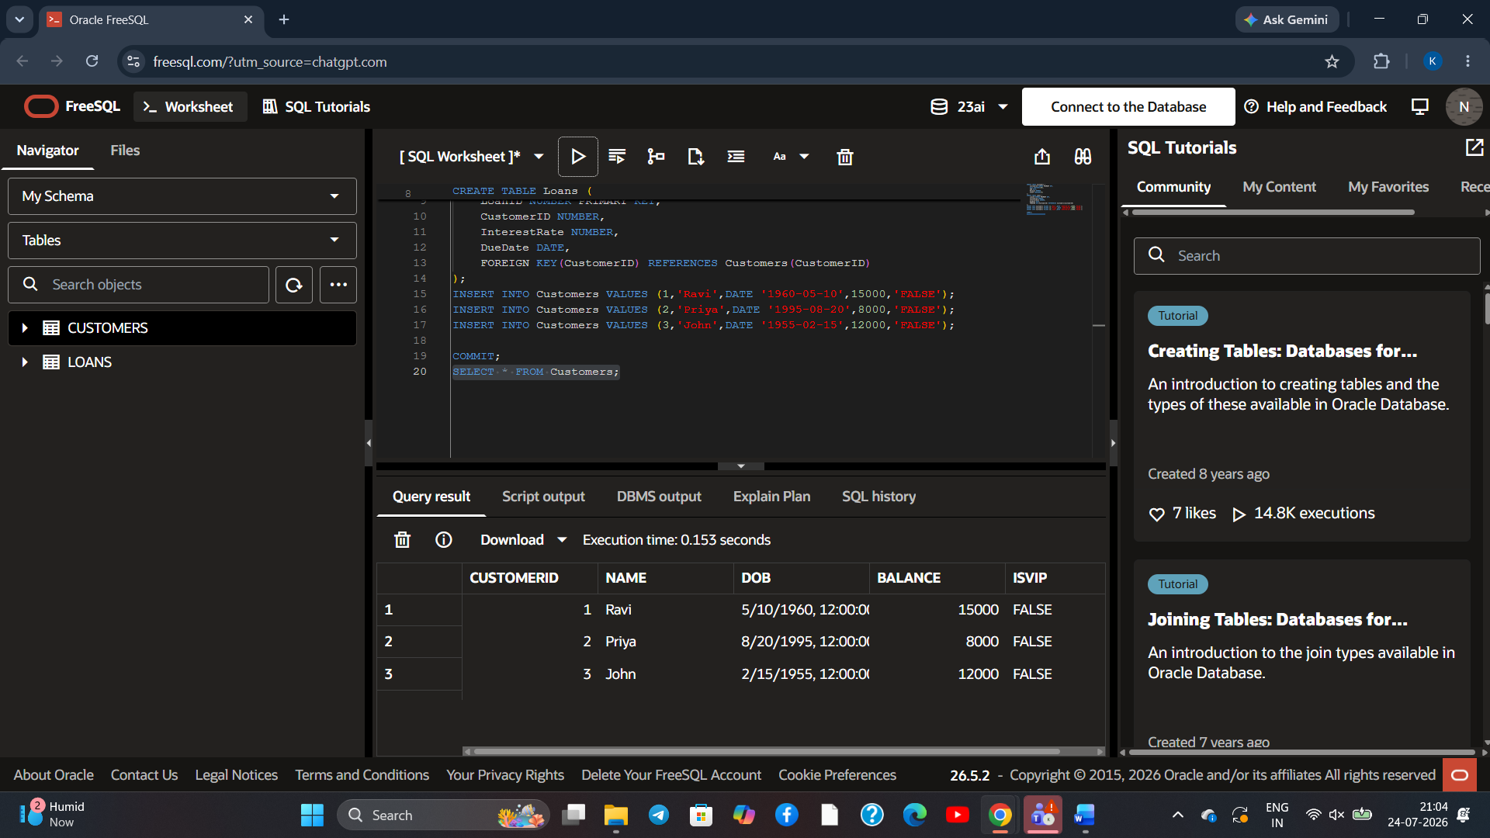
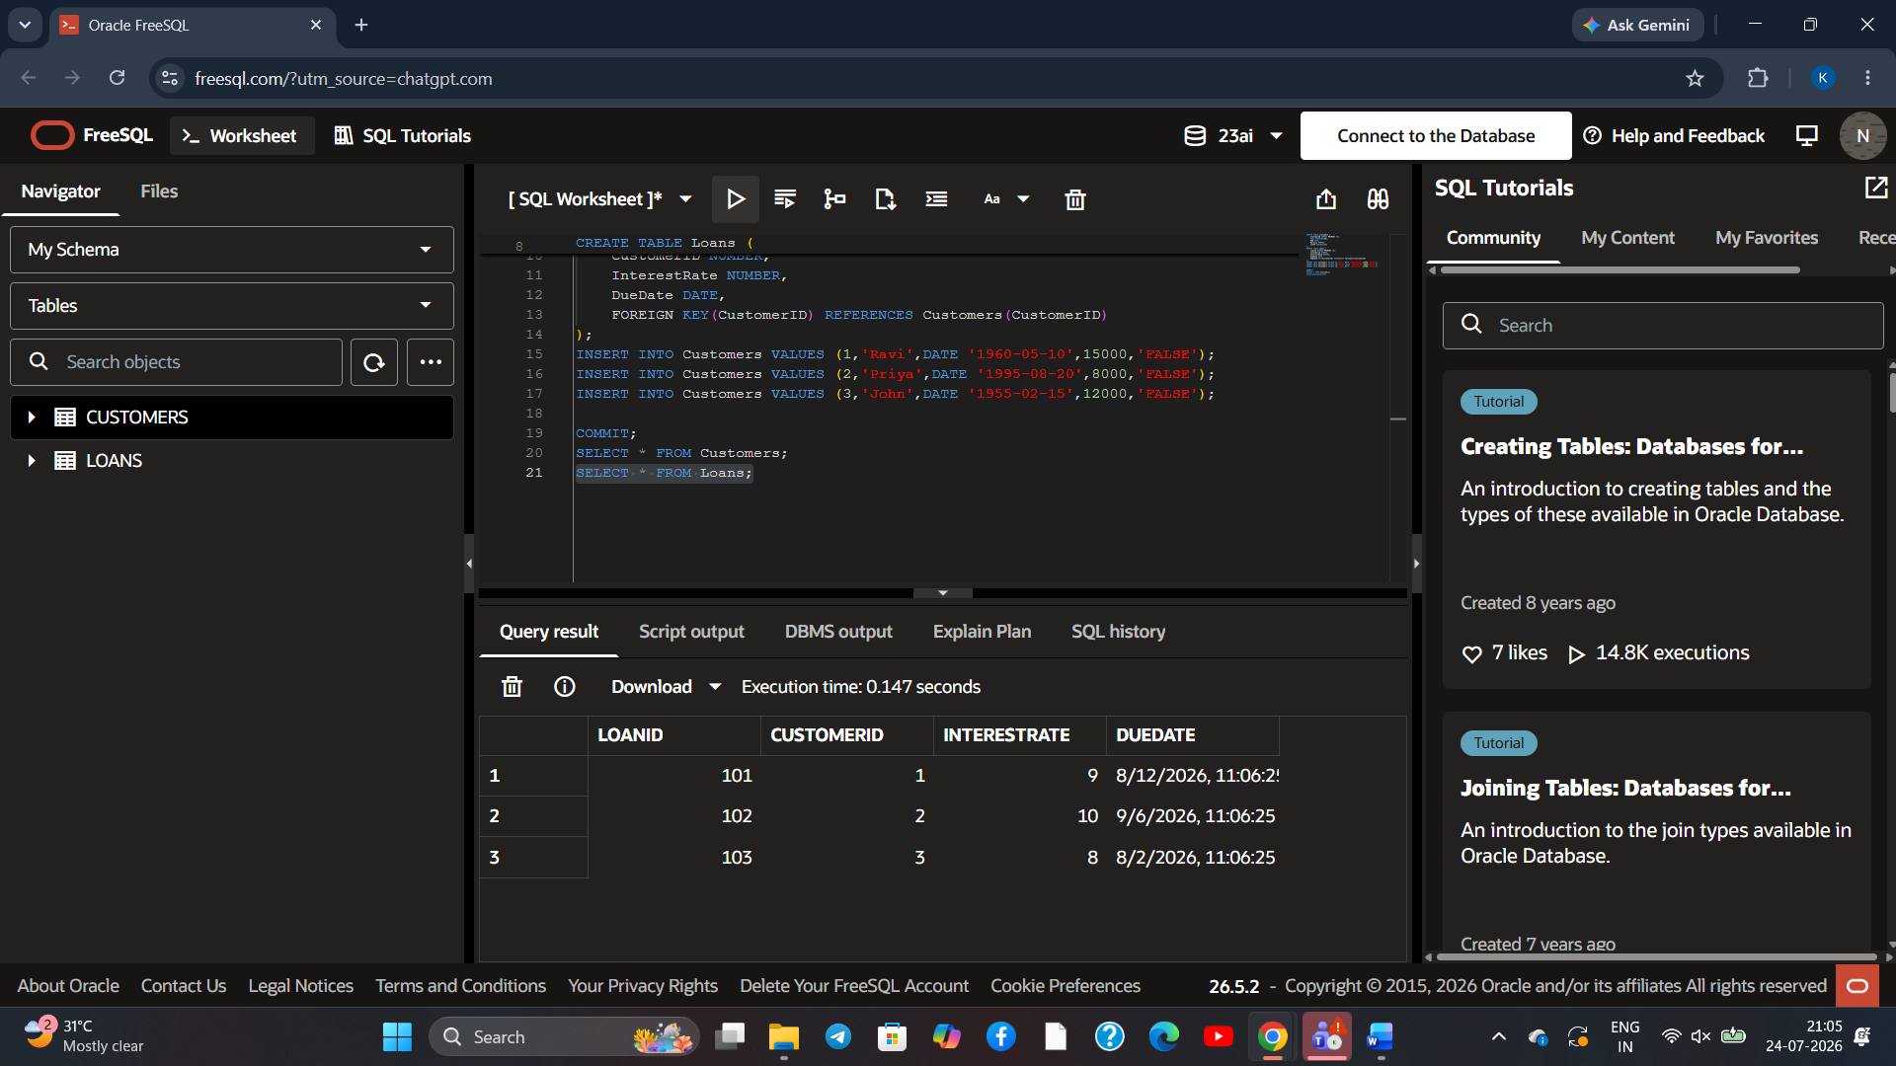
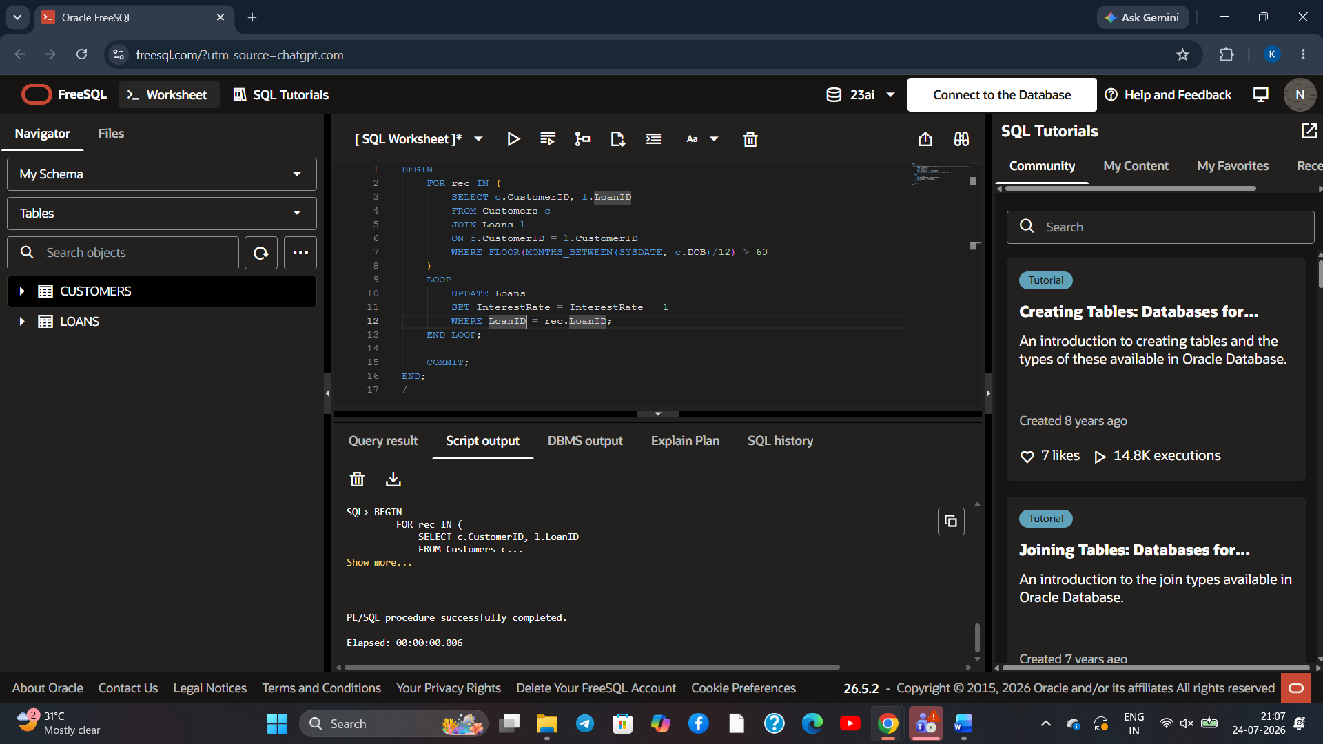
Update loan details
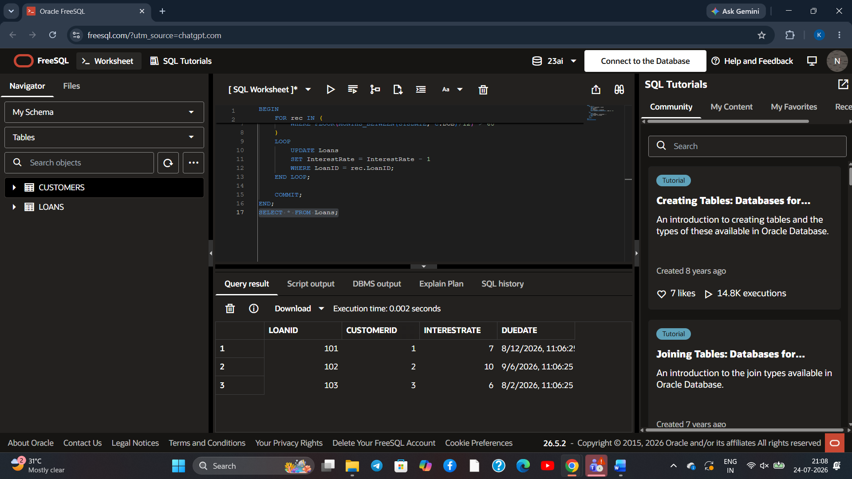
Senario 2: Promote Customers to VIP:
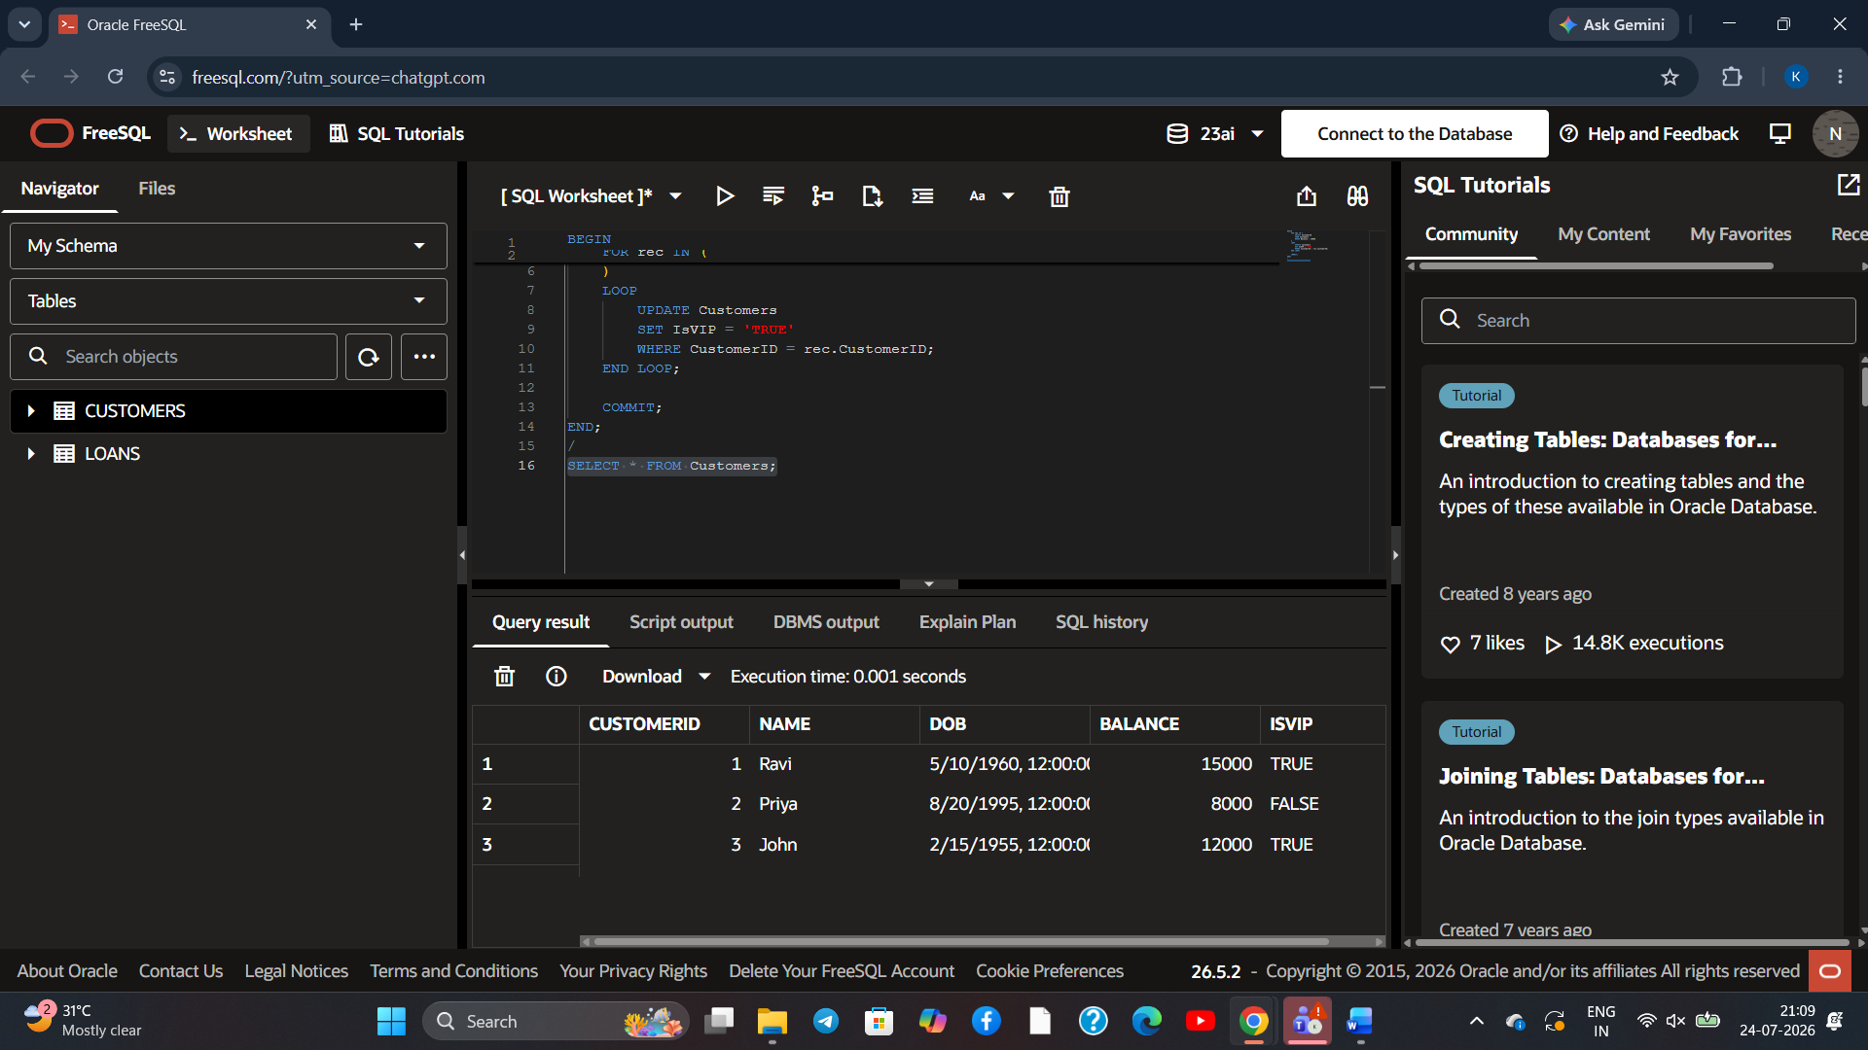
Scenario 3: Generate Loan Due Reminder Messages:
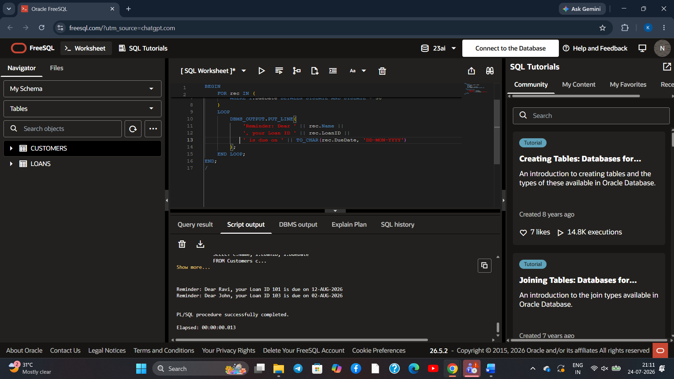
2.Scenario 1: Process Monthly Interest for Savings Accounts:
To create and execute a PL/SQL stored procedure that calculates and updates the balance of all savings accounts by applying a monthly interest rate of 1%.

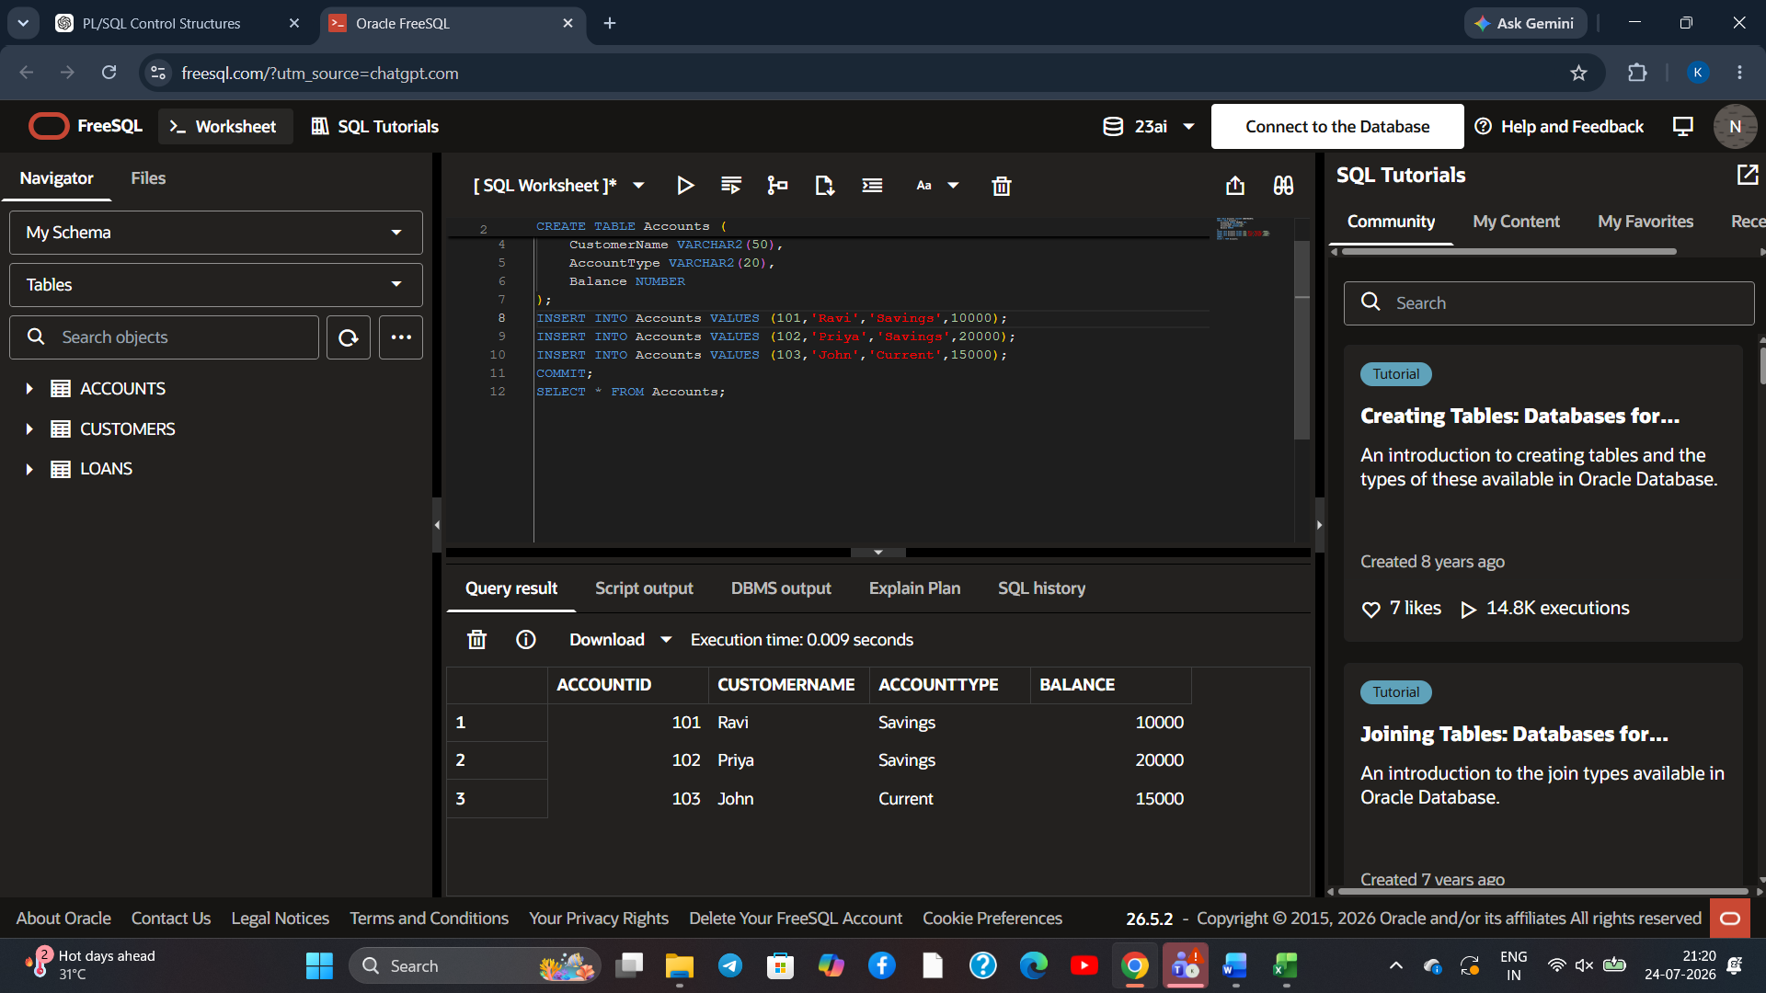
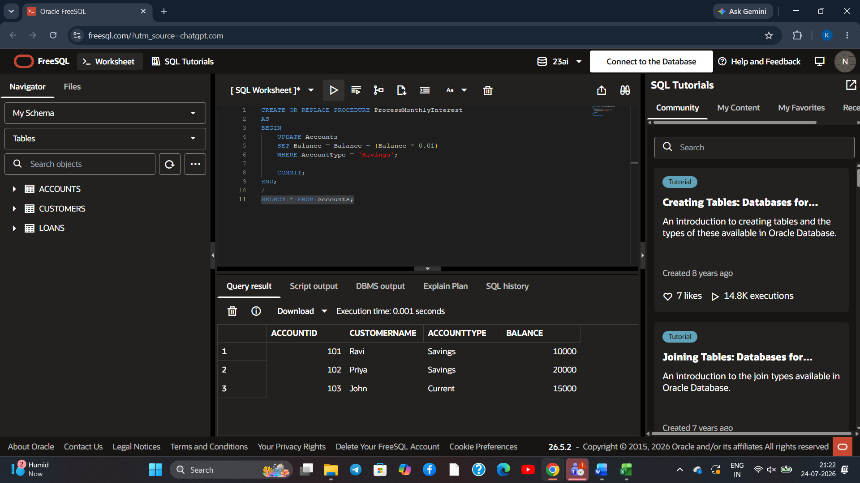
Scenario 2: Update Employee Bonus Based on Department:
To create and execute a PL/SQL stored procedure that updates the salaries of employees in a specified department by applying a bonus percentage passed as a parameter.

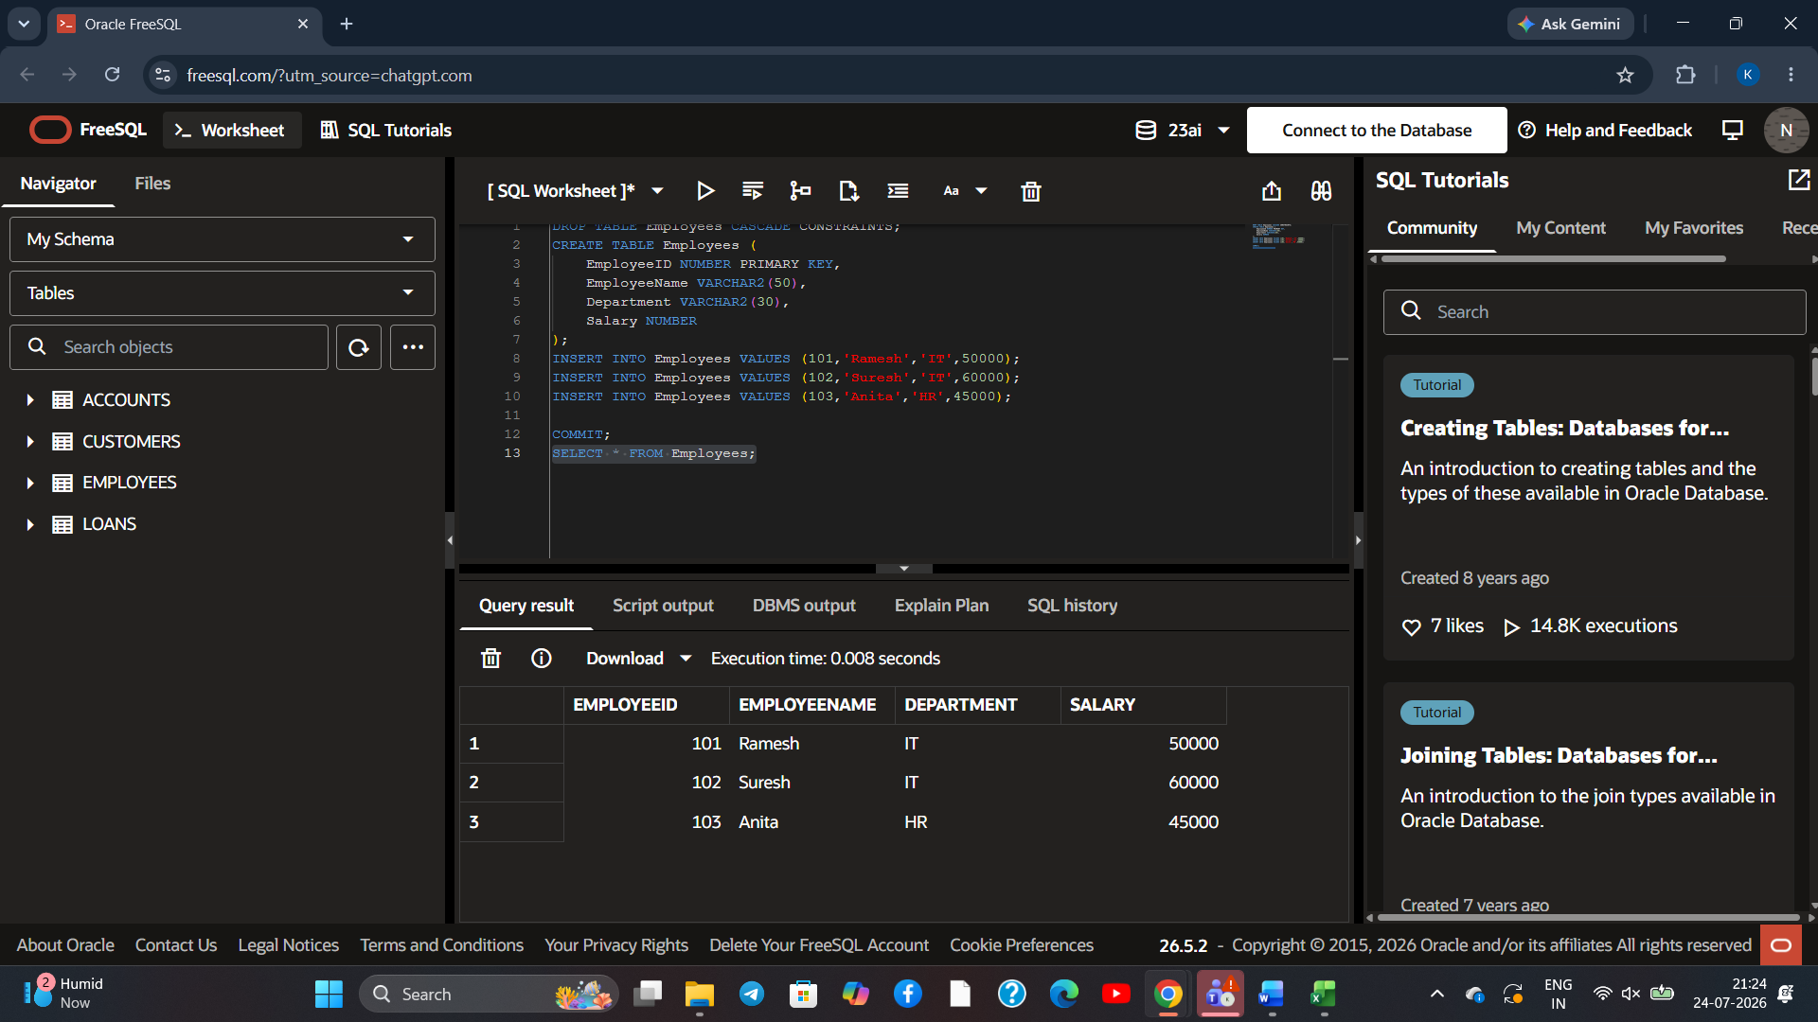
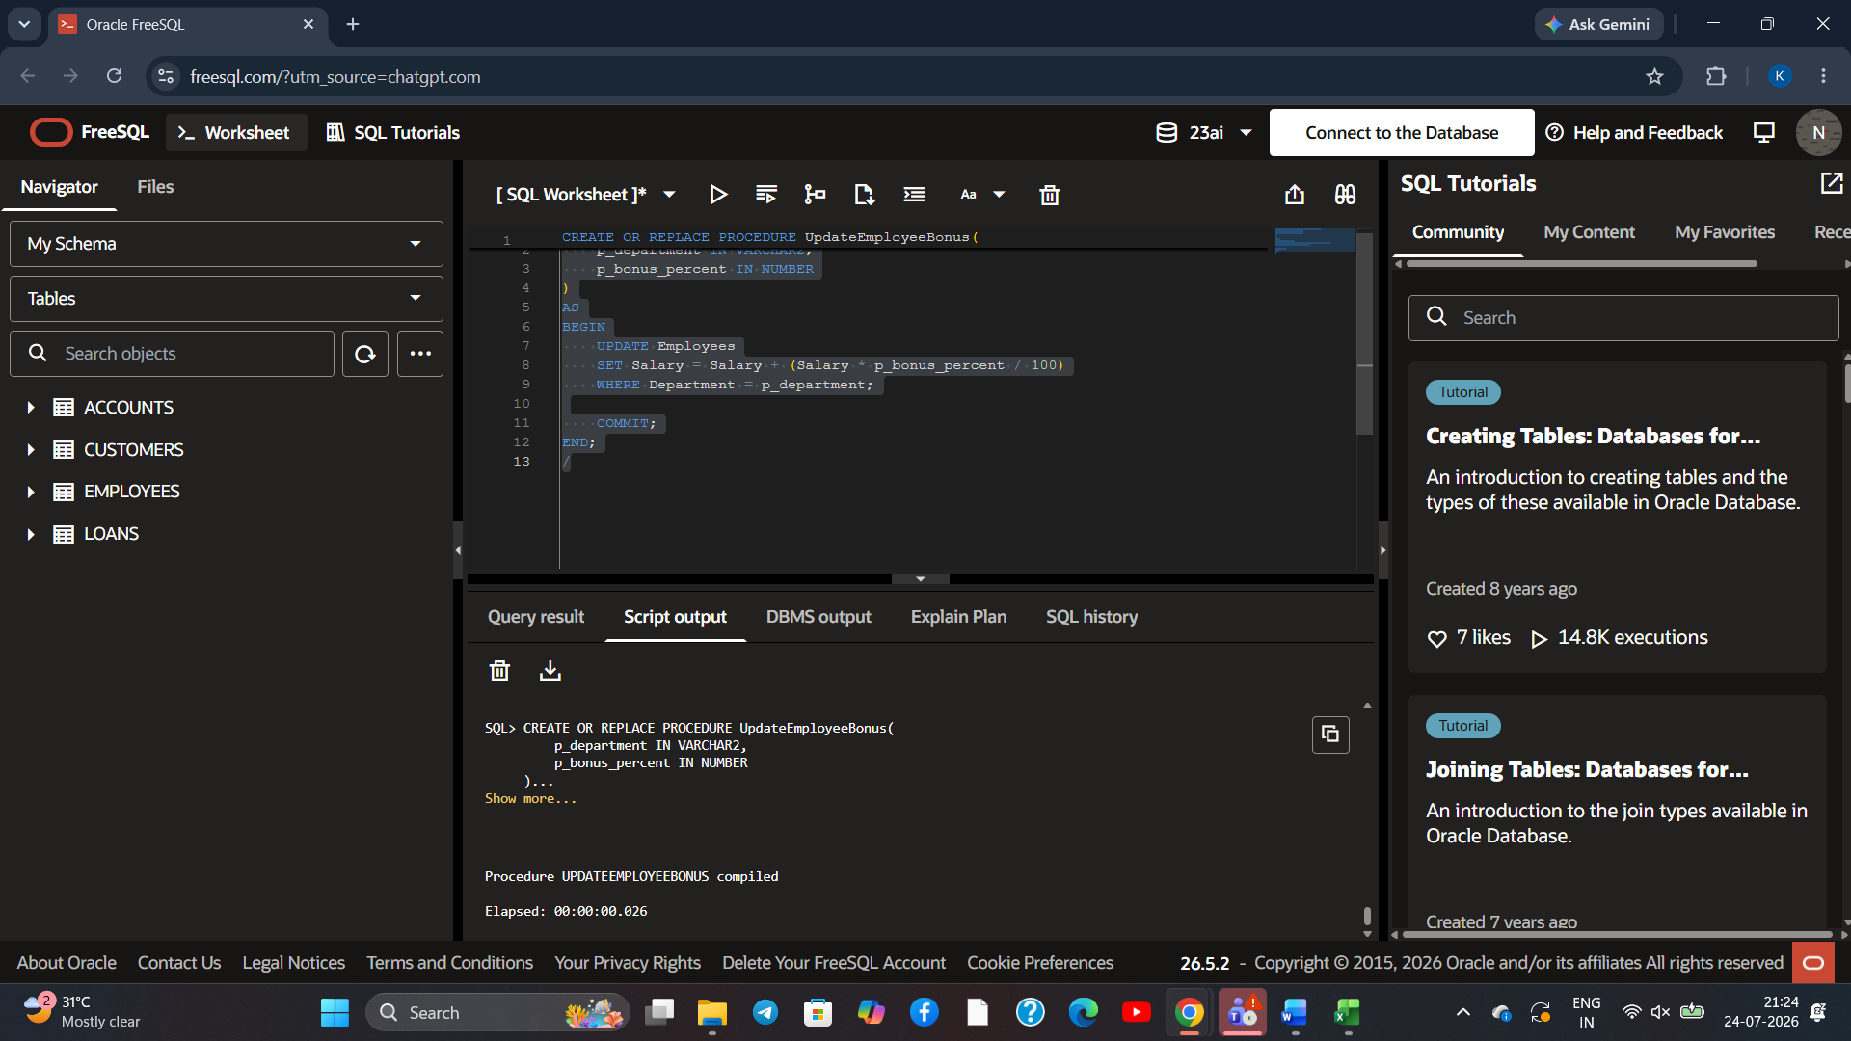
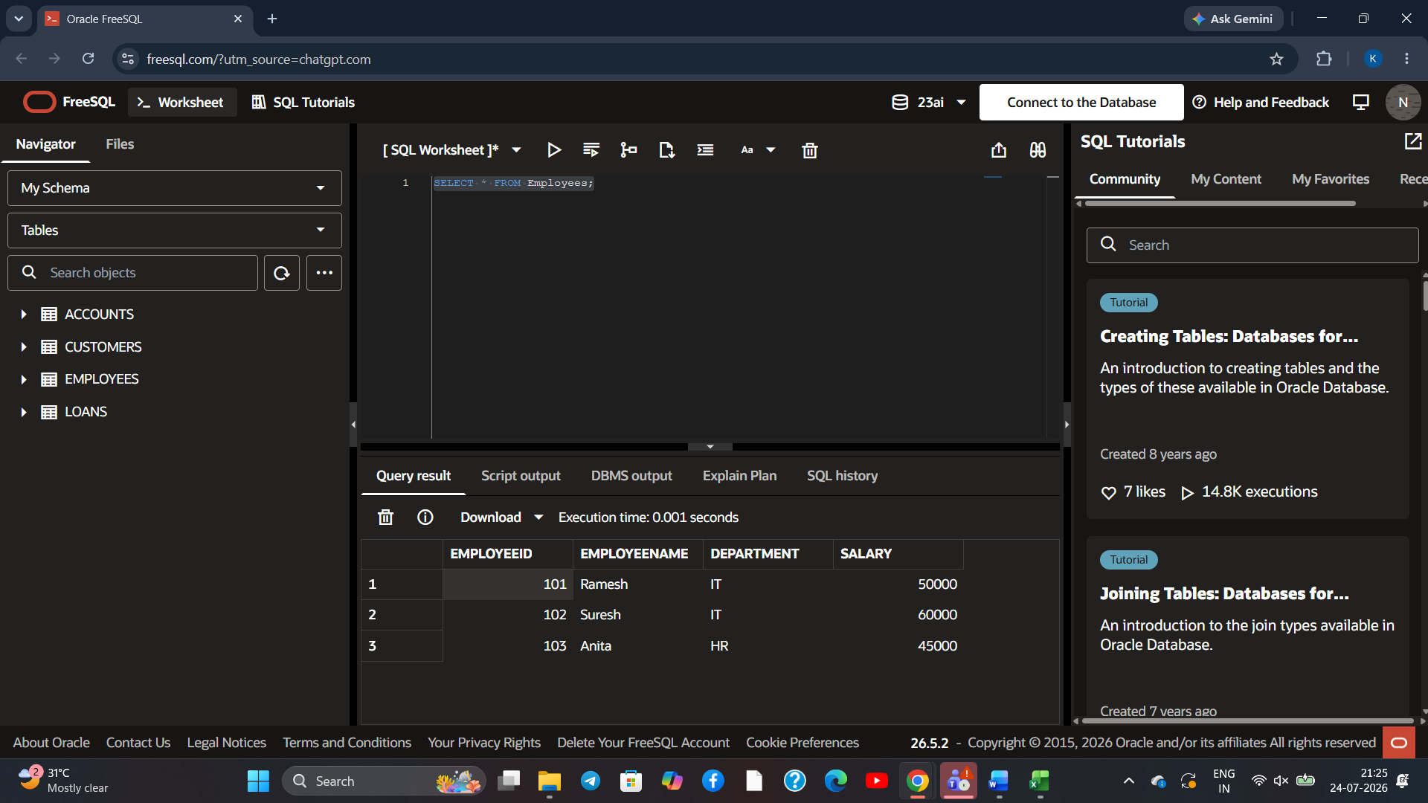
Scenario 3: Transfer Funds Between Accounts:
To create and execute a PL/SQL stored procedure that transfers a specified amount from one customer account to another after verifying that the source account has sufficient balance.
