Mockito
Exercise 1: Mocking Databases and Repositories:
Aim:To create a mock repository using Mockito, stub the repository methods, and test the service logic without using a real database.
OUTPUT:
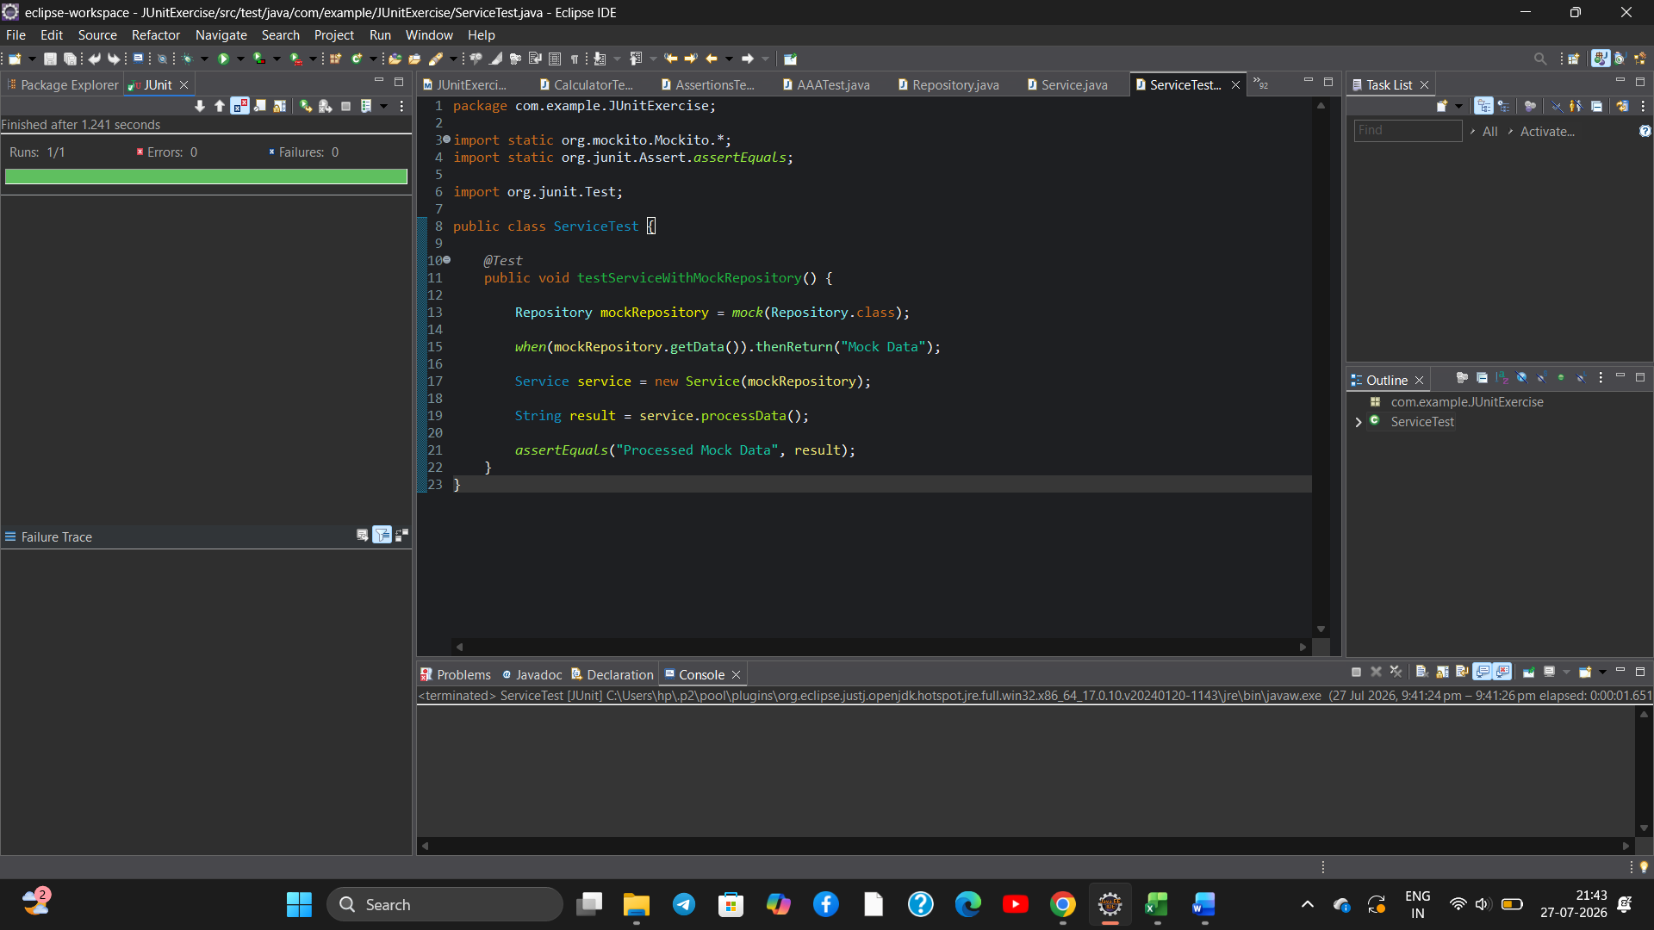
Result:
The repository was successfully mocked using Mockito, the service logic was tested using the mocked repository, and the JUnit test passed successfully without any errors or failures.
Exercise 2: Mocking External Services (RESTful APIs):
Aim: To create a mock REST client using Mockito, stub the REST client methods, and verify the API service logic using the mocked REST client.
OUTPUT:
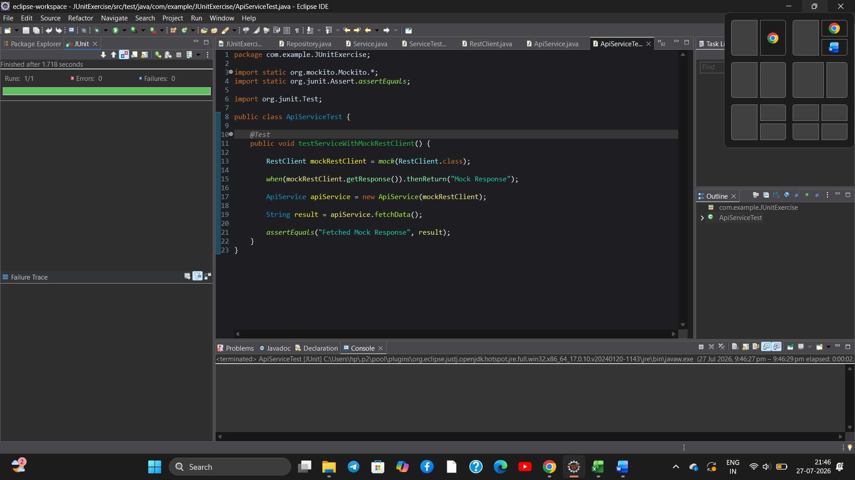
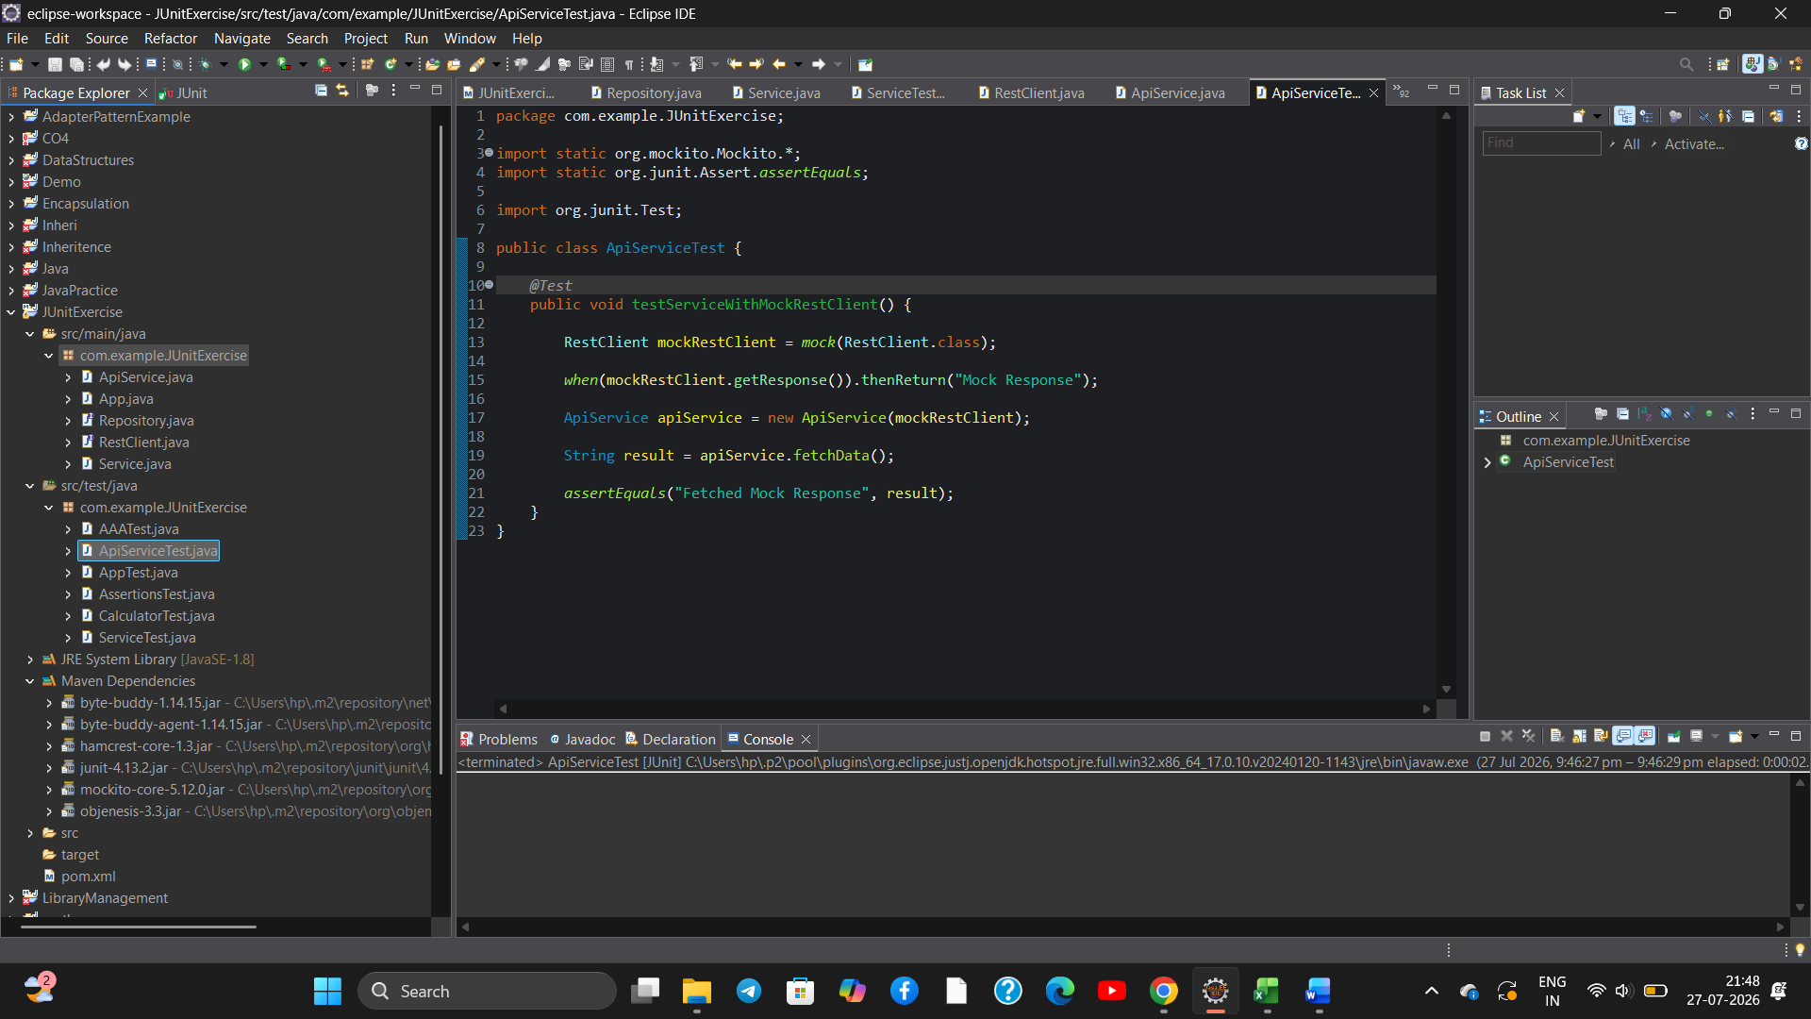
Result:
The REST client was successfully mocked using Mockito, and the API service logic was tested successfully without calling an actual RESTful API. The JUnit test passed successfully without any errors or failures.

