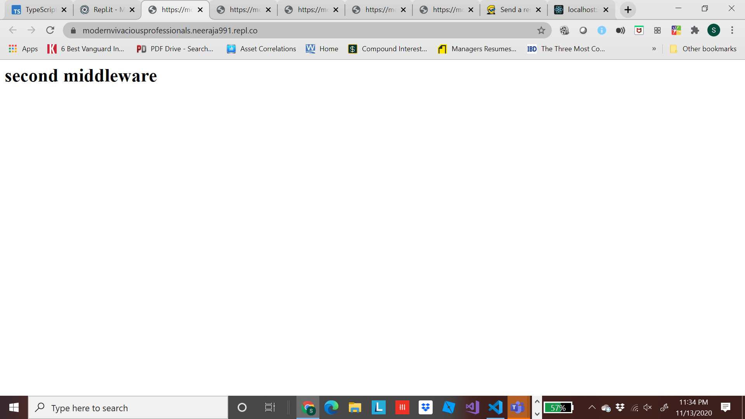

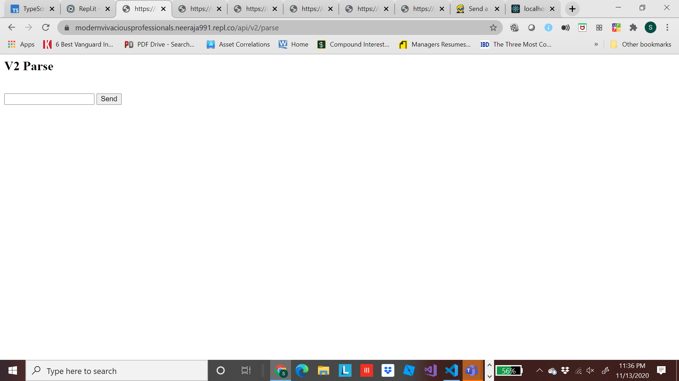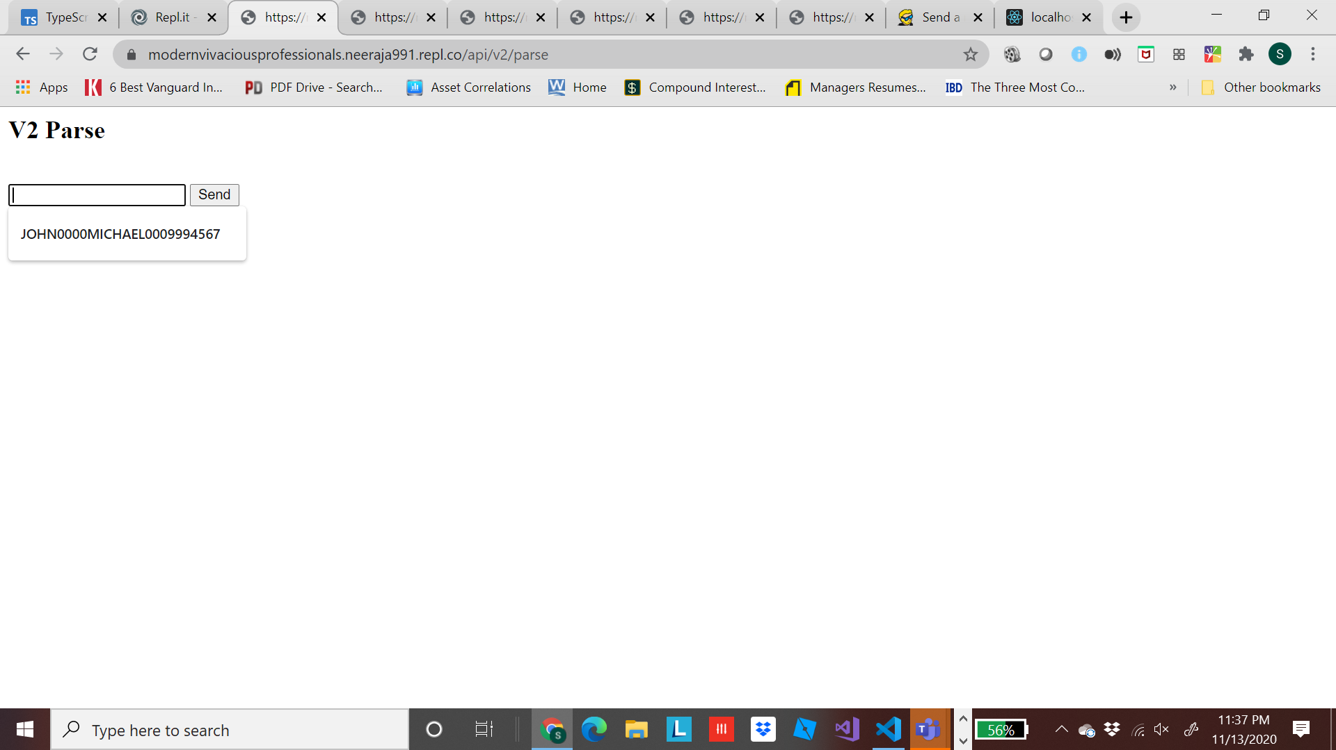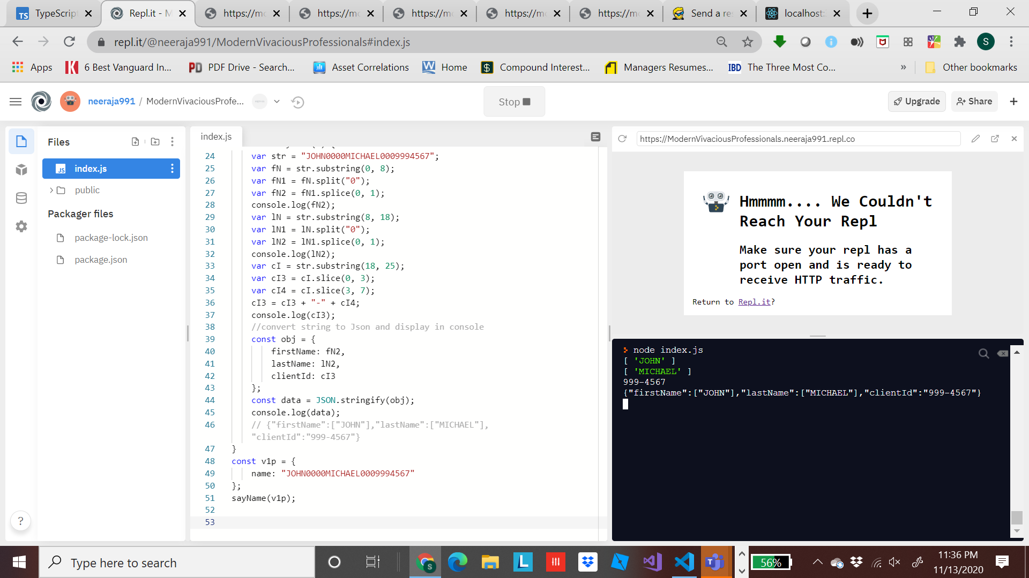

https://github.com/neeraja991/parse

Code:

"use strict";

const http = require('http');

const express = require('express');

const bodyParser = require('body-parser');

const app = express();

app.use(bodyParser.urlencoded({ extended: false }));

app.use('/', (req, res, next) => {

next();

});

app.get('/api/v2/parse', (req, res, next) => {

res.send('<h2>V2 Parse</h2><br><form action="/post2" method="POST"> <input type="text" name="value2"> <button type="submit"> Send </button> </form>');

});

app.post('/post2', (req, res, next) => {

console.log('data from v2: ', req.body.value2);

res.status(200).send('OK');

res.end();

res.redirect('/api/v2/parse');

});

app.use('/', (req, res, next) => {

res.send('<h1> second middleware</h1>');

});

const server = http.createServer(app);

server.listen(3000);

function sayName(o) {

var str = "JOHN0000MICHAEL0009994567";

var fN = str.substring(0, 8);

var fN1 = fN.split("0");

var fN2 = fN1.splice(0, 1);

console.log(fN2);

var lN = str.substring(8, 18);

var lN1 = lN.split("0");

var lN2 = lN1.splice(0, 1);

console.log(lN2);

var cI = str.substring(18, 25);

var cI3 = cI.slice(0, 3);

var cI4 = cI.slice(3, 7);

cI3 = cI3 + "-" + cI4;

console.log(cI3);

//convert string to Json and display in console

const obj = {

firstName: fN2,

lastName: lN2,

clientId: cI3

};

const data = JSON.stringify(obj);

console.log(data);

// {"firstName":["JOHN"],"lastName":["MICHAEL"],"clientId":"999-4567"}

}

const v1p = {

name: "JOHN0000MICHAEL0009994567"

};

sayName(v1p);