**EY Task: Report on Challenges and Solutions**

1. **Billing Setup**

During the billing setup, the system indicated that the process would take approximately 24 hours to complete.

1. **Cluster Provisioning Challenges**

**Quota Restrictions:**

* + Initially, a cluster was created in the us-west1 region.
  + An attempt to create a cluster in the us-central1 region failed due to insufficient quota.

**The error details are as follows:**

Google_container_cluster.gke_cluster: Creating...  
╷  
│ Error: googleapi: Error 403: Insufficient regional quota to satisfy request: resource "SSD_TOTAL_GB": request requires '600.0' and is short '350.0'. project has a quota of '250.0' with '250.0' available. View and manage quotas at <https://console.cloud.google.com/iam-admin/quotas?usage=USED&project=ey-demo-proj>.  
│ Details:  
│ [  
│   {  
│     "@type": "[type.googleapis.com/google.rpc.RequestInfo](http://type.googleapis.com/google.rpc.RequestInfo)",  
│     "requestId": "0xf9bf10416b7bfca3"  
│   },  
│   {  
│     "@type": "[type.googleapis.com/google.rpc.ErrorInfo](http://type.googleapis.com/google.rpc.ErrorInfo)",  
│     "domain": "[container.googleapis.com](http://container.googleapis.com)",  
│     "reason": "INSUFFICIENT_QUOTA_REGIONAL"  
│   }  
│ ]  
│ , forbidden  
│   
│   with google_container_cluster.gke_cluster,  
│   on [main.tf](http://main.tf) line 18, in resource "google_container_cluster" "gke_cluster":  
│

**Resolution:**

1. **The cluster was successfully created in the us-west1 region.**
2. **Later, a new cluster was provisioned in the us-central1 region with the name ey-task-cluster after quota adjustments**
3. **But when tried to use Cloud build to trigger application deployment on GKE it display region not supported as below**

<https://cloud.google.com/build/docs/locations#restricted_regions_for_some_projects>

**Cloud Build Deployment Issues**

**Region Limitations:**

* + While using **Cloud Build** to trigger application deployment on GKE, an error occurred indicating that the selected region was not supported.
  + Depending on usage, certain projects may be restricted to only use Cloud Build in the following regions:
* us-central1
* us-west2
* europe-west1
* asia-east1
* australia-southeast1
* southamerica-east1

**The error details are as follows:**

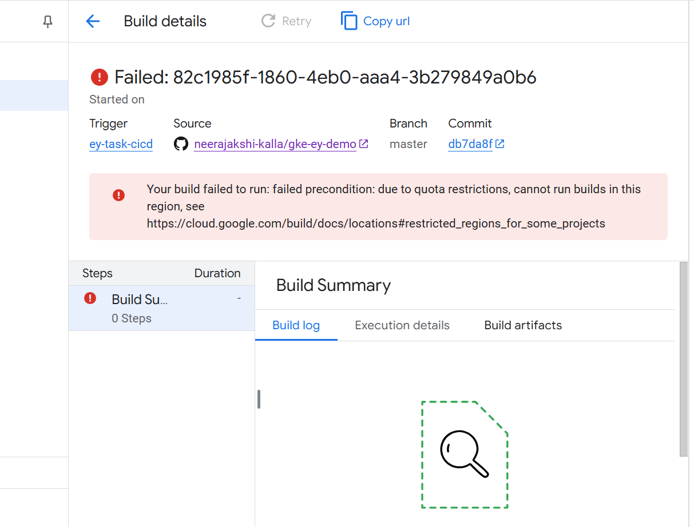

1. **Resolution: Deleted the created cluster in us-central1 region**
2. **The cluster was deleted in the unsupported region and re-created in a supported region (us-central1) with the same name ey-task-cluster**

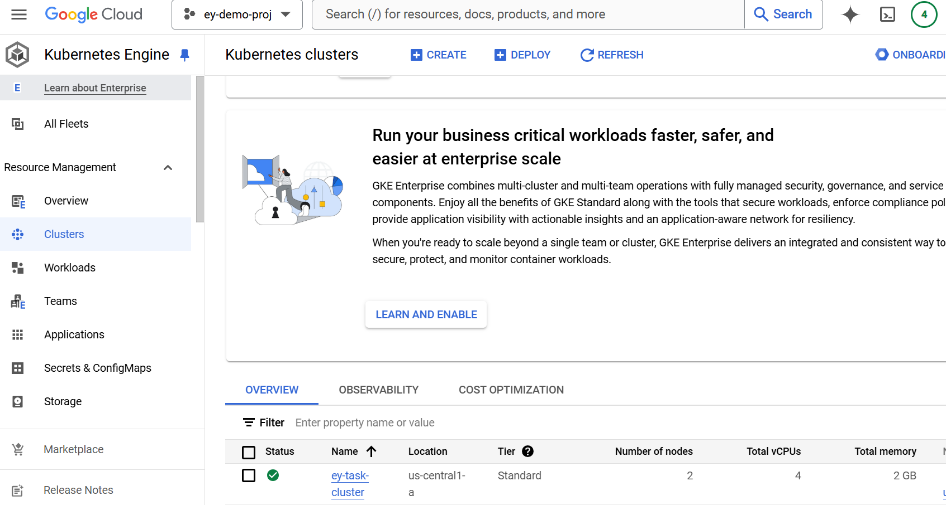

1. **Deploy an application on the GKE cluster using Jenkins/Cloud Build.**
2. **GitHub source repo details :** [**https://github.com/neerajakshi-kalla/gke-cicd**](https://github.com/neerajakshi-kalla/gke-cicd)

**Trigger Creation for CI/CD**

1. **GitHub Repository:**
   * Repository: [GKE-CICD Repository](https://github.com/neerajakshi-kalla/gke-cicd)
2. **Trigger Details:**
   * A trigger was created and connected to the repository.
   * Event: **Push to a branch**.
   * Configuration:
     + **Source:** First Generation.
     + **Branch Commit:** Any branch (.*).
     + **Build Configuration File:** YAML or JSON from the GitHub repository.
   * Service Account:
     + Selected a relevant service account with appropriate permissions.
3. **Execution Steps:**
   * Made code changes, followed by:

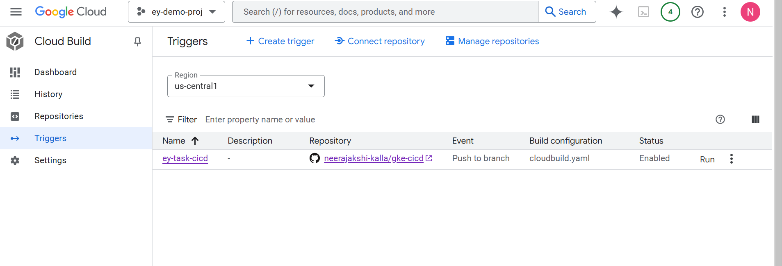

1. **Created trigger and connect to repo and selected Event Push to a branch**

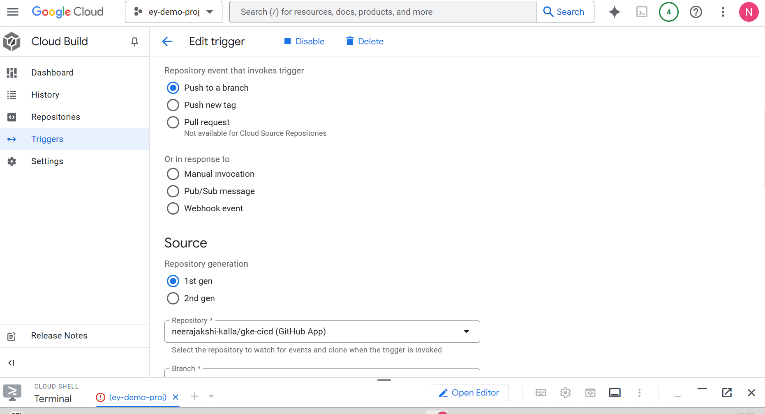

1. **Used 1st Gen source and Branch commit to any .* (any Branch)**
2. **Configuration selected as Cloud Build configuration file (yaml or json)**
3. **Location is our GitHub App repo**
4. **Select relevant service account and if required need to provide required privileges by granting to the user**
5. **Once Trigger creation and connect to repository done**
6. **Do some changes and do git add . , commit and push those changes**
7. **It will trigger build history need to refresh the page to see the build steps if failed any where as per the error need to update the build steps.**

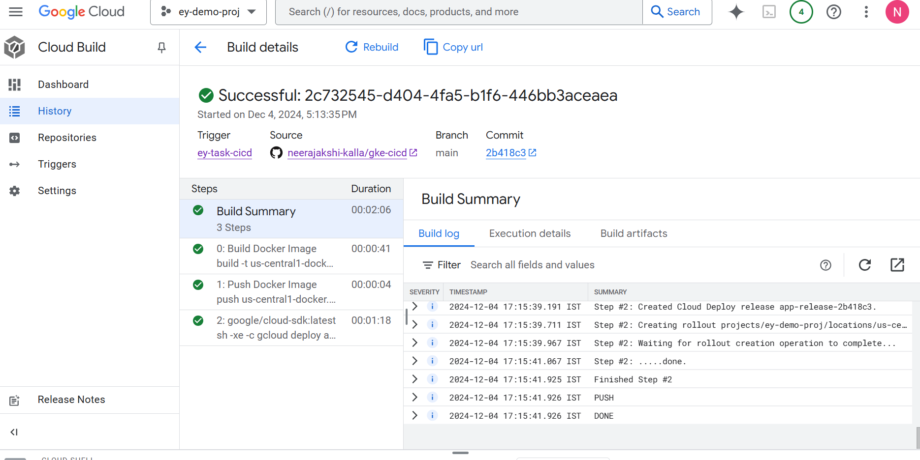

1. **It creates the Application deployment on Cluster, access workload and validate it**

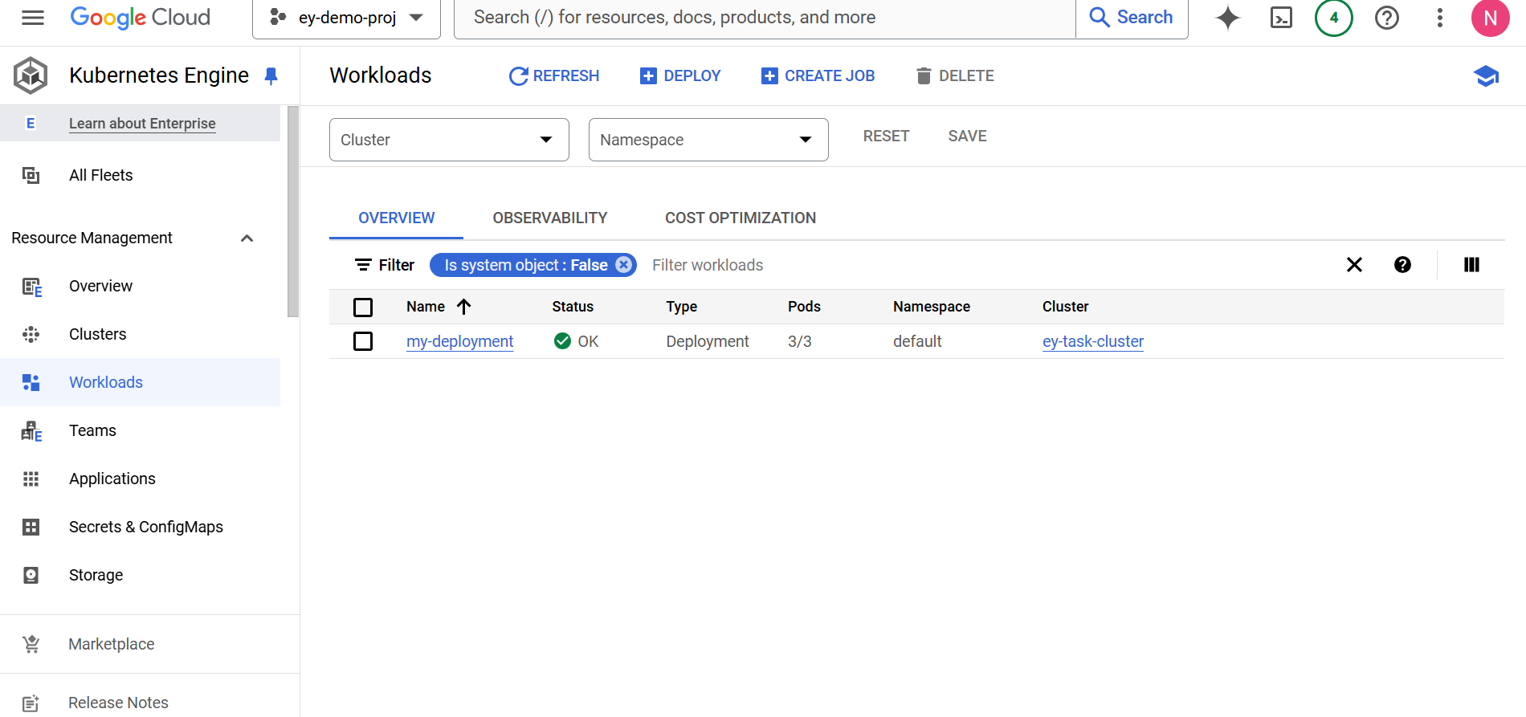

1. **Access the deployed application under exposing service as my-service with type: Load balancer**

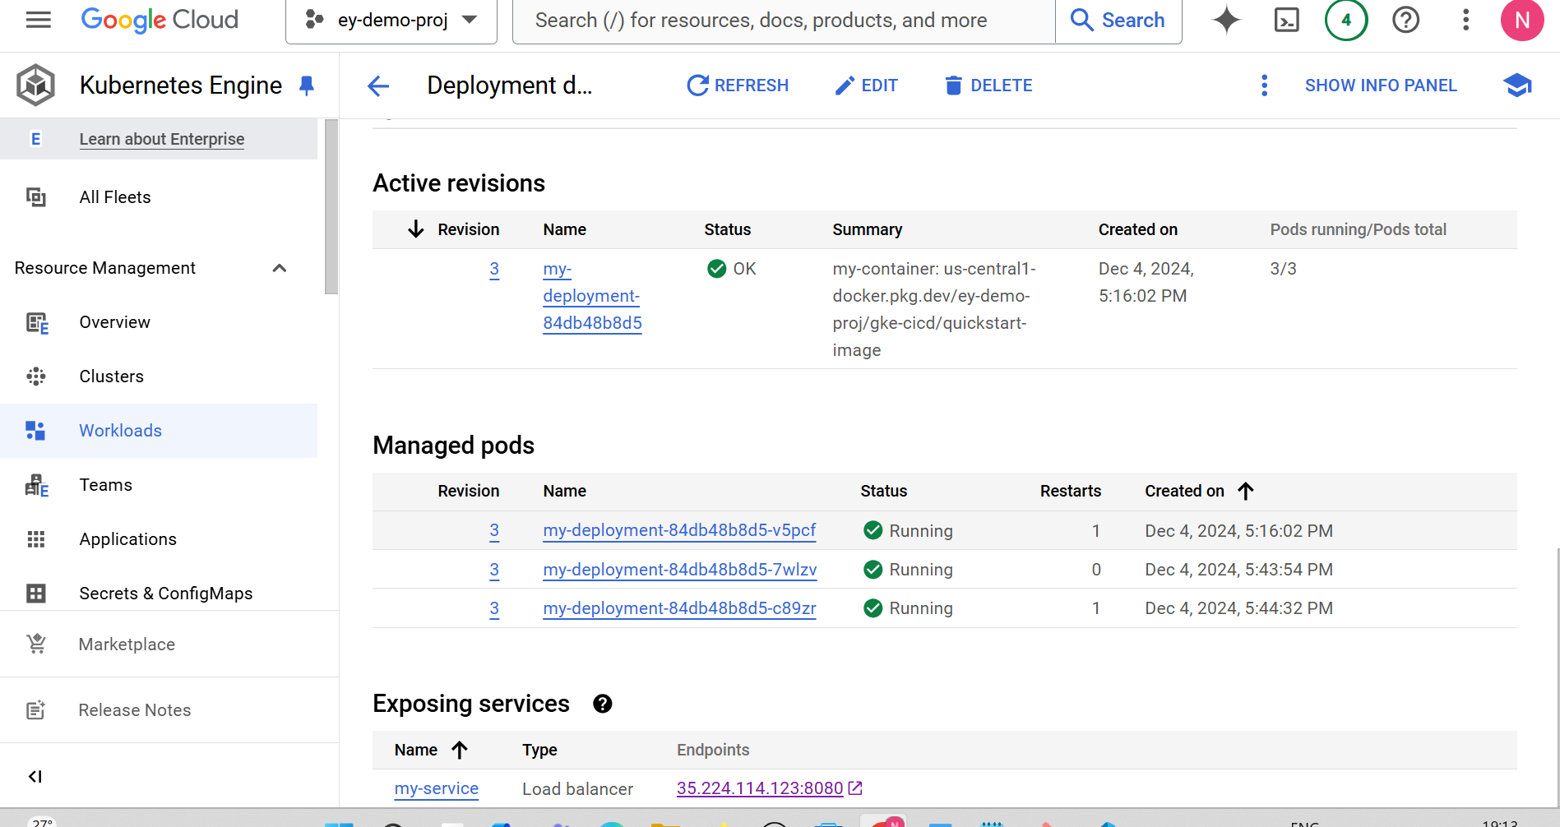

1. Service details and servicing pods

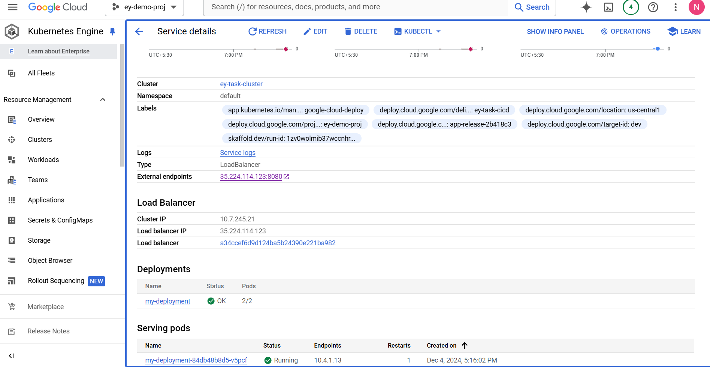

1. **For Blue-Green deployment used below Git repo:** [**https://github.com/neerajakshi-kalla/blue-green-deployment**](https://github.com/neerajakshi-kalla/blue-green-deployment)
2. **Implement a blue-green deployment strategy to showcase your ability to manage deployments with minimal downtime and risk.**

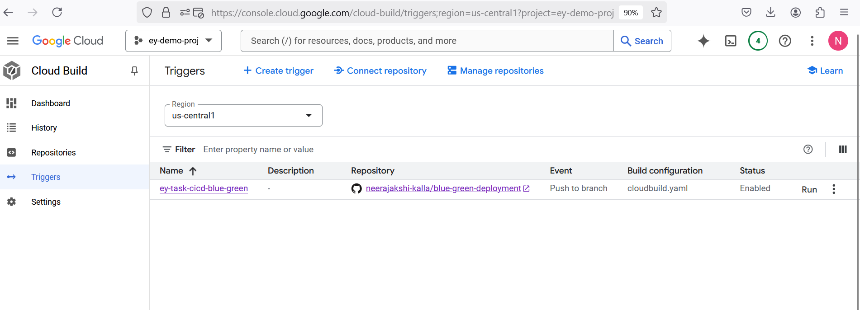

1. **Created trigger and connected repository as below**

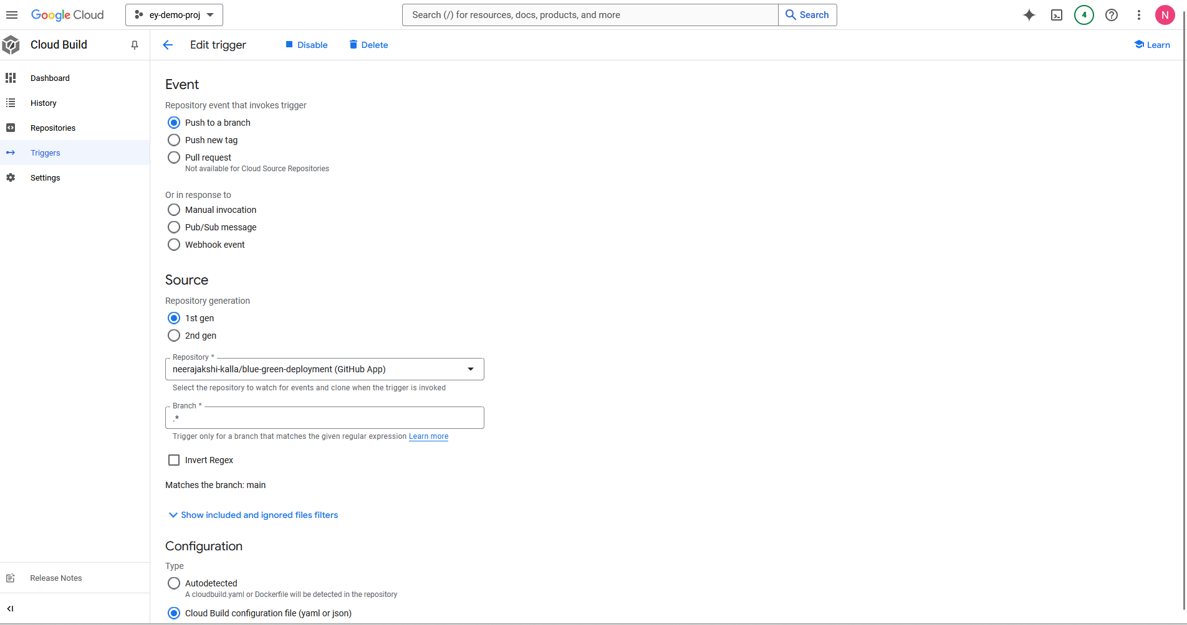

1. **Build history details:**

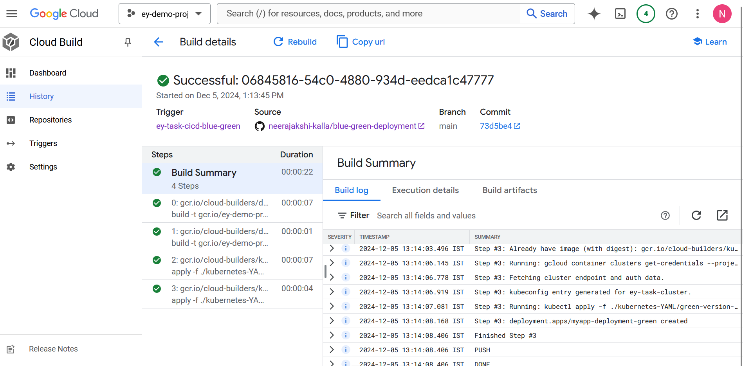

1. **Workloads on created cluster**

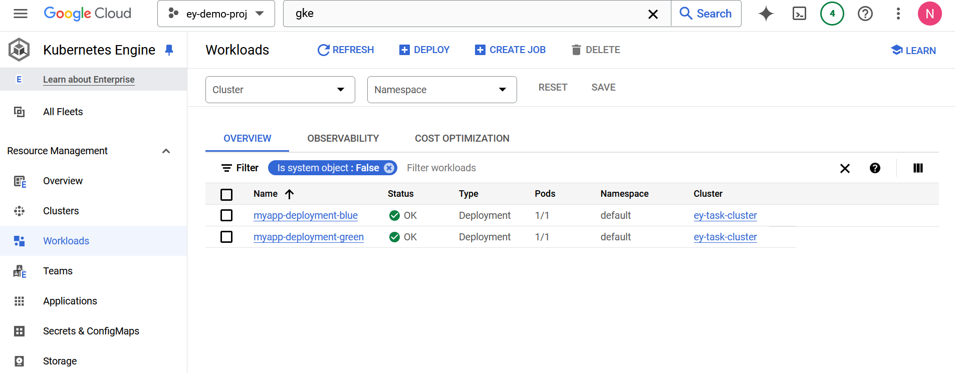

1. **Exposed blue deployment using service**

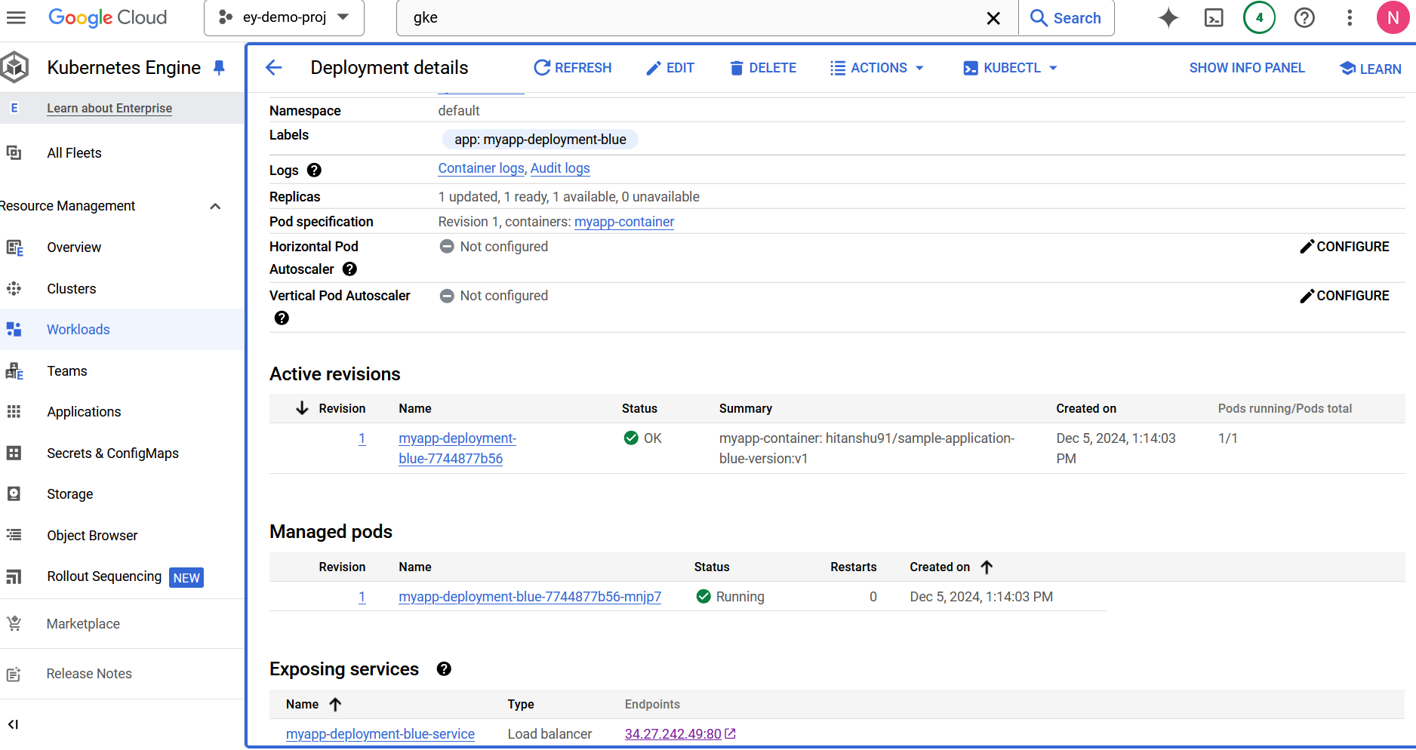

1. **Accessible ip for the exposed application for Blue deployment -service:** [**http://34.27.242.49/**](http://34.27.242.49/)

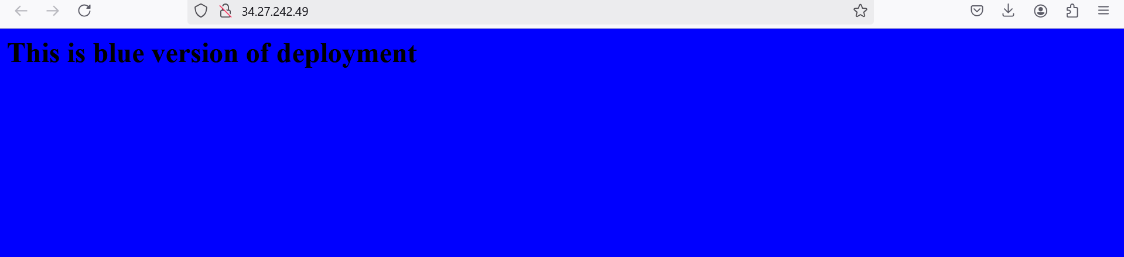

1. **Accessible ip for the exposed application for Green deployment -service:** [**http://34.27.242.49/**](http://34.27.242.49/)

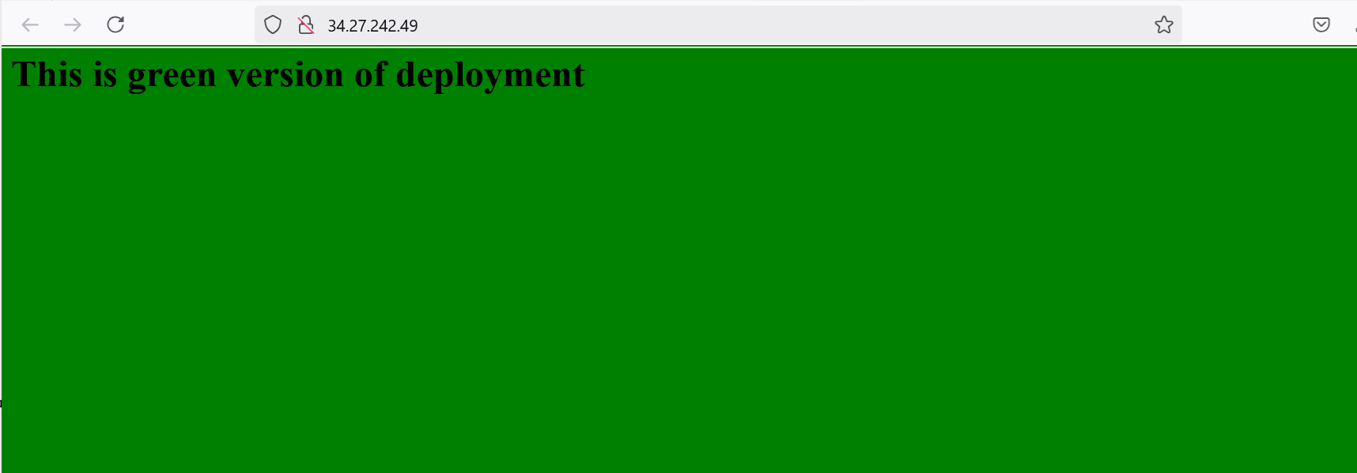

**Challenges Encountered**

1. **Google Cloud Selection of Regions:**
   * Ensuring the selected region supported all required services.
   * Adjusting quotas to meet provisioning requirements.
   * Billing setup related to personal Gmail account not able to verify it
2. **Quota Allocation:**
   * Limited quotas for certain regions, leading to failed provisioning attempts.
3. **Cluster Creation Delays:**
   * Time-consuming process for cluster creation, particularly in regions with quota limitations.
4. **YAML File Indentation:**
   * Errors due to incorrect YAML file indentation and tagging issues during resource configurations.
5. **IAM Permissions:**
   * The service account used by Terraform might not have sufficient permissions to create GKE clusters.
6. **Cost:**
   * Network usage cost became more
   * While doing cloud build trigger connected with GitHub repo and vulnerabilities of the docker images