FOOD DETECTION SYSTEM
End-to-End Technical Documentation
Prepared By: Neeraja Kumari Raulo
Project Type: Deep Learning + Web Application
Technology: Python, TensorFlow, Flask, Redis

ABSTRACT
The Food Detection System is an end-to-end deep learning web application designed to classify food images and provide nutritional information. This project integrates data preprocessing, deep learning model training, model evaluation, backend API development, database integration, and frontend user interaction. The system supports three architectures: Custom CNN, VGG16, and ResNet50. After prediction, nutritional data such as calories, protein, carbohydrates, and fats are retrieved from a Redis database and displayed to the user through a Flask-based web interface.

TABLE OF CONTENTS
1. Introduction
2. Problem Statement
3. System Architecture
4. Dataset Preparation
5. Data Preprocessing
6. Model Development
7. Transfer Learning
8. Model Training Process
9. Model Evaluation Metrics
10. Backend Development (Flask)
11. Image Processing & Prediction Flow
12. Redis Database Integration
13. Frontend Design
14. Deployment Process
15. Challenges & Solutions
16. Future Enhancements
17. Conclusion

1. INTRODUCTION
Food image recognition is a computer vision problem where a system identifies food items from images using deep learning models.
This project was developed to create an intelligent system that:
- Detects food from images
- Predicts the correct food category
- Retrieves nutritional information instantly
It combines AI modeling with backend deployment, making it a real-world practical system.

2. PROBLEM STATEMENT
Manual calorie tracking is:
- Time-consuming
- Error-prone
- Not user-friendly
Many individuals want to monitor their nutrition but lack automated tools.
Solution:
Develop an AI-based food detection system that:
- Automatically classifies food images
- Fetches nutrition data
- Displays results through a web interface

3. System Architecture
The system follows a modular architecture:
- Dataset Preparation Module
- Model Training Module
- Model Evaluation Module
- Flask Backend Module
- Redis Database Module
- Frontend Interface
Workflow:
User Upload → Image Preprocessing → Model Prediction → Nutrition Retrieval → Display Result
5. DATASET PREPARATION
What Was Done:
- Food images organized into class-based folders
- Dataset split into:
  - Training Set
  - Validation Set
  - Testing Set
- Used split_data.py for automated splitting
Why It Was Done:
- Training set helps model learn patterns
- Validation prevents overfitting
- Test set evaluates final performance
Benefit:
Ensures proper model generalization and fair evaluation.

6. DATA PREPROCESSING
Steps Performed:
- Resized images to 224x224 pixels
- Normalized pixel values (0–1 range)
- Shuffled dataset
Why:
- CNN models require fixed input size
- Normalization improves gradient convergence
- Shuffling prevents bias
Benefit:
Faster training and improved accuracy.

6. Model Development
Three models were implemented:
CONVOLUTIONAL NEURAL NETWORK (CNN)
Definition:
A Convolutional Neural Network (CNN) is a deep learning architecture specifically designed for image processing tasks.
Structure:
- Convolution Layers
- ReLU Activation
- Pooling Layers
- Fully Connected Layers
- Softmax Output
What Was Done:
A custom CNN model was built from scratch to serve as a baseline model.
Why:
To understand internal CNN working and compare performance with advanced models.
Advantage:
- Lightweight
- Suitable for small datasets
- Easy to implement
VGG16 ARCHITECTURE
Definition:
VGG16 is a 16-layer deep convolutional neural network pre-trained on the ImageNet dataset.
What Was Done:
- Loaded VGG16 without top classification layer
- Froze convolutional base
- Added custom Dense layers
- Trained final layers
Why Used:
To apply transfer learning and reuse learned image features.
Benefits:
- High accuracy
- Reduced training time
- Better feature extraction
RESNET50 ARCHITECTURE
Definition:
ResNet50 is a 50-layer deep residual network that introduces skip connections to solve the vanishing gradient problem.
Vanishing Gradient Problem:
In very deep networks, gradients become very small, stopping effective learning.
Residual Formula:
Output = F(x) + x
What Was Done:
- Loaded pre-trained ResNet50
- Fine-tuned final layers
- Compared performance with VGG16 and CNN
Benefits:
- Very high accuracy
- Stable deep learning
- Industry-standard architecture

7. Transfer Learning
Definition:
Transfer learning is a technique where a pre-trained model is reused for a new task.
Why Used:
- Saves training time
- Works well with smaller datasets
- Improves performance
Benefit:
Achieved better accuracy compared to training from scratch.

8. Model Training Process
Configuration:
- Optimizer: Adam
- Loss Function: Categorical Crossentropy
- Metrics: Accuracy
- Epochs: Multiple iterations
- Saved as .h5 files
Why:
- Adam provides faster convergence
- Crossentropy is best for multi-class classification
Benefit:
Efficient and reusable trained models.

9. Model Evaluation Metrics
Metrics Used:
- Accuracy
- Precision
- Recall
- F1 Score
Why Not Only Accuracy?
Accuracy alone may be misleading.
- Precision → Correctness
- Recall → Coverage
- F1 Score → Balance
Benefit:
Ensures model reliability.

10. Backend Development (Flask)
What Was Done:
- Created Flask server
- Defined routes:
  - / → Homepage
  - /predict → Image prediction
- Loaded models at startup
Why:
Flask is lightweight and suitable for ML deployment.
Benefit:
Transforms AI model into real-world web application.

11. Image Processing & Prediction Flow
- User uploads image
- Image saved to uploads folder
- Image preprocessed
- Model predicts class probabilities
- Argmax selects highest probability
- Redis fetches nutrition data
- Results displayed to user

12. Redis Database Integration
Definition:
Redis is an in-memory key-value database designed for fast data retrieval.
What Was Done:
- Stored nutrition data in Redis
- Used food name as key
- Retrieved calories, protein, carbs, fats
Why Used:
- Faster than traditional databases
- Suitable for real-time systems
Benefit:
Instant nutrition lookup during prediction.

13. Frontend Design
HTML forms allow image upload. CSS improves styling. Prediction results are displayed dynamically using Flask templates.
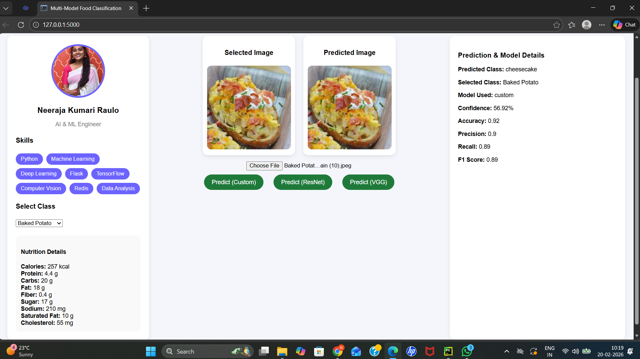

14. Deployment Process
Steps:
1. Install dependencies
2. Start Redis server
3. Train models
4. Run Flask server
5. Access localhost:5000
The system can be deployed on cloud platforms with Docker.

15. CHALLENGES AND SOLUTIONS
Challenge | Solution
Overfitting | Validation split & Transfer Learning
Slow training | Pre-trained models
Vanishing Gradient | ResNet residual connections
Slow nutrition lookup | Redis

16. FUTURE ENHANCEMENTS
- Cloud deployment (AWS/GCP)
- User authentication
- Mobile app integration
- More food categories
- Advanced models like EfficientNet
17. CONCLUSION
The Food Detection System successfully demonstrates a complete AI pipeline including:
- Dataset preparation
- Deep learning model development
- Transfer learning
- Model evaluation
- Backend deployment
- Database integration
This project reflects strong practical skills in Artificial Intelligence, Deep Learning, and Full-Stack Development.

